Renal/Urology Questions – Fellowship SAQ

Question 1

A 17 year male presents with a 5 hour history of a painful left testicle and nausea. He has been playing football and thinks his testicle may have been “knocked” during the game, although doesn’t recall a specific event.

a) List the features on history and examination that make torsion of the testicle the most likely differential diagnosis above any other (5 marks)

b) List four additional differential diagnoses and for each a positive examination finding that would make this diagnoses most likely (8 marks)

|  |  |
| --- | --- |
| Differential | Examination Finding |
|  |  |
|  |  |
|  |  |
|  |  |

**The urology team available are currently operating on a critically unwell patient. They are likely to be 1 hour before they can see the patient**.

c) How will you manage this patient (4 marks)

**Question 2**

**A 76 year old man presents to ED with right loin to groin pain. He has a history of hypertension, gout and hypercholesterolaemia. His observations are shown below:**

**P 130**

**Sats 99% RA**

**RR 30**

**BP 100/60**

**Temp 37.6**

**The RMO looking after the patient is keen to put the patient into the Short Stay area to await a CTKUB to exclude renal colic as a cause.**

a) List 5 exclusion criteria you might include in a short stay renal colic protocol (5 marks)

**The CTKUB is shown below**



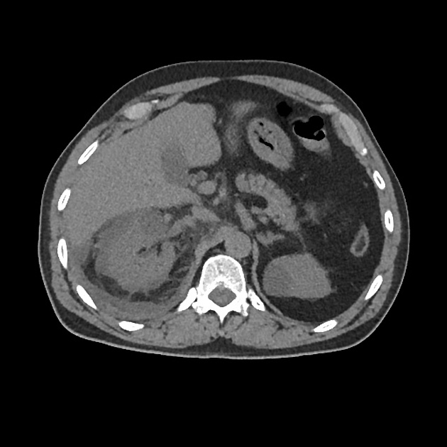



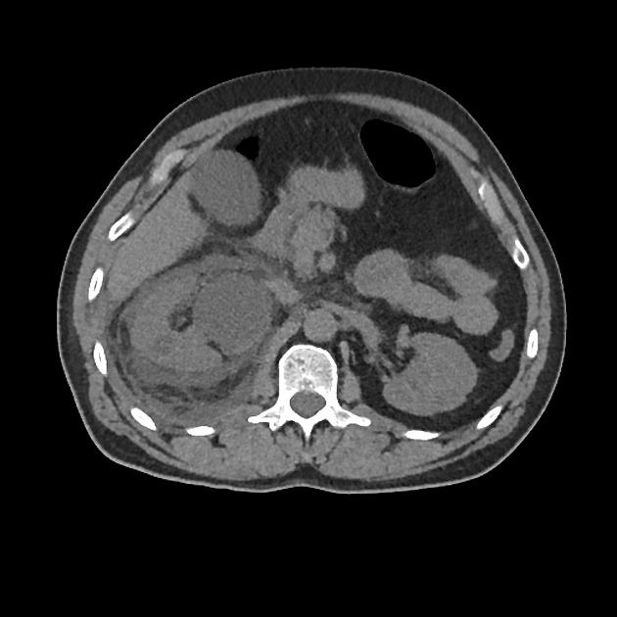





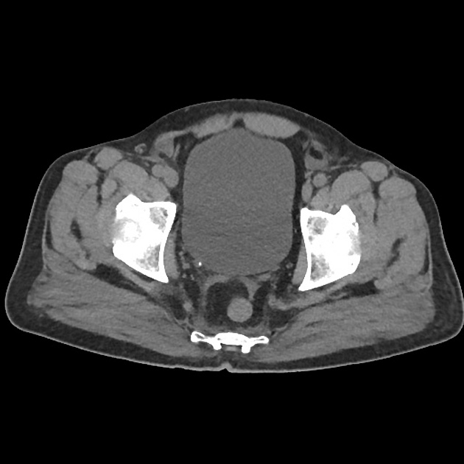

b) List the abnormal features on these CT slices (3 marks)

c) How will you treat this patient in the ED (5 marks)

**Question 3**

**A 32 year old man presents to ED with a swollen penis.**

[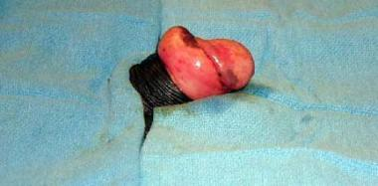](http://www.google.com.au/url?sa=i&rct=j&q=&esrc=s&source=images&cd=&cad=rja&uact=8&ved=0ahUKEwiBo6m6x8bSAhVIVZQKHQaIDFkQjRwIBw&url=http://emedicine.medscape.com/article/442883-overview&psig=AFQjCNG7OxYq-orBnBfHf4Xjdd9dx_FnDw&ust=1489050047860792)

a) What is the diagnosis (1 mark)

b) List in the table the 3 strategies you might use to correct this problem with a short description of how to perform (in escalating order of use, assuming that the one prior has failed) (6 marks)

|  |  |
| --- | --- |
| Technique | Description |
|  |  |
|  |  |
|  |  |
|  |  |

c) What discharge advice will you give to the patient when the abnormality is sucessfully corrected? (4 marks)

**Question 4**

**A 54 year old man presents to a rural ED with a persistent erection after taking several Viagra tablets at what he describes as a “swingers party”.**

**He has priapism and resolved chest pain**

a) List the steps involved in managing his priapism (assuming no resolution after each step) (7 marks)

b) List 5 causes of priapism (5 marks)

**During the procedure he develops chest pain. His ECG is shown. There is no onsite cardiology service, the nearest is 3 hrs away. He is moved to resus, monitored and has 2 IV lines inserted**



[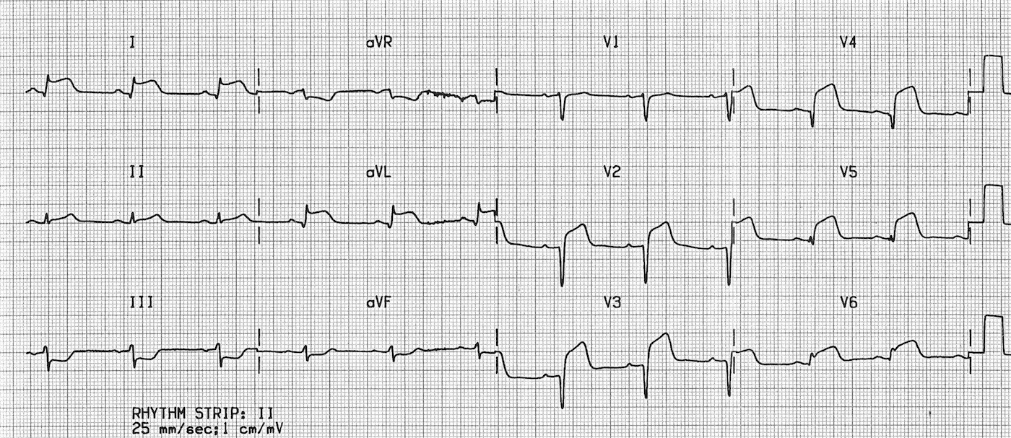](http://www.google.com.au/url?sa=i&rct=j&q=&esrc=s&source=images&cd=&cad=rja&uact=8&ved=0ahUKEwiKyNrAz8bSAhVGJJQKHc74A9MQjRwIBw&url=http://lifeinthefastlane.com/ecg-library/lateral-stemi/&psig=AFQjCNHVzTcUrk6oIZENkfAgo5_OEBfqmQ&ust=1489052634300719)

c) List the immediate **management** steps (6 marks)

**Question 5**

**A 43 year old lady with dialysis dependant diabetic nephropathy presents to a tertiary ED with lethargy and SOB. Her venous blood gas and observations are shown below**

**pH 7.1**

**pO2 64**

**pCO2 29**

**HCO3 15**

**K 7.1**

**Lact 4.3**

**P 120**

**BP 80/40**

**Sats 93% on 15L NRB**

**RR 30**

**Temp 37.9**

**BSL 30**

**She has a declining GCS and increased work of breathing necessitating urgent intubation.**

a) In the table below list 4 potential complications you could encounter in the peri-intubation period specific to this patient, and for each, a specific measure that you will take to prevent the complication (8 marks)



|  |  |
| --- | --- |
| **Complication** | **Measure taken to prevent** |
|  |  |
|  |  |
|  |  |
|  |  |

When you attempt to intubate the patient this is the best view you can get with the video laryngoscope

[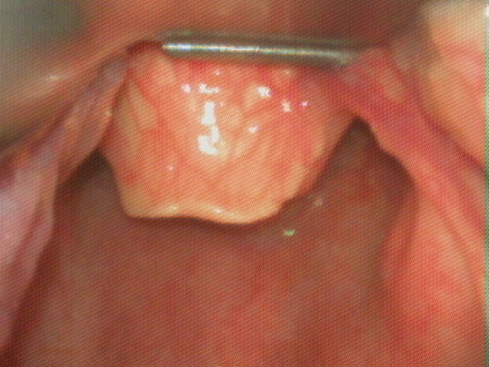](http://www.google.com.au/url?sa=i&rct=j&q=&esrc=s&source=images&cd=&cad=rja&uact=8&ved=0ahUKEwimoLurycjSAhVCJpQKHaODC6IQjRwIBw&url=http://openairway.org/tag/cormack-lehane/&bvm=bv.149093890,d.dGo&psig=AFQjCNFotuaSZnN-OhiJnLxRwKjZXmwABQ&ust=1489119696251496)

b) That is the Cormack-Lehane grade? (1 mark)

c) List the 5 differential diagnoses you will consider for this patients presentation (5 marks)

**Question 6**

**A 28 year old renal transplant patient presents to the tertiary ED where you are working. He had a transplant 8 months ago after developing glomerulonephritis. His immunosuppression has recently been increased but he hasn’t been admitted to hospital since the transplant.**

**He presents with lethargy, weakness, mild abdominal/flank pain and nausea.**

**Obs**

**P110**

**BP 140/100**

**Sats 94% RA**

**Temp 37.5**

a) List the 5 most important differentials you will consider in this patient

**His CXR is shown below**

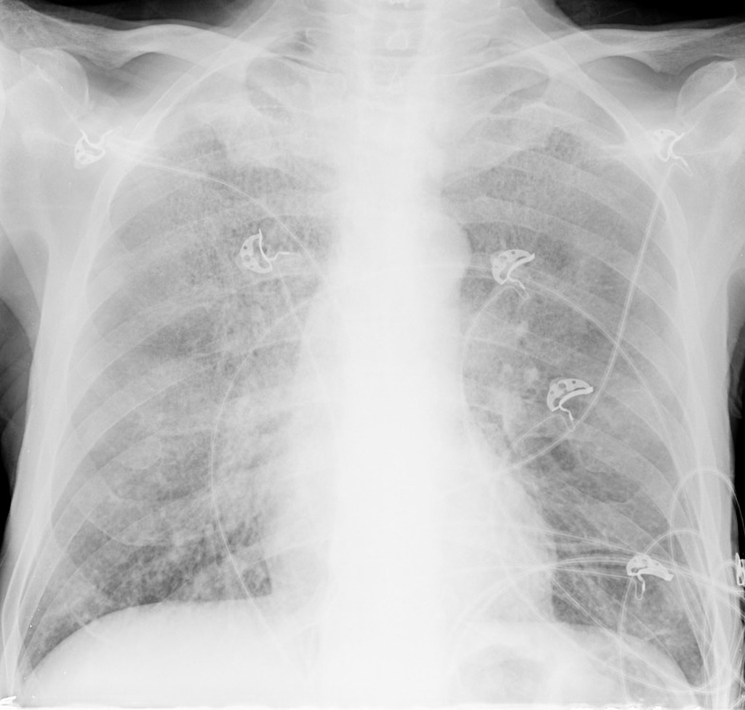

b) List the positive findings on this XRay (2 marks)

Hazy perihilar opacity

Slight blunting of right heart border ? early consolidation (silhouette sign)

c) List 5 potential organisms that could cause respiratory infection in this patient (5 marks)

**The patients cyclosporin levels are low normal and the renal team decide to increase the dose. The patient is keen to know the adverse effects.**

d) List the main side effects of cyclosporin (4 marks)



**Question 7**

**The is a 42 year old patient in resus who has peritoneal dialysis. She presents with generalised abdominal pain and fever without associated symptoms . The VBG and observations are shown. IV access and monitoring are in situ. The RMO has sent FBC/EUC/LFT/CMP/CRP/Lipase.**

**UA is negative and a CXR and ECG are unremarkable**

**The RMO has asked you to review the patient as he is worried they have cholecystitis**

**pH 7.21 P 110**

**pO2 23 BP 90/60**

**pCO2 32 Sats 95% RA**

**HCO3 16 RR 25**

**Na 129 Temp 37.9**

**K 5.1**

**Cl 102**

**Lactate 2.1**

**Cr 340**

**Gluc 32**

**Ketones 0.9**

a) List the abnormalities on the blood gas, show the calculations you have performed

b) List your actions in the first hour of this patient’s presentation (6 marks)

**Later that day the nurses report that the patient is confused and is trying to leave the ward.**

c) List the criteria that you use when assessing a person’s capacity to make decisions that are at odds with the medical opinion (4 marks)

d) List 4 likely causes for the patient’s delirium (4 marks)

**Question 8**

**A 45 year old man with chronic renal impairment presents to ED with mild confusion. He has had longstanding haematuria and flank pain which has been worse recently. He has recently been treated with rivaroxaban for lower leg DVT.**

**Bedside ultrasound of his flanks shows the following**



[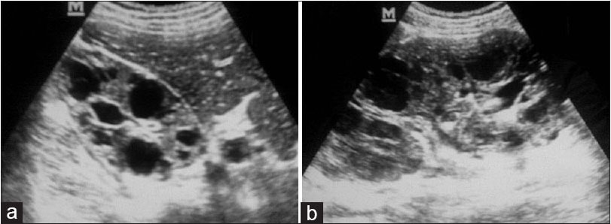](http://www.njcponline.com/article.asp?issn=1119-3077;year=2015;volume=18;issue=2;spage=178;epage=182;aulast=Okere)

**a)** What is the abnormality on the bedside ultrasound and what condition does it likely represent (2 marks)

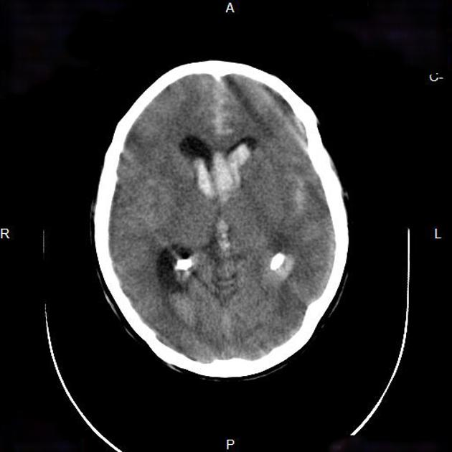

b)List the abnormal positive and relevant negative features on the CT scan (4 marks)

c) What is the underlying intracerebral pathology? (1 mark)

d) Which other regions might the patient be likely to have cysts (3 marks)

e) How will you deal with the patients anticoagulation (2 marks)

**Question 9**

**A 17 year old soldier presents with nausea, vomiting and confusion post a 15km training run in Perth. He is dehydrated and has evidence of early shock. His observations are shown below:**

**P120**

**BP 90/60**

**Sats 97% RA**

**RR 32**

**Temp 39.9**

**The patient’s urine results are shown below**

**SG 1.050**

**Blood –large**

**Protein- +**

**Leucs – neg**

**Nitrites – neg**

**Microscopy**

**leucocytes – <10**

**erythrocytes – <10**

**Squamous epithelial cells - <10**

a) In the table below outline the 5 most important tests (aside from urine analysis/microscopy) that you will order to determine the severity of the patients disease process (5 marks)

|  |  |
| --- | --- |
| **TEST** | **RATIONALE** |
|  |  |
|  |  |
|  |  |
|  |  |
|  |  |
|  |  |
|  |  |

c) What condition do these urine findings suggest? (1 mark)

d) List 5 potential complications of this condition (5 marks)

e) In the table below list 3 intravenous treatments that have been traditionally used to treat this condition, and one con/adverse effect of each (6 marks)

|  |  |
| --- | --- |
| **IV treatment** | **Con/Adverse Effect** |
|  |  |
|  |  |
|  |  |