2010:1 SCE Rehash

SCE1

Domains
Medical Expertise (40%)
Prioitisation and Decision Making (40%)
Professionalism (20%)

This is a standardised case based discussion. You will be discussing an evolving case with the examiner.
Be specific when answering including dosages and equipment sizes. It is important to explain your rationale for decisions made.

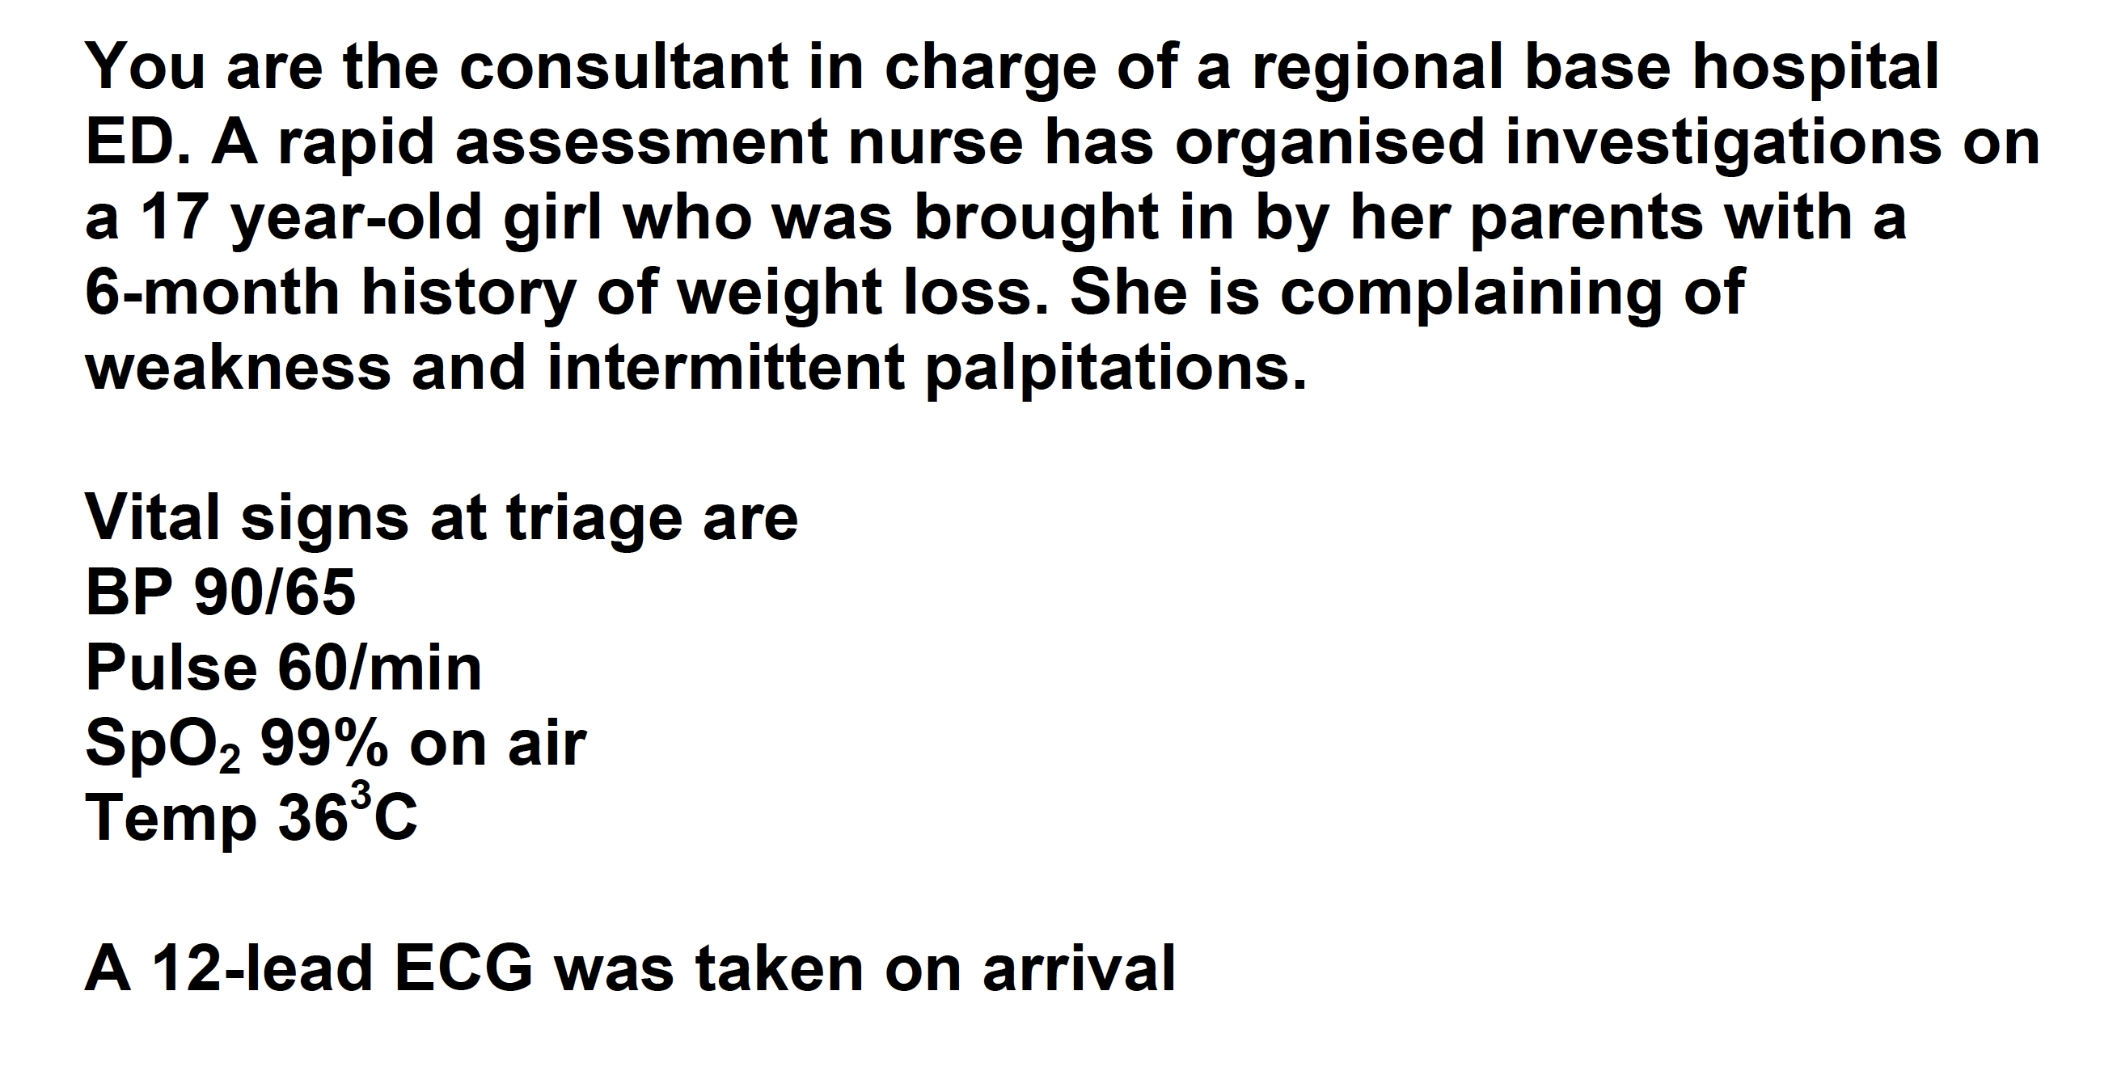

Outline the assessment of this patient

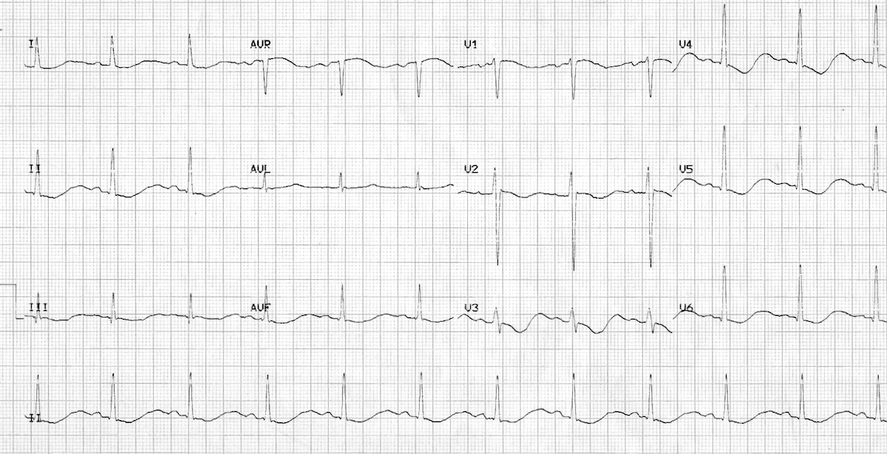
SCE 2

Medical Expertise (40%)
Prioitisation and Decision Making (40%)
Health Advocacy (20%)

This is a standardised case based discussion. You will be discussing an evolving case with the examiner.
Be specific when answering including dosages and equipment sizes. It is important to explain your rationale for decisions made.

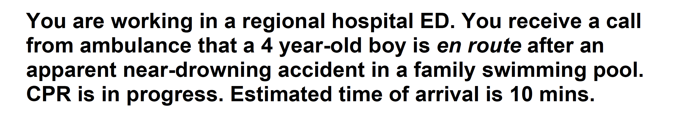

Outline your preparation for the arrival of this patient

Communication Station 3

Communication (50%)
Prioritisation and Decision Making (30%)
Health Advocacy (20%)

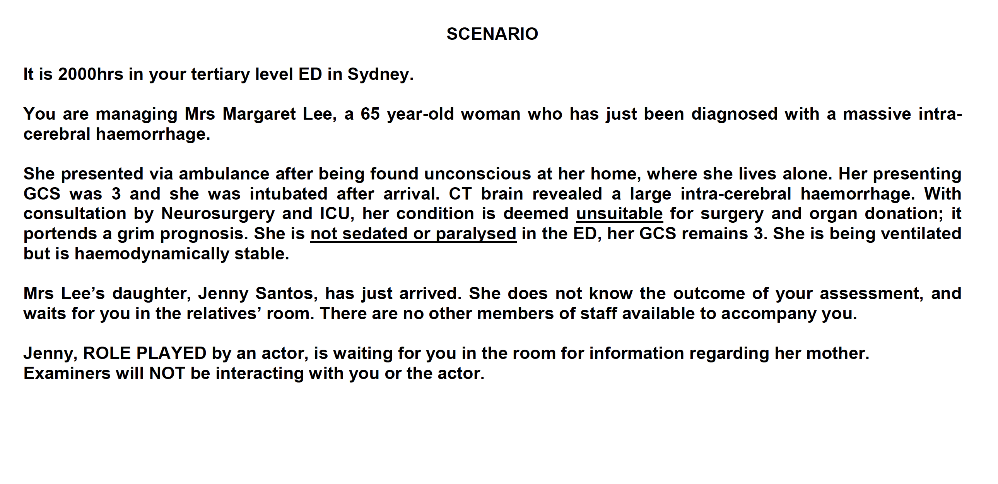

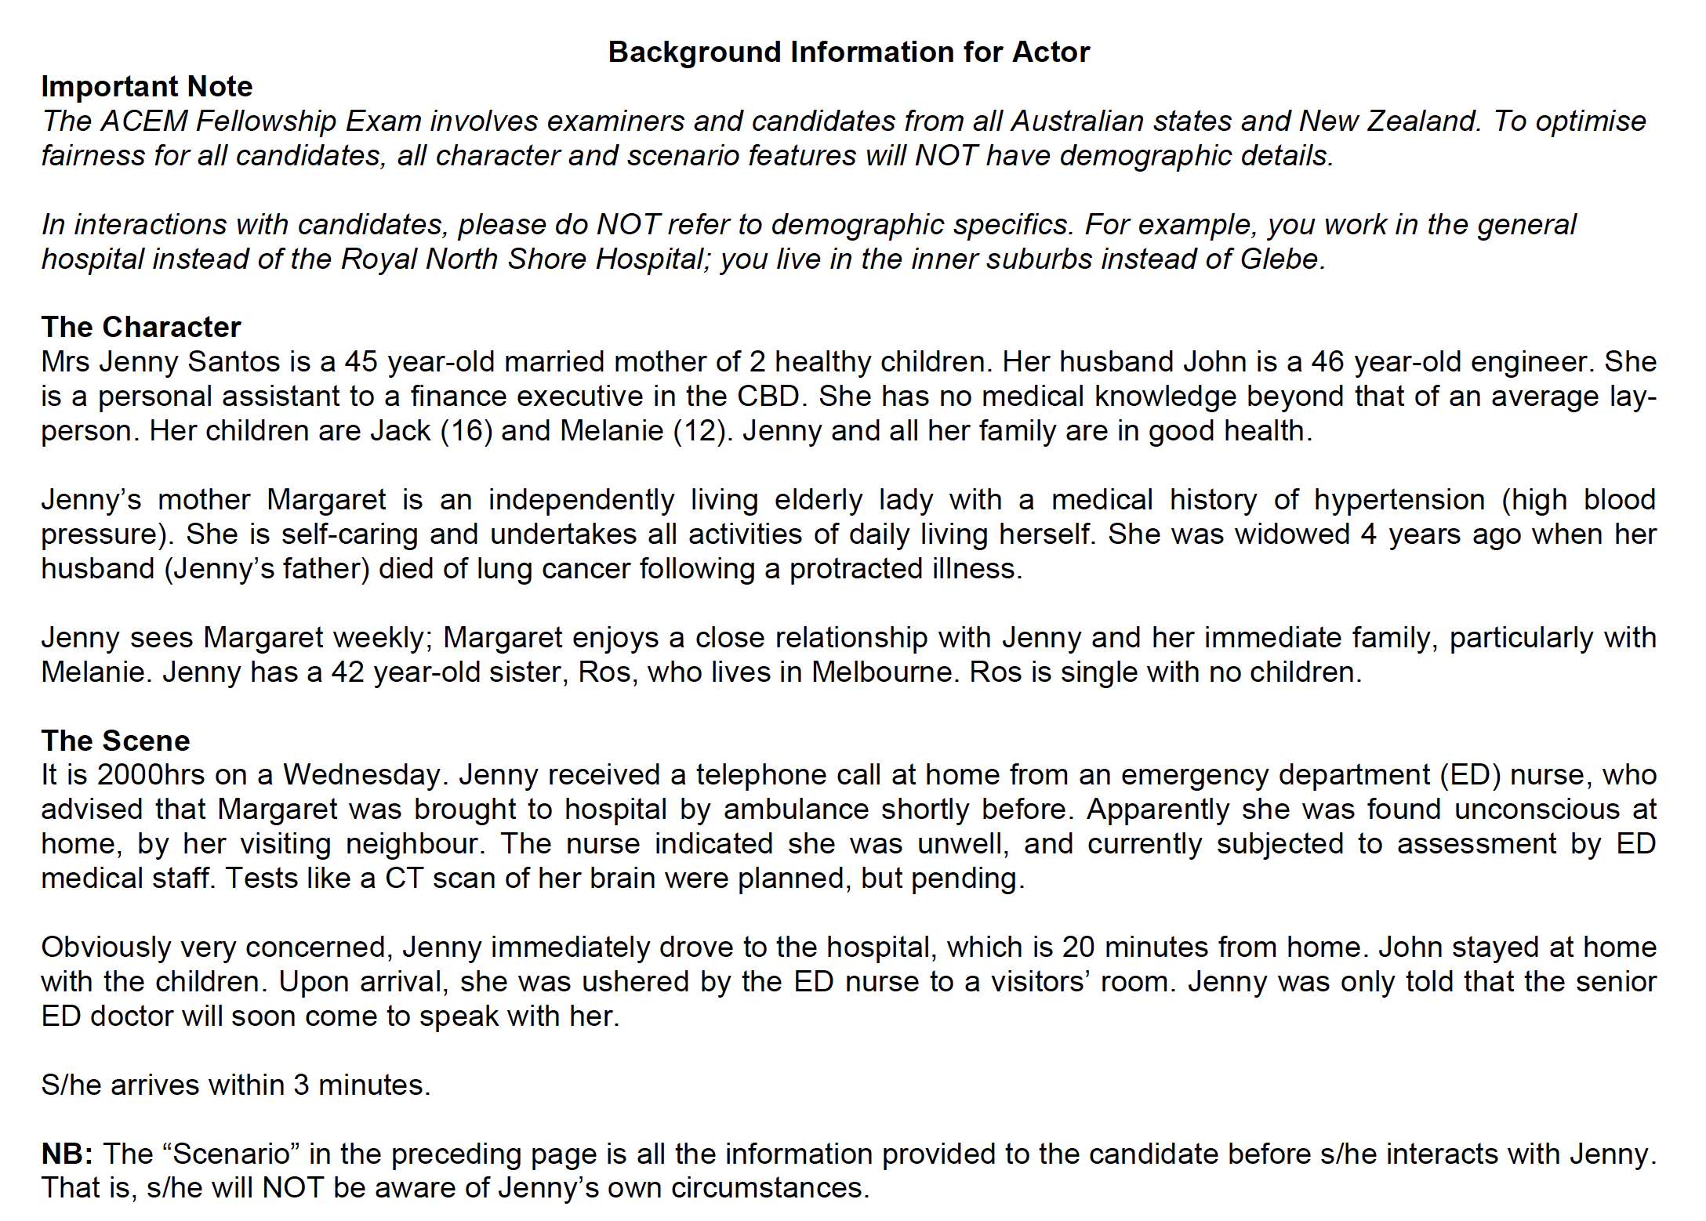

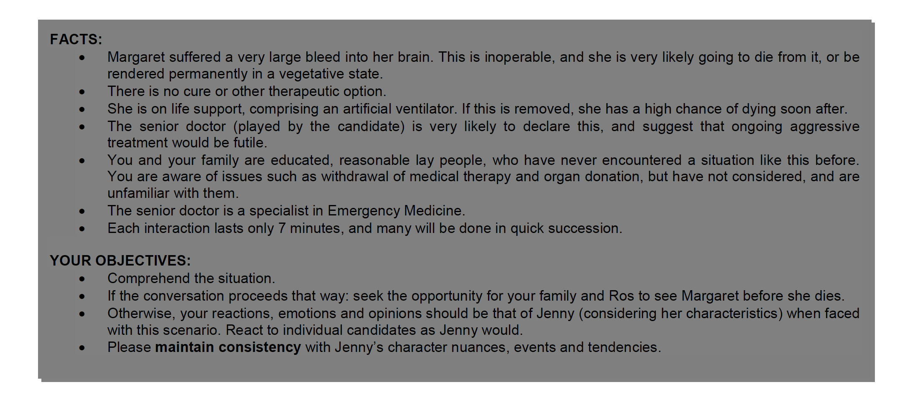
SCE 4

Domains
Medical Expertise (40%)
Prioitisation and Decision Making (40%)
Professionalism (20%)

This is a standardised case based discussion. You will be discussing an evolving case with the examiner.
Be specific when answering including dosages and equipment sizes. It is important to explain your rationale for decisions made.

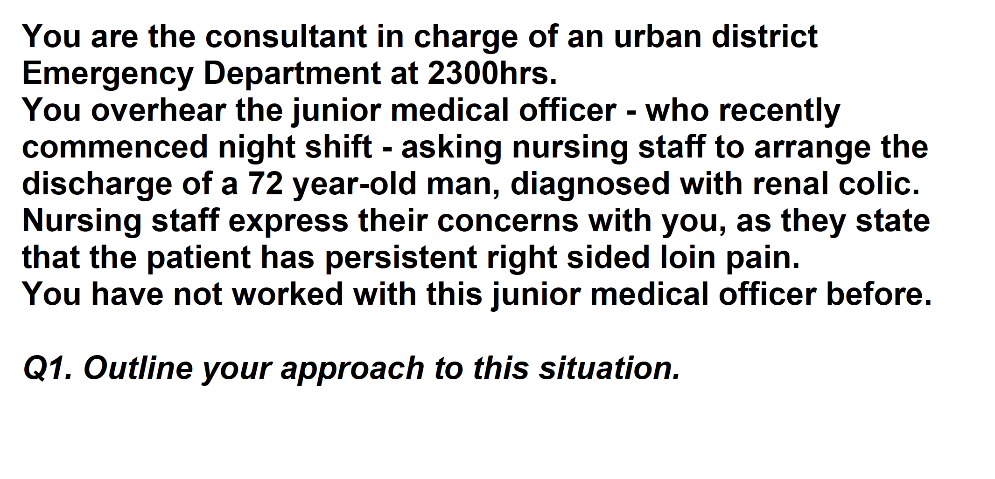

SCE 5

Domains
Medical Expertise (40%)
Prioitisation and Decision Making (40%)
Professionalism (20%)

This is a standardised case based discussion. You will be discussing an evolving case with the examiner.
Be specific when answering including dosages and equipment sizes. It is important to explain your rationale for decisions made.

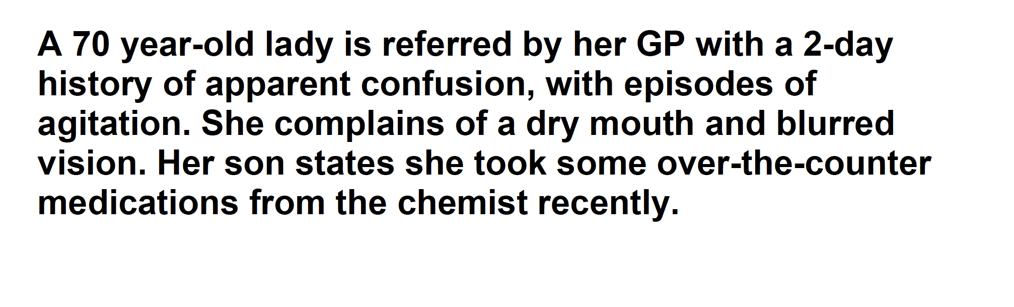

Outline your differential diagnosis in this patient

SCE 6

Domains
Medical Expertise (50%)
Prioritisation and Decision Making (50%)

This is a standardised case based discussion. You will be discussing an evolving case with the examiner.
Be specific when answering including dosages and equipment sizes. It is important to explain your rationale for decisions made.

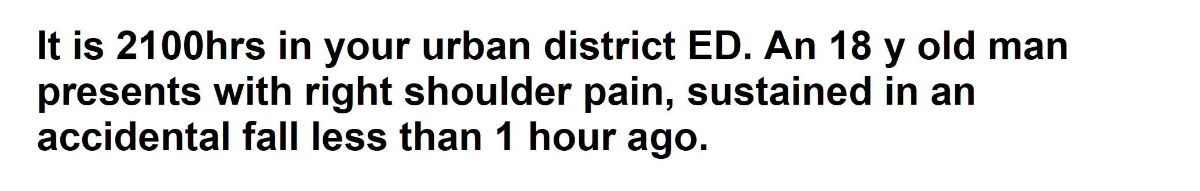
Interpret the XRay

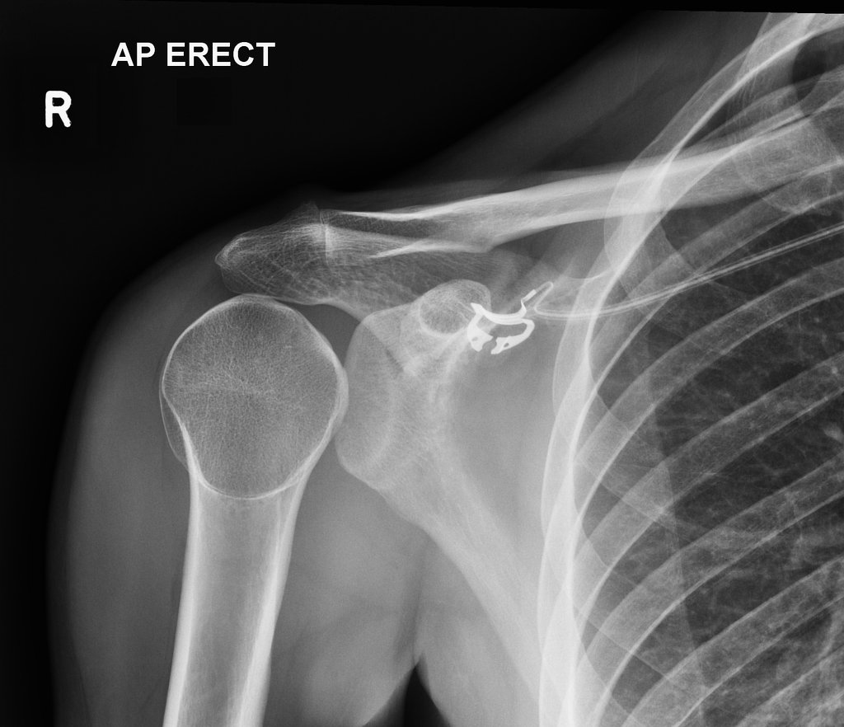

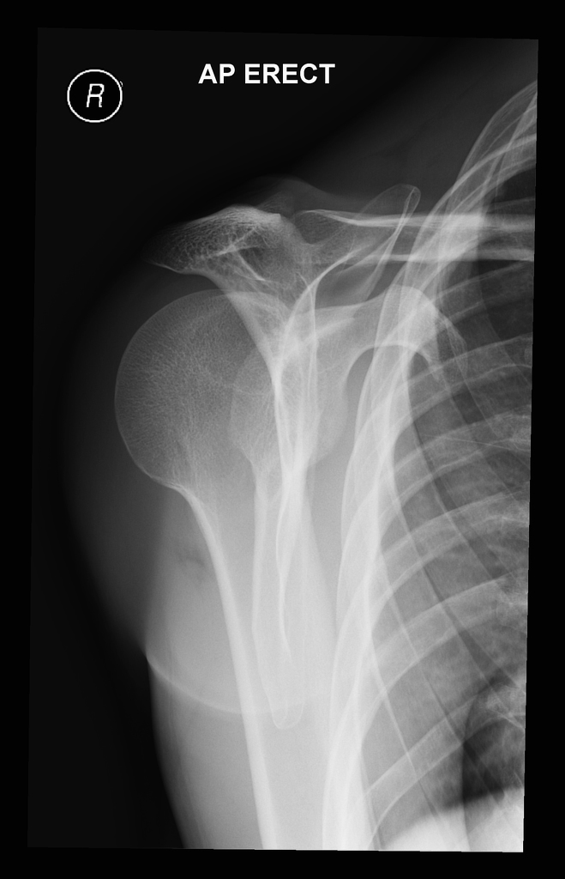

SCE Rehash SIMs (Feb 3)

SIM 1
The is a 7 minute simulation station

Domains
Medical Expertise (30%)
Prioritisation and Decision Making (40%)
Teamwork and Collaboration (30%)

She has deteriorated and has been moved to the resus room. The registrar has asked you to come and assist. You are the team leader and as such should instruct the team from the end of the bed. You have a competent registrar and nurse assisting you who can perform all reasonable tasks that you ask of them.

ECG Provided with stem
pH 7.51
pCO2 47
HCO3 38
BE +9

K 1.4
Na 131
Gluc 3.0
Cl 81

Lact 3.4

Creat 150

(VBG provided during SIM)

SIM 1 Instructions

Handover of food restriction Hx and that patient appeared to have an episode of reduced LOC before she was on the monitor but has recovered. Exam findings reveal a thin and dehydrated girl with lanugo hair. Poor teeth and some grazes on knuckles

ECG – Long QT, U waves, ST/T changes, broad p waves

Directed to assessment of patient – VBG, Other bloods specifically electrolytes

2 Mins into SIM has a 20 second episode of torsades (conscious)

VBG shows K 1.4

Recurrent episodes of torsades requiring Mg, K replacement, IV fluids, isoprenaline, atropine, pacing if persistent

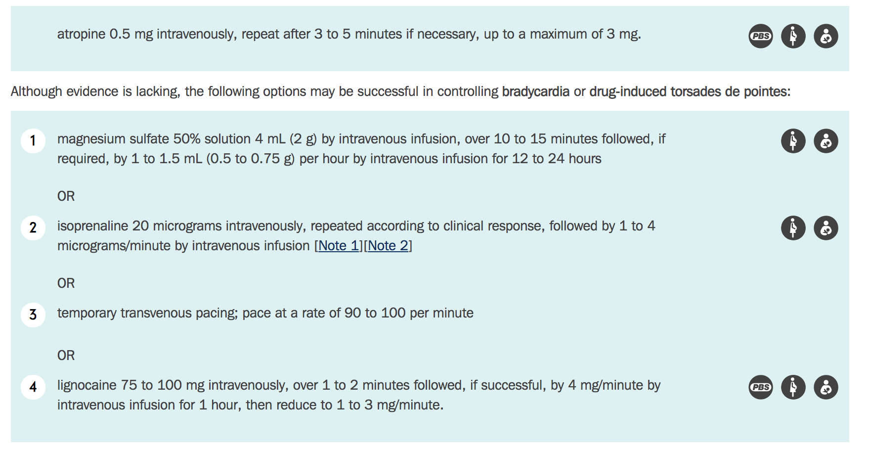

Prolonged episode of torsdes degenerates to VF? If time

ALTERNATIVE SIMs
- Enters the room as patient in Torsades and rapidly degenerates to VF
- Requires full ALS with shocks etc

SIM 2

The is a 7 minute simulation station

Domains
Medical Expertise (30%)
Prioritisation and Decision Making (40%)
Teamwork and Collaboration (30%)

You are working in a regional centre and have been called out of a meeting to assist the registrar. A 4 year old boy (est weight 20kg) has been brought in by ambulance after a near drowning in a swimming pool. CPR is in progress. He has had an LMA placed en route and has adequate IV access.

You are the team leader and as such should instruct the team from the end of the bed. You have a competent registrar and nurse assisting you who can perform all reasonable tasks that you ask of them.

pH 7.1
pCO2 80
HCO3 12

K 3.4
Na 143
Cl 110

Gluc 5.4

Lact 9.0

SIM Instructions

Handover from registrar
- Found in pool, last seen 5 mins before playing on the deck
- Face down, parental CPR
- Down time 15 mins
- No shocks, Adrenaline x4 with ambos – nil here yet
- LMA – but poor seal and very noisy chest
- Team doing 30:2 incorrectly
- Pupils equal but fixed
- 200mls saline given

Obs
PEA
Sats unrecordable

Priorities
- Oxygenation, intubation – size 5 ETT, no drugs
- Tube to 14cm
- Suction
- FIO2 1.0
- Neuroprotective strategies
- Adrenaline 2mls 1:10000 or 200mcg every 3-5mins
- Instruct team to do 15:2 till intubated then continuous resps 8-10,
- CPR rate 100/min
- Look for signs of trauma
- Retrieval if get ROSC
- Parents/SW

Progress
ROSC after intubated
Post ROSC management
- check tube
- vent settings (FIO2 1.0, Vt 120, PEEP 10, RR 25-30)
- Sedate, analgese and paralyse
- Neuroprotective considerations
- CXR/CO2/check position
- A-D assessment
- ICD/NG/Temp/other supportive care
- ICU

SIM 3

The is a 7 minute simulation station

Domains
Medical Expertise (30%)
Prioritisation and Decision Making (40%)
Teamwork and Collaboration (30%)

A 65 year old female who lives alone has presented after a fall at home, she was found confused and unable to give any Hx by the cleaner. She had a GCS of 11 on arrival and has just returned from CT with the registrar. (See CT prop)

She had a brief self terminating seizure en route back from CT.

Observations
P 100
BP 170/70
Sats 96% RA
RR 20
T 37

You are the team leader and as such should instruct the team from the end of the bed. You have a competent registrar and nurse assisting you who can perform all reasonable tasks that you ask of them.

SIM Instructions

Reg to provide Hx
- GCS 10 in CT
- Seizure 1min en route back from CT
- GCS initially 3 but rapidly returned to 10
- Family member has just arrived and given the Hx that the patient is on warfarin for AF. No other comorbidities or meds
- INR pending
- VBG normal
- ECG normal
- No advanced care directive

Reassess A-D plus

Appropriate reversal of warfarin
- 10mg vit K
- Prothrombinex 4 factor (or 3 factor plus 15mls/kg FFP)

Urgent neuroSx contact

Patient has a further seizure
- Midazolam
- Intubate and ventilate
- Neuroprotective strategies

SIM 4

The is a 7 minute simulation station

Domains
Medical Expertise (30%)
Prioritisation and Decision Making (40%)
Teamwork and Collaboration (30%)

You are the team leader and as such should instruct the team from the end of the bed. You have a competent registrar and nurse assisting you who can perform all reasonable tasks that you ask of them.

A 58 year old man has presented to ED with abdominal pain and a collapse. He has a history of AAA and is wait listed for an endovascular graft. He has hypertension and AF.

Observations
BP 60/40
P 130
Sats 97% RA
RR 26
T 36.2

VBG
pH 7.1
pCO2 30
HCO3 14
Lact 6
K 3.4
Cr 150

SIM instructions

Hx from Reg
- Sudden abdo pain and collapse
- Hypotensive and confused
- Had 1L saline
- No mention of meds unless specifically asked – non anticoagulated if asked but on aspirin
- Only 1 access in left hand 22G

Priorities
Surgeons
Access with IO/RICC
Bloods/VBG and CM/Esp Ca
Volume replacement/MTP with end points/TXA/fluid warmer
Keep warm
Discuss with family/wishes

Progress
Patient arrests in PEA
ALS per protocol
ETT/LMA/BVM
Ongoing products ++++
Expedite surgeon in case of ROSC

After 2 units get ROSC
Standard post ROSC care plus ongoing MTP

SIM 5

The is a 7 minute simulation station

Domains
Medical Expertise (30%)
Prioritisation and Decision Making (40%)
Teamwork and Collaboration (30%)

You are the team leader and as such should instruct the team from the end of the bed. You have a competent registrar and nurse assisting you who can perform all reasonable tasks that you ask of them.

A 70 year old lady presents with a 2 day Hx of apparent confusion and agitation. She appears dehydrated and is severely bradycardic. She has a history of angina, hypertension and osteoarthritis. She takes verapamil, aspirin, panadol osteo and perindopril. She recently had a psychogeriatric admission for severe depression with suicidal ideation 1 month ago.

Observations
P 30
BP 60/40
Sats 91% RA
RR 18
T 37

GCS 10

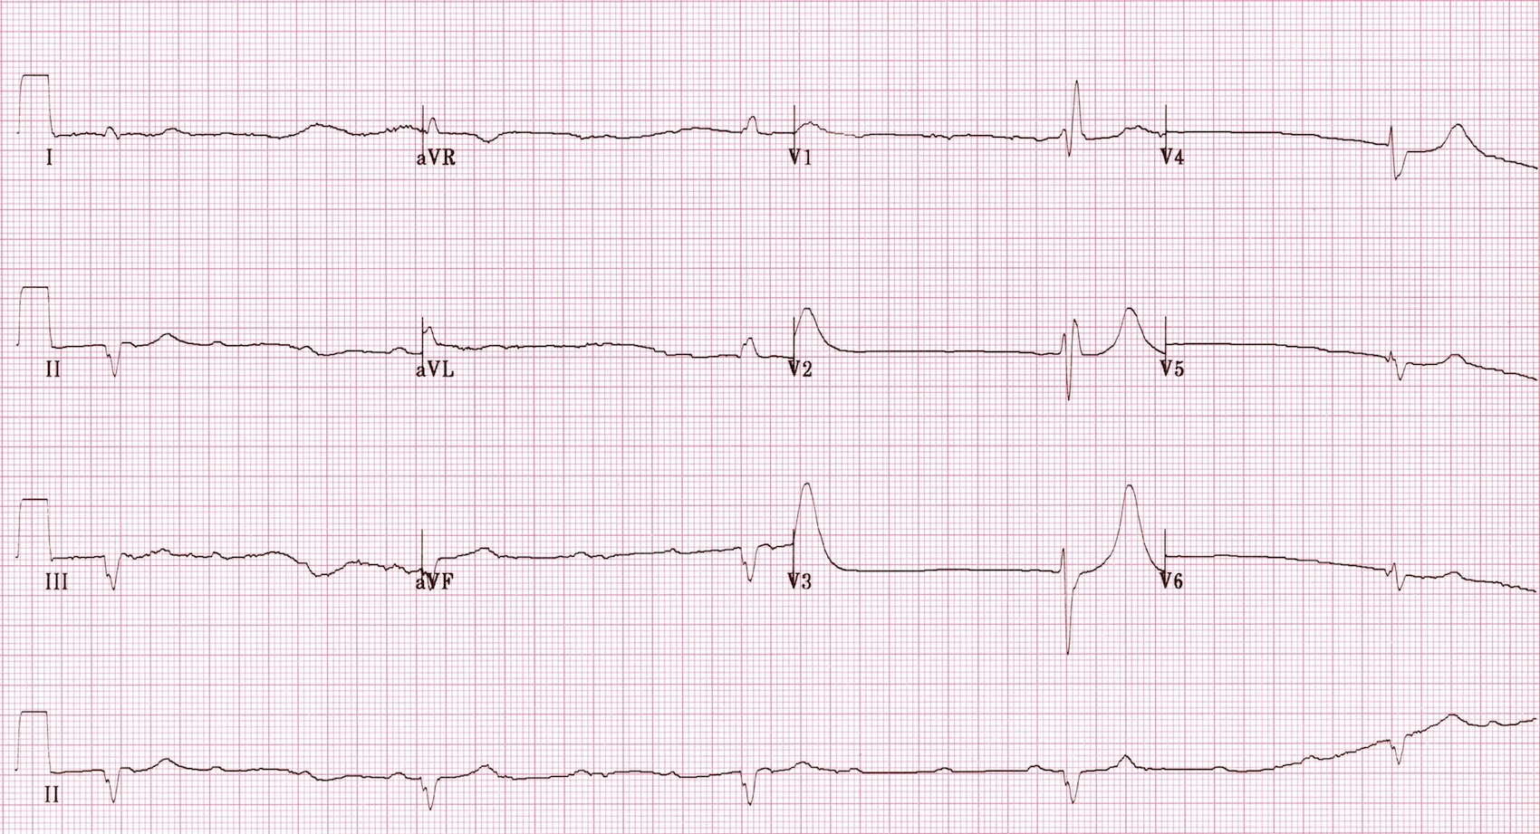
SIM Instructions

Registrar Handover
- Found confused and collapsed by son
- He is on way but told ambos that worried she has taken an overdose
- All pills are missing, not sure of quantities
- Perindopril, verapamil, aspirin 100mg, panadol osteo
- No Hx from patient
- Hypotensive and bradycardic, GCS 10, wont speak
- Had 1L saline
- VBG shows an uncompensated high AG metabolic acidosis with lactate of 5 and renal impairment
- No evidence of triple base defecit of salicylates if asked

- BSL normal if asked for – don’t state unless asked

ECG interp
High grade AV Block

Priorities
- Send panadol and salicylate levels
- Manage CCB overdose
- Discuss WBI with tox – if suggested state that
- Calcium 30mls 10% gluconate – can repeat
- Inotropes – Nad/Ad
- Fluids
- HIET – 1unit/kg
- Consider Intralipid

HR drops to 20
- Pacing/atropine

- Likely to need intubation but not immediate
- Start NAc as timings and doses unclear and panadol level unavailable

- Discussion with Son

