2009:2 SCE Rehash
Question 1

Domains
Medical Expertise (40%)
Decision Making and Prioritisation (40%)
Leadership and Management (20%)

This is a structured case based discussion. You will be discussing an evolving case with an examiner. Please try to be as specific as possible with your responses and include the rationale for decisions that you make.

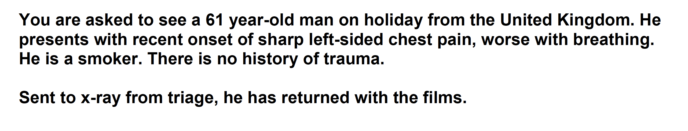

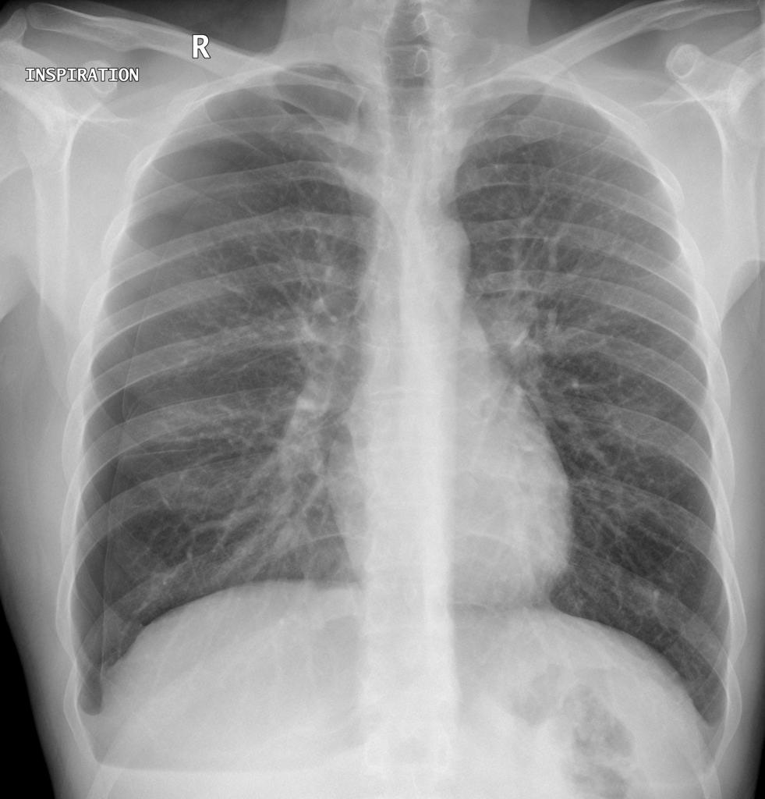

Question 2

Domains
Medical Expertise (50%)
Decision Making and Prioritisation (50%)

This is a structured case based discussion. You will be discussing an evolving case with an examiner. Please try to be as specific as possible with your responses and include the rationale for decisions that you make.

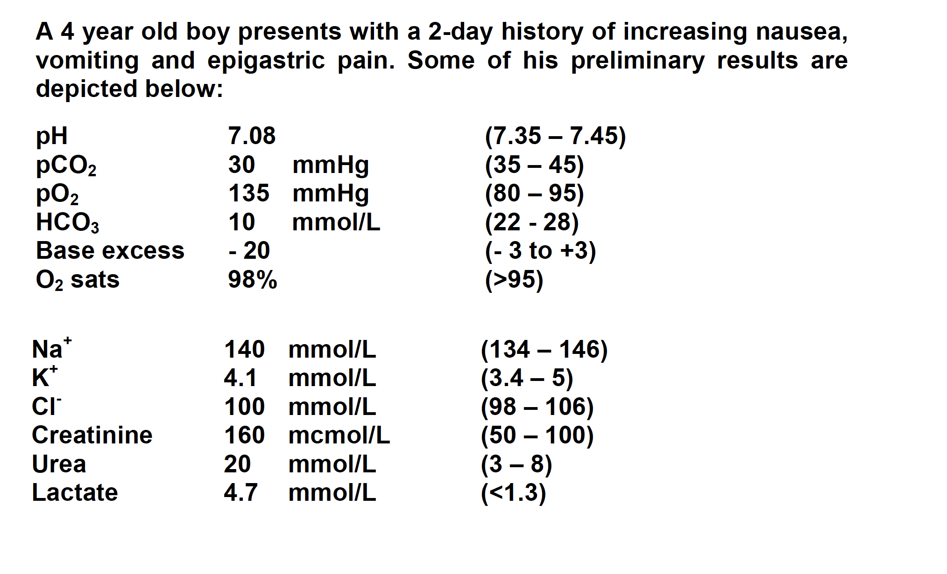

Question 3

Domains

Medical Expertise (40%)
Decision Making and Prioritisation (40%)
Leadership and Management (20%)

This is a structured case based discussion. You will be discussing an evolving case with an examiner. Please try to be as specific as possible with your responses and include the rationale for decisions that you make.

A 67 year-old woman who lives independently has been brought in after being found by her daughter on the floor of her shower. It appears that she has been there all night. She was well the day before.

Initial observations:
• GCS 7/15 (E-1 V-2 M-4);
• PR 40
• BP 70/40;
• RR 6/min;
• SaO2 95%.

This is her initial ECG

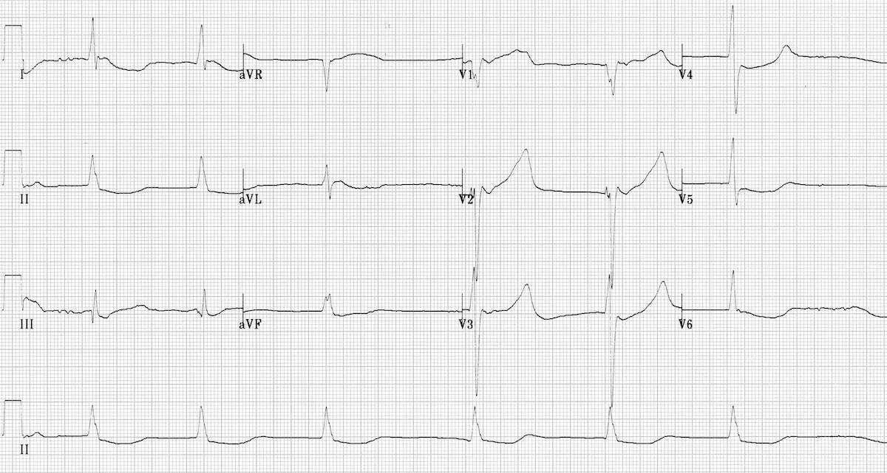
Question 4

Medical Expertise (30%)
Decision Making and Prioritisation (30%)
Teamwork and Collaboration (40%)

This is a structured case based discussion. You will be discussing an evolving case with an examiner. Please try to be as specific as possible with your responses and include the rationale for decisions that you make.

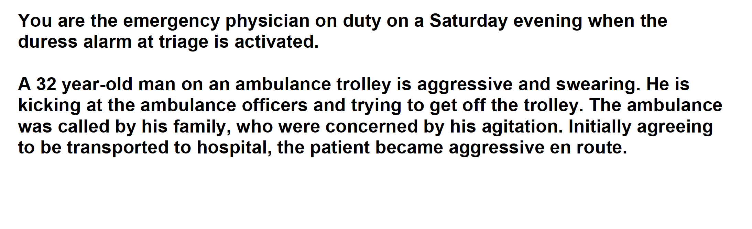

Question 5

Medical Expertise (30%)
Decision Making and Prioritisation (30%)
Teamwork and Collaboration (40%)

This is a structured case based discussion. You will be discussing an evolving case with an examiner. Please try to be as specific as possible with your responses and include the rationale for decisions that you make.

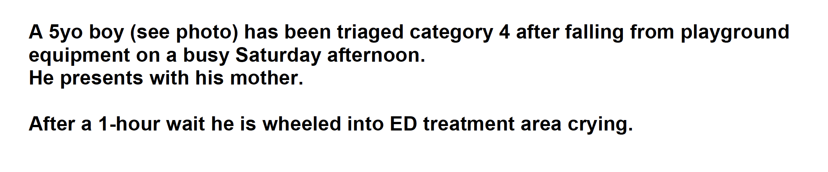

XR PROPS not to be given to candidate with stem
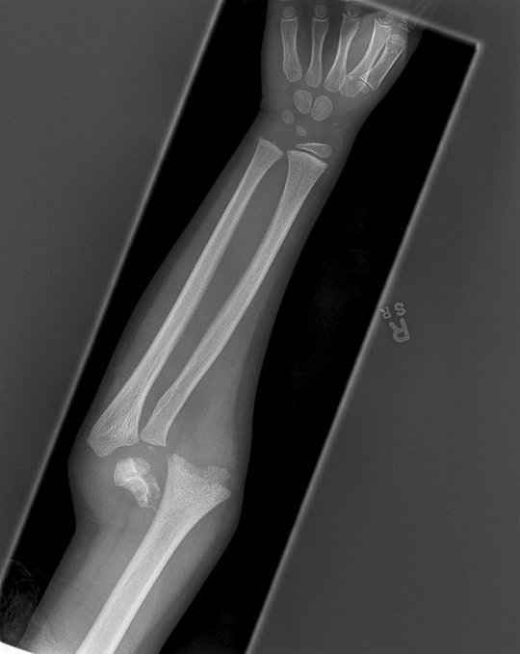
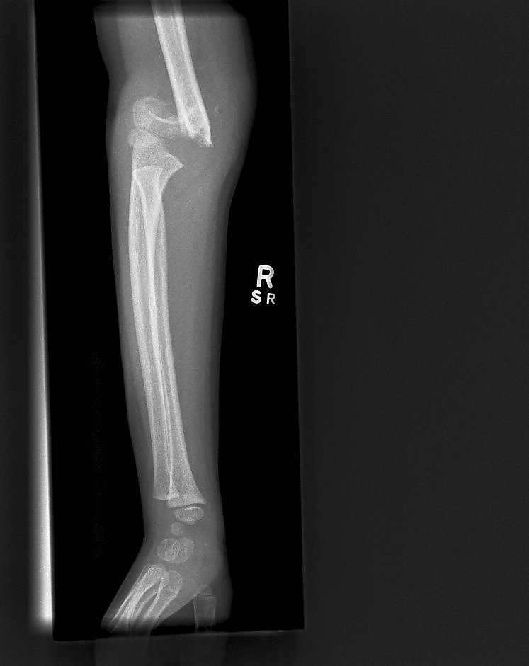

Question 6

Medical Expertise (30%)
Decision Making and Prioritisation (30%)
Teamwork and Collaboration (40%)

This is a structured case based discussion. You will be discussing an evolving case with an examiner. Please try to be as specific as possible with your responses and include the rationale for decisions that you make.

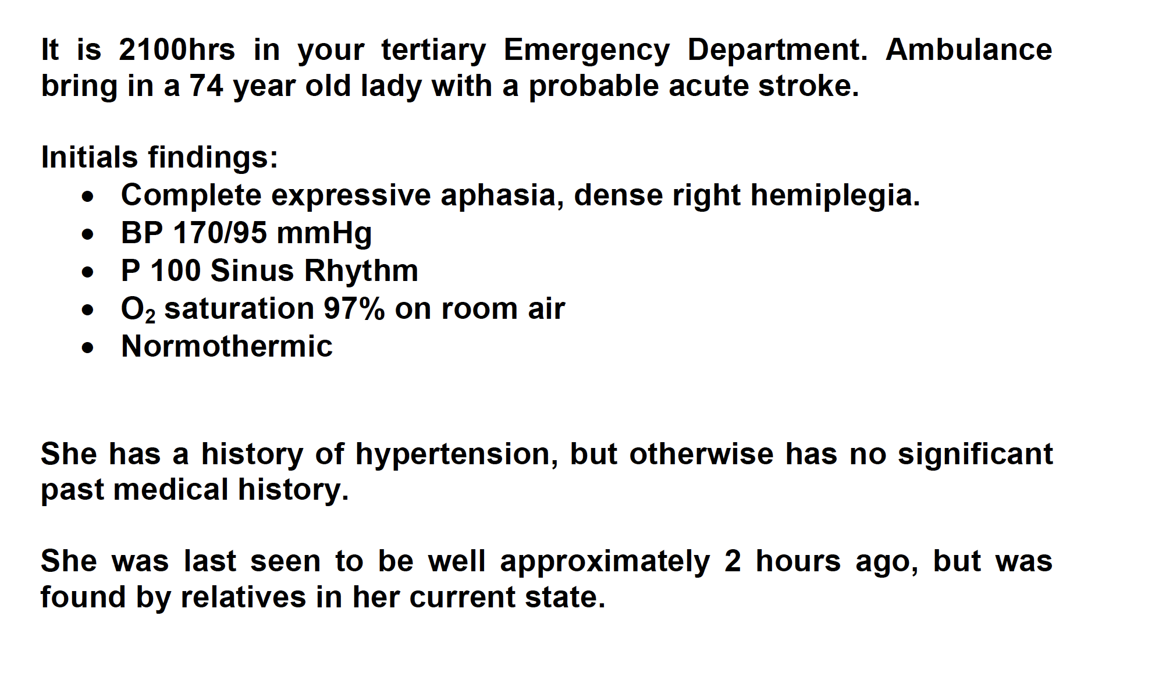

SIMs from SCEs

Question 2

Domains
Medical Expertise (30%)
Teamwork and Collaboration (30%)
Decision Making and Prioritisation (40%)

You are the team leader managing a small team in a rural hospital. You have been called in at 2am to assist the senior registrar and nurse. There are no other available staff to assist. It will take the retrieval service 2 hrs to get to you.

Question 3

Medical Expertise (30%)
Decision Making and Prioritisation (30%)
Teamwork and Collaboration (40%)

You are the team leader managing a small team in a tertiary hospital. You have been called in from home to assist the senior registrar and nurse. There are no other available staff currently.

A 67 year-old woman who lives independently has been brought in after being found by her daughter on the floor of her shower. It appears that she has been there all night. She was well the day before.

Initial observations:
• GCS 7/15 (E-1 V-2 M-4);
• PR 40
• BP 70/40;
• RR 6/min;
• SaO2 95%.

This is her initial ECG

Instructor Info

Events – found on floor, not very responsive, ?fall, feels very cold, tympanic temp 23, A-D, got the pads on
Assessment and interp of ECG –
Temp (core) – 26
Asks for Ix – specifically BSL/VBG/FBC/EUC/LFT/CMP
Suggests rewarming strategies – humidified O2/bair hugger/cavity warming/dialysis/EMCO/Bypass
VF – only 3 shocks, no meds till 30 degrees then 2x dosing interval
Consider intubation ? LMA to temporise

Question 4

Medical Expertise (30%)
Decision Making and Prioritisation (30%)
Teamwork and Collaboration (40%)

You are the team leader managing a small team in a tertiary hospital.

You have been called to resus to assist with a 56M who was phyically and verbally aggressive. He was BIB police who have him handcuffed to the bed.

The senior registrar has given him 20mg IM midazolam and 10mg droperidol in increments over the last 5 mins. He is now obtunded and has noisy breathing

Instructor Info

Events from registrar – 56M threatening to kill his family, BIBP and ambulance who had to physically restrain him, given 20mg midaz and 10mg droperidol iM within last 5 mins – worried they gave too much
Now very sleepy and noisy breathing.
No history from patient, no ID (unknown pt)

Obs – P110, BP 90/70, Sats 85% RA, RR 10, Temp 37.9

A-D
Summary of priorities – Airway – adjuncts then intubate/O2/Fluids
Appropriate Ix of cause – Sepsis/head injury/ intracranial cause/pscyh/metabolic/BSL/tox/hypoxia
ECG NAD/Panadol/VBG/BSL
BSL 2.5 – give 25mls 50% dextrose
Consider broad spec abx given fever
Inotropes for dropping BP

Has a seizure – Rx with further benzos and load with keppra or phenytoin
Collateral Hx – relatives/ID

ECG shows Long QTc

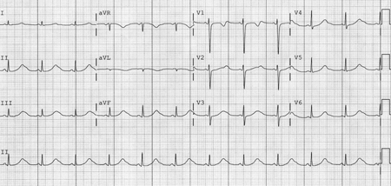

COMMUNICATION STATION FROM SCE
Question 6

Domains
Communication (50%)
Medical Expertise (30%)
Prioritisation and Decision Making (20%)

You have been called to assist with a patient in the majors bay as the registrar feels out of his depth

The CT perfusion has been reported to have a large MCA CVA, no salvageable penumbra and no lesion that is amenable to clot retrieval.

Discuss the case with the daughter.

Instructor Info

Clarify who person is and relationship to patient
Check current understanding – daughter will insist on “that clot busting drug my dad got – he got better”
Explain results of scans
Expain why cannot have thrombolysis
- strict criteria to maintain safety and efficacy only for those that likely to benefit
- no brain still with salvageable area – “already dead brain”
- high risk of bleeding especially in older age group/HTN
-
Listen to concerns, acknowledge and explore reasons
Offer second opinion/neurology consult
Ultimately explain that not a candidate and wont be administering drug
Explain care in a stroke ward/aspirin/?NG
Consider broaching goals of care/advanced planning

Additional tasks –
Q1 – Teach a medical student the management of PTX – spont/all sizes/secondary/traumatic/tension/methods of decompression/follow up etc
Q2 – Explain the VBG to a junior reg
Q3 – Explain ECG
Q4 – Communication with the mother based on SCE4 Q4
Q5 – Demonstrate the neuro exam of an upper limb
Q6 – Explain assessment of a patient with a left hemiparesis to determine eligibility of patient for thrombolysis – junior reg

