2009:1 SCE Rehash
QUESTION 1 – Communication station – per original SCE
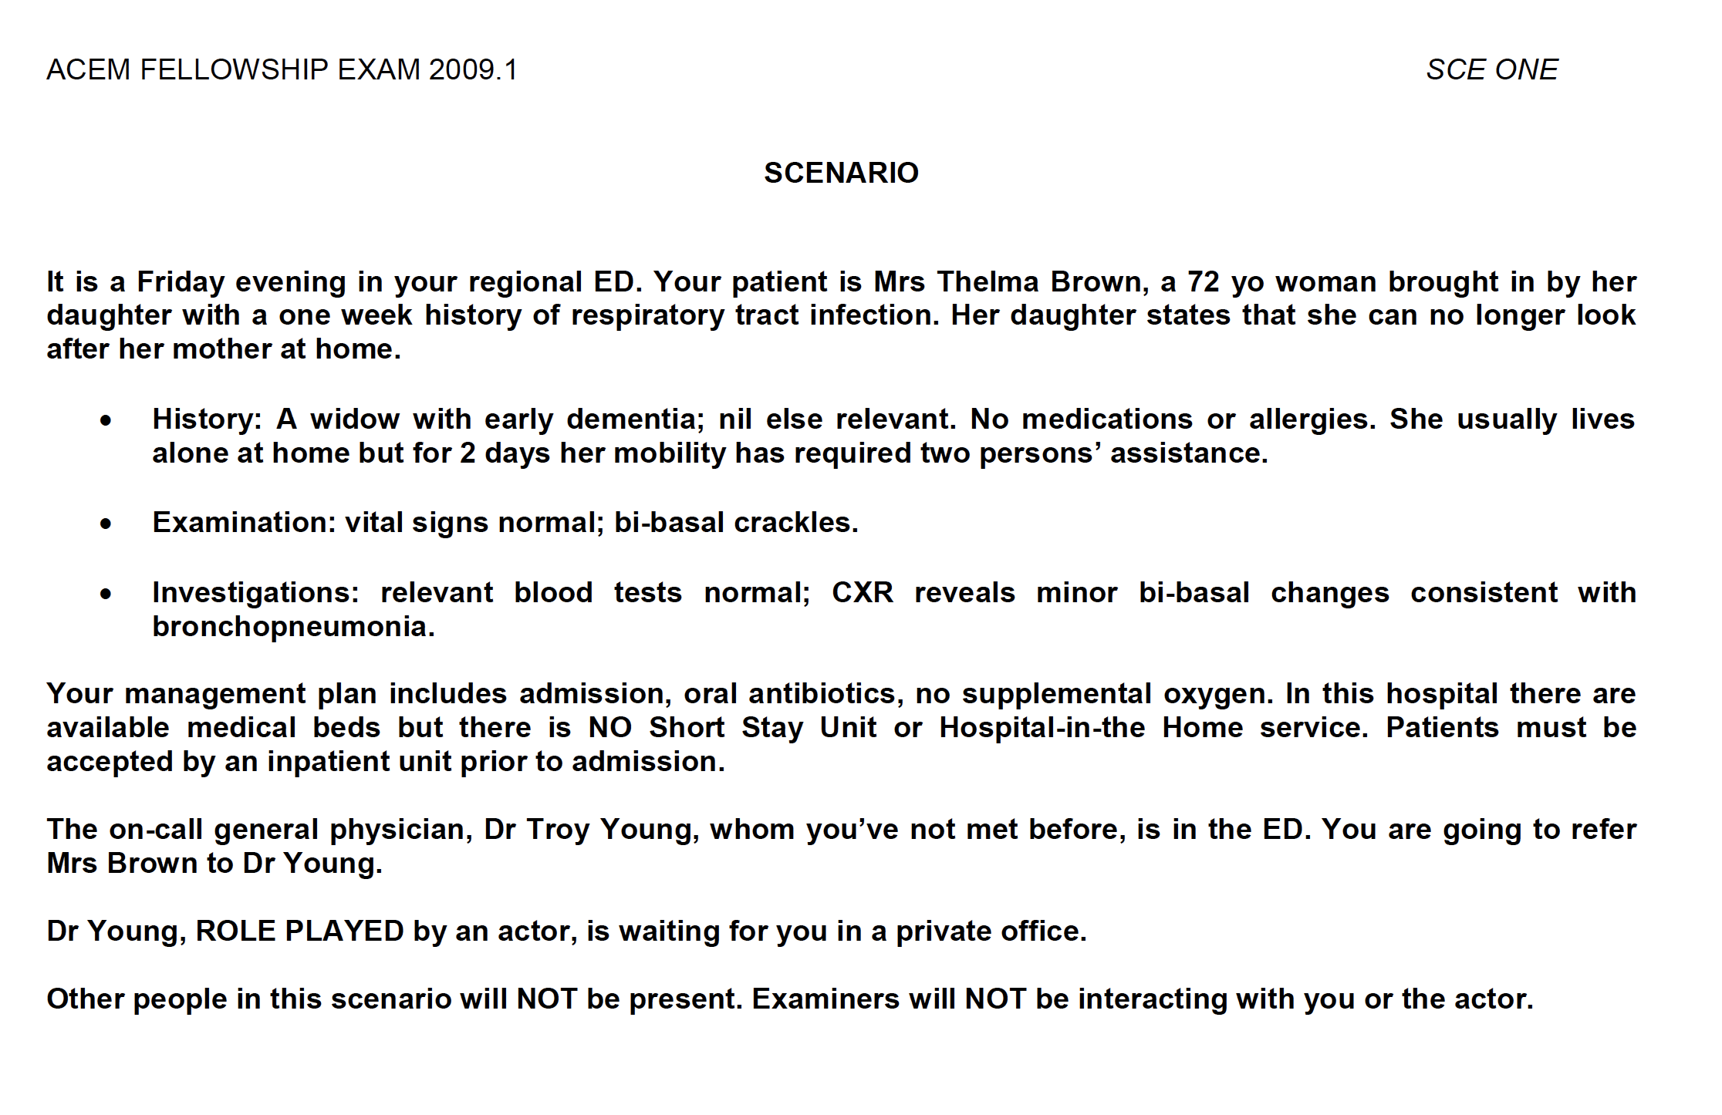

QUESTION 2
2009:1 SCE2

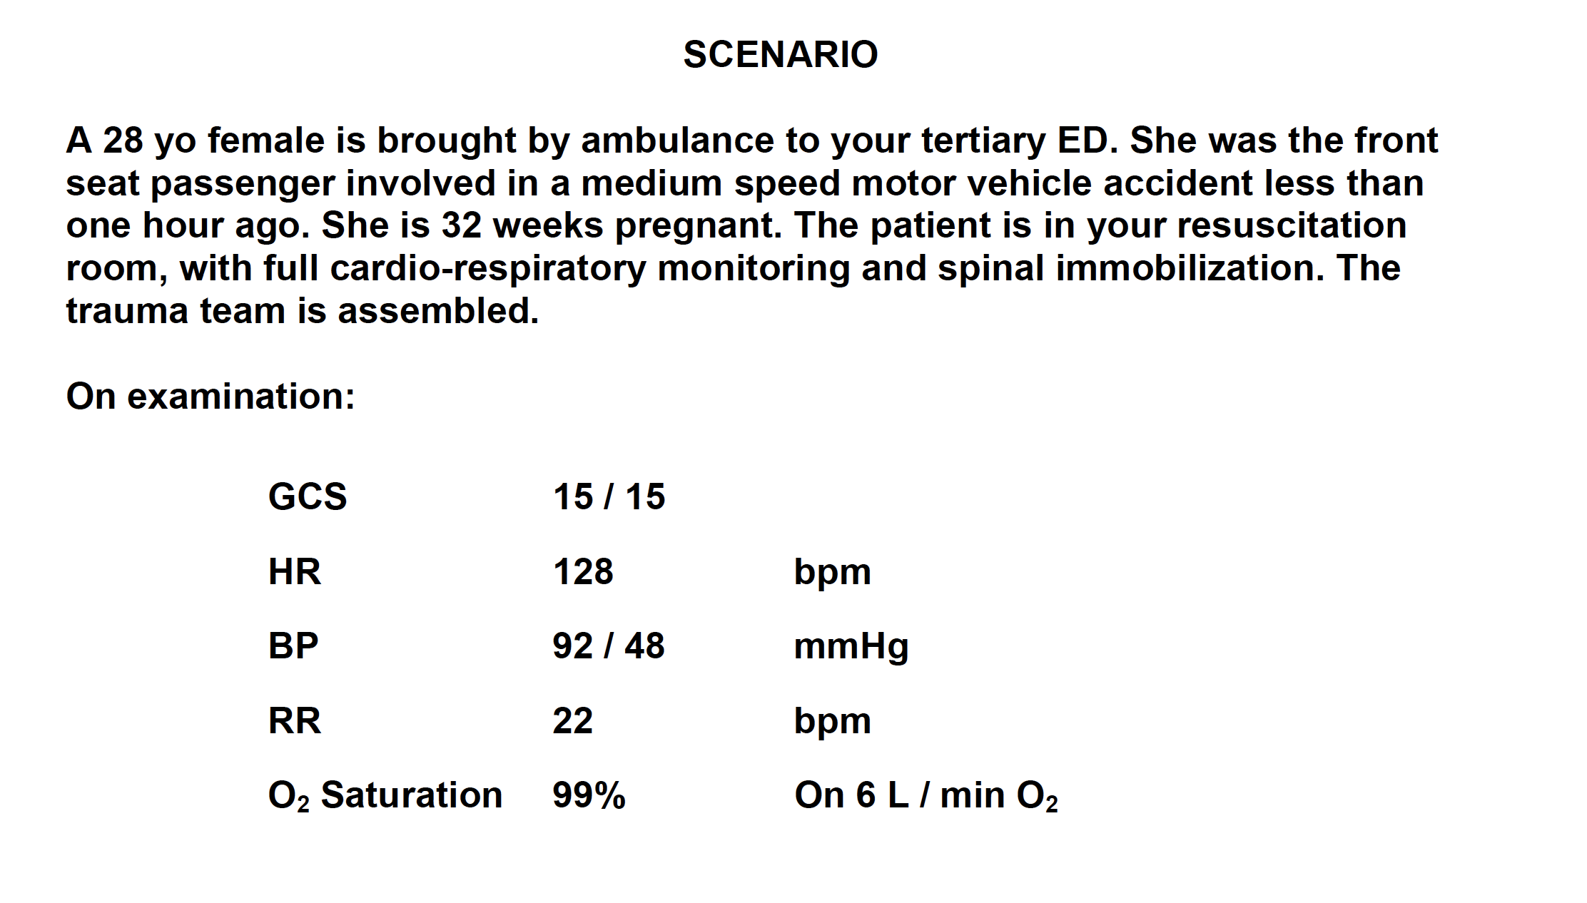

QUESTION 3

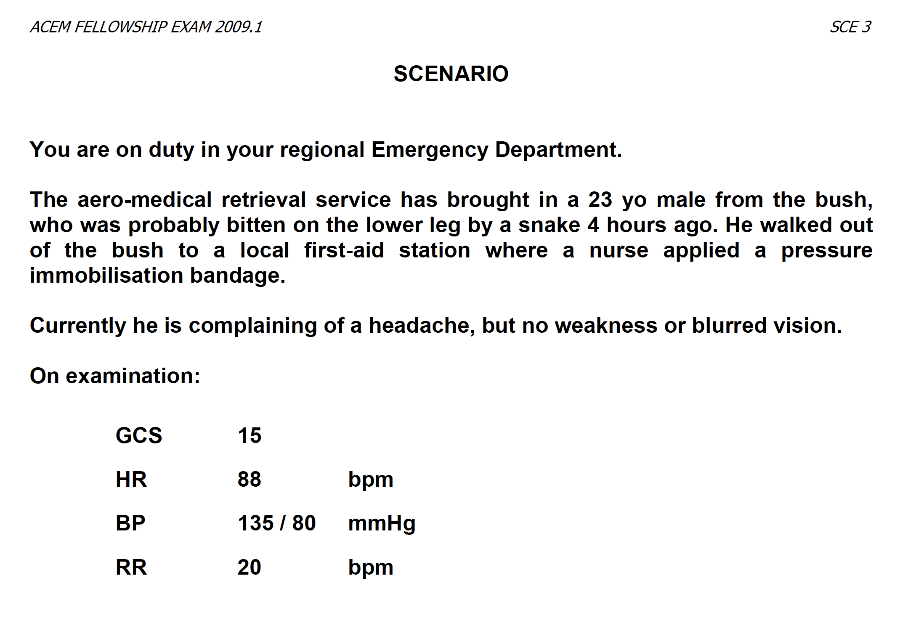

Q2 PROPS – NOT be be given with STEM

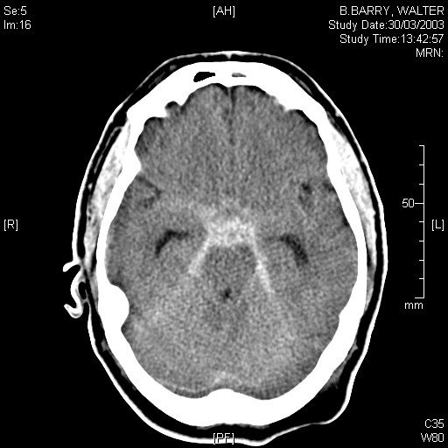

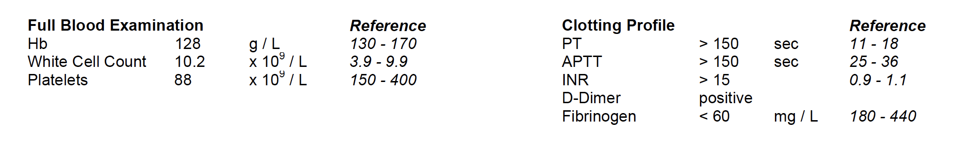

(CT brain not part of original SCE but can be easily adapted to include for SCBD)
QUESTION 4

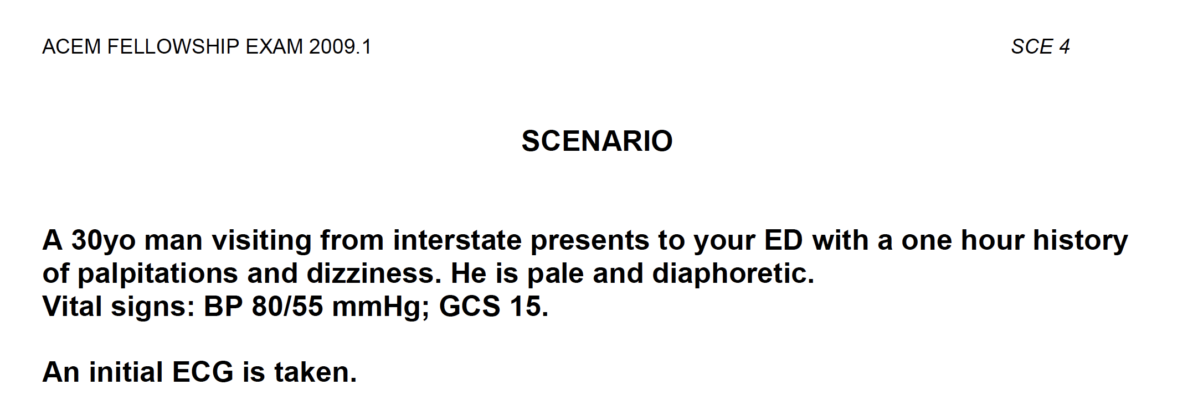

(First ECG Provided to Candidate)

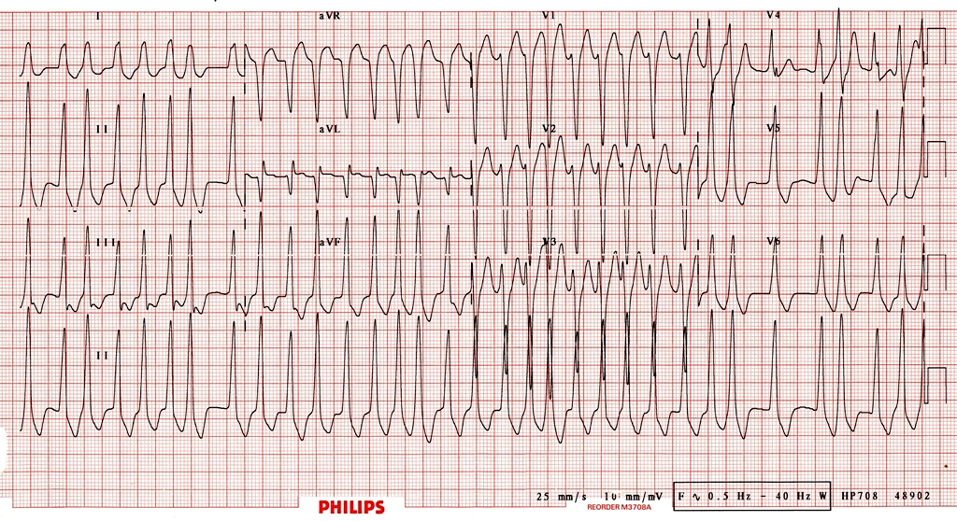
Q4 Props – not to be given

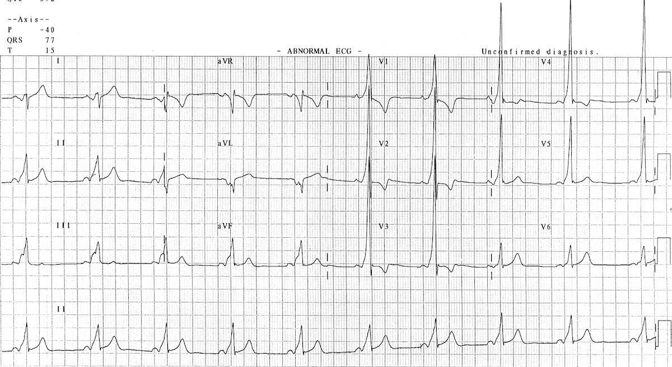
Question 5

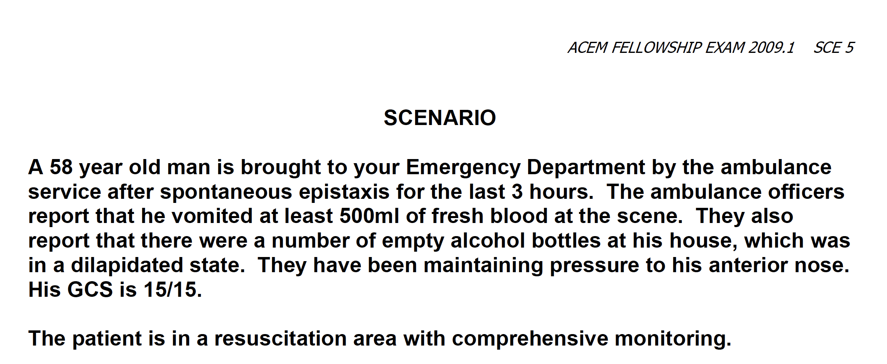

Q5 Prop – not to be given to candidate initially – presented during discussion
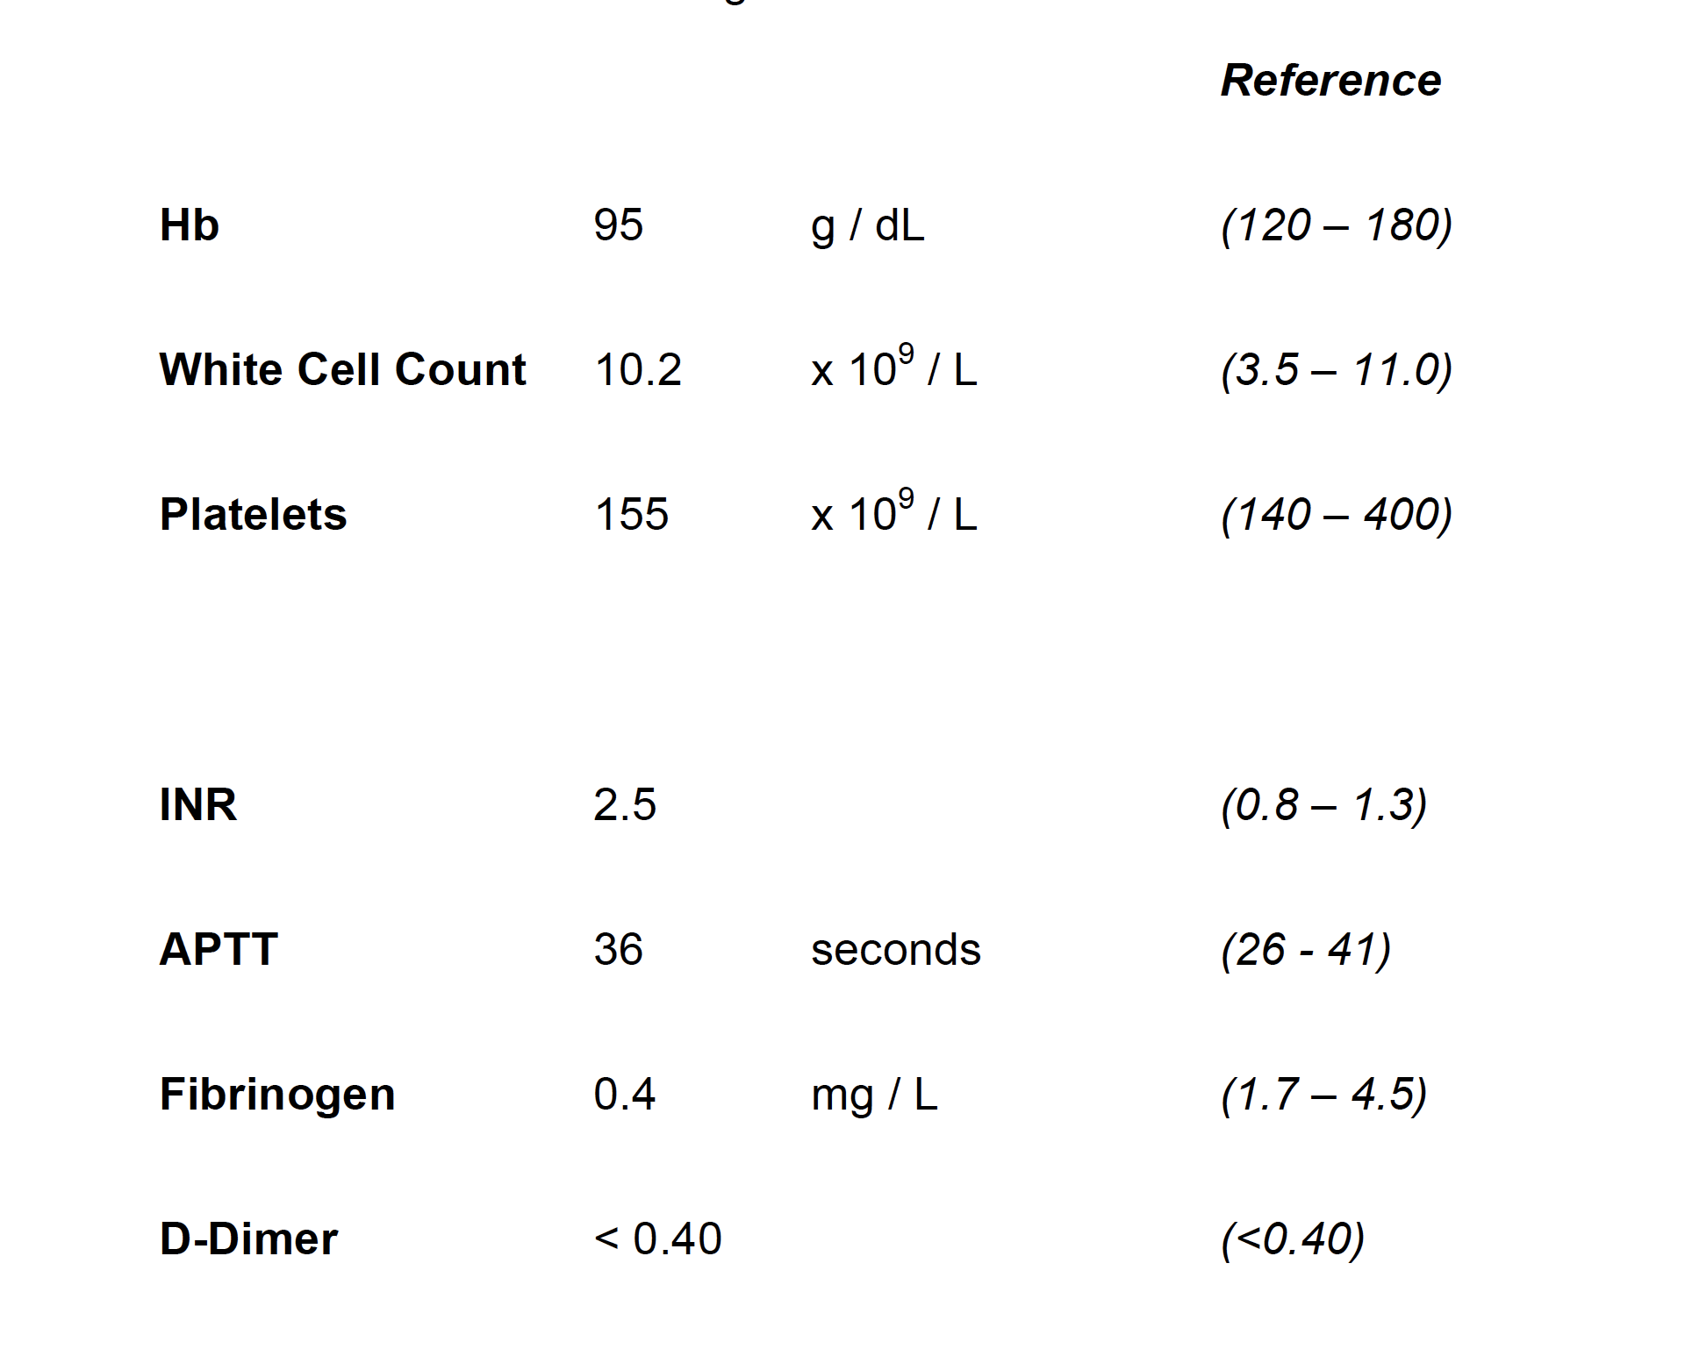

Question 6

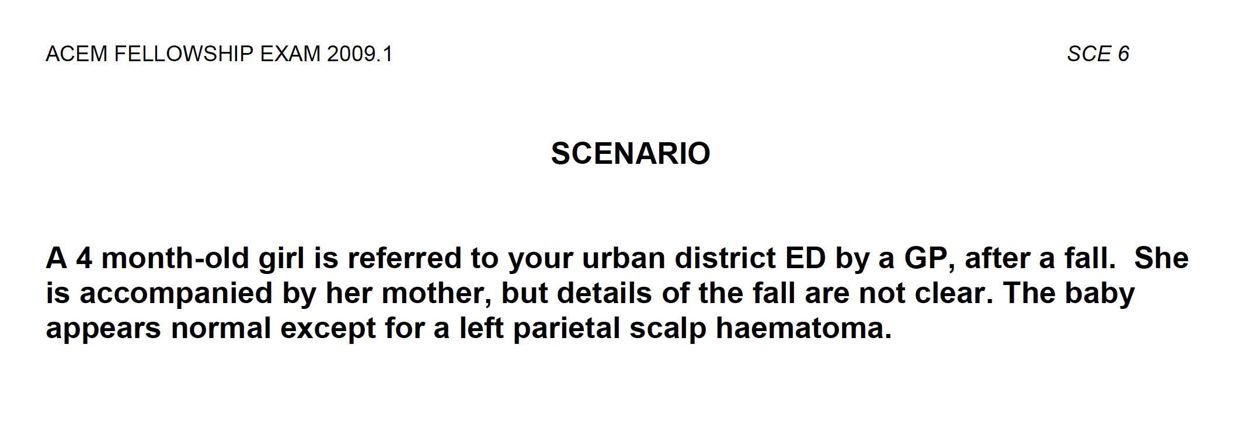

(Props not to be given to candidate)

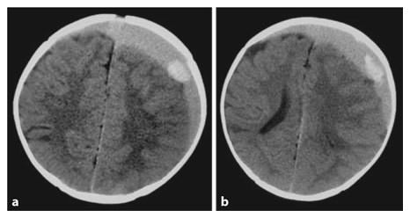
Q6 Prop NOT to be given to candidate with stem

CT Interpretation - A left subdural hematoma causing a midline shift and compression of the left lateral ventricle and sulcal effacement. The hyperdense area on the left side represents an acute hemorrhage.
No evidence of depressed skull fracture – appropriate suture separation of age of child

Suggested Add On Questions/Station Ideas/Candidate Homework
- Q2_SIM Preg Trauma
- Q3_Demonstrate Examination of patient/PIB application in snake bite
- Q3_Explain interpretation of head CT to a junior – Mnemonic Blood, Can, Be, Very, Bad (Blood/Cisterns/Brain/Ventricles/Bone)
- Q4_Explain ECGs to a junior – pre and post reversion
- Q5_Demonstrate how to insert a rapid rhino/pack a nose/Use a foley to cease epistaxis
- Q6_NAI Comminication station with actor

