RDH Practice Paper – GIT, vascular and surgery

Question 1: 12 marks

A 56-year-old female presents to your rural ED with haematemesis and is actively vomiting. She is heavily intoxicated and unable to give a clear history of events. She has known Childs-Pugh C cirrhosis. She is in the resus bay with full non-invasive monitoring attached. There is no endoscopy service at your hospital

BP 70/40
P 120
Sats 90%
RR 32
Temp 35.2
GCS 13

a) List the 4 most likely causes of her haematemesis (4 marks)

_______________________________________________________________________________________
_______________________________________________________________________________________
_______________________________________________________________________________________
_______________________________________________________________________________________

She has a large volume bright red vomit of estimated volume 1000mls.
Her VBG is shown:

pH 7.1
pCO2 31
HCO3 15
Hb 56
Na 137
K 3.1

b) List the management steps you will undertake within the next 30 minutes
(8 marks)

_______________________________________________________________________________________
_______________________________________________________________________________________
_______________________________________________________________________________________
_______________________________________________________________________________________
_______________________________________________________________________________________
_______________________________________________________________________________________
_______________________________________________________________________________________
_______________________________________________________________________________________

The patient becomes aggressive and is attempting to leave the department.

c) List the strategies you will use, in escalating order, to manage this situation
(4 marks)
_______________________________________________________________________________________
_______________________________________________________________________________________
_______________________________________________________________________________________
_______________________________________________________________________________________

Question 2: 14 marks

An 84-year-old man presents to your tertiary ED with a 2-week history of worsening jaundice and abdominal pain. He is a nursing home resident and has moderate dementia. He is sweaty, confused and distressed. He has had a very low alcohol intake throughout his life. His only comorbidity is hypertension.

a) List the most likely differentials you will consider (6 marks)

_______________________________________________________________________________________
_______________________________________________________________________________________
_______________________________________________________________________________________
_______________________________________________________________________________________
_______________________________________________________________________________________
_______________________________________________________________________________________
_______________________________________________________________________________________
_______________________________________________________________________________________

b) Complete the table below for the 5 most important tests that you will order, giving a reason for each (10 marks)

Test | Reason

The patient expresses a wish NOT to have any further tests and is distressed and aggressive when you attempt to take blood.

c) What factors will you consider when deciding whether to palliate vs actively manage this patient? (4 marks)

_______________________________________________________________________________________
_______________________________________________________________________________________
_______________________________________________________________________________________
_______________________________________________________________________________________

Question 3: 12 marks

A 74-year old man presents to ED with severe, sudden onset R leg pain. There is no history of trauma to the leg and no previous history of vascular disease. The distal pulses in the painful limb are not palpable.

What other signs would you look for on clinical examination to determine the urgency of intervention? (4 marks)

_______________________________________________________________________________________
_______________________________________________________________________________________
_______________________________________________________________________________________
_______________________________________________________________________________________

Which bedside tests would assist in further assessing this patient? Give a reason for each test. (8 marks)

Test | Reason

You assess the limb to be critically ischaemic. Your small outer-metropolitan hospital does not have vascular surgery or interventional radiology. List four treatments you will initiate while arranging transfer, including doses where appropriate. (4 marks)

_______________________________________________________________________________________
_______________________________________________________________________________________
_______________________________________________________________________________________
_______________________________________________________________________________________

Question 4: 9 marks

An 84-year-old man presents with a painful distended abdomen. He has vomited several times over the last 24 hours.

His AXR is shown in Figure 1 and 2 in the props booklet.

a) List the abnormal features on this XRay (2 marks)

_________________________________________________________________________________________
_________________________________________________________________________________________

c) What is the diagnosis? (1 mark)

_________________________________________________________________________________________

The medical student that you are supervising asks you how you can tell the difference between large and small bowel on an X-ray.

d) Complete the table below outlining the features of large versus small bowel obstruction as seen on a plain abdominal film (6 marks)

Large Bowel | Small Bowel

Question 5: 12 marks

A mother brings her 2-year-old child to ED and states that the child may have swallowed a battery from a toy. The child put the battery in her mouth, fell over, and now the battery can’t be found.

a) List the 4 most relevant points to obtain from the history (3 marks)

_________________________________________________________________________________________
_________________________________________________________________________________________
_________________________________________________________________________________________
_________________________________________________________________________________________

A CXR is performed, demonstrating a 20mm diameter battery, which appears to be in the stomach. The child is for discharge.

b) What advice should be given to the mother regarding the ongoing care? (2 marks)

_________________________________________________________________________________________
_________________________________________________________________________________________

c) If the battery was smaller (10mm) and seen to be beyond the pylorus how would the discharge advice have changed? (1 mark)

_________________________________________________________________________________________

The child returns after 3 days with abdominal pain, dark stools and refusal to eat or drink for 12 hours.

c) List and justify your 6 actions you will take in the Emergency Department (6 marks)

_________________________________________________________________________________________
_________________________________________________________________________________________
_________________________________________________________________________________________
_________________________________________________________________________________________
_________________________________________________________________________________________
_________________________________________________________________________________________

Question 6: 31 marks

A 25-year-old female presents with 3 months of non-bloody diarrhoea without vomiting or fevers. Her GP has sent 2 stool samples, which have been negative. She has lost 5 kilos in weight and is currently 45kg (BMI 17). She is lethargic, weak and mildly dehydrated. He has no history of medical conditions and takes no medications.

BP 130/70
P 100
Sats 99% RA
RR 16
Temp 37.1

a) In the table below list 5 potential differential diagnoses and 2 features in the history you will ask relating to each differential. (10 marks)

Differential | History

The nurses perform an ECG “as a baseline”.

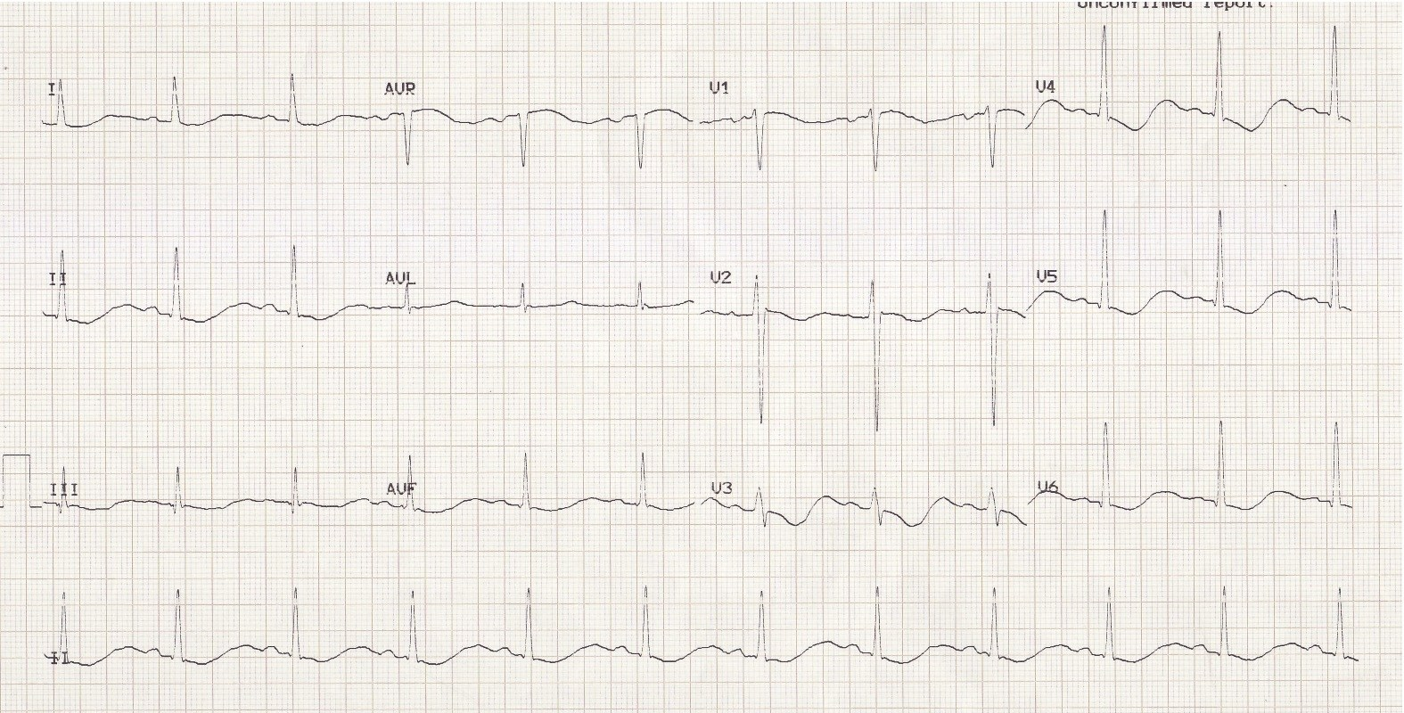

b) List the positive findings on the ECG (4 marks)

_________________________________________________________________________________________
_________________________________________________________________________________________
_________________________________________________________________________________________
_________________________________________________________________________________________

c) What is the likely cause of this ECG abnormality (1 mark)

_________________________________________________________________________________________

d) What 8 blood investigations would you consider ordering in ED to narrow your differential - with justification for each (16 marks)

Blood test | Justification

Question 7: 13 marks

A 5-week-old child presents to ED with vomiting. The mother brought her child to ED 3 days earlier and was sent home with a diagnosis of “overfeeding and reflux”. Mum states that the child has been very hungry but has become lethargic over the last 24 hrs and has only had 1 wet nappy. The child weighs 4kg. You estimate that they are moderately dehydrated (5%). The venous gas performed shows the following:

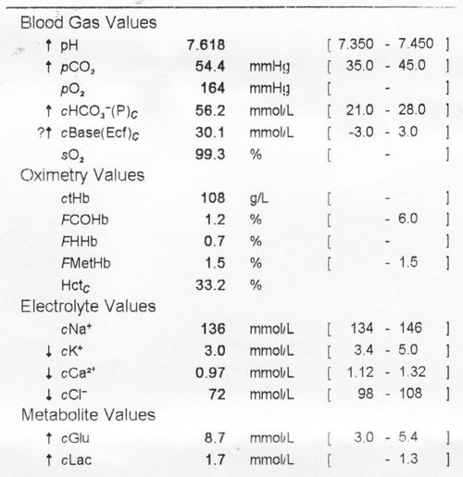

a) What abnormality does this VBG show? (4 marks)

_________________________________________________________________________________________
_________________________________________________________________________________________
_________________________________________________________________________________________
_________________________________________________________________________________________

b) What is the likely cause? (1 mark)

_________________________________________________________________________________________

c) List 2 other surgical differentials (2 marks)
_________________________________________________________________________________________
_________________________________________________________________________________________

d) What examination findings might you expect to see if your first differential is correct? (3 marks)
_________________________________________________________________________________________
_________________________________________________________________________________________
_________________________________________________________________________________________

e) Outline the fluid management for this child (assuming they are to be nil by mouth) (3 marks)
_________________________________________________________________________________________
_________________________________________________________________________________________
_________________________________________________________________________________________

Question 8: 16 marks

A 56-year-old male presents with fresh red PR bleeding and a lump that can’t be “pushed back in anymore”. He is crying with pain. On inspection of the anus you see the following.

He is unable to tolerate PR due to pain. He has no medical comorbidities and takes no medications.

a) What is the abnormality (3 marks)

_________________________________________________________________________________________
_________________________________________________________________________________________
_________________________________________________________________________________________

b) Outline the steps you would take to surgically manage this condition in the ED (5 marks)

_________________________________________________________________________________________
_________________________________________________________________________________________
_________________________________________________________________________________________
_________________________________________________________________________________________
_________________________________________________________________________________________

c) Outline the discharge advice you will provide post procedure (6 marks)

_________________________________________________________________________________________
_________________________________________________________________________________________
_________________________________________________________________________________________
_________________________________________________________________________________________
_________________________________________________________________________________________
_________________________________________________________________________________________

d) List 3 patient groups in whom it is NOT appropriate to manage surgically in the ED (3 marks)

_________________________________________________________________________________________
_________________________________________________________________________________________
_________________________________________________________________________________________

Question 9: 19 marks

A 56 year old presents with a SOB and chest pain. He has recently been diagnosed with hypertension and started on perindopril and amlodipine. He presents to ED because he has measured a BP of 210/110 at home. He is convinced that he is going to have a stroke. You are concerned that he is having an aortic dissection.

BP 230/120
P 130
Sats 99% RA
RR 26
T 36.9

a) Complete the table below outlining the other acute serious consequences of uncontrolled hypertension and the signs or bedside investigations you will employ to rule them in or out. State nil if there is no relevant diagnostic bedside test. (15 marks)

Acute Consequence | Possible Signs | Potentially Diagnostic Bedside Investigations

His chest pain worsens and you decide to send him for a CT aortogram.

c) List 2 drugs that you will choose to lower his BP assuming that this study is positive for aortic dissection. List them in the order you will chose to give them (4 marks)

_________________________________________________________________________________________
_________________________________________________________________________________________
_________________________________________________________________________________________
_________________________________________________________________________________________

PROPS BOOKLET:

Figure 1:

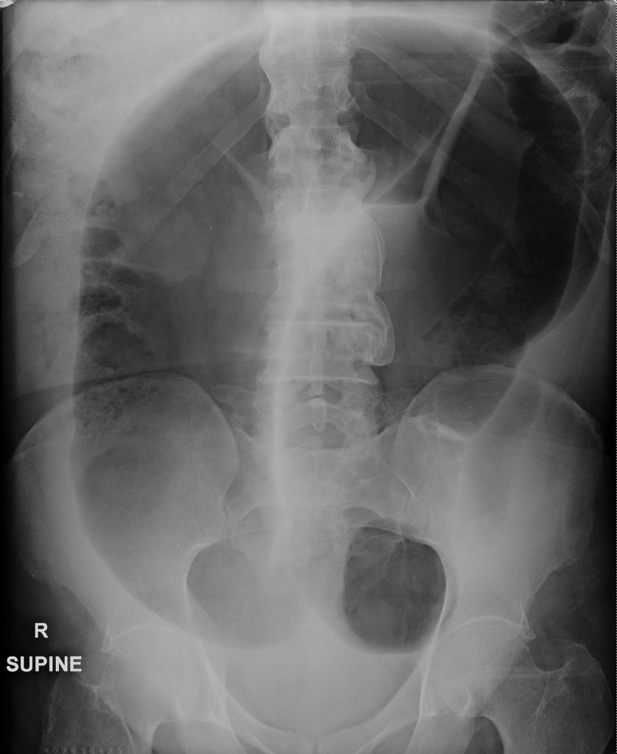

Figure 2:

