RDH SAQ BOOKLET- PSYCH

Q1. (15 marks) (John Larkin)
A 45 yr old male has been brought to your Emergency Department by ambulance. He has been allegedly assaulted and has sustained a head injury and laceration with a period of LOC. He has declined to have observations performed and wishes to leave the Emergency Department.

a. What are the essential elements of competency required to consent to, or refuse treatment? (4 Marks)

b. The ambulance crew tell you the patient was assessed by the police at the scene of the alleged assault. He undertook a breath alcohol test, the result of which was 0.18%. The patient is becoming increasingly agitated and wishes to leave. Outline your management of this situation. (7 Marks)

c. Which patient groups may be unable to consent ? (4 Marks)

Q2.
A 35 yr old male has been brought to your Emergency Department complaining of auditory hallucinations. He has been seen directly by the Psychiatry team who wish to admit him as an involuntary patient under the Mental Health Act 1983.

a. What is the purpose of the Mental Health Act? (2 marks)

b. What is the definition of mentally ill patient? (2 marks)

c. What are the criteria for admission and detention as an involuntary patient? (4 marks)

d. What is the role of the emergency physician? (2 marks)

Q3. (17 marks) (Acem 2015.1)
A 25 year old patient is in the emergency department for 8 hours of observation following a
polypharmacy ingestion. You have been asked to provide “medical clearance” prior to
transfer of the patient for mental health assessment.

a. List three (3) factors that you would consider for this safe transfer. (3 marks)

b. Provide seven (7) factors that distinguish between a delirium and a psychosis. (14 marks)

DELERIUM | PSYCHOSIS

Q4. (15 marks) (Topend exam)
A 44 year old man presents with “bizarre behaviour”. He was seen initially by the Mental Health Assessment Team who were concerned that his presentation may have an underlying organic cause.

a. List five (5) different categories of diagnosis’ that can mimic psychiatric behavioural disturbances, for each type give a very specific example and an investigation that would be useful to prove that diagnosis. An example is given in the first row. (15 marks)

Diagnosis Type (5 marks) | Specific Diagnosis (5 marks) | Investigation (5 marks)
Metabolic | Hypercalcaemia 2 malignancy | CMP, TFT, PTH
Q5. (24 marks) (Topend exam)
A 27 year old female presents after spending the weekend at a dance festival. She admits to the use of illicit drugs and alcohol. She has a history of depression and has been an antidepressant for 7 months. She feels like she is having a “come down” after a big weekend. She appears anxious and her face is flushed.

P 120
BP 170/110
Sats 97%
RR 32
Temp 38.1

a. Complete the table below outlining the differences between the serotonic syndrome, NMS and anticholinergic syndrome (24 marks)

 | Anticholinergic Syndrome | Serotonin Syndrome | Neuroleptic Malignant Syndrome
Example of drug
Onset
Vitals
Mental Status
Pupils
Skin
Neuromuscular Tone
Reflexes

Q6. (26 marks) (Topend exam)
A 21 year old man with a recent diagnosis of schizophrenia presents with a behavioural disturbance. He has been found wrapped in tin foil lying in a neighbours shed. He is agitated in the triage area where there are several children waiting to be seen. Verbal de-escalation has failed and he is refusing to come to the psychiatric assessment room or take any oral medications.

a. For each facet of the mental state exam, give one (1) finding that could suggest acute psychosis in the context of a known schizophrenic patient. (14 marks)

b. The patient requires chemical sedation for his own, and the safety of others. In the table below list 6 measures you will take to increase the safety of this procedure, giving details for each. (12 marks)

SAFETY MEASURE | DETAIL

Q7.
A 72 year old man is brought in by police after his neighbours found him intoxicated in a barn with a gun. He has longstanding untreated depression.

a. List 10 major risk factors for suicidal behaviour in the elderly that you will explore in your assessment of this man (10 marks)

Q8.
A 15 year old girl presents after not eating for 3 days, she states that she is trying to starve herself to death because someone has repeatedly physically and sexually assaulted her. She is tearful and withdrawn. Her father is a single parent and she has a younger sibling. Her father is en route to the hospital. She won’t disclose who assaulted her. The sexual assault team have been called.

a. List 10 issues that will need to be addressed in this child by the ED and sexual assault team (10 marks)

RDH SAQ BOOKLET- PSYCH ANSWERS

Q1
a. Essential elements of competency required to consent to, or refuse treatment? (4 Marks)
Ability to appreciate the situation and its consequences
Ability to understand the relevant information eg treatment required and the risks, benefits of and the risks of doing nothing
Ability to weigh information in a rational way
Ability to maintain and communicate a decision

Textbook of Adult Emergency Medicine, Cameron, 3rd Edition, Chp 25.3
Consent to Treatment Policy for the Western Australian Health System 2011, 3rd Edition

b. The ambulance crew tell you the patient was assessed by the police at the scene of the alleged assault. He undertook a breath alcohol test, the result of which was 0.18%. The patient is becoming increasingly agitated and wishes to leave. Outline your management of this situation. (7 Marks)

Ensure staff and other patient safety
Attempt verbal de-escalation, if unable to, escalate to show of force, if unable to, consider 5 point physical restraint and then chemical take down with Droperidol 10mg IM, repeated if required under Duty of Care legislation
Move patient to high fidelity area with full cardiac monitoring including CO2, support airway, administer oxygen of required to maintain saturations >94% and establish IVC
Organise investigations including ecg, uds, bal, ctbrain if clinically indicated
Assess wound and manage appropriately with washout, laceration, adt and Abs if required
Consider IVF + Thiamine
Monitor till improved GCS and reassess cognition and neurology.

c. Which patient groups may be unable to consent? (4 Marks)

Children
Intellectually impaired
Dementia / Alzheimer's
Mentally ill
Drug / alcohol affected
Critically unwell patients

Q2.
a. What is the purpose of the Mental Health Act? (2 marks)
The mental health act provides legislation for patients with a mental illness who are detained in hospital involuntarily or involuntarily as it is in the best interest of the patient and others; but treatment is by consent.

b. What is the definition of mentally ill patient? (2 marks)
Disturbance of mood, thought, perception, memory posing a risk to self or others.

c. What are the criteria for admission and detention as an involuntary patient? (4 marks)
Patient has a mental illness/disturbance
Without treatment, the patient is likely to cause serious harm to himself or someone else
The mental illness needs treatment that is available at an approved facility
They have refused or lack capacity to consent to treatment
There is no less restrictive way

d. What is the role of the emergency physician? (2 marks)
Differentiate between patients with psychiatric illness, psychiatric manifestation of a physical illness who require medical care, assess for concurrent physical illness, toxicology or injury.
Q3. (15 marks)
a. List three (3) factors that you would consider for this safe transfer. (3 marks)

The toxins ingestions and their risk assessment.
The current clinical status of the patient.
Any concomitant medical issues that need to be addressed for eg, injury, concurrent illnesses, pregnancy etc.

b. Provide seven (7) factors that distinguish between a delirium and a psychosis. (12 marks)

DELERIUM | PSYCHOSIS
Rapid onset | Slower onset
Fluctuant | Consistent
Altered level of consciousness | Alert
Cognition impaired | Cognition not impaired
Visual hallucinations | Auditory hallucinations
Poor attention | Disordered attention
Abnormal vital signs | Normal vital signs
Other physical symptoms | No physical symptoms

Q4.

Diagnosis Type | Specific Diagnosis | Investigation
Hypoxia/Hypercarbia | Pneumonia, PE, hypoventilation due to opiates, COPD exac etc | Sats/ABG
Sepsis | Any source e.g.UTI | Septic screen –BC/UA/MCS
Intracranial infection | Encephalitis due to HSV | LP
Head Injury | Subdural, Concussion, SAH, Extradural | Imaging – CT/MRI
Neoplastic | Brain tumour – primary or mets | Imaging – CT/MRI
Toxic | Serotonin syndrome, anticholingergic syndrome | Drug levels/tox screen
Endocrine | Thyroid Storm, Addisions crisis, | TSH, cortisol
Drug Induced | Illicit drugs, prescription drugs SE, intentional OD – as long as appropriate specific drug | Urine drug screen, ECG, VBG

Q5. 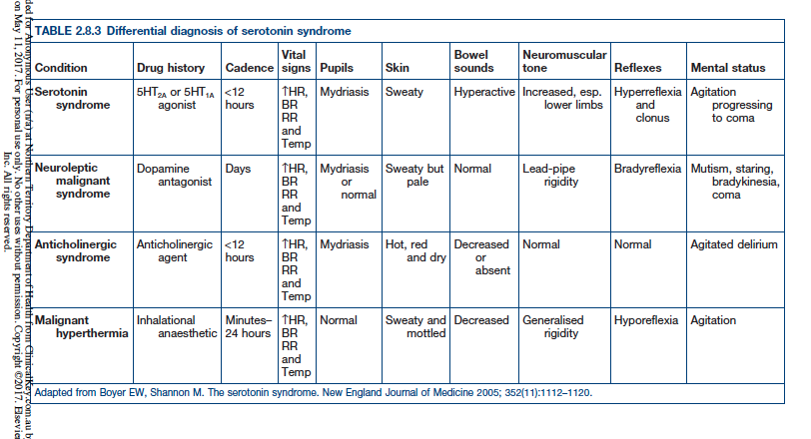

Q6.
a. For each facet of the mental state exam, give one (1) finding that could suggest acute psychosis in the context of a known schizophrenic patient. (14 marks)

Appearance + behaviour- disheveled, agitated, poor eye control
Mood + affect- often elevated with elevated affect
Speech- pressured, loud, rapid
Cognition- variable
Thoughts- delusions, preoccupations, self harm, suicdality, homicidality, obsessions, grandeur, paranoia; flight of ideas, tangentiality, word salad
Perception- dissociation, illusions, hallucinations
Insight + judgement + impulse control- poor, poor, poor

b. The patient requires chemical sedation for his own, and the safety of others. In the table below list 6 measures you will take to increase the safety of this procedure, giving details for each. (12 marks)

Safety Measure | Details
Call a CODE | Gets appropriately trained help and numbers of people required for a 5 point restraint
Briefing outside of room | To ensure everyone is aware of the process and has an opportunity to ask questions
Remove other people from the area | Prevents injuries
Ensure all staff participating have appropriate training and no impediments to participating | Reduces risk of physical harm to all if everyone knows the techniques
Use a specific room | Mattress, O2, safe space from other patients
Ensure patients record is checked for ADRs | Could have dystonic/anaphylactic/Long QTc previously
Check current meds | To ensure patient has no interactions with proposed medications to be used
Administer drugs IM rather than IV | Less likely to get a needle stick as takes less time
Check Obs immediately afterwards then continuous monitoring | To ensure no
Manage supine | Less likely to asphyxiate
Obtain IVC | To allow investigations as well as access if further sedation required or reversal
Provide 1-1 nursing and a special afterwards in room of high fidelity | To detect when patient is waking
Use sedation score | To detect oversedation, risk of aspiration and hypoxia

Q7.
a. List five (5) major risk factors for suicidal behaviour in the elderly that you will explore in your assessment of this man (5 marks)

SADPERSONS
Sex M>F
Age <19 + >45
Depression
Previous attempt
Etoh/Substance
Rational thinking loss; eg emotional crisis, schizophrenia, bpad
Social supports lacking
Organised attempt
No spouse/widowed/divorced
Sickness/ chronic pain

0-2 Minimal risk
3-4 Could be discharged but with frequent input
5-6 Consider/likely hospitalization or early return for ongoing sessions
7-10 Hospitalisation

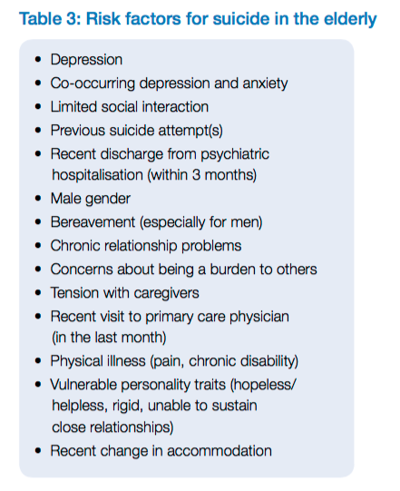

Q8. List 10 issues that will need to be addressed to this child and in this child by the ED and sexual assault team (10 marks)

Provide support and reassurance that she is safe
Determine if there are any immediate life threats for example, hypoglycaemia, electrolyte disturbance/serious injuries that need to be treated
Rehydrate/ feed
Determine if pregnant
Determine the need for post coital contraception
Determine the need for PEP for HIV/immunisation for Hep B
Screen for STDs
Determine the risk posed by immediate family members to her and her sibling; notify police if immediate; notify FACS/DOCS otherwise
Assess mental state exam + risk

Ensure chain of evidence – brown bag all clothes, encourage her not to shower till seen by Sexual Assualt team
Involve Paediatrician
Contact police to report assault of a minor

