Renal and Urology Fellowship Questions

HOT TOPICS
UTI/Pyelonephritis - paed
Acute Renal Failure
Rhabdomyolysis
Hyperkaleamia dialysis patient
Subacute Bacterial Peritonitis in PD Patient
Renal Transplant patient
HUS Paed
PSGN
Renal Colic SSU Patients
Torsion
(Para)Phimosis
Priapism

Trainee Topics
- Danika - Acute Renal Failure Adult
- John - Post Strep GN
- Claire- Rhabdo and Renal Failure
- Sarah - Testicular Pain in a teenager

Question 1
(13 marks)
A 46 years old female presents to ED after a brief episode of witnessed unconscious collapse in the foyer of the hospital. She did not hit her head. She is a haemodialysis patient and was on her way to the dialysis unit for her treatment. She feels short of breath and missed her last dialysis session 2 days ago. She has a history of IHD, AF, heavy smoker and hazardous alcohol use with frequent binge drinking.
Her observations and ECG are shown below
GCS 14
P 110
Sats 94% RA
RR 22
Temp 37.7
BP 90/50
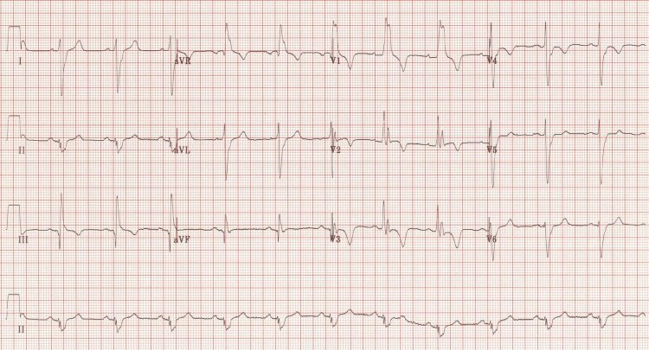

i. List the five (5) MOST LIKELY causes of her collapse that you will seek to identity
(5 marks)
Hyperkalaemia with subsequent arrhythmia
Cardiac failure/fluid overload with poor cardiac output
Cardiac Arrhythmia
Cardiac Ischaemia
Pulmonary Embolus
Seizure secondary to alcohol/withdrawal
Sepsis – any focus (only a single mark if multiple infections given)

ii. List four (4) abnormal features on the ECG
(4 marks)
RBBB
Extreme right axis deviation (+180 degrees)
S1 Q3 T3
T-wave inversions in V1-4 and lead III
Clockwise rotation with persistent S wave in V6

The renal registrar calls the department to ask whether the patient will be able to attend dialysis in her allocated slot 90 minutes from now
iii. List the four (4) MOST important tests you would like to perform in the next 60 minutes prior to answering the renal registrar’s question.
(4 marks)
Venous blood gas to check potassium
CXR to guide onward imaging
CTPA or VQ
Trop to delineate ischaemia or massive PE
Other tests are important but not THE MOST IMPORTANT

Question 2
()
A 66 year schizophrenic old man presents with first episode of left loin pain radiating to his umbilicus. He has been given morphine. The RMO thinks that the patient is suitable to go to the ED Short Stay Unit (SSU) to wait for his CTKUB.
Observations
P 90
BP 160/90
Sats 98
RR 12
T 37.0

i. List five (5) features in the ASSESSMENT of this patient that would exclude this man from being sent to SSU
Significant acute renal dysfunction/elevated Cr
Pain that has lasted for more than 24hrs/48hrs – unlikely to pass, suggests large impacted stone
Fevers/signs of sepsis (hypotension/tachycardia/tachypnea)
UA has leucs/nitrites
Unable to pass urine (??)
Diagnosis uncertain e.g. features that might suggest AAA/bowel obstruction
Patient has a single kidney/significant underlying chronic renal impairment
Significant comorbid conditions/immobility likely to impact need for admission
Social situation that may preclude discharge
Uncontrolled pain despite opiate and NSAID analgesia
Violent or disruptive behaviour

The man is transferred to short stay, he is given Panadol and indomethacin with good effect and his observations are now within normal limits. There are no striking abnormalities on routine bloods. The image below shows the a subsequent slice of the man’s CT
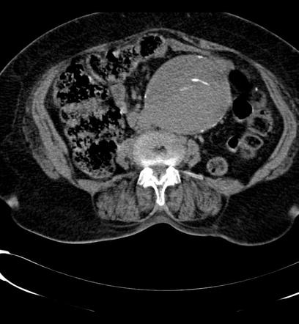

ii. What is the most striking abnormality on the CT
(1 mark)
Large infrarenal AAA
The diagnosis is explained to the patient
iii. List the next five (5) actions you will take immediately
(5 marks)
Move patient to resus/full continuous monitoring
Contact surgical team/ICU/Anaesthetics asap – likely needs urgent OT
Large wide bore access x2 minimum
Crossmatch blood pre-empting rupture/OT
IDC/CVC/Aline all appropriate if not delaying definitive management
Arrange Aortagram (patient stable currently and will help with surgical planning)

Question 3
(14 marks)
A 6 year old boy presents 1 week after the onset of diarrhoeal illness. He initially had bloody motions but today passed a semi formed stool. He is lethargic, nauseated and pale. Mum states that he has not passed much urine for 24 hrs. He is clinically euvolamic. He was seen in ED 1 week prior and had normal bloods including EUC, FBC and CRP.
His observations and currently available pathology results are shown below
BP 130/95 pH 7.21 Na 136 BC – pending
P 130 pCO2 19 K 6.6
Sats 98% RA HCO3 14 Ur 7.0
RR 40 Lact 3.2 Cr 180
T 37.3 Cl 98
Hb 90
Plt 70
WCC 15.4
CRP 45
Stool culture – pending
BC – pending
i. Interpret the bloods gas result, including any calculations you would perform
(5 marks)
High Anion Gap metabolic acidosis (lactate) and respiratory alkalosis
Winters formula 1.5 x HCO3 +8 (+/-2). Expected CO2 = 29 (+/-2)
Anion Gap = 136 – 98 – 14 = 28
Delta Gap = AG/HCO3 change = 28-12/24-12 = 14/12 = Between 1 and 2 (uncomp HAGMA)

ii. List your most likely and 3 other differential diagnoses for this presentation
(4 marks)
HUS
TTP (neuro sx can be present) – Remember FATRN – Fever/Anaemia/Thrombocytopenia/Renal Failure/Neuro sx
DIC
Sepsis secondary to a diarrhoeal illness – with lactic acidosis
Any other cause of haemolysis

iii. List the five (5) MOST important additional tests that you will request in ED, with reasons for each
(5 marks)
ECG – to check for signs of hyperK and guide Ca treatment vs other hyperK Rx alone
Urine dipstick – check for urine casts, infection,
Coags – check for DIC secondary to sepsis
Haemolysis screen/Blood Film– retics/haptoglobins
Renal USS – to check for intrinsic renal anatomical issues

iv. List the organism that is most likely implicated
(1 mark)
E.Coli 0157 – shiga toxin causes the disease

Question 4
(13 marks)
A 3 years old African refugee presents to ED with priapism. He is screaming in pain and refusing to let anyone examine him.
i. List the stepwise actions you will take to manage this situation, assuming at each stage that the action is unsuccessful in resolving the priapism
(5 marks)

Analgesia – titrated opiates +/- penile block under sedation - may need ketamine/nitrous to control
IV fluids - warmed
Aspiration of cavernosum with 2 x butterfly needles
Cavernosal irrigation with 1:1000000 adrenaline or phenylephrine or metaraminol
Surgical consultation for operative intervention
Transfusion/Exchange transfusion

ii. What is the most likely cause of prispism in this child
(1 mark)
Sickle Cell Disease

iii. In the table below compare low and high flow prispism
(8 marks)
 | Low Flow Priapism | High Flow Priapism
Degree of Pain

Causes

Blood Gas Analysis of Cavernosal Aspirate

Treatments

 | Low Flow Priapism | High Flow Priapism
Degree of Pain | Painful | Painless
Causes | Drugs e.g Viagra/neuroleptics/ antihypertensives  Sickle Cell | Fistula/Trauma
Blood Gas Analysis of Cavernosal Aspirate | Ischaemic, acidotic blood | Normal
Treatments | As above in i. | Surgical/Embolisation

Question 5
(14 marks)
A 34 year old male presents to ED with 2 days of gradual mild right-sided abdominal pain deteriorating renal function. Bloods taken by the GP 2 days ago show a creatinine rise from 120 to 230. He has no upper GI symptoms, no urinary Sx or bowel habit alteration. He had a renal transplant 2 months ago for IgA nephropathy and is taking prednisolone, tacrolimus and mycophenolate mofetil.

BP 230/120
P 120
Sats 98%
RR 24
T 38.5

i. List five (5) likely potential causes for this patient’s presentation
(5 marks)
Mechanical surgical issue – obstruction/anastomosis issue/leak/thrombosis
Vascular – RAS/RV thromb
Infection – transplant pyelo/UTI
Rejection –acute
Nephrotoxic drug effect of
Non renal issue e.g gallstones/appendicitis (much less likely – only allow 1 non transplant related cause)

ii. In the table below outline the MOST IMPORTANT initial investigations you will perform with a reason for each
Bedside Tests (3 marks) | Laboratory Tests (4 marks) | Imaging Tests (2 marks)
TEST:  REASON: | TEST:  REASON: | TEST:  REASON:
TEST:  REASON: | TEST:  REASON: | TEST:  REASON:
TEST:  REASON: | TEST:  REASON:
TEST:
REASON:

Bedside Tests | Laboratory Tests | Imaging Tests
ECG  Check for hyperK changes | EUC  Decline in renal function/K | Renal USS  Check for signs pyelo/graft obstruction
Urine Dip  Casts – rec glomeruloneph  Leuc/nit/bld- pyelo | Blood cultures  Guide abx | CXR  As part of septic workup in immunocomp pt/?pulm oedema
VBG  Quick check K/Cr/for acidosis and lactate in sepsis | FBC  ?neutropenia with immunosurp
Tac/MM levels
To determine if toxic levels

Question 6
(12 marks)
A 50 year old man presents in cardiac arrest. He has been unwell at home, in bed, for 1 week with diarrhoea and vomiting. He has a history of AF, IHD, and peri-dialysis diabetic nephropathy. He was being worked up for renal transplant and has a fistula in his left arm which is still immature. He takes digoxin, aspirin, amlodipine, allopurinol and simvastatin.
He has been shocked 3 times en route to ED and has the ALS algorithm has been initiated in the resus bay. He has been intubated
i. In the table below the four (4) MOST likely reversible causes for this man’s cardiac arrest
(4 marks)
Hyperkalaemia secondary to dehydration and renal failure
IHD given history
Sepsis/dehydration due to intraabdominal cause/gastro
PE due to immobility and dehydration
Digoxin toxicity

After 4 cycles of CPR you get ROSC.
The ECG and VBG are shown below
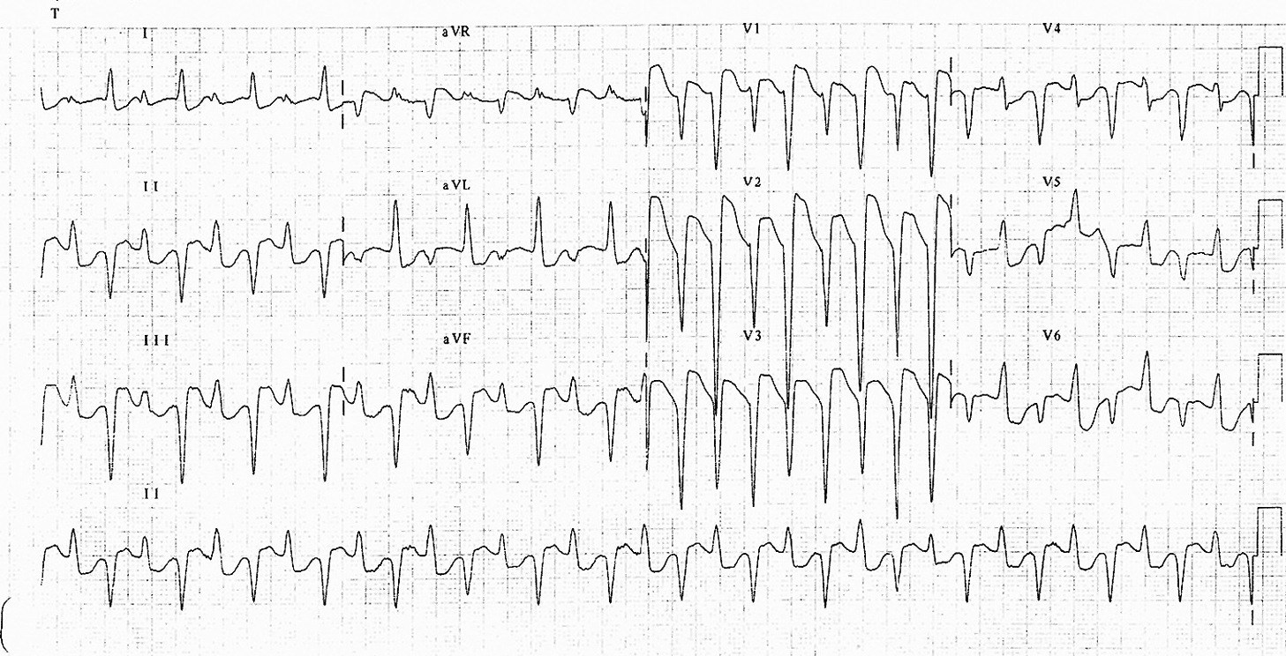
pH 7.10
pCO2 79
HCO3 12
Lactate 9.0
Na 124
K 8.0
Cl- 98

ii. What is the abnormality seen on the ECG
(1 mark)
Bidirectional VT
iii. Interpret the blood gas including any calculations you will perform
(4 marks)
Respiratory and Metabolic Acidosis
Winters formula (HCO3 x 1.5) +8 (+/-2) Expected C02 = 36 +/-2 – inadequate compensation
HAGMA = (124+8) – (98 – 12) = 22
iv. List the three (3) MOST immediate treatments you will administer to the patient to address the underlying cause of the arrest
(3 marks)
Digibind 20 amps
Insulin 10 units actrapid and 50mls 50% dextrose
Bicarbonate 100mls 8.4% - can be repeated
Salbutamol continuous via ETT or IV
(DC shock very unlikely to be effective in digoxin tox)
Calcium Gluconate 20mls 10% - repeat – theoretically contraindicated but in the case of severe hyperK?? where unsure if digoxin truly the issue or other it can be considered – if ever writing to give it in digoxin tox need to make a statement around this

Question 7
(13 marks)
A 78 year old demented indigenous man from a nursing home presented to ED yesterday in urinary retention. He had a catheter inserted by the intern who it appears forgot to replace the foreskin after the procedure. There is no surgical team at your rural hospital site
The image shown below outlines the current problem.
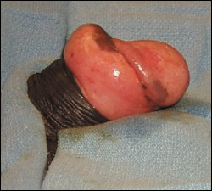
i. What is the abnormality shown
(1 mark)
Paraphimosis

ii. List the stepwise actions you will attempt to deal with the problem, assuming at each stage you are unsuccessful
(4 marks)
Analgesia (titrated IV opiates and lingo gel), lube to foreskin and glans then gentle traction to the foreskin
Compression bandage and ice to try and reduce swelling then retry
Multiple pin pricks to oedematous foreskin to let out oedema fluid (Dundee-Perth technique)
Penile block with lignocaine and dorsal slit to foreskin with iris scissors

The intern who saw the patient is very distressed. She wasn’t aware of the need to replace the foreskin after catheterisation. She states that she was supervising the medical student who actually inserted the catheter. The consultant who was on duty yesterday is not available at present.
iii. In the table below list the issues that need to be dealt with and the actions you will take
(8 marks)
Issue | Action

Issue | Action
Knowledge gaps for intern/med student | Teaching sessions, resources, use of task trainers
Distress of intern | Counsel, follow up, ensure support/mentoring
Medical error | RiskMan report, investigate, feedback, open disclosure to patient/family, produce guideline if approprate
Inadequate supervision of junior staff | Discussion with consultant and wider group regarding appropriate supervision requirements

Question 8
(7 marks)
A 59 years old female has been brought to your resus bay with a fever and confusion. She usually performs home peritoneal dialysis but has been unwell and did not complete it for the last 2 days. She is unable to give much history. She lives alone and her sister found her sitting on the floor in the bathroom. She has full non-invasive monitoring in situ and two 18G cannulas. She is trying to climb out of bed and is currently being physically restrained
PMH – Type 2 DM, IHD, AF, replacement of Tenchkoff catheter 4 days ago
P 130 pH 7.14
BP 70/50 pCO2 22
Sats 91% RA HCO3 14
(99% on 15L) Lact 4.3
RR 28 Na 131
T 38.9 K 5.7
GCS 12 (M 5, V3, E4) Cr 490
Cl 102
Hb 105
Blood has been sent for FBC, EUC, LFT, BC, CMP, CRP and results are pending
UA from IDC specimen – leuc trace, blood neg, nit neg
Her CXR is shown below
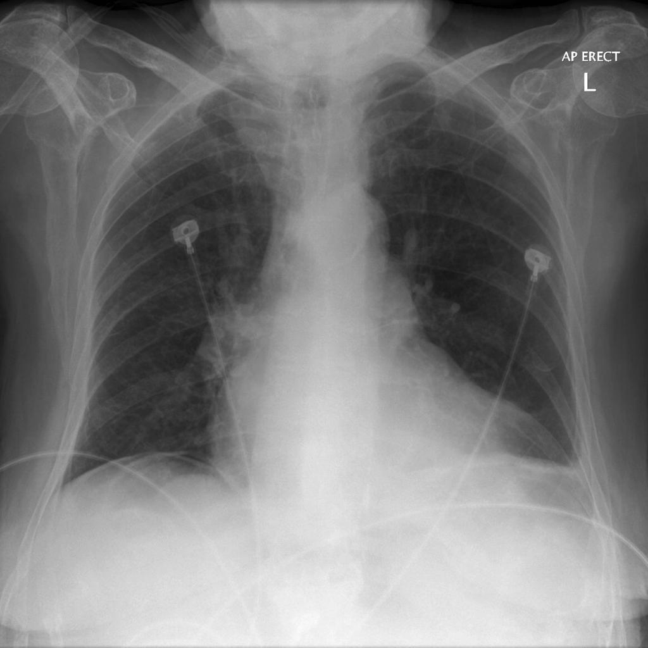
i. What is the one (1) most obvious abnormality on the CXR
(1 mark)
Free intraperitoneal gas
ii. List the two (2) most important further investigations would you like to perform to define the underlying cause
(2 marks)
MCS of peritoneal diasylate fluid- ?cloudy/high leuc count/positive for bacteria
CT Abdomen - ?perforation/complication during catheter replacement or gas just due to replacement
iii. Outline four (4) immediate treatments for this patient
(4 marks)
IV Fluid boluses 500mls repeated
Metaraminol 1mg boluses for BP management +/- Noradrenaline if non responsive to fluid therapy
Sedation for control –droperidol/ketamine/midazolam –any appropriate agent
Antibiotics – broad spectrum IV – Source Unknown regime ( fluclox 2g/gent 5-7mg/kg/vanc 25-30mg/kg) OR GI source (Amp/Gent/Metro)
OR
Intraperitoneal antibiotics if cloudy effluent (Cefazolin or ceftaz 20mg/kg, Gent 0.6mg/kg to 50mg +/- Vanc)
Intubation may be appropriate for control of patient – however needs to come with a statement that demonstrates an understanding of the issues around potential deterioration and measures taken pre intubation to mitigate risks

Question 9
(12 marks)
A 9 week old boy presents with a reported fever at home. He has no overt focus on full clinical examination and looks well. He is feeding well, has good hydration and normal amounts of wet nappies. You are keen to get a urine sample.
P 180
BP 90/60
Sats 98
RR 40
T 36.9
i. List three (3) methods of gaining a urine sample with 1 pro and 1 con of each.
(9 marks)
Method | Pro | Con

Method | Pro | Con
Clean Catch | Requires no invasive or distressing procedures  Painless  Parents can catch | Can be contaminated if parents touch pot on perineum (25%)  Can take a long time/Often missed  Requires commitment from parents
IDC/In Out Catheter | Relatively clean/Sterile – more so than clean catch  3% risk contamination | Can be distressing to child  Small risk of urethral trauma  3% risk contamination
SPA | Very clean and controlled  Quick, no waiting  Method of choice in a <3 mth old | Small risk of damage to other structures – although inconsequential usually even if hit bowel  Distressing to parent and child
Bag Urine  (Not really recommended) | Non invasive  Requires no parental input | Only useful if dipstick entirely normal  Often contaminated  Slow

The most sterile method of collecting urine is utilised and the following result is obtained
SG 1.02
pH 6.0
Leuc 2+
Nit pos
Ket neg
Gluc neg
ii. List your three (3) MOST important investigation and management steps
(3 marks)
Admit paeds for IV abx (Ben Pen and Gent) given persistent tachycardia and risk of sepsis in young age is ideal
If patient is discharged MUST state that FU arranged within 24hrs/planned rv in ED and started on po abx with Bactrim or ceflex – appropriate safety netting
USS as male <3 months mandatory pre discharge
+/- bloods – In this age group not unreasonable to do WCC/CRP/BC
NOTE: No need for IV fluids/IDC/other management as child well
Doesn’t need an LP as >1mth and well

