Obs and Gynae

Fellowship Questions 2017
Question 1

A 40 year old indigenous female from a remote community has been flown into the city to your tertiary ED. She is pregnant with estimated, but unsure, gestation of 7 weeks. She has PV bleeding and abdominal pain. BHCG was 1300 4 days ago. She has IV access.

P 100
BP 90/70
Sats 99%
RR 16
Temp 36.9

a) List the important features in the history that will help you to differentiate between a miscarriage and an ectopic pregnancy? (6 marks)

b) List the 5 most important tests you will order to investigate her presentation, giving reasons for each? (5 marks)

30 mins later the arrest buzzer is pressed for this patient . She is sitting up in a resus bed, white and barely responsive. Airway is patent and she is breathing adequately.

Observations
P 40
BP 50/30
Sats 99%
RR 26
Temp 37.1

c) What are the 2 most likely causes of her deterioration?

d) What will be your first 5 actions ? (5 marks)

Question 2
A 32 year old female G5P4 presents 90mins after an unplanned home birth. She has had a post partum haemorrhage of unknown volume. The newborn is well and has been taken to the nursery for assessment. She has 2 wide bore IV lines in situ and full non-invasive monitoring in the resus room

P130
BP 70/56
Sats 95%
RR 32
Temp 37.4

a) List 5 causes of PPH that you will need to consider? (5 marks)

She is becoming more unresponsive

b) List your immediate management (6 marks)

Her partner arrives and states that they are Jehovah’s Witnesses. The patient had not mentioned this when she was awake. She is unable to give consent to blood products as she is obtunded.

c) How will you proceed with regard to the need for urgent transfusion? (3 marks)

Question 3

A 23 year old female, G1P0, presents to ED for the 4th time in the last 2 weeks. She has an estimated gestation by dates of 7/40. She has been vomiting and has been unable to tolerate any fluids or food for the last 24 hours. She has some mild abdominal discomfort that she thinks is muscular due to retching. The presumptive diagnosis of hyperemesis gravidarum is made.
She has observations within normal limits

a) What are the clinical hallmarks/defining features of hyperemesis gravidarum (4 marks)

b) Complete the table below with 4 options for acute antiemetic treatment with 2 cons/side effects of each (12 marks)

Antiemetic with dose/freq | Side Effects/Cons

c) List 2 maintainence antiemetic therapies that can be commenced for ongoing prevention of N&V (2 marks)

d) List 6 alternative diagnoses that you will consider (6 marks)

e) What criteria will you use to determine when the patient is safe to discharge (4 marks)

Question 4

A 36 year old female is sent to ED by her GP with hypertension in pregnancy. She is 32 weeks gestation and has had an uncomplicated pregnancy thus far.

Obs
BP 160/100
P 100
Sats 99% RA
RR 22
Temp 37.2

a) What are the diagnostic criteria for preeclampsia (3 marks)

b) What features in the history will you seek to determine if SEVERE preeclampsia exists (4 marks)

c) List 7 initial tests will you order, with justification for each (7 marks)

d) Complete the table below with 3 ANTIHYPERTENSIVES that you could consider using for acute severe preeclampsia in this patient

Agent | Dose and Route

The patient has a 5 minute tonic clonic seizure and is post ictal but recovering, with a GCS of 14. She has non invastive monitoring in the resus room and 2 IV lines.

e) Aside from antihypertensives list the other actions you will take to treat and monitor her eclampsia (6 marks)

Question 5

You receive notification from the ambulance service that they are bringing a G6P4 female into your rural ED She is in labour and is currently pushing. Her estimated gestation is 30 weeks. She has not received any antenatal care. There is no obstetric/ICU/anaesthetic service at your site, and most women are transferred to the nearest tertiary centre 50km away prior to the onset of labour. There is no one capable of doing a C-Section safely.

a) How will you prepare for the arrival of this patient? (6 marks)

On arrival the patient is screaming and non compliant. When you examine her you notice that there is umbilical cord hanging out of the vagina. She has 2 IV lines and is fully monitored.

b) Outline your management of this abnormal presentation (8 marks)

Question 6
A 14 year old female presents 1 week after first intercourse with her partner. She is complaining of severe dysuria and vulval itch. She is avoiding passing urine due to the pain. On talking to the patient you judge her to be Gillick competent.

a) What 6 differential diagnoses do you need to consider for her symptoms (6 marks)

When you examine her she is very distressed with pain

b) Outline the tests that you will offer to perform

Her partner arrives at the hospital and he appears to be approximately 30 years old. You see her kissing him intimately in the waiting room, but then she later denies that he is her boyfriend

c) How will you approach this situation (2 marks)

Question 7

Your registrar has asked you to review a 26 year old female who presents with midline pelvic pain for the last 2 years. She has been to her GP several times and has had several pelvic ultrasounds that have been normal during episodes of pain. This is her 7th presentation to ED in a year. She is demanding morphine. She was previously referred to the gynae team for consideration of a laparoscopy but failed to attend the appointment.

Urine BHCG and dipstick is negative

She has had a normal FBC/EUC/LFT/CMP/Coag today
Her cervix looks normal and there is no vaginal discharge or cervical excitation
She doesn’t report any other symptoms at all apart from severe pelvis pain on a full systems enquiry

a) What diagnoses do you think are most likely, given her negative investigations thus far (3 marks)

The patient is becoming agitated and is pacing around the waiting room. She is shouting loudly and threatening to sue the hospital for “ignoring her”.

b) What non invasive strategies can you use to try and de-escalate her behaviour whilst maintaining safety (8 marks)

The immediate attempts to de-escalate are unsuccessful and she continues to be verbally aggressive.

c) Assuming she is a competent adult what would be the next step (1 mark)

Question 8

A 23 year old female presents to ED with 4 days of epigastric pain. She is 32 weeks pregnant. She has been taking Panadol for her pain. Her GP has already performed some baseline blood tests shown below

BP 130/95
P 100
Sats 97%
RR 23
Temp 37.1

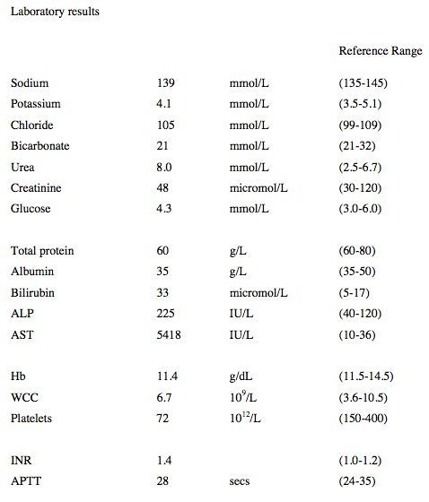

a) List your differential diagnoses (6 marks)

During your assessment of the patient she starts to cry and admits that her partner has been verbally and physically aggressive towards her recently. She has 2 children at home, aged 2 and 4 and is concerned for their safety.

2 views of her bedside USS are shown below

RUQ
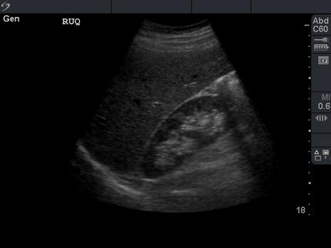

LUQ
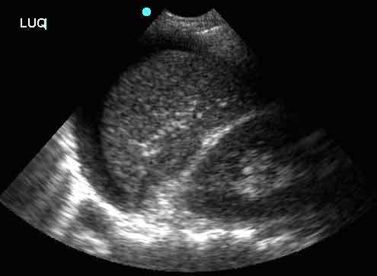

b) What do these images demonstrate (2 marks)

c) What actions will you take in the next hour (7 marks)

Question 9

A 79 year old female presents with post menopausal bleeding and a feeling of dragging in her pelvis. She has a history of uncontrolled hypertension and T2DM.

a) List the potential differential diagnoses (4 marks)

When you attempt a speculum examination you see the following

b) What is this abnormality (2 marks)

The O&G registrar opts to admit the patient to hospital for an immediate operative management

c) What discharge advice/information would you give to women presenting with lesser degrees of the same problem (4 marks)

