Obs and Gynae

Fellowship Questions 2017
Question 1

A 40 year old indigenous female from a remote community has been flown into the city to your tertiary ED. She is pregnant with estimated, but unsure, gestation of 7 weeks. She has PV bleeding and abdominal pain. BHCG was 1300 4 days ago. She has IV access.

P 100
BP 90/70
Sats 99%
RR 16
Temp 36.9

a) List the important features in the history that will help you to differentiate between a miscarriage and an ectopic pregnancy? (6 marks)
Location of pain – unilateral vs central or bilateral
Type of pain – crampy like a period more likely miscarriage
Any previous scans during the pregnancy
Risk factors for ectopic – e.g. anatomical/surgery/PID/IUD/prev ectopic etc
Passage of products
Amount of bleeding – miscarriage usually heavier than ectopic
Shoulder tip pain
Syncope

b) List the 5 most important tests you will order to investigate her presentation, giving reasons for each? (5 marks)
FBC – evidence of anaemia suggests significant intra-peritoneal bleed
BHCG – If doubled every 48 hrs i-e now 5200 then less likely ectopic
Group and hold – to determine if needs AntiD and in case needs transfusion
FAST scan – looking for free fluid of ruptured ectopic
Formal USS – to determine if IAP or ectopic definitively

30 mins later the arrest buzzer is pressed for this patient . She is sitting up in a resus bed, white and barely responsive. Airway is patent and she is breathing adequately.

Observations
P 40
BP 50/30
Sats 99%
RR 26
Temp 37.1

c) What are the 2 most likely causes of her deterioration?
Cervical shock due to products in the cervical os
Haemorrhagic shock

d) What will be your first 5 actions ? (5 marks)
Lie patient flat/head down
Immediate speculum to pull products from os/check degree of bleeding
Apply O2 15L NRB
Fluid bolus 20mls/kg – consider O negative if obvious severe haemorrhage
Recheck VBG Hb

Question 2
A 32 year old female G5P4 presents 90mins after an unplanned home birth. She has had a post partum haemorrhage of unknown volume. The newborn is well and has been taken to the nursery for assessment. She has 2 wide bore IV lines in situ and full non-invasive monitoring in the resus room

P130
BP 70/56
Sats 95%
RR 32
Temp 37.4

a) List 5 causes of PPH that you will need to consider? (5 marks)
Tissue – RPOC
Trauma – cervical laceration/birth canal trauma
Thrombin – coagulopathy/DIC/amniotic embolism etc
Tone – uterine atony

Uterine Inversion
Uterine Rupture
Twin – less likely 90 mins later

She is becoming more unresponsive

b) List your immediate management (6 marks)
Call for help – O&G/anaesthetics as may need theatre
Rub up uterus to encourage tone
Speculum to check for products in Os and amount of bleeding/lacerations/uterine inversion
Consider O neg blood/MTP depending on amount of visualised blood loss
Oxytocin 10IU stat then 40IU in 1L, give 500mls over 10mins then 250ml/hr
(Carboprost 0.25mg IM repeated every 10mins up to 2mg OR Misoprostol 1mg pr are alternatives)

Her partner arrives and states that they are Jehovah’s Witnesses. The patient had not mentioned this when she was awake. She is unable to give consent to blood products as she is obtunded.

c) How will you proceed with regard to the need for urgent transfusion? (3 marks)
Seek a legal advanced directive
If not available give immediately life saving treatment until can establish her wishes
Consider use of products other than blood or its constituents e.g. albumin/colloids
Consider the use of a cell saver – potentially more acceptable?
Consult with hospital legal team

Question 3

A 23 year old female, G1P0, presents to ED for the 4th time in the last 2 weeks. She has an estimated gestation by dates of 7/40. She has been vomiting and has been unable to tolerate any fluids or food for the last 24 hours. She has some mild abdominal discomfort that she thinks is muscular due to retching. The presumptive diagnosis of hyperemesis gravidarum is made.
She has observations within normal limits

a) What are the clinical hallmarks/defining features of hyperemesis gravidarum (4 marks)
Intractable vomiting
Weight loss
Volume Depletion
Hypokaleamia or Ketonuria
Usually first 12 weeks of pregnancy

b) Complete the table below with 4 options for acute antiemetic treatment with 2 cons/side effects of each (12 marks)

Antiemetic with dose/freq | Side Effects/Cons

Antiemetic with dose/freq | Side Effects/Cons
Promethazine 12.5-25mg po/pr 4hrly | Causes drowsiness, CAT C
Ondansetron 4-8mg, 6-12hrly, max 16mg/day | Expensive, HA, constipation, diarrhoea, lightheadedness
Metoclopramide 10mg tds po/iv | Risk of akithisia/dystonic reaction, poor efficacy
Prochlorperazine | Causes drowsiness/hypotension/dystonic reactions
Chlorpromazine | Causes drowsiness/dystonic reaction, CAT C

c) List 2 maintainence antiemetic therapies that can be commenced for ongoing prevention of N&V (2 marks)
Doxylamine with pyridoxine (B6) or B6 alone
Diphenhydramine
Ginger

d) List 6 alternative diagnoses that you will consider (6 marks)
Ectopic pregnancy
Cholecystitis/cholelithiasis
Gastroenteritis
Pancreatitis
Appendicitis
Hepatitis
Peptic ulcer
Pyelonephritis

e) What criteria will you use to determine when the patient is safe to discharge (4 marks)
Diagnosis certain i.e. ectopic/other IA causes ruled out if clinically suspected
Able to tolerate fluids
Resolution of ketonuria/dehydration/electrolyte abnormalities
Favourable social circumstances e.g supported, transport, communication

Question 4

A 36 year old female is sent to ED by her GP with hypertension in pregnancy. She is 32 weeks gestation and has had an uncomplicated pregnancy thus far.

Obs
BP 160/100
P 100
Sats 99% RA
RR 22
Temp 37.2

a) What are the diagnostic criteria for preeclampsia (3 marks)
SBP >=140
DBP>=90

Proteinuria >0.3g/24 hrs

>20 weeks gestation

b) What features in the history will you seek to determine if SEVERE preeclampsia exists (4 marks)

SOB/wheeze/cyanosis – suggesting pulmonary oedema
Epigastric pain/RUQ pain – suggesting HELLP
Easy bruising – low platelets of HELLP
Reduced urine output – oliguria <500mls/24hrs

c) List 7 initial tests will you order, with justification for each (7 marks)
FBC – can see haemoconcentration or falling HCT, low plts with HELLP
Creatinine – renal impairment and oliguria with severe disease
Transaminases – elevated in HELLP
LDH – can suggest microangiopathic haemolysis of HELLP
Urinary protein – part of diagnostic criteria for preeclampsia
Protein:Cr Ratio - >0.1-0.3 suggests need for a urine 24 hrs collection
Uric Acid - >5.5 mg/dL suggests preeclampsia superimposed on chronic hypertension
CTG – for fetal wellbeing check

d) Complete the table below with 3 ANTIHYPERTENSIVES that you could consider using for acute severe preeclampsia in this patient

Agent | Dose and Route

Agent | Dose and Route
Labetolol | 10mg Iv then 20-40mg every 10mins up to 300mg or infusion of 1-2mg/min
Nifedipine | 10mg orally 30 minutely
Hydralazine | 5-10mg over 5-10mins, then 5mg/hr IVI
MgSO4  Dilates as well as preventing/treating seizures | 4-6g over 20-30mins then 2g/hr
SNIP not appropriate as only for use within 30mins of delivery
As per Tintinalli

The patient has a 5 minute tonic clonic seizure and is post ictal but recovering, with a GCS of 14. She has non invastive monitoring in the resus room and 2 IV lines.

e) Aside from antihypertensives list the other actions you will take to treat and monitor her eclampsia (6 marks)
MgSO4 – 4-6g over 20-30mins then 2g/hr – watching the level of consciousness and reflexes, plus monitoring Mg levels every 4-6 hrs
Corticosteroids for fetal maturation – Betamethasone 11.4g po
Continuous CTG monitoring
IDC
Correct intravascular fluid depletion with cautious small boluses of NaCl
Arterial line with continuous invasive monitoring
Urgently contact O&G/ICU as needs delivery of fetus as soon as possible

Question 5

You receive notification from the ambulance service that they are bringing a G6P4 female into your rural ED She is in labour and is currently pushing. Her estimated gestation is 30 weeks. She has not received any antenatal care. There is no obstetric/ICU/anaesthetic service at your site, and most women are transferred to the nearest tertiary centre 50km away prior to the onset of labour. There is no one capable of doing a C-Section safely.

a) How will you prepare for the arrival of this patient? (6 marks)
Notify midwife/paediatrician if available. Get help – phone/telehealth link up from tertiary centre if possible
Arrange a maternal and child team to manage both patients – allocate roles etc
Set up the resusitaire/warm towels/paed resus equipment
Prepare a resus bay
Get equipment ready – delivery pack, nitrous, analgesia, IV lines, IV fluids, ensure O neg blood available, Oxytocin
Contact retrieval services to be en route – high likelyhood that the child will be significantly unwell

On arrival the patient is screaming and non compliant. When you examine her you notice that there is umbilical cord hanging out of the vagina. She has 2 IV lines and is fully monitored.

b) Outline your management of this abnormal presentation (8 marks)
Knee to chest or Simms position
Replace cord in vagina, cover with a sterile wet gauze to prevent drying out
Push presenting part up to prevent pressure on the cord
Discourage the patient from pushing
Analgesia – nitrous/opiates/panadol
Tocolysis with salbutamol
IDC and fill bladder with 1000mls of water
Corticosteroids – betamethasone 11.4mg po
Urgent transfer to tertiary obstetric centre for CSection– will need to transfer with a hand insitu on presenting part

Question 6
A 14 year old female presents 1 week after first intercourse with her partner. She is complaining of severe dysuria and vulval itch. She is avoiding passing urine due to the pain. On talking to the patient you judge her to be Gillick competent.

a) What 6 differential diagnoses do you need to consider for her symptoms (6 marks)
Herpes infection
UTI
PID – chlamydia/gonnorhoea/trichomonas
Genital tract trauma
Candida
Others – Lichen Sclerosis; Non specific vulvovaginitis – e.g allergic/contact/perfumed soaps/condom allergy;

When you examine her she is very distressed with pain

b) Outline the tests that you will offer to perform
Swabs of lesions for herpes simplex
HVS and endocerival swabs for chlamydia, gonorrhoea, trichomonas, candida
Urine dipstick and MCS/gonno/chlamydia
Offer HIV, syphilis serology, hepatitis B&C screening – blood tests
Urine or blood HCG testing

Her partner arrives at the hospital and he appears to be approximately 30 years old. You see her kissing him intimately in the waiting room, but then she later denies that he is her boyfriend

c) How will you approach this situation (2 marks)
This is statutory rape and is illegal, have a duty of care to the vulnerable minor
Discuss with the patient and try to encourage her to seek parental input/support if appropriate
Requires mandatory reporting to police and child services.

Question 7

Your registrar has asked you to review a 26 year old female who presents with midline pelvic pain for the last 2 years. She has been to her GP several times and has had several pelvic ultrasounds that have been normal during episodes of pain. This is her 7th presentation to ED in a year. She is demanding morphine. She was previously referred to the gynae team for consideration of a laparoscopy but failed to attend the appointment.

Urine BHCG and dipstick is negative

She has had a normal FBC/EUC/LFT/CMP/Coag today
Her cervix looks normal and there is no vaginal discharge or cervical excitation
She doesn’t report any other symptoms at all apart from severe pelvis pain on a full systems enquiry

a) What diagnoses do you think are most likely, given her negative investigations thus far (3 marks)
Mittelschmertz Pain
Endometriosis
Psychological causes e.g. domestic abuse/cry for help
Drug seeking behaviour

The patient is becoming agitated and is pacing around the waiting room. She is shouting loudly and threatening to sue the hospital for “ignoring her”.

b) What non invasive strategies can you use to try and de-escalate her behaviour whilst maintaining safety (8 marks)
See the patient immediately
Enlist a friend or family member to help
Move to a quieter area of ED
Acknowledge her distress
Alert security/take a duress alarm
Allow more personal space that is usual, ensure you ae
Speak quietly and calmly, do not stand over the patient, sit down if possible
Allow her time to speak, and listen intently
Keep your hands visable and do not touch the patient
Ensure no weapons e.g. hot cups of tea
Retreat if increasing agitation

The immediate attempts to de-escalate are unsuccessful and she continues to be verbally aggressive.

c) Assuming she is a competent adult what would be the next step (1 mark)
Escort the patient from the hospital grounds by security/police

Question 8

A 23 year old female presents to ED with 4 days of epigastric pain. She is 32 weeks pregnant. She has been taking Panadol for her pain. Her GP has already performed some baseline blood tests shown below

BP 130/95
P 100
Sats 97%
RR 23
Temp 37.1

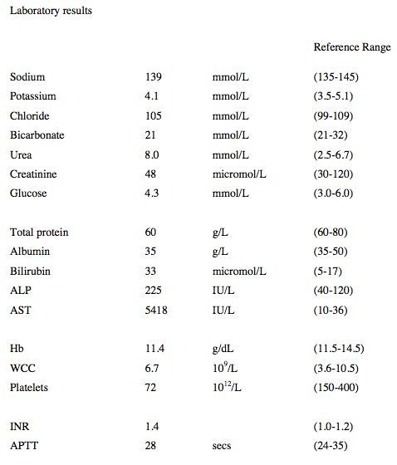

a) List your differential diagnoses (6 marks)
Preeclampsia with HELLP
Acute fatty liver of pregnancy
Hepatotoxins e.g. paracetamol in excess?
Gallstones and their complications
Pancreatitis
Other potential causes of haemolysis/low platelets e.g MAHA/snake bite/TTP etc – any that are reasonable

During your assessment of the patient she starts to cry and admits that her partner has been verbally and physically aggressive towards her recently. She has 2 children at home, aged 2 and 4 and is concerned for their safety.

2 views of her bedside USS are shown below

RUQ
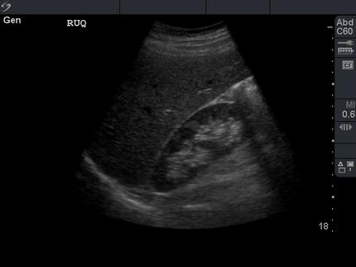

LUQ
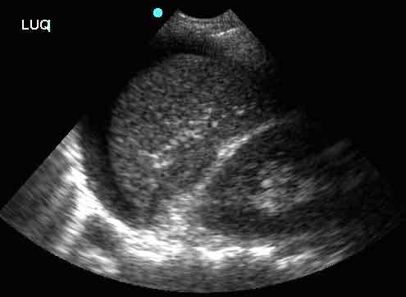

b) What do these images demonstrate (2 marks)
Normal RUQ view
Positive FF in LUQ above the spleen ? ruptured viscus secondary to trauma/other cause

c) What actions will you take in the next hour (7 marks)
Analgesia – avoid Panadol, titrated opiates
Ensure IV access and monitoring
Arrange CTG
Cross match blood and contact haematologist as may need complex products given potential haemolysis/HELLP
Formal USS – with consideration of CT, risk to be discussed with patient
Contact O&G plus surgical team - ? need exploratory laparoscopy
Contact FACS and police to ensure safety of children

Question 9

A 79 year old female presents with post menopausal bleeding and a feeling of dragging in her pelvis. She has a history of uncontrolled hypertension and T2DM.

a) List the potential differential diagnoses (4 marks)
Cancer – cervical, endometrial, ovarian
Atrophic Vaginitis
Exogenous Hormone Use
Uterine Prolapse

When you attempt a speculum examination you see the following

b) What is this abnormality (2 marks)
Uterine prolapse – Complete or Procedentia

The O&G registrar opts to admit the patient to hospital for an immediate operative management

c) What discharge advice/information would you give to women presenting with lesser degrees of the same problem (4 marks)
Lose weight
Avoid lifting and straining
Keep bowels regular and not constipated – laxatives
Pelvic floor exercises
Referral to O&G for consideration of ring pessary/surgery

