Trauma and Burns Session - Feb 20th 2018

Question 1
(11 marks)

A 45 year old man has been found at the side of the road on a country lane. He is intoxicated and unable to recall how he got there. The last thing he remembers is arguing in a local pub with another man. He has severe pelvic pain. He has been given 15mg morphine and methoxyfluorane en route via ambulance.

Observations

P 120
BP 90/60
Sats 97% NRB
RR 30
Temp 35.1
GCS 15

His pelvic XRay is shown below

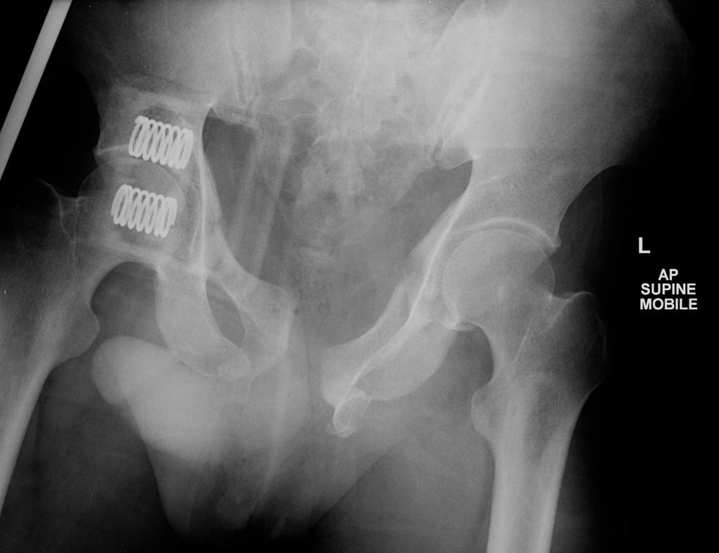

i. Describe five (5) most important findings on the XRay
(3 marks)

_____________________________________________________________________
_____________________________________________________________________
_____________________________________________________________________
_____________________________________________________________________
_____________________________________________________________________

ii. Which mechanism of injury pattern (Young and Burgess Classification) does this injury represent
(1 mark)

_____________________________________________________________________

ii. List four (4) potential immediate complications from this pelvic injury in this man (4 marks)

_____________________________________________________________________
_____________________________________________________________________
_____________________________________________________________________
_____________________________________________________________________

He remains hypotensive at 80/50 despite 2L crystalloid and 2 units of PRC.

iii. List the two (2) MOST important factors that will determine whether the patient receives surgical or angiographic management of the injury
(2 marks)

_____________________________________________________________________
_____________________________________________________________________

Question 2
(16 marks)

A 40kg 12 years old female has been involved in a house fire that started on an old sofa in the living room. She was trapped in an upstairs bedroom for 20mins and was pulled from the building through a burning room 30 minutes ago. She has burns to her face, neck, anterior Left arm, entire right arm, anterior legs and anterior torso that total approximately 50% partial and full thickness. She had a three minute tonic clonic seizure en route to hospital which has now terminated after 5 mg of midazolam.

P 130
BP 90/60
Sats 88% 15L NRB
RR 34
Temp 37.3
GCS 7

VBG
pH 7.09
pO2 16
pCO2 76
HCO3 14
Lact 16
HbCO 25%

i. List four (4) immediate threats to life
(4 marks)

_____________________________________________________________________
_____________________________________________________________________
_____________________________________________________________________
_____________________________________________________________________

ii. List four (4) other complications that you will seek in your assessment over the next 2 hours
(4 marks)

_____________________________________________________________________
_____________________________________________________________________
_____________________________________________________________________
_____________________________________________________________________

iii. List four (4) priority management areas for this patient with brief details of each intervention
(8 marks)

Management Priority | Brief Details

Question 3
(13 marks)

A 54 years old man was found in the garden lying on concrete after cleaning leaves from a gutter. His wife last saw him 3 hours ago when she left the house to go shopping. He has obvious signs of external head trauma, bleeding from his left ear and has epistaxis. His GCS is 7 and he has unequal pupils. He is on warfarin for AF, but takes no other medications. He has 2 IV lines.

BP 220/120
P 55
Sats 95% on 15L NRB
RR 12
Temp 34.1

Several slices of his CT are shown below

The rest of his trauma CT pan-scan shows only 2 fractured lower ribs on the left. There are no other significant injuries.

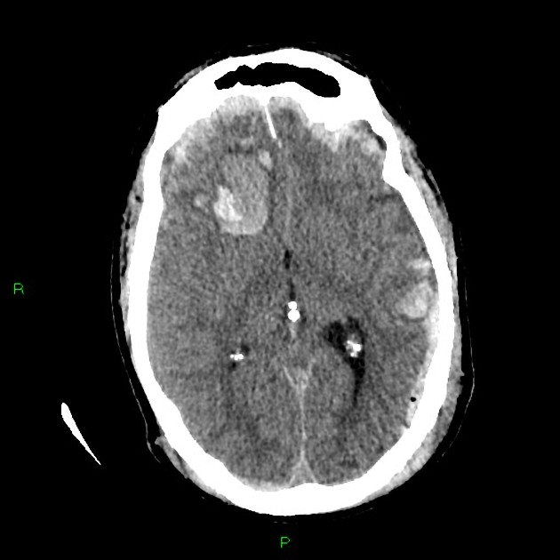

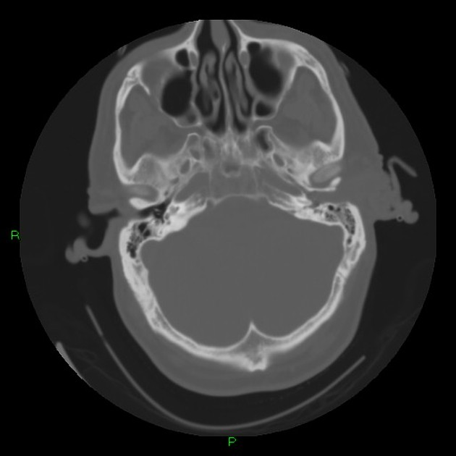
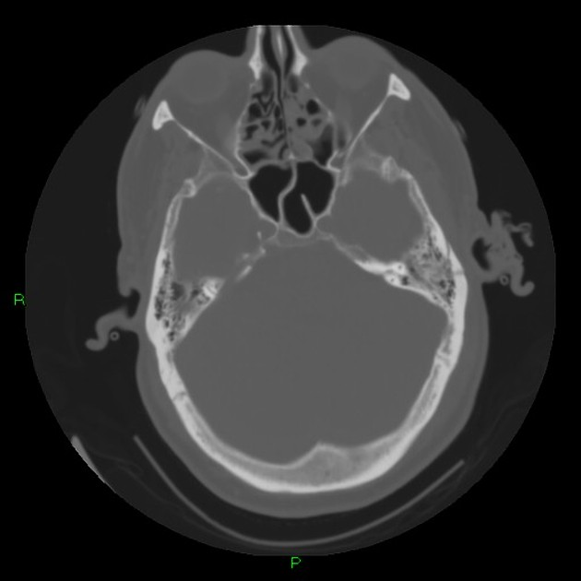

i. List four (4) important positive findings on his head CT
(4 marks)

_____________________________________________________________________
_____________________________________________________________________
_____________________________________________________________________
_____________________________________________________________________

ii. In the table below list your three (3) clinical priorities and brief details of the actions you will take to achieve these. Assume that the neurosurgery team are already aware and will be ready to receive the patient in OT in 30 minutes.
(9 marks)

Clinical Priority (3 marks) | Actions (6 marks)

Question 4
(19 marks)

A 27 years old male has been involved in a gangland fight. He has presented with stab wounds to the neck. He has rapid shallow breathing and is intermittently agitated and swearing.

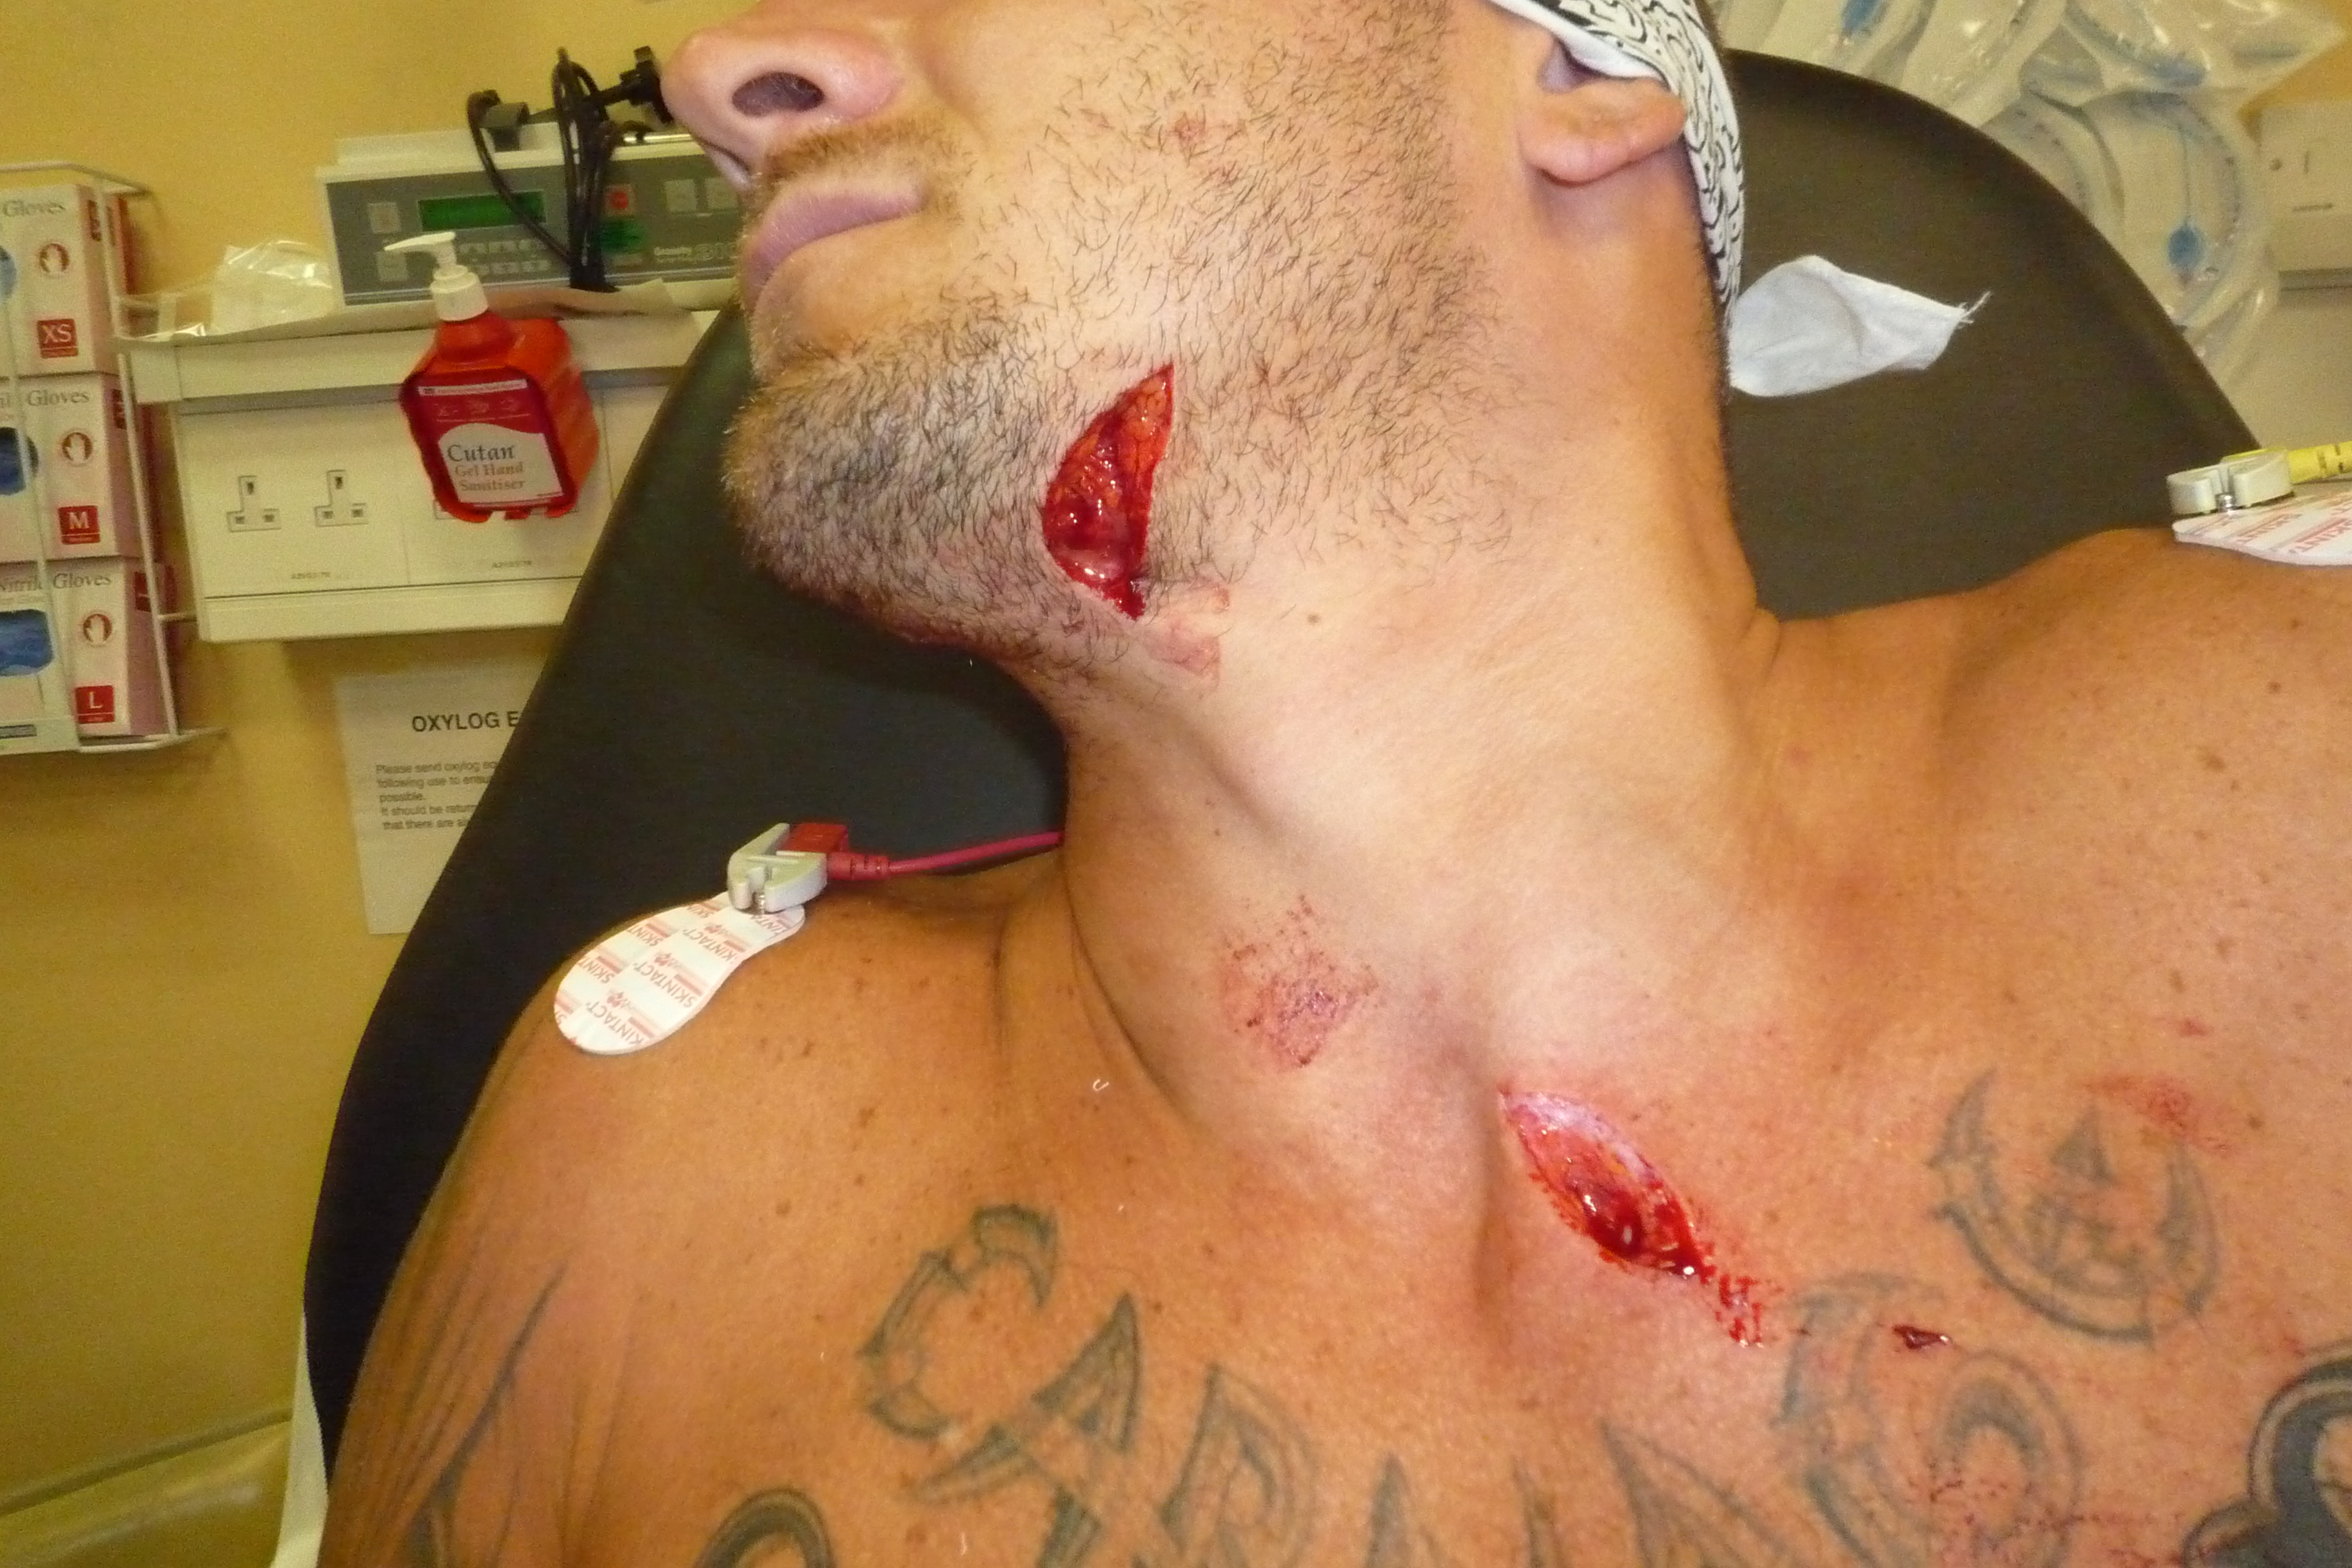

i. In the table below list the two (2) zones likely involved in this injury, the boundaries of each zone and three (3) structures most likely involved in the injury
(10 marks)

Zone | Boundary | 3 Structures

ii. List six (6) physical signs you will seek that will guide your immediate management of this patient.
(6 marks)

_____________________________________________________________________
_____________________________________________________________________
_____________________________________________________________________
_____________________________________________________________________
_____________________________________________________________________
_____________________________________________________________________

The patient gets off the bed and states that he is going to leave and that he is “going to kill the person that did this”

iii. State four (4) elements that MUST be present to determine that he has capacity to consent to, or refuse treatment.
(4 marks)
_____________________________________________________________________
_____________________________________________________________________
_____________________________________________________________________
_____________________________________________________________________

Question 5
(7 marks)

As the receiving tertiary centre you have been called by a small rural hospital 50km away regarding a 50kg 24 year old female who has dived into a backyard pool and presented with neck pain. She is now adequately analgesed. She has had plain radiographs of the C Spine as there is no availability of CT scanning at the smaller hospital.

The rural GP has asked for advice on interpreting the cervical spine XRays.

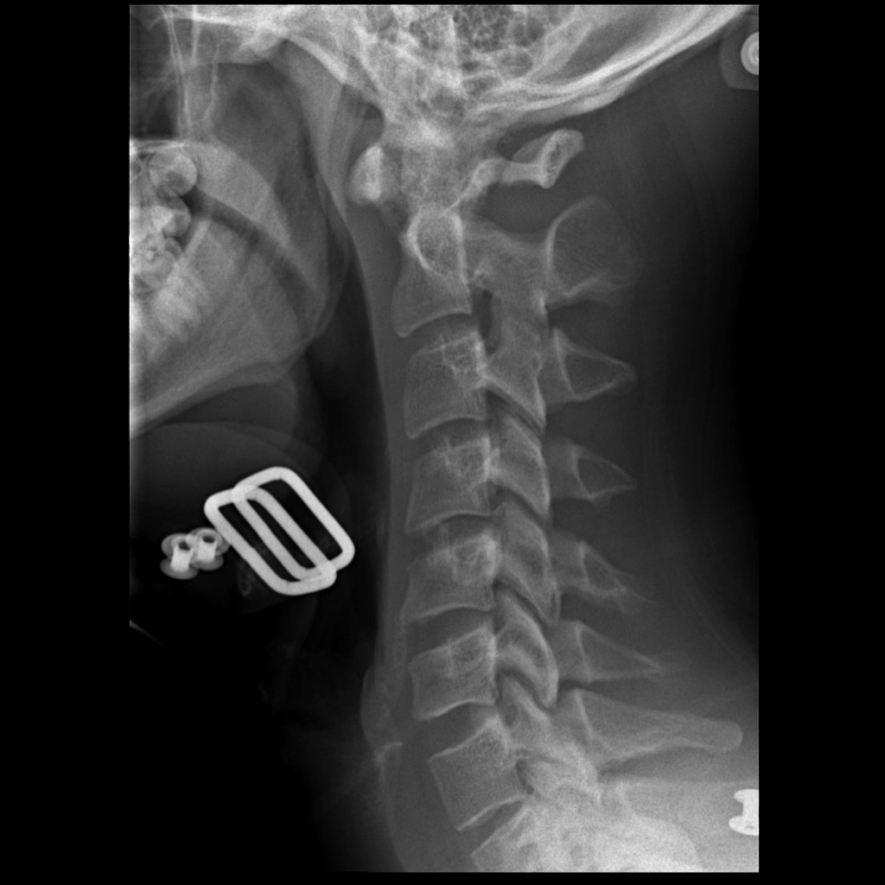

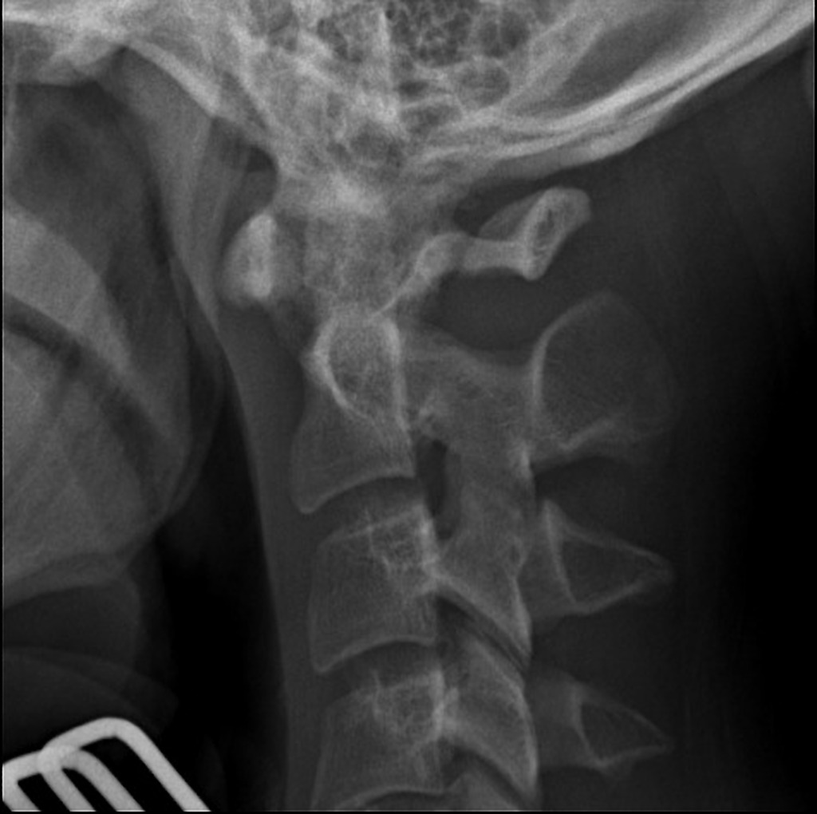

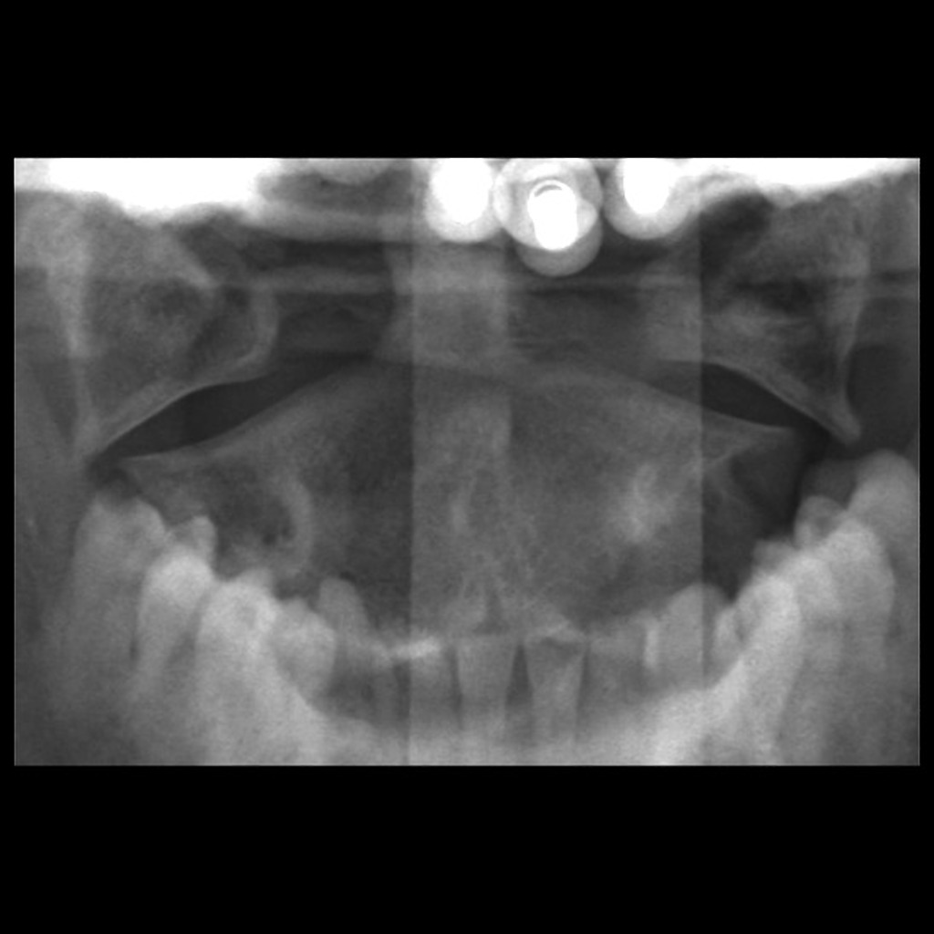

i. List three (3) abnormal features seen on these radiographs
(3 marks)

_____________________________________________________________________
_____________________________________________________________________
_____________________________________________________________________

ii. What is the eponymous name for this abnormality
(1 mark)

_____________________________________________________________________

ii. List the three (3) MOST important pieces of information that you will seek from the rural GP in order that you can arrange an appropriate transfer and provide appropriate advice to the GP
(3 marks)

_____________________________________________________________________
_____________________________________________________________________
_____________________________________________________________________

Question 6
(21 marks)

You receive pre hospital notification of a patient who will be arriving in 15 minutes. A pregnant female who is 25 weeks gestation has been involved in a head on collision with another vehicle. She was the restrained driver. She was trapped in the car for 45 minutes before being extricated by the fire service. She has had tourniquets applied to bilateral legs, bilateral humeral IO insertions and 15L O2 via non-rebreather mask applied. The paramedic reports at least 1500 mls of blood loss and 2L of crystalloid given.

GCS 7
BP 70/40
Sats 83% 15L NRB
RR 30
Temp 36.5

i. List the four (4) pregnancy specific investigations and treatments that you will consider in this patient, that differ from the non-pregnant patient
(4 marks)

_____________________________________________________________________
_____________________________________________________________________
_____________________________________________________________________
_____________________________________________________________________

The patient has a cardiac arrest 2 minutes after arrival to the resus bay

iii. In the table, list the four (4) immediate lifesaving interventions that you will perform with brief details of each intervention
(12 marks)

Intervention | Brief Details

After your interventions the patient has ROSC and is found to have a severe trauma induced coagulopathy

ii. List five (5) measures you will take to address this coagulopathy
(5 marks)

_____________________________________________________________________
_____________________________________________________________________
_____________________________________________________________________
_____________________________________________________________________
_____________________________________________________________________

Question 7
(11 marks)

A 10kg 12 months old child has been brought to your tertiary department by his father with swelling of bilateral knees. The child is inconsolable. There are multiple bruises to both legs from ankles to hips. The father states that he “probably fell down” but nothing specific was witnessed.

X Rays of the lower limbs are shown

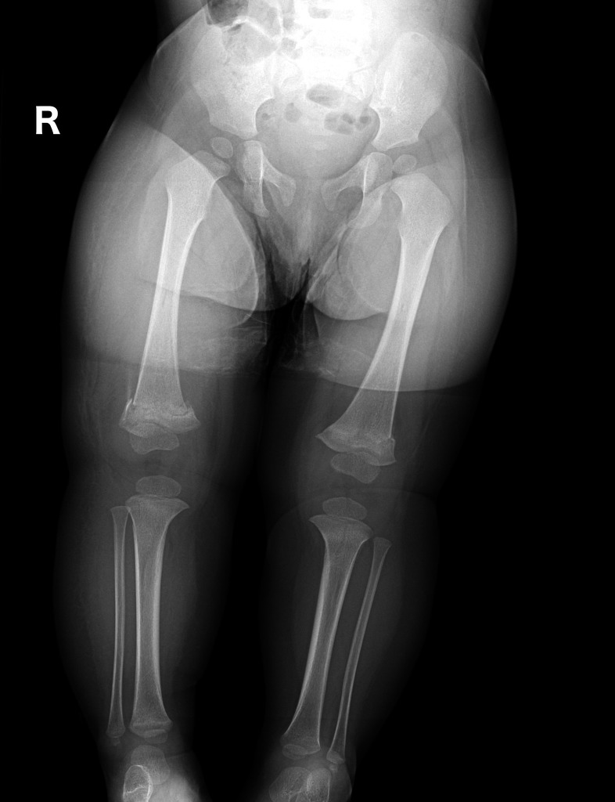

i. Describe the abnormality on the X Ray and its relevance to this case
(2 mark)

_____________________________________________________________________
_____________________________________________________________________

ii. List the next MOST IMPORTANT assessment and management steps for this child (9 marks)

_____________________________________________________________________
_____________________________________________________________________
_____________________________________________________________________
_____________________________________________________________________
_____________________________________________________________________
_____________________________________________________________________
_____________________________________________________________________
_____________________________________________________________________
_____________________________________________________________________

Question 8
(18 marks)

You are working in an urban district hospital that has no access to radiology overnight. The nearest tertiary hospital is 20km by road. A 17 years old male has been assaulted by another male during a nightclub brawl at 2am. He was punched and kicked to the face and head. He has a swollen left eye and cannot open his eye. He is heavily intoxicated and becomes agitated when you try to examine him. He has no injuries to the trunk or limbs.

P 110
BP 100/50
Sats 93% RA
RR 14
Temp 37.1
GCS 11

You are suspicious that he has facial bone fractures and wish to transfer him to the local tertiary hospital for a CT scan.

i. List six (6) other significant injuries or complications do you wish to exclude in this man
(6 marks)

_____________________________________________________________________
_____________________________________________________________________
_____________________________________________________________________
_____________________________________________________________________
_____________________________________________________________________
_____________________________________________________________________

ii. In the table below compare intubation (with Propofol and Rocuronium) versus Ketamine sedation without intubation for the transfer of this patient. List three (3) pros and three (3) cons for each.
(12 marks)

 | Intubation With Propofol and Rocuronium | Ketamine Sedation Without Intubation
Pros
Cons

Question 9
(20 marks)

A 38 years old man presents to Emergency with painful hands after using industrial glass etching solution that contains Hydrofluoric Acid.

P 120
BP 110/80
Sats 96% RA
RR 25
Temp 37.2

His ECG is shown below

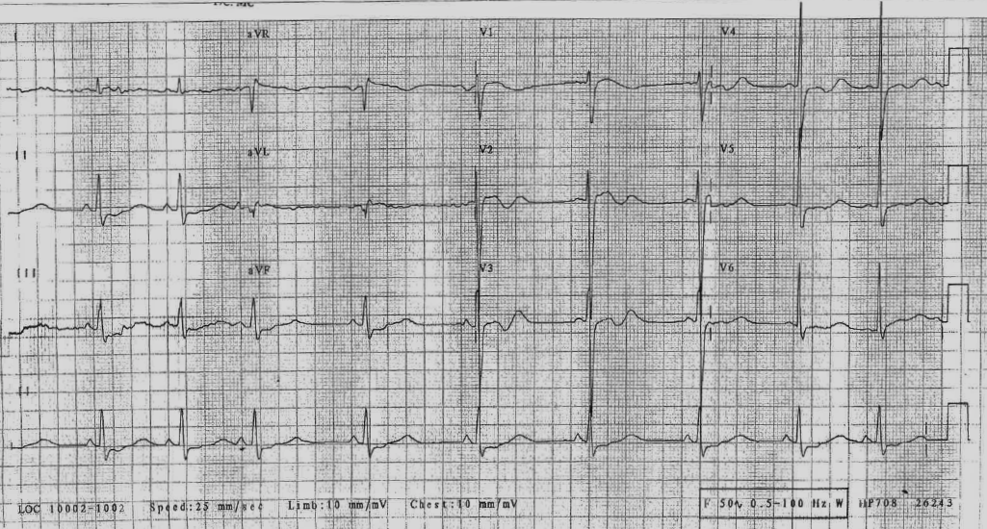

i. List the eight (8) assessment factors that you will consider in the risk assessment of this patient
(8 marks)

_____________________________________________________________________
_____________________________________________________________________
_____________________________________________________________________
_____________________________________________________________________
_____________________________________________________________________
_____________________________________________________________________
_____________________________________________________________________
_____________________________________________________________________

ii. List three (3) ECG findings
(3 marks)

_____________________________________________________________________
_____________________________________________________________________
_____________________________________________________________________

iii. What are the three (3) likely causes for the ECG findings
(3 marks)

_____________________________________________________________________
_____________________________________________________________________
_____________________________________________________________________

iii. List the six (6) specific management and supportive care options for this patient
(6 marks)

_____________________________________________________________________
_____________________________________________________________________
_____________________________________________________________________
_____________________________________________________________________
_____________________________________________________________________
_____________________________________________________________________

SUPPLEMENTARY QS

A. Mechm: Straddle Injury onto a metal pole after falling on a building site
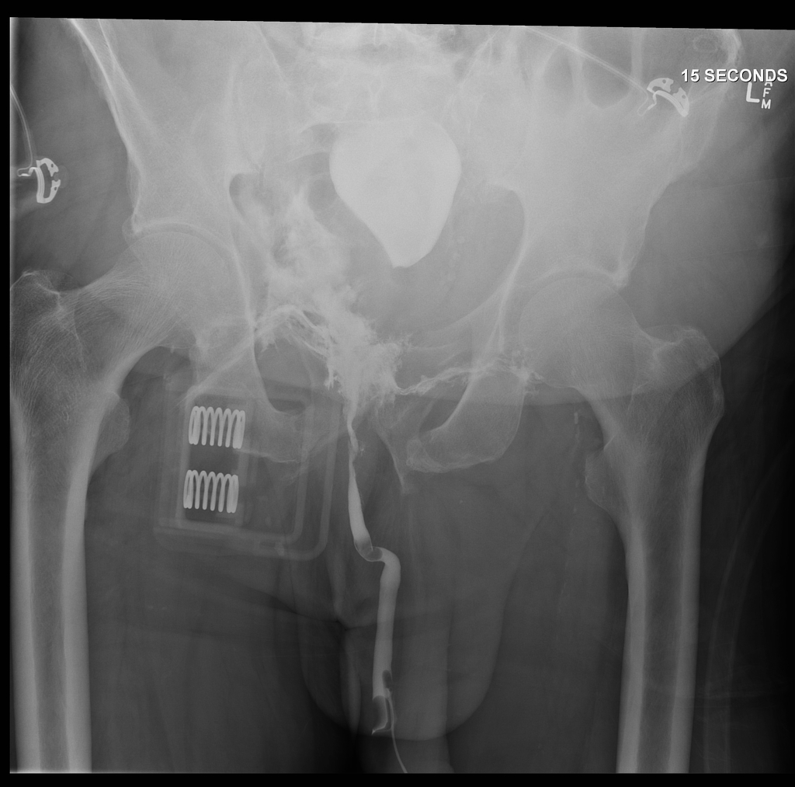
What study is this?

What does it show

What clinical findings might you expect to see?

