Trauma and Burns Session
Feb 20th 2018

HOT TOPICS
-Description of intracerebral trauma on CT
- Management of traumatic PTX/HTX/Flail
- Splenic and liver lacs – grades
- Straddle injury and urethral rupture
- Pelvic injury patterns – Young and Burgess classification
- Eponymous spinal fractures – hangmans, chance, jefferson
- Spinal Cord Injury Patterns –central cord, hemisection, anterior cord
- Le Fort Fractures
- Penetrating Neck Trauma - zones of neck, investigative pathways
- Pregnancy trauma/wedging/perimortem CSection
- Paediatric trauma – NAI patterns of injury
- Burns – Rule of 9’s and Parkland Calcs
- Airway burns -an airway plan
- Complications of severe burns – (inhalation/cyanide/CO/circumferential/rhabdo/hypothermia)
- Hydrofluoric Acid Burn Management

1.
(11 marks)

A 45 year old man has been found at the side of the road on a country lane. He is intoxicated and unable to recall how he got there. The last thing he remembers is arguing in a local pub with another man. He has severe pelvic pain. He has been given 15mg morphine and methoxyfluorane en route via ambulance.

Observations

P 120
BP 90/60
Sats 97% NRB
RR 30
Temp 35.1
GCS 15

His pelvic XRay is shown below

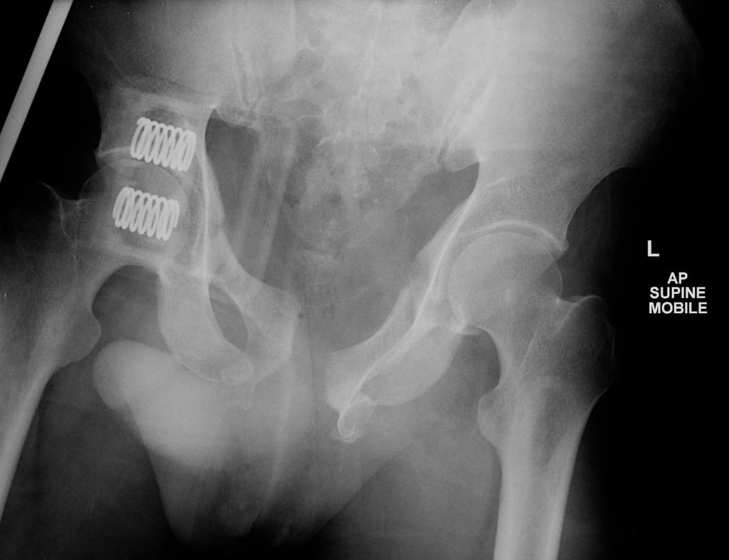

i. Describe five (5) most important findings on the XRay
(3 marks)

Bilateral Ischial #
Wide Pubic Symphysis
Inferior Pubic Rami Fractures
Widening on the Left SIJ
Binder in Situ

ii. Which mechanism of injury pattern (Young and Burgess) does this injury represent (1 mark)

AP Compression

ii. List four (4) potential immediate complications from this pelvic injury in this man (4 marks)

Uretheral rupture
Bladder injury/disruption if seminal vesicles
Venous plexus bleeding
Disruption of common iliac artery at SIJ/int iliac/gluteal
Lumbar or Sacral plexus injury
Rectal injury

He remains hypotensive at 80/50 despite 2L crystalloid and 2 units of PRC.

iii. List the two (2) most important factors that will determine whether the patient receives surgical or angiographic management of the injury
(2 marks)

Availability of each service and in what time frame
Whether free fluid is present in the abdomen on FAST/CT **REQUIRED ANSWER***
Rapidy of deterioration – safety for TF to angiography suite

2.
(16 marks)

A 40kg 12 years old female has been involved in a house fire that started on an old sofa in the living room. She was trapped in an upstairs bedroom for 20 mins and was pulled from the building through a burning room 30 minutes ago. She has burns to her face, neck, anterior Left arm, entire right arm, anterior legs and anterior torso that total approximately 50% partial and full thickness. She had a three minute tonic clonic seizure en route to hospital which has now terminated after 5 mg of midazolam.

P 130
BP 90/60
Sats 88% 15L NRB
RR 34
Temp 37.3
GCS 7

VBG
pH 7.09
pO2 16
pCO2 76
HCO3 14
Lact 16
HbCO 25%

i. List four (4) immediate threats to life
(4 marks)

Airway Burns/ obstruction
Inhalational Injury - pneumonitis
Cyanide Poisoning
Carbon Monoxide Poisoning

ii. List four (4) other complications that you will seek in your assessment over the next 2 hours
(4 marks)

Hypovolaemia
Hypothermia
Rhabdomyolysis/AKI
Compartment Syndrome secondary to circumerential burns
Electrolyte disturbances (K/Phos)
Arrhythmias/neurological disturbance secondary to COHb

iii. List four (4) priority management steps for this patient with brief details of each intervention
(8 marks)

Airway protection – VL, Size 7 ETT, Ketamine+sux or roc, anticipate difficulty, utilise anaesthetics help +/- fibreoptic, apnoeic oxygenation

Circulation – Parkland formula 4 x 50 x 40 = 8L, 4L in first 8 hrs, 4L in subsequent 16h
IDC

Management of cyanide poisoning – consider hydroxycobalamin and sodium thiosulphate. Consult poisons specialist

Management of CO poisoning – 100% O2, consider hyperbaric if very high levels

Escharotomy for circumferential arm burns

Analgesia with fentanyl/ketamine infusion

3.
(13 marks)

A 54 years old man was found in the garden lying on concrete after cleaning leaves from a gutter. His wife last saw him 3 hours ago when she left the house to go shopping. He has obvious signs of external head trauma, bleeding from his left ear and has epistaxis. His GCS is 7 and he has unequal pupils. He is on warfarin for AF, but takes no other medications. He has 2 IV lines.
The rest of his trauma CT pan-scan shows only 2 fractured lower ribs on the left. There are no other significant injuries.

BP 220/120
P 55
Sats 95% on 15L NRB
RR 12
Temp 34.1

Several slices of his CT are shown below

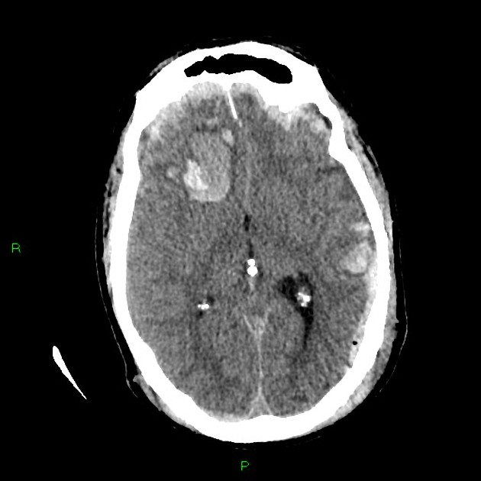

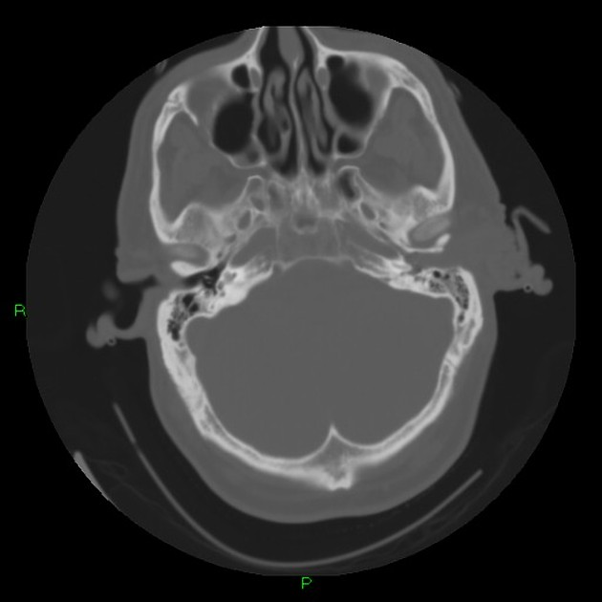
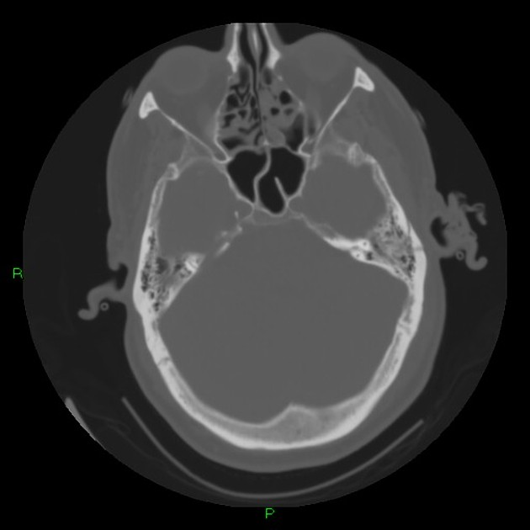

i. List four (4) important positive findings on this head CT
(4 marks)

Bilateral frontal subdural haemorrhages
Multiple well defined hyerdensities in the frontal and temporal regions (contusions)
Frontal subfalcine displacement/midline shift
Subarachnoid blood
Effacement of Right lateral ventricle
Temoral bone fracture involving mastoid and external auditory canal
Pneumocephaly Left temporoccipital lobe

ii. In the table below list your three (3) priority clinical endpoints and brief details of the treatments you will deliver to achieve these. Assume that the neurosurgery team are already aware and will be ready to receive the patient in OT in 30 minutes.
(9 marks)

Clinical Priorities | Actions
Airway Protection/Oxygenation/Control of CO2 | Intubate  Appropriate induction agent – ketamine or lower dose agent that can c
Reduce Intracerebral Pressure/Treat Coning | Mannitol 1g/kg  3% saline 3mls/kg  Hyperventilate  30% head up/tape not tie  Heavily sedate and paralyse
Reversal of Anticoagulation | Prothrombinex – 25ml/kg  FFP  Vit K 5-10mg Iv
BP Management  <160/100?? | No more than 10% reduction with an appropriate agent  Fentanyl titrates  Any titrateable IV antihypertensive  Aim <160/100  Avoid hypotension

4.
(19 marks)

A 27 years old male has been involved in a gangland fight. He has presented with stab wounds to the neck. He has rapid shallow breathing and is intermittently agitated and swearing.

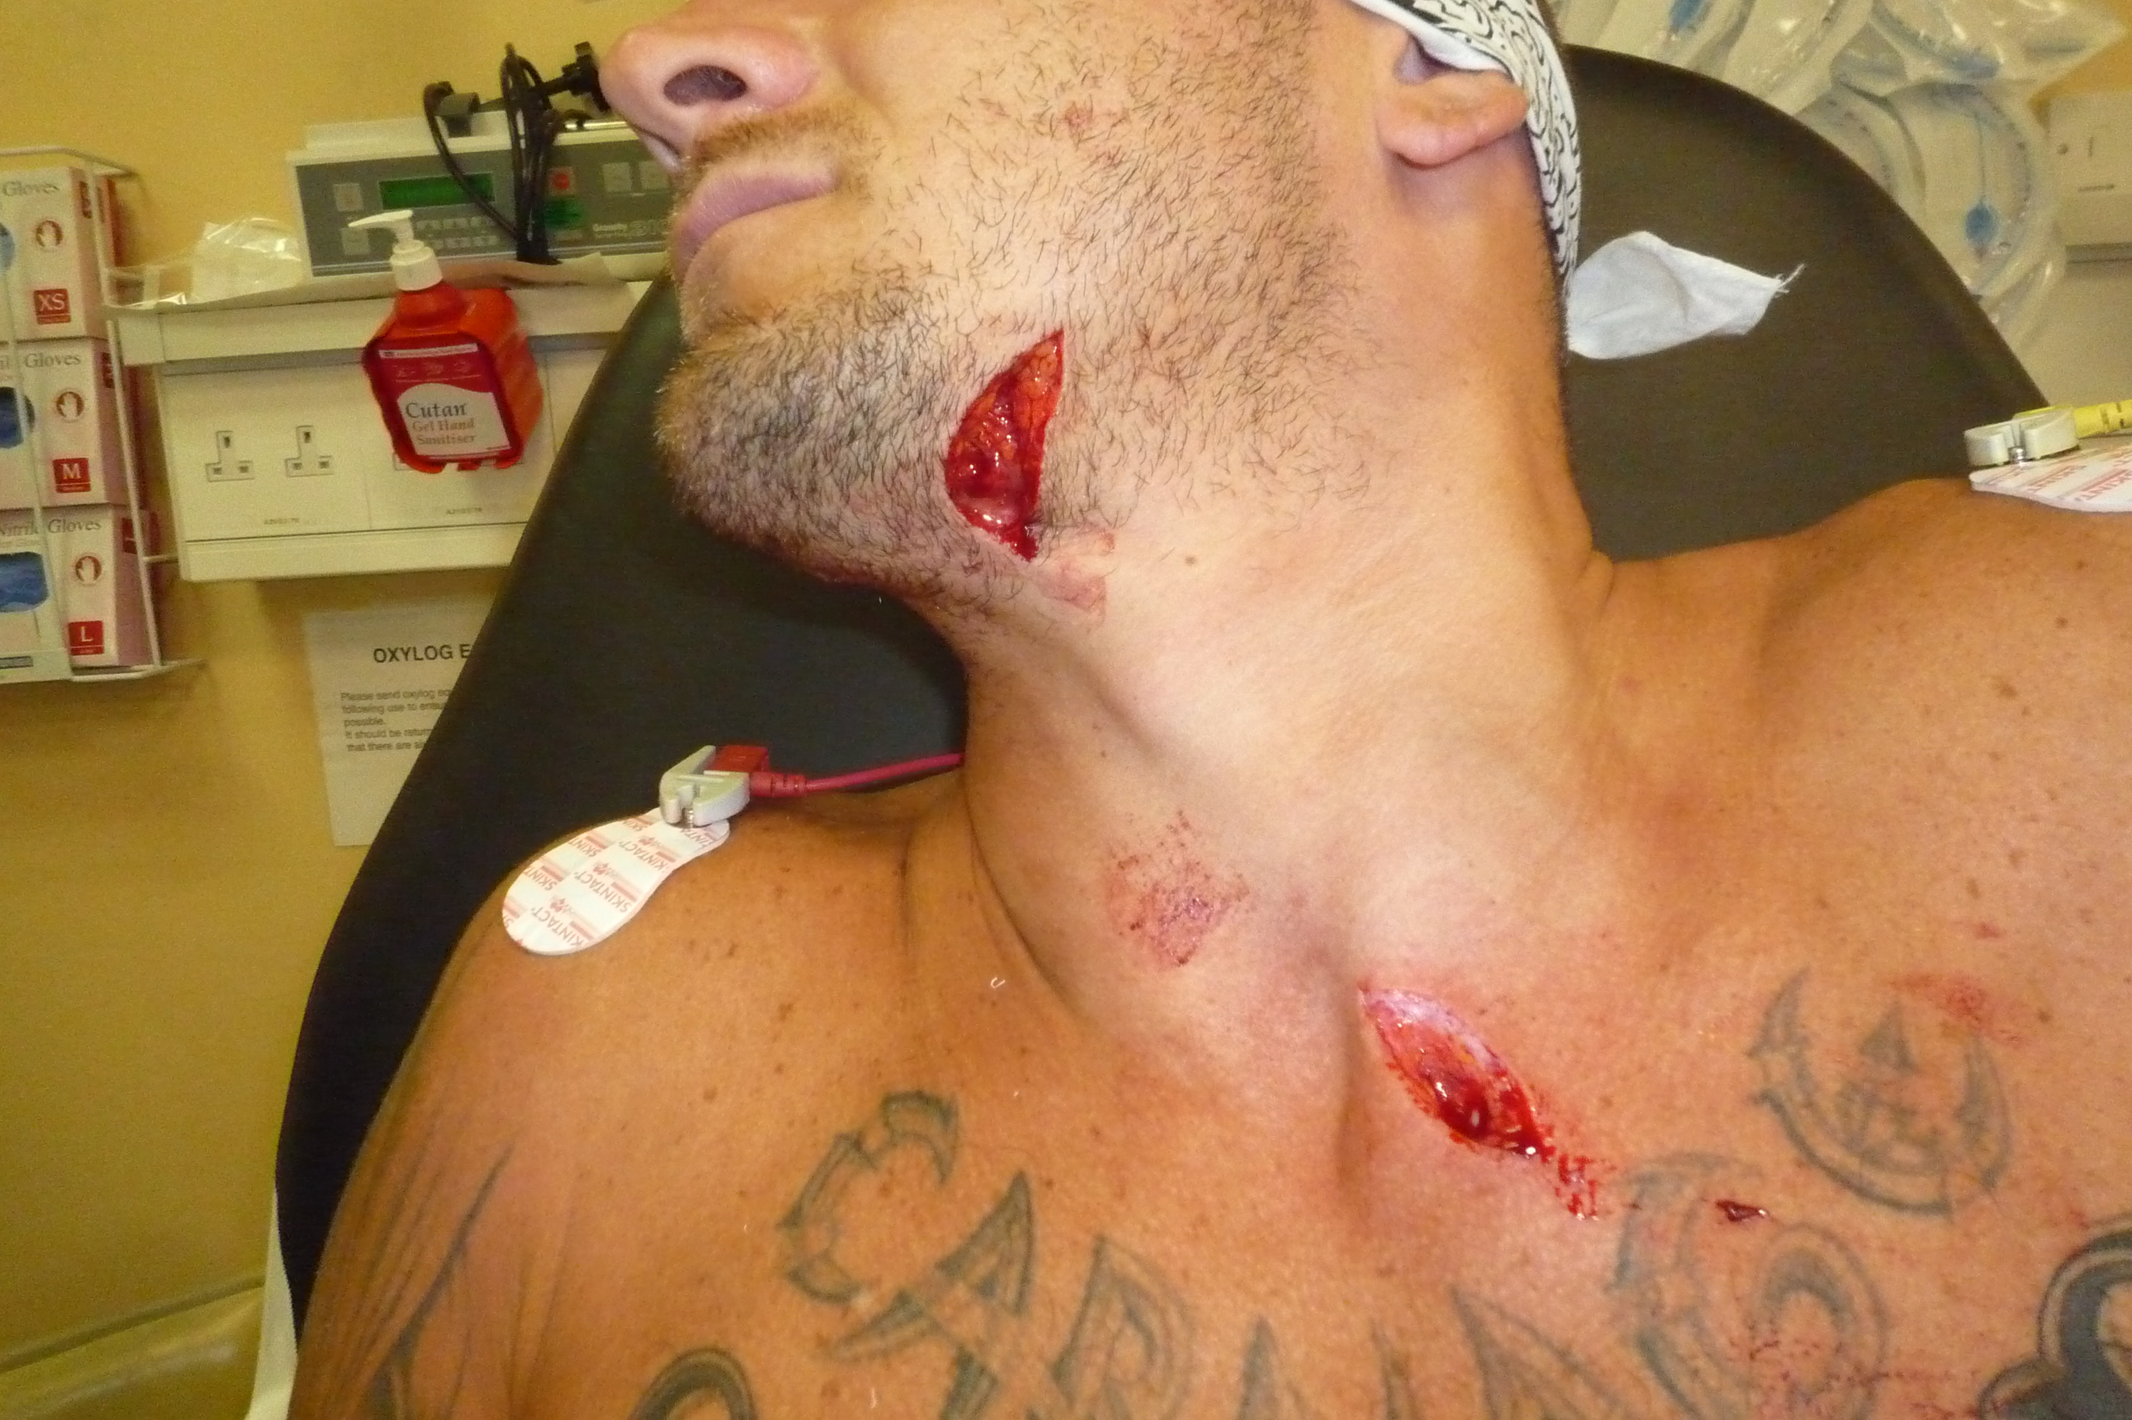

i. In the table below list the two (2) zones likely involved in this injury, the boundaries of each zone and three (3) structures most likely involved in the injury
(10 marks)

Zone | Boundary | 3 Structures
1 | Clavicles to cricoid | -vertebral and proximal carotid arteries  -major thoracic vessels  -lungs  -oesophagus  -trachea  -thoracic duct  -spinal cord  -superior mediastinum
2 | Cricoid to Angle of Mandible | carotid and vertebral arteries  jugular veins  oesophagus  trachea  larynx  spinal cord

ii. List five (5) physical signs that will guide your immediate management of this patient.
(5 marks)

Unstable vital signs – tachycardia/hypotension/desaturation

Signs of tension PTX – unequal chest expansion, deviated tachea, hypotension,

Breach of Platysma – warrants mandatory exploration IN THEATRE

Suggestion of Aurodigestive tract injury - Gas from wound/bubbling/subcutaneous emphysema/voice change

Pulsatile haematoma/large expanding haematoma

Haematemesis/Haemoptysis

Thrill OR Bruit

Neurological deficit

The patient gets off the bed and states that he is going to leave and that he is “going to kill the person that did this”
iii. State four (4) elements that MUST be present to determine that he has capacity to consent to, or refuse, treatment.
(4 marks)
Decision-Making Capacity:
- recognises that there is a decision to be made,
- understands the relevant risks,
- understands the treatment options,
- understands the likely consequences of each option (i.e. risks, burdens, and benefits),
- can rationally manipulate the information to come up with a decision consistent with his or her values.

Question 5
(7 marks)

As the receiving tertiary centre you have been called by a small rural hospital 50km away regarding a 50kg 24 years old female who has dived into a backyard pool and presented with neck pain. She is now adequately analgesed. She has had plain radiographs of the C Spine as there is no CT availability at the smaller hospital.

The rural GP has asked for advice on interpreting the cervical spine XRays.

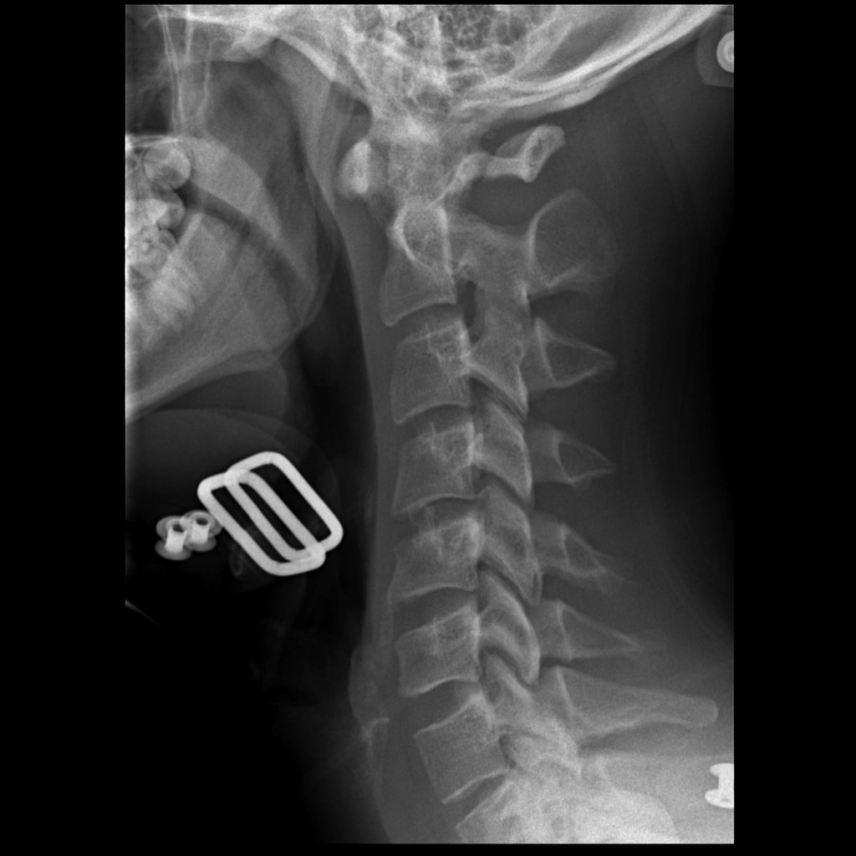

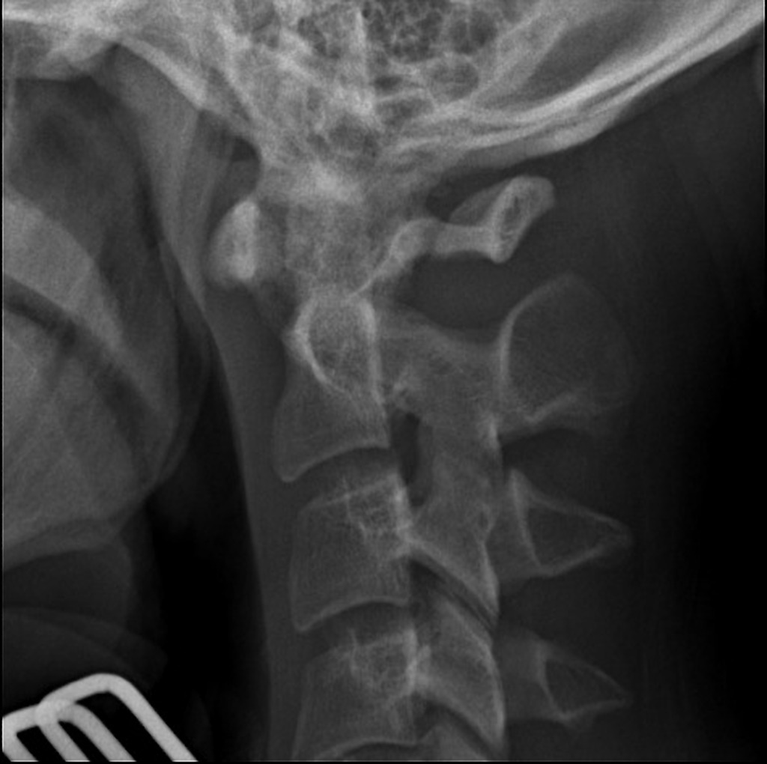

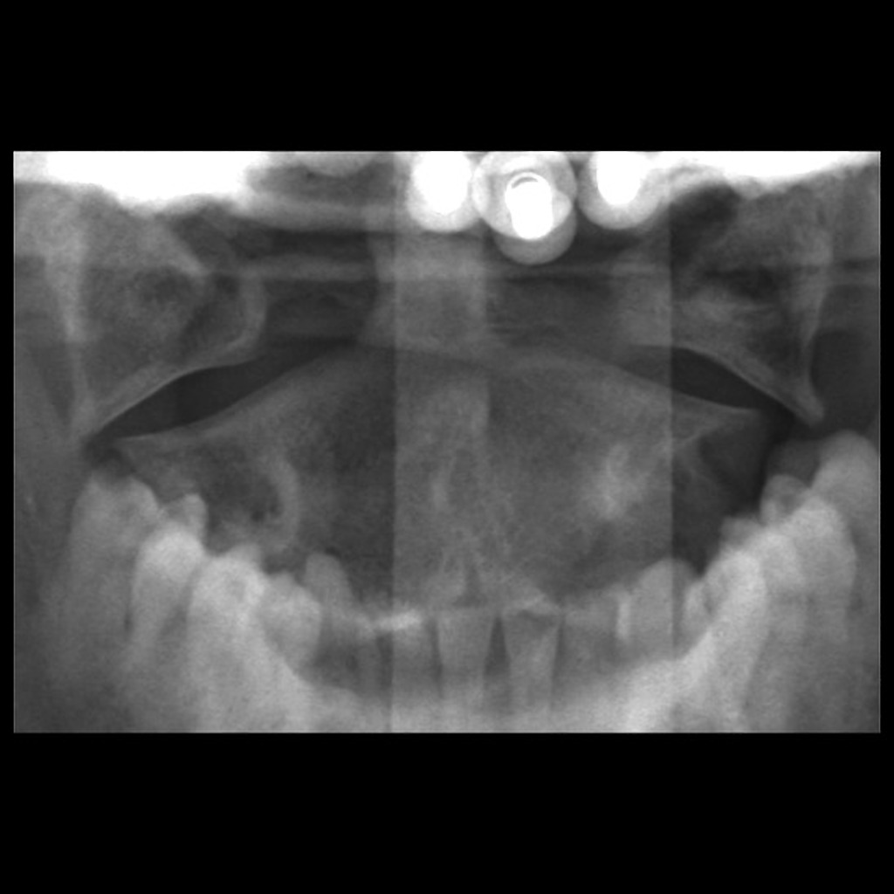

i. List three (3) abnormal features seen on these radiographs
(4 marks)

Widening of the atlanto-dens interval >3mm
Displacement of lat masses of C2 with respect to to C1 on PEG view
Lucency traversing posterior arch of C2

ii. What is the eponymous name for this abnormality
(1 mark)

Jefferson Fracture

ii. List the three (3) MOST important pieces of information that you will seek from the rural GP in order that you can arrange an appropriate transfer and provide appropriate advice to the GP
(3 marks)

Current positioning/spinal immobilisation/collar type
Other injuries e.g. head injury/other spinal injuries
Neurological defecits – motor/sensory level/bladder emptying
Any resp compromise suggesting high spinal injury that will require intubation pre transfer

6.
(21 marks)

You receive pre hospital notification of a patient who will be arriving in 15 minutes. A pregnant female who is 25 weeks gestation has been involved in a head on collision with another vehicle. She was the restrained driver. She was trapped in the car for 45 minutes before being extricated by the fire service. She has had tourniquets applied to bilateral legs, bilateral humeral IO insertions and 15L O2 via non-rebreather mask applied. The paramedic reports at least 1500 mls of blood loss and 2L of crystalloid given.

GCS 7
BP 70/40
Sats 83% 15L NRB
RR 30
Temp 36.5

i. List the four (4) pregnancy specific investigations and treatments that you will consider in this patient, that differ from the non-pregnant patient
(4 marks)

Wedge to prevent aortocaval compression or manual displacement of uterus
Kleihauer test
Administration of Anti D if Rhesus D negative
Ultrasound and CTG to detect fetal distress
Consideration of caesarean section in fetal distress or maternal peri arrest/cardiac arrest

The patient has a cardiac arrest 2 minutes after arrival to the resus bay

iii. In the table, list the four (4) immediate lifesaving interventions that you will perform with brief details of each intervention
(12 marks)

Intervention | Brief Details
Bilateral Thoracostomies | 5th ICS Ant Axillary  In safe triangle  Incision through space  Finger to confirm in pleural space  Convert to ICC later
Perimortem CSection | Vertical Inscision from xiphi to PS  Blunt dissect down to peritoneum  Vertically incise peritoneum  Deliver uterus  Vertical incision through uterus  Deliver fetus  Pack uterus
Blood Products | Via Rapid Infuser  Through humeral IO  O Neg initially  Then per MTP with FFP/Plt/Cryo  TXA
Intubation | Cold – no drugs  Size 7.0 ETT or smaller  Mac 3-4 or VL  Bougie or stylet  Confirm with capnography

After your interventions the patient has ROSC and is found to have a severe trauma induced coagulopathy

ii. List five (5) measures you will take to address this coagulopathy
(5 marks)

Direct cessation of any bleeding e.g. direct pressure/tourniquets/surgical intervention
Replacement of products in 1:1:1 ratio PRC:FFP:Platelets with MTP
TXA 1g stat, 1g over 8 hrs
Cryoprecipitate administration aiming for Fibrinogen >1.0
Prothrombin Complex Concentrate (II,IX,X)
Consider other factor replacement e.g. NovoSeven

Question 7
(11 marks)

A 10kg 12 month old child has been brought to your tertiary department by his father with distress and swelling or bilateral knees. The child is inconsolable. There are multiple bruises to both legs from ankles to hips. The father states that he “probably fell down” but nothing was witnessed.

X Rays of the lower limbs are shown

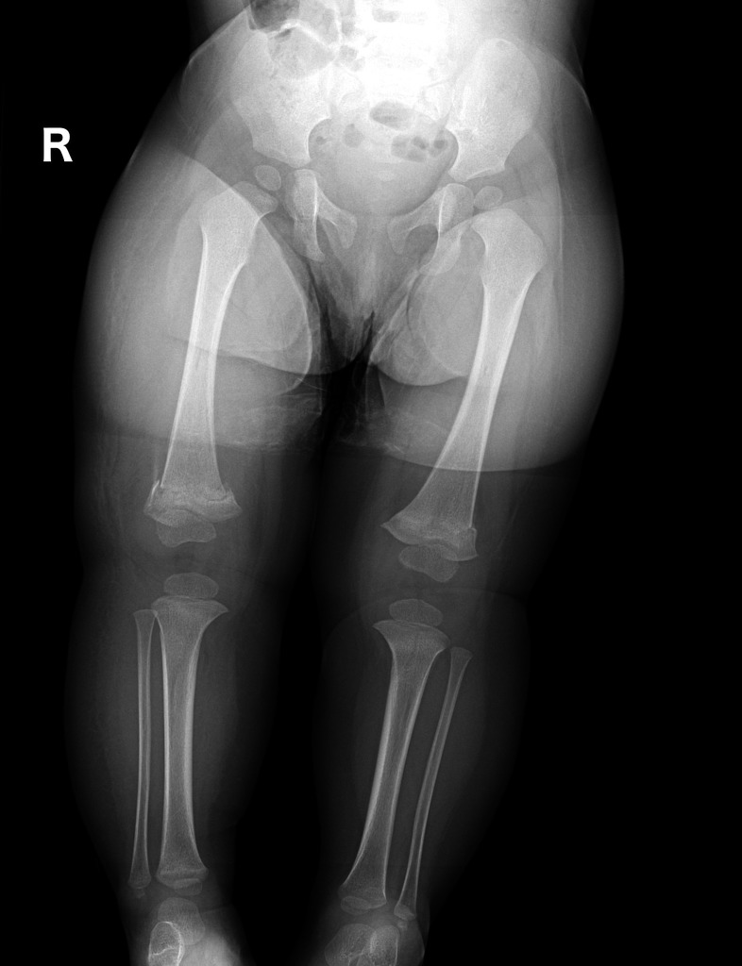

i. Describe the abnormality on the XRay and its relevance to this case (2 mark)

Bilateral metaphyseal corner fractures
Highly suspicious for NAI

ii. List the nine (9) next MOST IMPORTANT assessment and management steps for this child (9 marks)

DEAL WITH CURRENT INJURY
Analgesia – titrated opiates plus panadol and nurofen
Above knee backslabs for bilateral legs with sedation if required for distress
Consult Ortho

IDENTIFY OTHER MARKERS OF NAI
Full body examination to look for injuries suggestive of NAI e.g torn frenulum/retinal haemorrhages/bruises of different ages/cig burns/buttock bruising/evidence of sexual assault
Gather collateral from other sources – parents/GP/hospital presentations
Skelatal Survey/other Ix as indicated by examination findings

CHILD PROTECTION ISSUES
Report to FACS
Involve Social worker
Refer to paeds for admission

Question 8
(18 marks)

You are working in an urban district hospital that has no access to radiology overnight. The nearest tertiary hospital is 20km by road. A 17 year old male has been assaulted by another male during a nightclub brawl at 2am. He was punched and kicked to the face and head. He has a swollen left eye and cannot open his eye. He is heavily intoxicated and becomes agitated when you try to examine him. He has no injuries to the trunk or limbs.

P 110
BP 100/50
Sats 93% RA
RR 14
Temp 37.1
GCS 11

You are suspicious that he has facial bone fractures and wish to transfer him to the local tertiary hospital in order to get a CT scan

i. List six (6) other significant injuries or complications do you wish to exclude in this man
(6 marks)

ICH/subdural/SAH/extradural
Skull fracture/BOS #
CSpine injury/#
Globe Rupture
Orbital Compartment Syndrome/Retroorbital haematoma
Injury to infraorbital nerve
Tympanic Membrane rupture
Laryngeal fracture and assoc neck injuries e.g. haematoma

ii. In the table below compare intubation with Propofol and Rocuronium versus Ketamine sedation without intubation for the transfer of this patient. List 3 pros and 3 cons for each.
(12 marks)

 | Intubation With Propofol and Rocuronium | Ketamine Sedation Without Intubation
Pros | Airway protected  Less Aspiration Risk  Less likely hypoxia/hypercapnia  High risk of deterioration  Less risk to staff of aggression | Less technical skill/equipment required (however still should be able to intubate in case of spasm)  Easy to achieve – can give IM if patient agitated  Lower risk of hypotension  Analgesic properties  Can detect if seizures
Cons | Risk of hypotension on induction  Requires skilled operator/expertise  CSpine Immobilised – difficult airway with MILS  Will need doctor transfer/retrieval team  Require ongoing infusions | More aspiration risk  Risk of increasing IOP in eye injury  Laryngospasm Risk  Vomiting risk  Emergence phenomena  Will require re-dosing or infusion en route  Patient still moves/less control

Question 9
(20 marks)

A 38 years old man presents to Emergency with painful hands after using industrial glass etching solution that contains Hydrofluoric Acid.

P 120
BP 110/80
Sats 96% RA
RR 25
Temp 37.2

His ECG is shown below

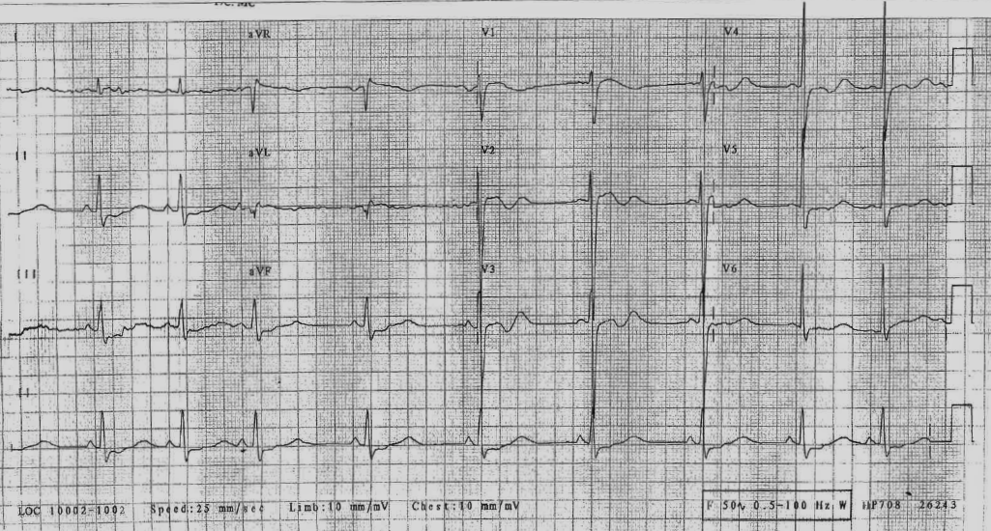

i. List the eight (8) assessment factors that you will consider in the risk assessment of this patient
(8 marks)

% solution
Duration of contact
BSA exposed
Decontamination to date ?washed for 15 mins
Comorbid conditions
Skin changes - Presence of blanching, vesiculation, necrosis of tissue suggests severe
Clinical features of hypoK – tetany, musc spasms, long Qtc, perioral tingling
Levels of Ca/Mg on blood testing
Systemic signs of Fluorosis – abnormal obs

ii. List three (3) ECG findings
(3 marks)

SR 56
Sinus Arrhythmia
Long QTc
Non specific lateral/inferior STD
Voltage Criteria for LVH

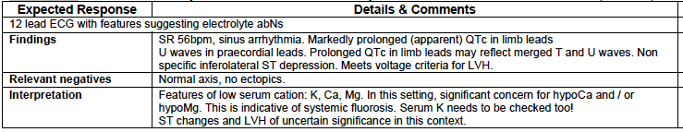

iii. What are the three (3) likely causes for the ECG findings
(3 marks)

Low Ca
Low K
Low Mg
(ALL due to fluorosis)

iii. List six (6) specific management and supportive care options for this patient
(6 marks)

Decontamination with water for 15 mins
Analgesia – titrated opiates – avoid local anaesthetic as pain is an endpoint of Ca therapy
Calcium Gluconate Paste – poorly penetrates skin
Calcium Gluconate Infiltration 5%, max 1ml per cm sq
Calcium Gluconate Biers Block
Intra-arterial Calcium Gluconate
(MUST HAVE 2 OPTIONS FOR CaGl to score full marks)

Replace Calcium with IV Calc Gluc or CaCl – titrate to normal QTc
Replace K and Mg

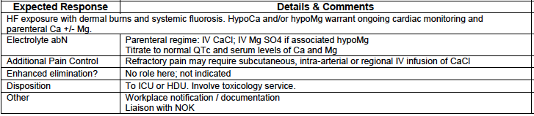

SUPPLEMENTARY QS

A. Mechm: Straddle Injury onto a metal pole after falling on a building site
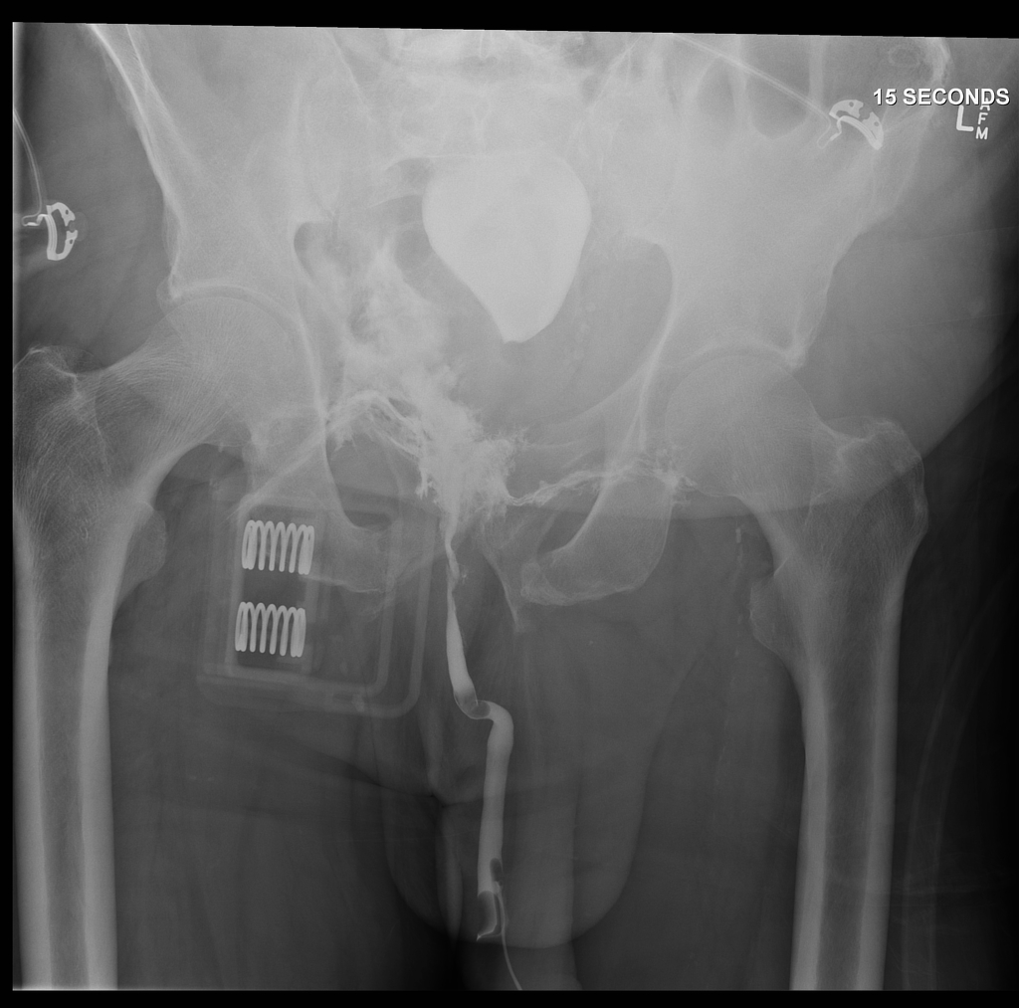
What study is this?
Retrograde Urethrogram

What does it show
Transction of the bulbous urethra with contrast extravasation
Bilateral inferior PR#
Pelvic Binder in Situ

What clinical findings might you expect to see?
Blood at meatus
Perineal bleeding
Testicular swelling/hydrocele
Evidence of shock from pelvic venous or arterial bleeding (int iliac/common iliac/gluteal As)
Evidence of neurological injury – lumbar and sacral plexus
Rectal bleeding
High riding or boggy prostate

