Resources for Trauma and Burns Session:
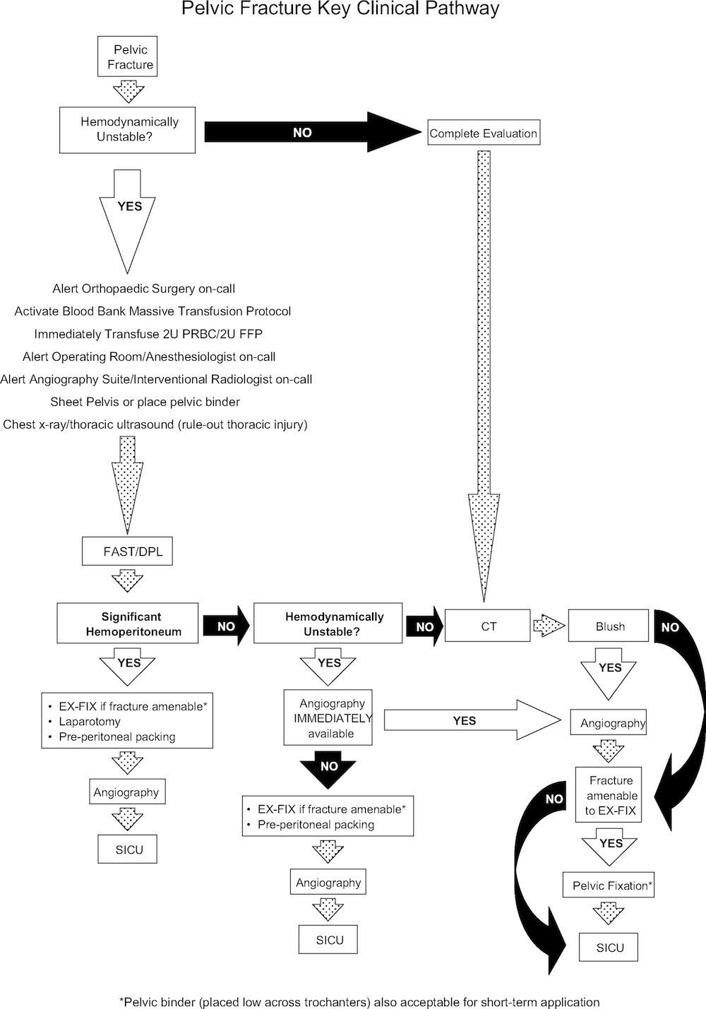

Trauma CT Brain
https://radiopaedia.org/articles/traumatic-brain-injury
Click on all the blue links in the article and look at as many pics as possible

Adult CSpine
https://www.ranzcr.com/documents/3831-print-version-adult-c-spine/file

Traumatic Pneumo
https://wikem.org/wiki/Traumatic_pneumothorax

Prehospital Guideline from HEMS on traumatic arrest but applicable all the same
https://sydneyhems.com/2015/11/03/new-traumatic-cardiac-arrest-guideline/

Traumatic Cardiac Arrest Guideline - From Page 160
http://www.resuscitationjournal.com/article/S0300-9572(15)00329-9/pdf

Splenic Injury – Trauma Professionals Blog
A simple way to remember splenic lac grade
http://regionstraumapro.com/post/1003595954
A dot point of the East Guidelines
http://regionstraumapro.com/post/4526061906

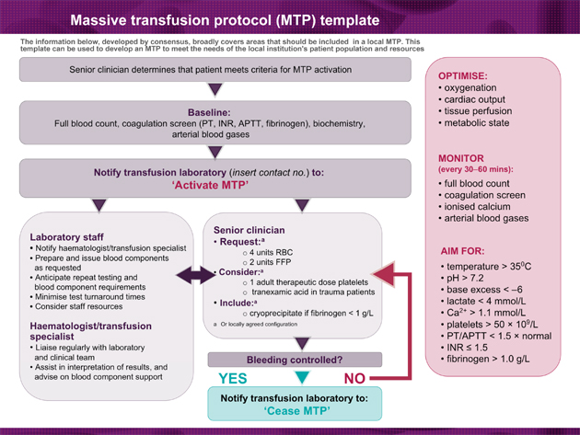

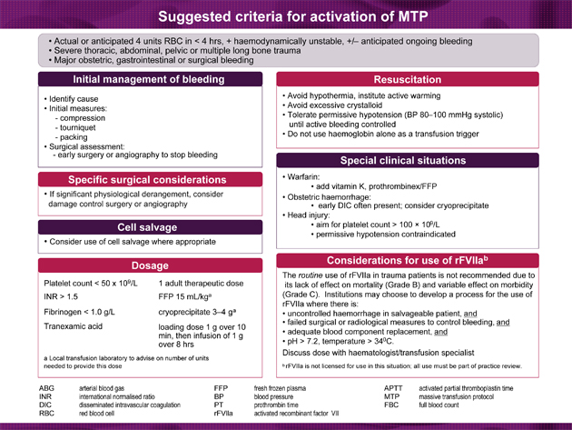

More detailed MTP info - https://www.blood.gov.au/pubs/pbm/module1/transfusion.html

Straddle Injury
Familiarise yourself with pics of retrograde urethrograms
https://radiopaedia.org/articles/urethral-injury-1

Paeds specific Rx - https://www.rch.org.au/clinicalguide/guideline_index/Straddle_injuries/

Young and Burgess Pelvic # Classification
https://lifeinthefastlane.com/ccc/classification-of-pelvic-fractures/

Eponymous Spinal Fractures
http://www.derangedphysiology.com/main/required-reading/neurology-and-neurosurgery/Chapter%202.1.2/eponymous-spinal-fractures

http://learningradiology.com/archives06/COW%20215-Chance%20Fx/chancefxcorrect.htm

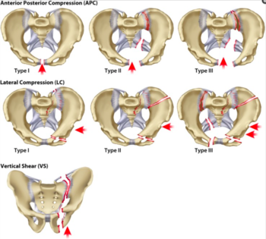

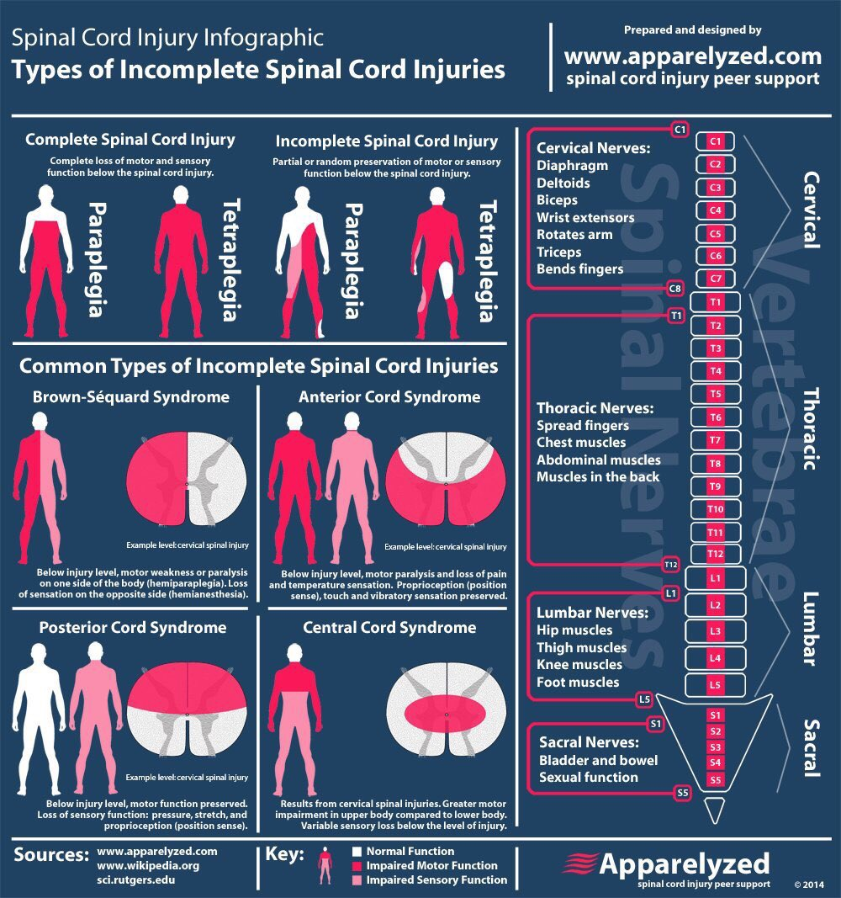

https://lifeinthefastlane.com/ccc/spinal-cord-anatomy-and-syndromes/

Le Fort
Classification - https://www.youtube.com/watch?v=QA1xHKSNGic
Management - https://www.ncbi.nlm.nih.gov/pmc/articles/PMC4843570/

Penetrating Neck Trauma
http://www.ucsfcme.com/2012/slides/MEM12002/5%20-%20Birnbaumer,%20Diane%20Neck.pdf

Penetrating neck Injuries – Notes

Rebecca Day

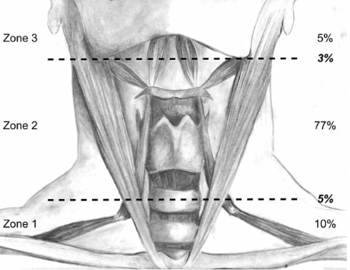

Zone 1 | Zone 2 | Zone 3
Prox CCA | Carotids | Extracranial carotid A
Vertebral/SCA | Jugular and Vert veins | Vert A
Subclav/innominate/jug V | Pharynx | Jugular V
Trachea | Larynx | Spinal Cord
Rec Laryngeal N | Proximal trachea | Cranial N IX-XII
Vagus N | Rec Laryn N | Sympathetic trunk
Oesophagus | Vagus N
Thoracic Duct | Spinal Cord
Zone 1 - Vasc injury challenging, high mortality, often sternotomy/thoracotomy reqd
Zone 2 – Straightforward access surgically
Zone 3 – Access difficult, high mortality, may need craniotomy/mandibulotomy or manoeuvres to displace the mandible

HARD SIGNS = CT NECK +/- Angiography

- Unstable vital signs
- Large, expanding, or pulsatile haematoma
- Active bleeding
- Air bubbling
- Voice or airway disturbance
- Haematemisis/haemoptysis
- Thrill/ bruit
- Neurological deficit
Pregnancy Trauma
https://lifeinthefastlane.com/trauma-tribulation-006/

http://www.resusme.em.extrememember.com/?p=2557

NAI
https://radiopaedia.org/articles/non-accidental-injuries

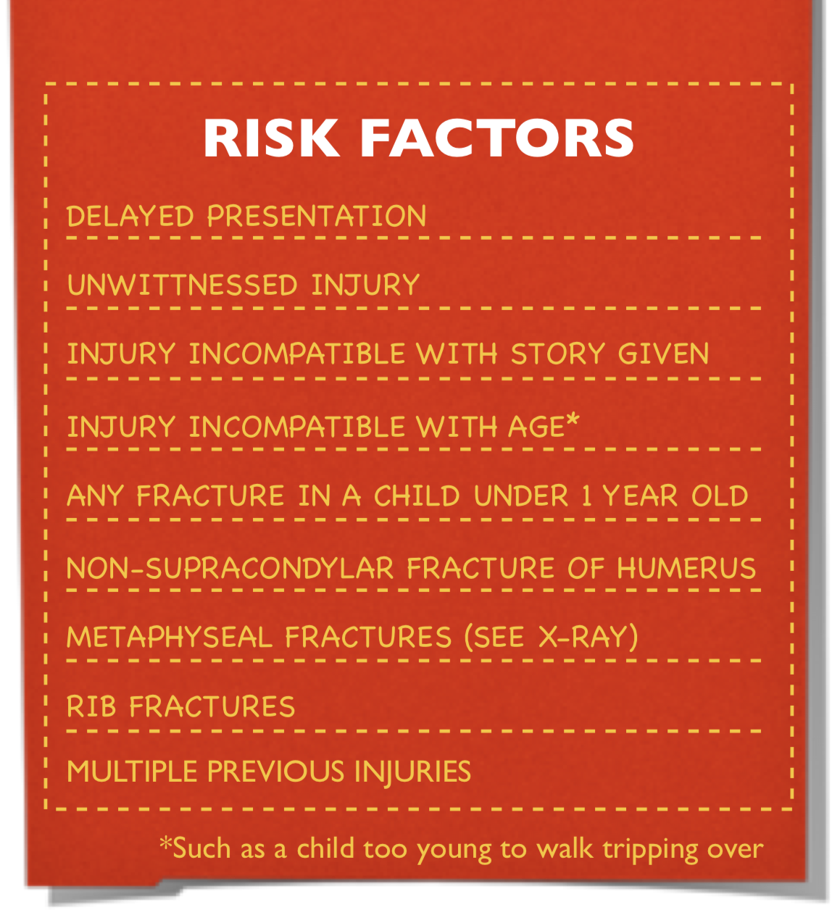

http://stemlynsblog.org/child-protection/

PAED head injury
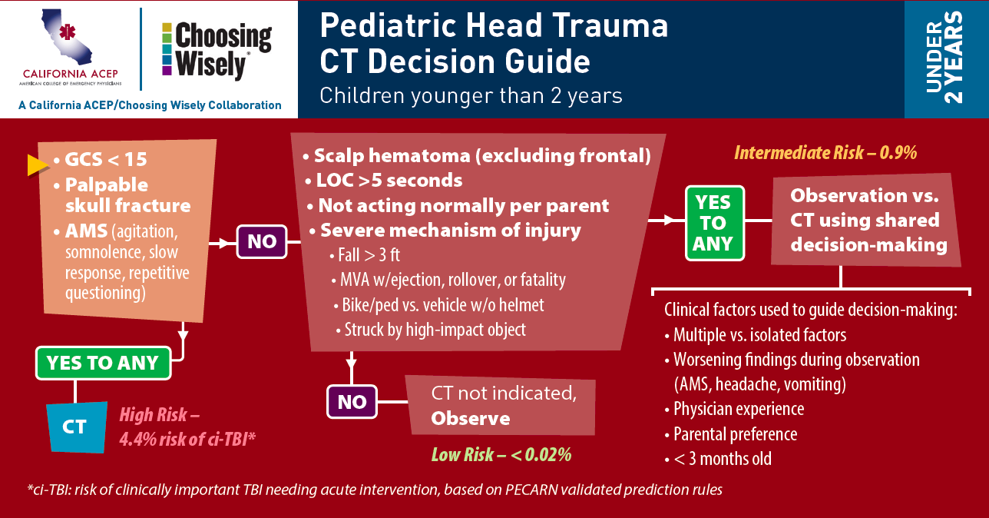

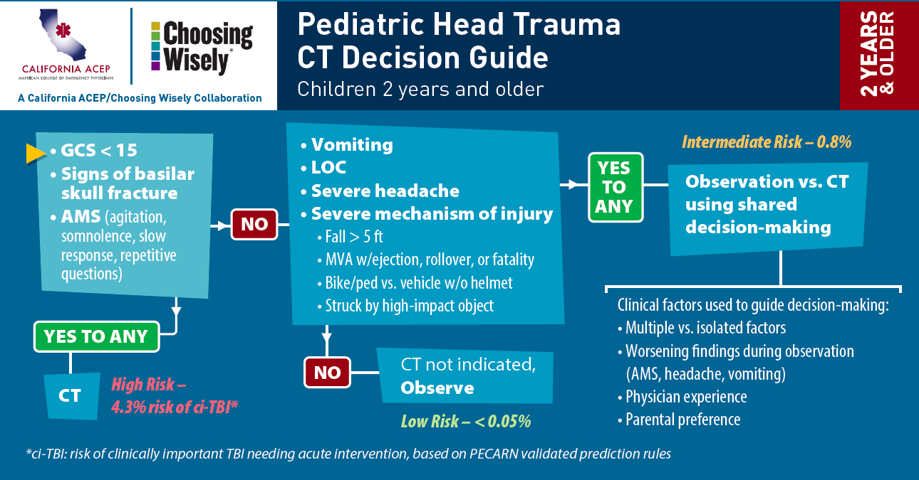

Burns
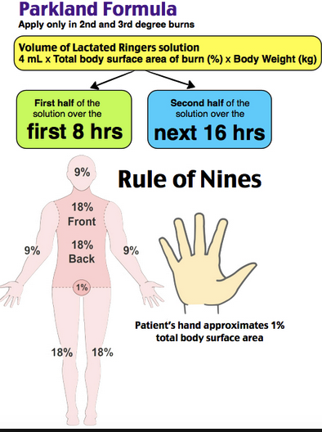

Victorian Burns Service - http://www.vicburns.org.au/severe-burns/early-management/

https://lifeinthefastlane.com/ccc/burns/

HFA
http://www.emdocs.net/hydrofluoric-acid-burn-keeps-burning/

