A 50 years old man presented to ED with the complaint of the wound on his right foot which he sustained on broken glasses yesterday. He has a history of T2DM but is not complaint with his regular medications. He was put in FT as Cat 3 and has been waiting to be seen. Two hours later, the triage nurse called you as he looks so unwell. His temp is 39.5’C, BP 90/60, RR 25, HR 120 and sPO2 96%RA. X ray of his right foot was taken.
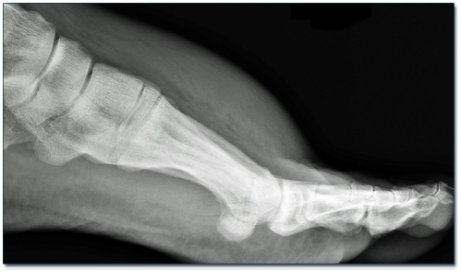
- Give two abnormality findings on the X ray provided. (2 marks)
__________________________________________________________________________________________________________________________________________________________________________________________

- What is the likely diagnosis? (1 mark)
_____________________________________________________________________________________________

- What are the usual causative organisms? (3 marks)
_______________________________________________________________________________________________________________________________________________________________________________________________________________________________________________________________________________________

- Outline your management for this patient. (4 marks)
____________________________________________________________________________________________________________________________________________________________________________________________________________________________________________________________________________________________________________________________________________________________________________________

