A 50 years old man presented to ED with the complaint of the wound on his right foot which he sustained on broken glasses yesterday. He has a history of T2DM but is not complaint with his regular medications. He was put in FT as Cat 3 and has been waiting to be seen. Two hours later, the triage nurse called you as he looks so unwell. His temp is 39.5’C, BP 90/60, RR 25, HR 120 and sPO2 96%RA. X ray of his right foot was taken.
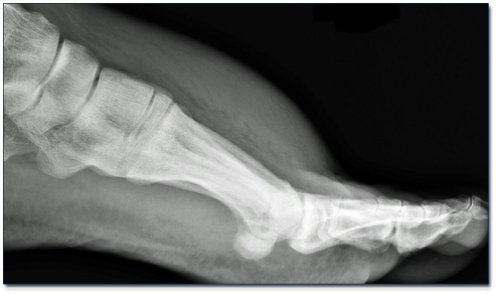
- Give two abnormality findings on the X ray provided. (2 marks)
- marked soft tissue swelling and liner streaks of gas in the soft tissue of the dorsum of the foot

- What is the likely diagnosis? (1 mark)
- necrotizing fascitis of the right foot

- What are the usual causative organisms? (3 marks)
- Clostridium
- E coli
- Strep pyogenes
- Bacteroides

- Outline your management for this patient. (4 marks)
- Full monitoring on the patient, put 2xIVC, start fluid resuscitation (eg: 1L of 0.9% Normal saline stat) aiming for SBP >90mmHg, HR <100, UO 0.5ml/kg/hr, perform FBC, UEC, CRP, Blood cultures
- Give broad-spectrum antibiotics :
> meropenem 1g (children: 25 mg/kg up to 1g) IV 8hourly
> clindamycin 600 mg (children: 15 mg/kg up to 600mg) IV 8 hourly
> for suspected MRSA infections add vancomycin 1.5g IV 12 hourly
- Provide adequate analgesia (eg: IV fentanyl 25 mcg and titrate accordingly)
- Urgent surgical referral for wound debridement, urgent ICU review if the patient remains unwell despite resuscitative measures.

