A 5yo child develops conjunctivitis, and then goes on to develop a tender widespread rash. After three days, the child and mother present to the ED with the following rash:

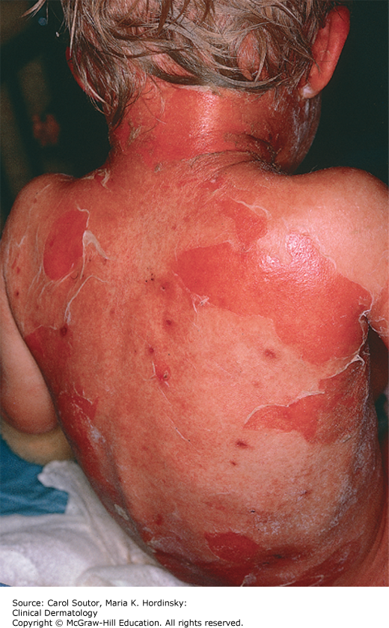

Describe the rash (1 mark):

_________________________________

_________________________________

List five causes for this rash (5 marks):

_________________________________

_________________________________

_________________________________

_________________________________

_________________________________

_________________________________

Outline your management for the most likely diagnosis (4 marks):

___________________________________________________________________________

___________________________________________________________________________

___________________________________________________________________________

___________________________________________________________________________

Your resident wonders if this could be toxic shock syndrome. Outline seven clinical signs seen in toxic shock syndrome (7 marks):

___________________________________________________________________________

___________________________________________________________________________

___________________________________________________________________________

___________________________________________________________________________

___________________________________________________________________________