A 5yo child develops conjunctivitis, and then goes on to develop a tender widespread rash. After three days, the child and mother present to the ED with the following rash:
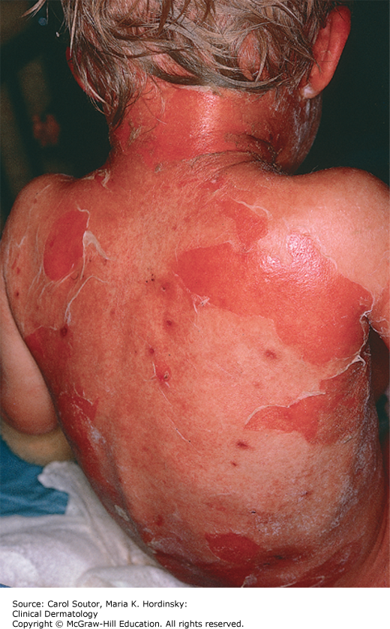
Describe the rash (1 mark):

Widespread exfoliative/desquammative rash (with bullous formation)

List five causes for this rash (5 marks):

Staphylococcal scalded skin syndrome
Toxic epidermal necrolysis
Toxic shock syndrome
Exfoliative drug eruption
Exfoliative erythromderma
Bullous impetigo

Outline your management for the most likely diagnosis (4 marks):

Staphylococcal scalded skin syndrome

- Fluid resuscitation – PO/IV fluid as required
- Correction of electrolyte abnormalities
- Identify and treat any possible source of S.aureus infection
- Wound care to prevent superimposed infection

Your resident wonders if this could be toxic shock syndrome. Outline seven clinical signs seen in toxic shock syndrome (7 marks):

- Fever (>38.5)
- Rash – diffuse macular erythroderma
- Desquamation – 1-2 weeks after onset, especially palms and soles
- Hypotension
- GI – vomiting/diarrhoea
- Muscular – severe myalgia, CK > 2x ULN
- Mucous membrane – vaginal, oropharyngeal or conjunctival hyperaemia
- Renal – elevated urea/creatinine > 2x ULN, or urinary sediment and pyuria without evidence of UTI
- Hepatic – bilirubin, ALT or AST > 2x ULN
- Haematological – platelets < 100
- CNS – disorientation or alterations to conscious state without focal neurological signs

