Trauma and Burns

Fellowship SAQ 2017:2
Question 1

A 13 year old boy is brought in by ambulance after being stabbed in the neck. There are no family members present and he states he doesn’t want his parents to be informed. He has 2 IV lines, non invasive monitoring and is situated in the resus bay.

Observations

P 90
BP 110/70
Sats 100% RA
T 37.1
RR 16

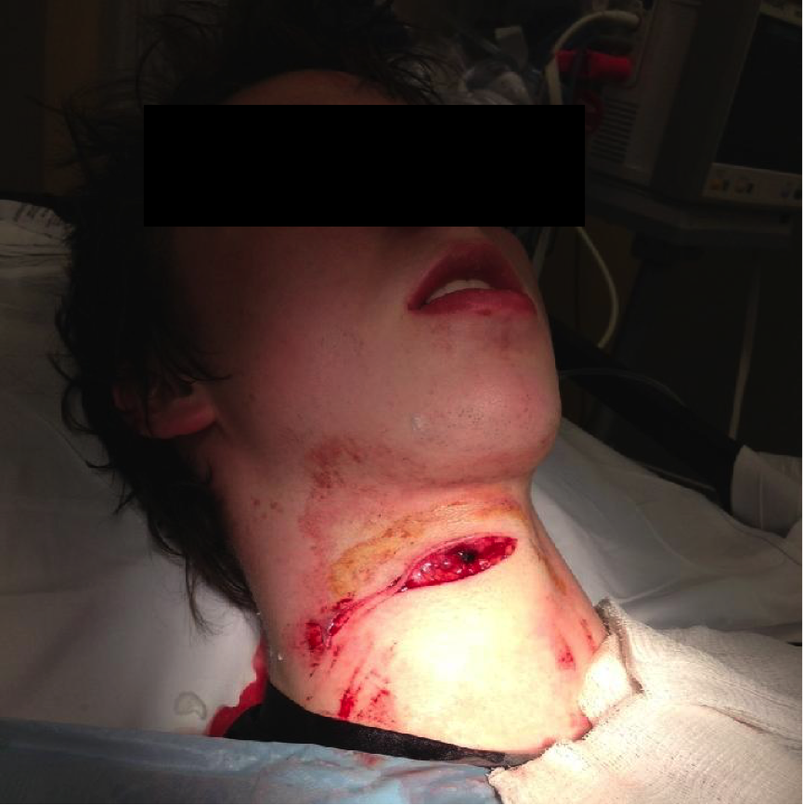

a) Describe the injury seen in the photograph (3 marks)

b) What are the boundaries of the zones of the neck (3 marks)

c) List 5 hard signs that would mandate an immediate exploration in the operating theatre (5 marks)

d) Assuming no hard signs are present outline your management in the first hour in ED, including any investigations ordered (9 marks)

Question 2
A 33 year old, 70kg male has presented to ED after a petrol explosion in garage full of furniture. He was trapped in the burning room for several minutes before being dragged to safety by a friend. He has an estimated total burn area of 20% including face/chest/hands and arms/anterior legs.

Observations
P 120
BP 100/60
RR 26
Sats 92%
Temp 37.3

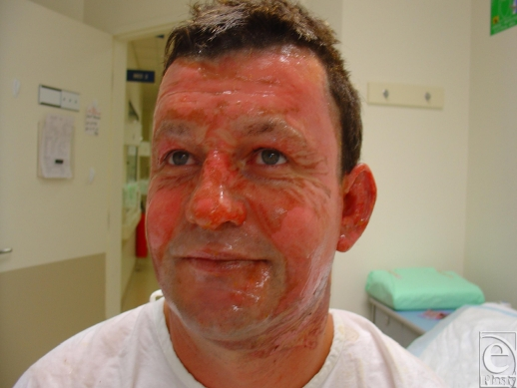

a) Aside from the skin burns/scarring list 5 other potential injuries or complications that could have occurred as a result of the accident (5 marks)

b) Outline your fluid management for this man over the next 24 hrs (3 marks)

c) Complete the table below with the features of each burn type (25 marks)

Burn Type | Skin Layers Affected | Clinical Features | Example | Healing duration/  Characteristics
Superficial (1st)
Superficial Partial
(Sup 2nd)

Deep Partial
(Deep 2nd)

Full Thickness
(3rd)

Fourth degree

Question 3
A 17 year old man has been involved in an MVA. He was unrestrained and ejected from the vehicle. He has been intubated, has C-Spine precautions in situ and is in the resus bay with full monitoring.

Observations
P 120
BP 90/60 (via Art line)
RR 30
Sats 99% 15L NRB
Temp 35.5

Relevant slices of his pan-scan CT are shown below

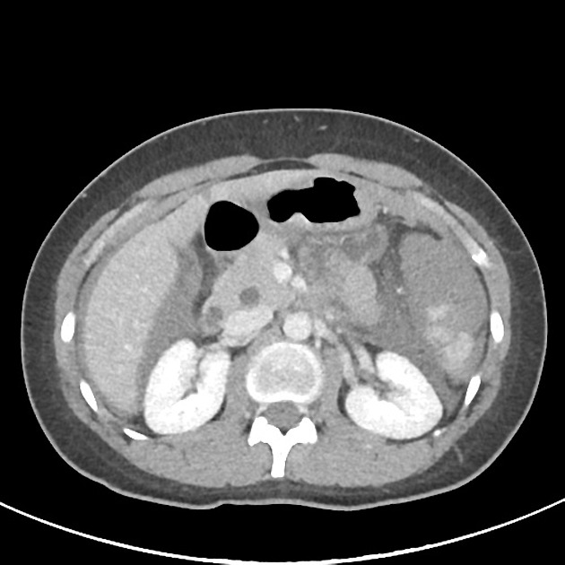

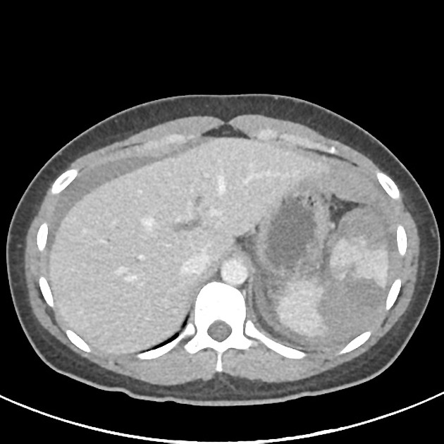

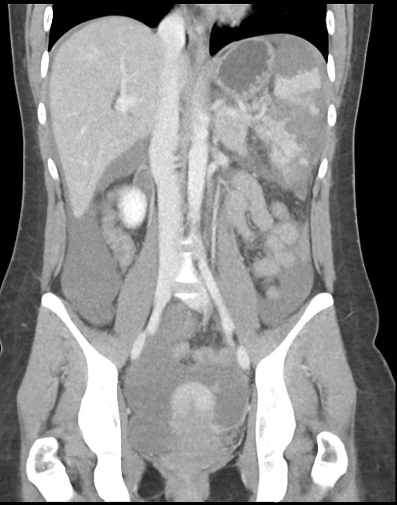

a) List the 2 most abnormal features seen on these CT slices (2 marks)

b) What are 2 options for treatment of this injury, with a pro and con of each (6 marks)

c) List 6 actions that you can take to maximise patient safety during a transfer to CT (6 marks)

Question 4

A 25 year old Irish backpacker presents to ED with a wound on his hand. He is complaining of severe pain and swelling. He had been in ED 3 days ago with the same injury but was intoxicated and had to be removed from the premises by security for his threatening behaviour. He can’t really recall the full events surrounding the injury but thinks he might have “punched this dude in the face”.

Observations
P 120
BP 110/70
RR 16
Sats 99%
Temp 37.9

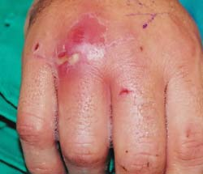

a) Describe the photograph (3 marks)

b) What is the likely cause (1 mark)

c) How will you investigate and manage this injury (8 marks)

The patient later makes a written complaint, stating that he was removed from the department when he had a significant injury, and that this led to an infection with the requirement for surgery.

d) How will you manage this complaint (9 marks)

Question 5
A 56 year old man presents to ED after an attempted hanging. He was found by his wife with a rope around his neck suspended 30cm above the ground from beam in the garage. He appears to have stepped from a low stool.

He is confused, combative and has stridor. He has assaulted at least one staff member. The ambulance officers have placed a cervical collar which is poorly fitting. There are currently 2 doctors, 2 nurses and 2 ambulance officers present.

P 130
BP 90/70
Sats 75% RA
RR 34
Temp 36.7
GCS 12

a) List the management steps in the next 30 mins for this patient (10 marks)

A slice of his CT Brain is shown below

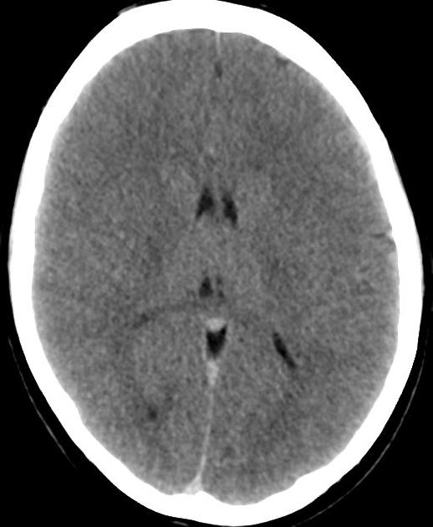

b) What does this CT show and what is it consistent with (3 marks)

c) List 2 other injuries that must be excluded in this patient, and the investigation of choice for each (4 marks)

Question 6

A 75 year old man with alzheimers dementia has fallen from a 2nd floor balcony after trying to “escape”. He is no more confused that normal according to his wife. He is distressed and unable to give you any meaningful information. There is some bruising on his buttocks and left flank.

The RMO who initially assessed the patient was unaware of the significant mechanism as the wife had not been present in the room. He had simply been noted as having “fallen” on the triage sheet and put into a majors bed as a CAT3. Xrays of the left ankle and foot only had been ordered.

P 120
BP 156/78
RR 22
Sats 97%
T 36.7
GCS 12
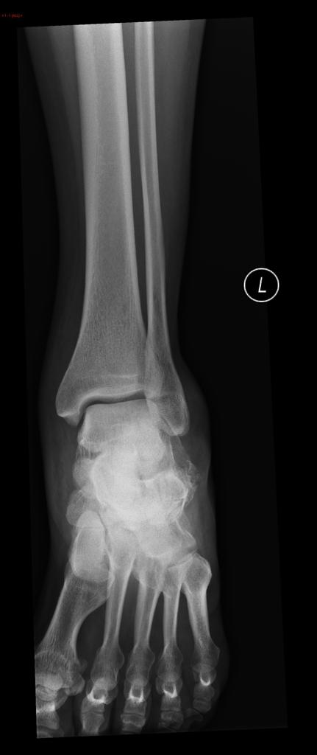
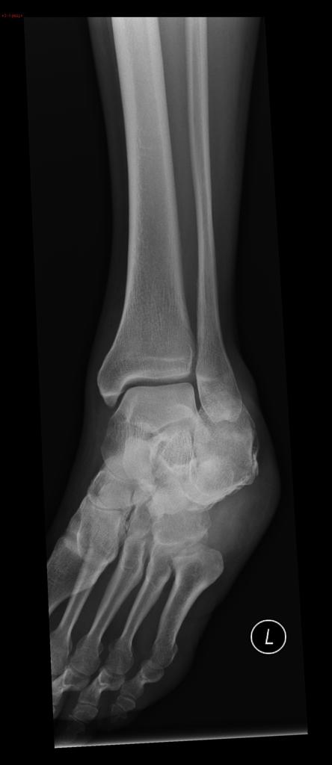
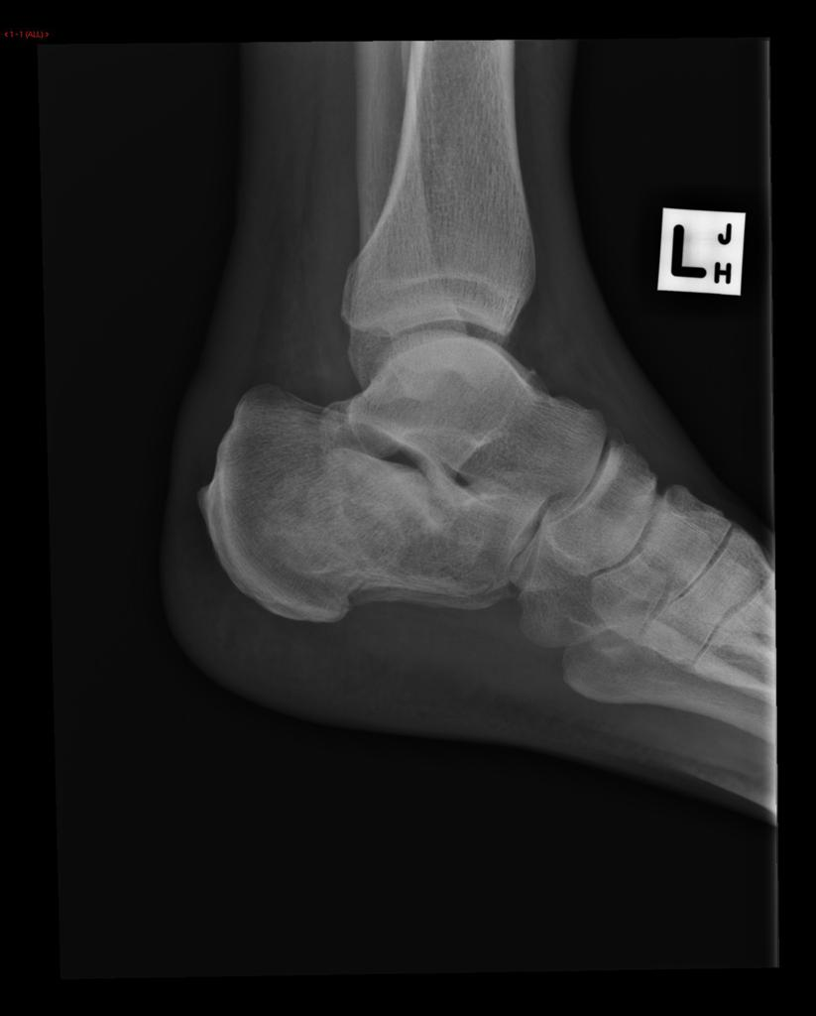
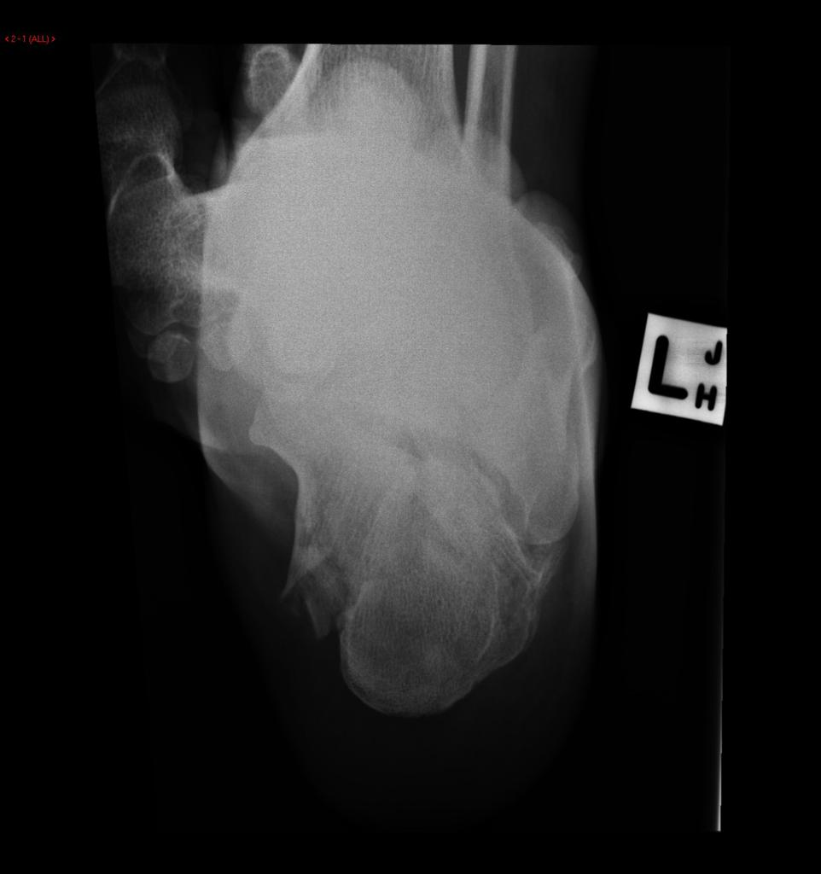

a) Describe the relevant positive and negative features of the XRays (3 marks)

b) Describe the further investigations that you will perform (7 marks)

c) List the management steps you will undertake whilst waiting for further imaging to be performed (10 marks)

Question 7

An 22 month old child has fallen from a change table (1m high) and hit their occiput on a concrete floor. They have been more quiet and clingy since the accident.

Observations

P 120
BP 80/60
Sats 99%
RR 28
T 37.1

You decide to use the PECARN criteria to delineate whether this child should have immediate CT imaging of the brain.

a) List 5 exclusion criteria, where the PECARN criteria cannot be reliably used (5 marks)

b) Complete the table below for the 3 features you will seek on history and 3 on examination to allow you to specifically apply the PECARN criteria in this case (6 marks)

HISTORY | EXAMINATION

After careful consideration a CT if performed and it shows the following

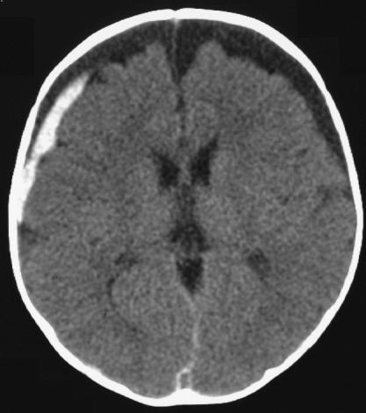

c) Describe 3 relevant positive findings on this CT slice (3 marks)

Concerns are raised for NAI as there have been 4 previous presentations to ED with trauma since birth

d) List 6 other injuries in this age group that might suggest NAI (6 marks)

Question 8

A 34 year old female attends ED after being punched in the face by her domestic partner
She has an obvious left facial swelling with a cm gaping left eyebrow laceration, and is complaining facial pain and a headache. A CT scan has been performed

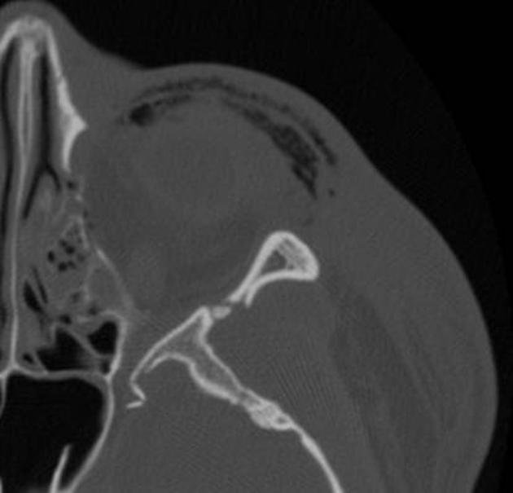

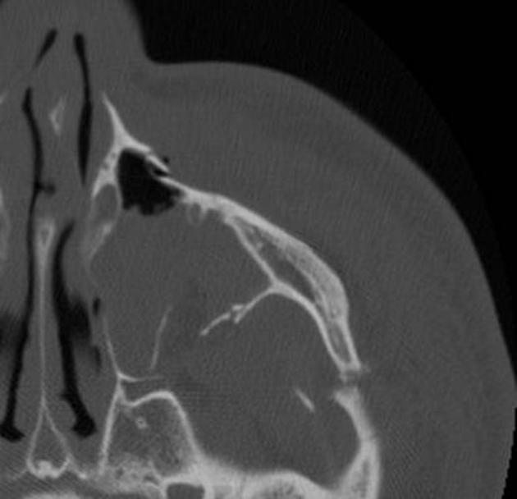
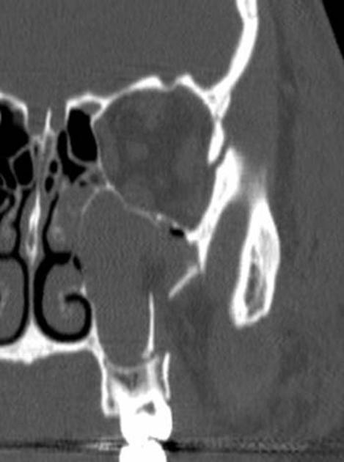

a) Describe the positive findings in the CT images shown (6 marks)

b) List 4 potential complications to be aware of this type of injury (4 marks)

c) List the ED management for this patient (8 marks)

Question 9

You are are ED physician on call in a rural hospital without CT capability. The nearest CT scanner is at a tertiary hospital 200km away.

A 17 year old boy has dived into a swimming pool whilst intoxicated. He is complaining of neck pain, with tingling and weakness in all four limbs. He has objective evidence of an incomplete quadriplegia.

He has a hard collar in situ, 2 IV lines and full non invasive monitoring

P 40
BP 70/60
Sats 91%
RR 12
Temp 36.6

His Cervical spine XRay is shown below

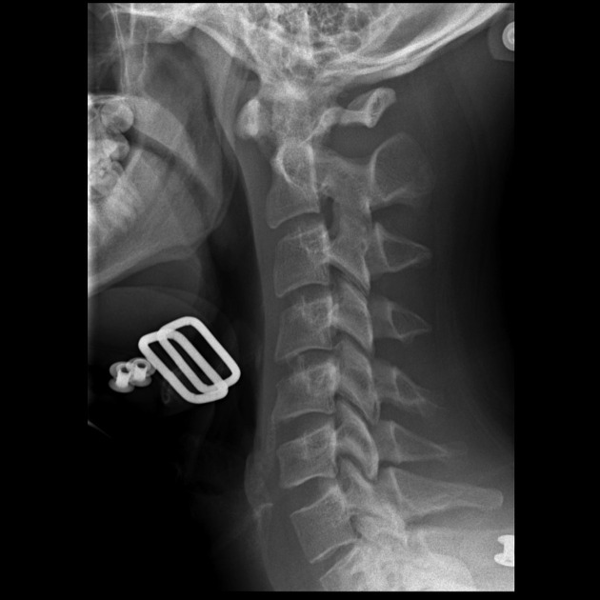

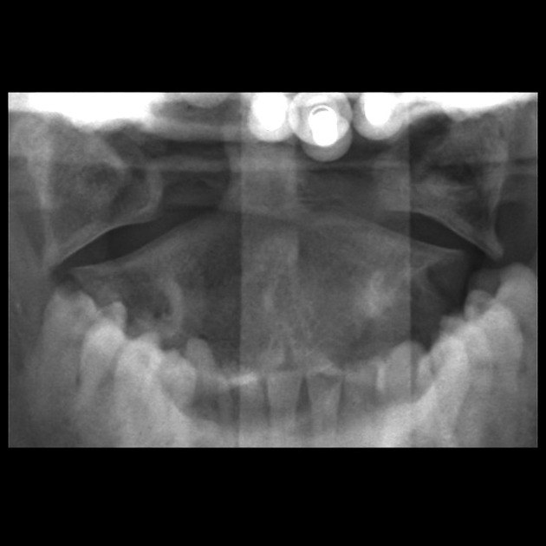

a) List the 3 most abnormal findings on this Xray and name the abnormality (3 marks)

b) List the management steps you will undertake in order to safely transfer this patient to the nearest CT scanner (8 marks)

c) List 5 potential complications of prolonged cervical immobilization in a collar (5 marks)

