Trauma and Burns

Fellowship SAQ 2017:2
Question 1

A 13 year old boy is brought in by ambulance after being stabbed in the neck. There are no family members present and he states he doesn’t want his parents to be informed. He has 2 IV lines, non invasive monitoring and is situated in the resus bay.

Observations

P 90
BP 110/70
Sats 100% RA
T 37.1
RR 16

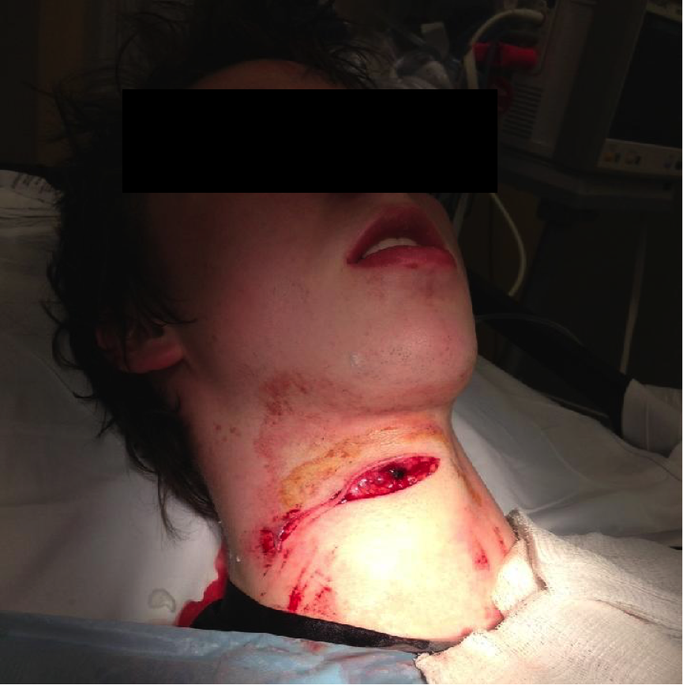

a) Describe the injury seen in the photograph (3 marks)
Transverse, deep, gaping wound on right side of anterior triangle of neck, approx. 5-7 cm?
Zone 2 of neck
Skin tear/abrasion to right side post triangle

b) What are the boundaries of the zones of the neck (3 marks)
Zone 1 – Clavicles to cricoid
Zone 2 – Cricoid to Horizontal line between Angles Mandible
Zone 3 – Angles Mandible Line upwards

c) List 5 hard signs that would mandate an immediate exploration in the operating theatre (5 marks)

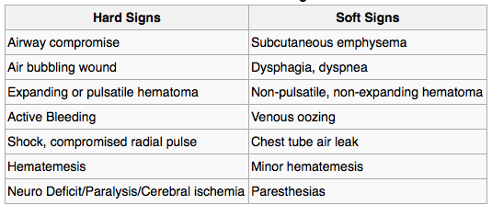

d) Assuming no hard signs are present outline your management in the first hour in ED, including any investigations ordered (9 marks)
Analgesia – titrated IV opiates
Send bloods for FBC/EUC/G&H or CM
CXR In resus to exclude PTX (unlikely)
Arrange CT Angio of neck
IV fluids at maintainence rate and NBM
Contact Surgical Team/Anaesthetics
Social Work and attempt to contact NOK given patient is a minor
Tetanus Prophylaxis
Antibiotics – Cefazolin 1-2g

Question 2
A 33 year old, 70kg male has presented to ED after a petrol explosion in garage full of furniture. He was trapped in the burning room for several minutes before being dragged to safety by a friend. He has an estimated total burn area of 20% including face/chest/hands and arms/anterior legs .

Observations
P 120
BP 100/60
RR 26
Sats 92%
Temp 37.3
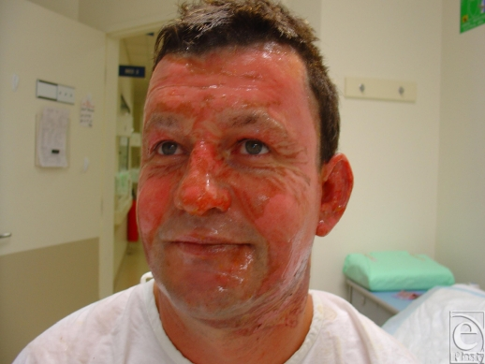

a) Aside from the skin burns/scarring list 5 other potential injuries or complications that could have occurred as a result of the accident (5 marks)

Ocular burns leading to visual loss
Airway burns leading to progressive oedema and airway obstruction
Smoke inhalation leading to hypoxia and resp distress
Carbon monoxide poisoning
Cyanide toxicity from burning furniture e.g sofas
Blast Injury – exclude other traumatic injuries e.g Cspine/limb injuries/head injury etc

b) Outline your fluid management for this man over the next 24 hrs (3 marks)
By Parkland formula 3-4 mls/kg/BSA
3-4 x 70 x 20 = 4200 ( or 5600mls) over 24 hrs

2100 over first 8 hrs since burn, 2100 over next 16hrs
(or 2800 over first 8 hrs since burn, 2800 over next 16hrs)

NaCl 0.9%
Adjusted for UO – aim 0.5mls/kg/hr

c) Complete the table below with the features of each burn type ( 25 marks)

Burn Type | Skin Layers Affected | Clinical Features | Example | Healing duration/  Characteristics
Superficial (1st)
Superficial Partial
(Sup 2nd)

Deep Partial
(Deep 2nd)

Full Thickness
(3rd)

Fourth degree

Burn Type | Skin Layers Affected | Clinical Features | Example | Healing duration/  Characteristics
Superficial (1st) | Epidermis | Pink, no blisters, painful | Sunburn | 7d, no scar
Superficial Partial-Thickness (Superficial 2nd) | Epidermis and Sup Dermis | Blisters, very painful | Hot Water Scald | 7-21d, no scar
Deep Partial-Thickness  (Deep 2nd) | Epidermis and deep dermis with sweat glands and hair follicles | Blisters, very painful | Hot Liquid, steam, grease, flame | 3-8w, perm scar
Full Thickness  (3rd) | Entire epidermis and dermis | Charred, pale, leathery, no pain | Flame | Months, severe scarring, requires grafts
Fourth Degree | All skin layers plus bone, fat, muscles | As above plus evidence of deep tissue damage | Flame | Months, severe scarring and disfigurement, multiple surgeries

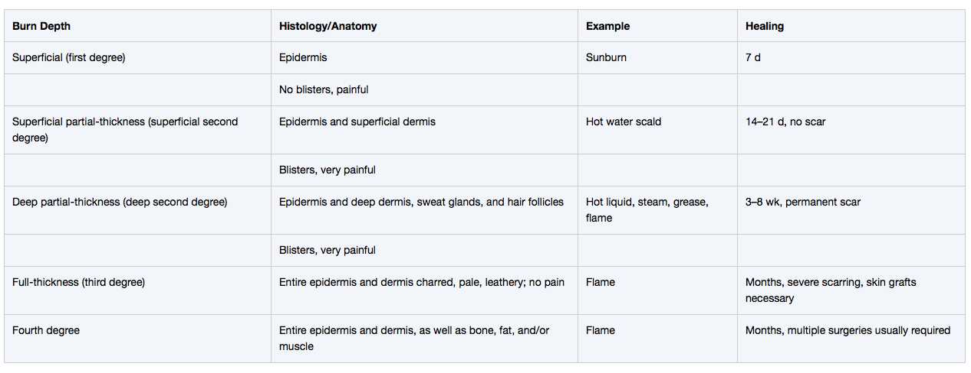

Question 3
A 17 year old man has been involved in an MVA. He was unrestrained and ejected from the vehicle. He has been intubated, has CSpine precautions in situ and is in the resus bay with full monitoring.

Observations
P 120
BP 90/60 (via Art line)
RR 30
Sats 99% 15L NRB
Temp 35.5

Relevant slices of his panscan CT are shown below

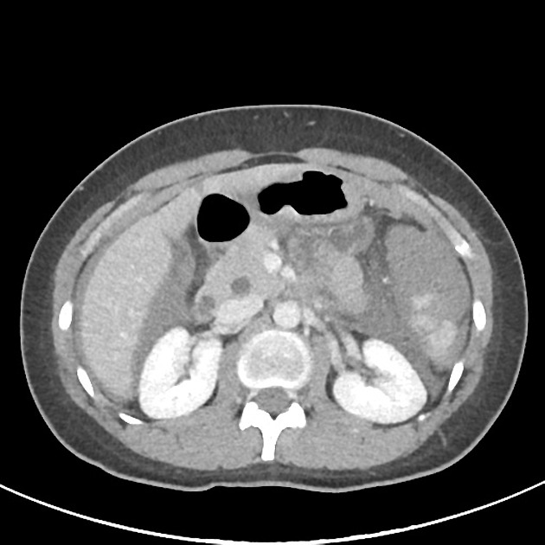

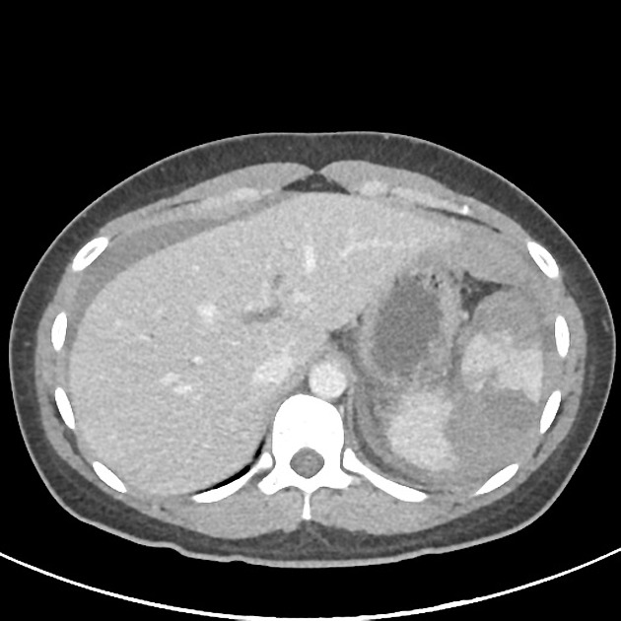

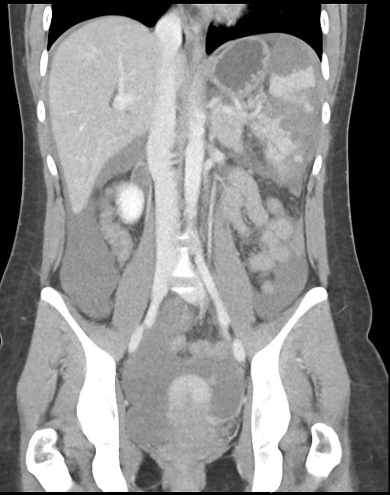

a) List the 2 most abnormal features seen on these CT slices (2 marks)
Grade IV splenic laceration
Haemoperitoneum – FF in RUQ and LUQ

b) What are 2 options for treatment of this injury, with a pro and con of each (6 marks)

Operative/Laparotomy and splenectomy
PRO – Can detect other occult injuries e.g bowel, better direct visualisation of injury
CON – Requires laparotomy/more invasive – risk of wound healing, infection, pain, damage to other structures
Post splenectomy issues e.g risk of non encapsulated organism infections/need for vaccination and abx

Angiographic Embolisation
PRO – Non invasive so less risk of surgical complications, retains some splenic tissue
CON – May become haemodynamically unstable in a non-OT environment, risk of deterioration, requires significant expertise not always immediately available, May miss other occult injuries e.g bowel/mesenteric

c) List 6 actions that you can take to maximise patient safety during a transfer to CT (6 marks)
Ensure adequate staff available – nursing/porter/senior doctor/ICU doctor
Check equipment e.g ventilator for power/battery, O2 cylinders
Ensure items that need securing are secure e.g ETT tie, fluid bags, ICC’s or IDCs
Take additional supplies of equipment and drugs – transport pack and defib
Sedate and paralyse the patient prior to transfer to ensure that doesn’t move
Ensure through good communication that there are no corridor delays and that CT are ready
Do a top to toe A-D check to ensure no deterioration prior to departure

Question 4

A 25 year old Irish backpacker presents to ED with a wound on his hand after punching another backpacker in the face. He is complaining of severe pain and swelling. He had been in ED 3 days ago with the same injury but was intoxicated and had to be removed from the premises by security after threatening behaviour. He can’t really recall the full events surrounding the injury.

Observations
P 120
BP 110/70
RR 16
Sats 99%
Temp 37.9

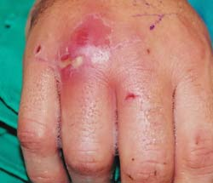

a) Describe the photograph (3 marks)
Left hand dorsum
Red, swollen area over the 4th MCPJ
Pus visable
Several smaller abrasions

b) What is the likely cause (1 mark)
Infected Fight Bite

c) How will you investigate and manage this injury (8 marks)
XRay LEFT hand
Swab of pus for MC and S
Bloods for pre-op work up
Elevate
Analgesia
Tetanus prophylaxis
Antibiotics – Tazocin (or Ceftriaxone and MZ) IV
Needs referral to hand surgeon for exploration, debridement and washout

The patient later makes a written complaint, stating that he was removed from the department when he had a significant injury, and that this led to an infection with the requirement for surgery.

d) How will you manage this complaint ( 9 marks)
Acknowledge complaint within 24hrs and agree to investigate
Gather information from notes and from individuals involved – ED, surgery, security etc
Contact complainant for further information if required
Express regret but not necessarily an apology
Review current policy and procedures on dealing with intoxicated and aggressive patients – determine if due process was followed
Discuss the case in M&M/consultant meeting
Document process
Respond to complainant within ideally 72 hrs
Make appropriate changes to process if necessary – e.g follow up phone call of high risk TOL patients
Audit changes made

Question 5
A 56 year old man presents to ED after an attempted hanging. He was found by his wife with a rope around his neck suspended 30cm above the ground from beam in the garage. He appears to have stepped from a low stool.

He is confused, combative and has stridor. He has assaulted at least one staff member. The ambulance officers have placed a cervical collar which is poorly fitting. There are currently 2 doctors, 2 nurses and 2 ambulance officers present.

P 130
BP 90/70
Sats 75% RA
RR 34
Temp 36.7
GCS 12

a) List the management steps in the next 30 mins for this patient (10 marks)
Ensure security are called – need to physically and chemically restrain patient to get control
Remove collar – non necessary as not jumped from greater than own height and the risk of CSpine injury is small
DSI with ketamine 1mg/kg to sedate/analgese
O2 via non rebreathe mask – pre-oxygenate as well as is possible
Intubate – predicted difficult so call anaesthetics/ENT for back up
- Mark the neck for potential cric
- Use CMAC/VL
- No time for transfer to OT for delayed intubation or fibreoptic intubation as critical sats
- Ketamine and Sux/Roc most appropriate
- Size 8.0 ETT but anticipate may need smaller
- 4-6mls/kg Vt and titrate O2 to sats >95%
3 marks for safe intubation plan which must include the need for immediate intubation and NOT transfer to OT, must recongnise likely difficult and call for help)
IV line and IV fluids pre intubation
Metaraminol boluses
Post intubation head injury measures e.g head up/tape not tie/well sedated to avoid coughing and straining
Contact ICU for ultimate disposition

CT Brain is shown below

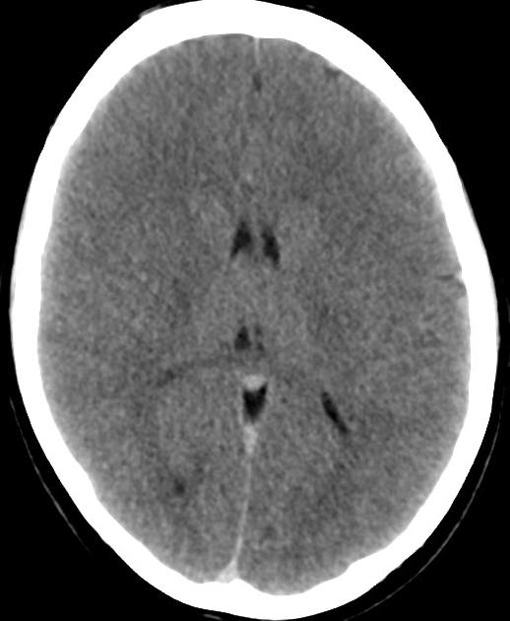

b) What does this CT show and what is it consistent with (3 marks)
Loss of grey white diff
Loss of sulcal spaces
Hypoxic brain injury

c) List 2 other injuries that must be excluded in this patient, and the investigation of choice for each (4 marks)

Tracheal/Laryngeal Injury e.g vocal cord palsy or cricoid/laryngeal fracture – CT neck/Laryngobronchoscopy when unintubated

Carotid Artery Dissection – CT angiogram neck vessels

Question 6

A 75 year old man with alzheimers dementia has fallen from a 2nd floor balcony after trying to “escape”. He is no more confused that normal according to his wife. He is distressed and unable to give you any meaningful information. There is some bruising on his buttocks and left flank.

The RMO who initially assessed the patient was unaware of the significant mechanism as the wife had not been present in the room. He had simply been noted as having “fallen” on the triage sheet and put into a majors bed as a CAT3. Xrays of the left ankle and foot only had been ordered.

P 120
BP 156/78
RR 22
Sats 97%
Temo 36.7
GCS 12
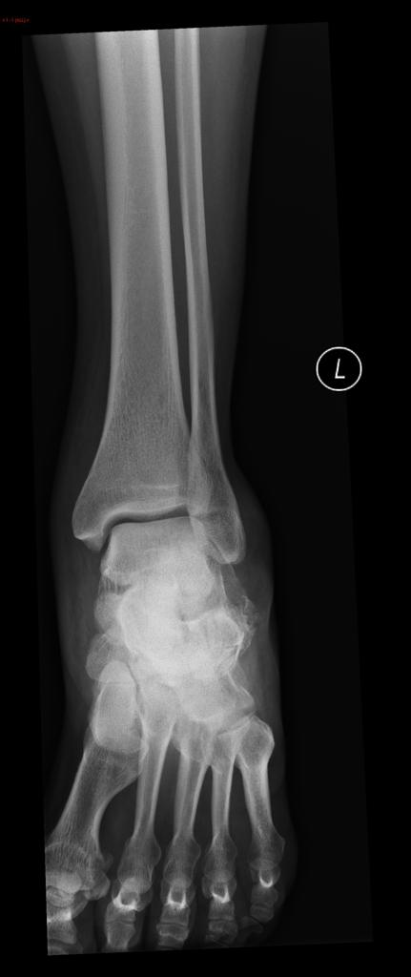
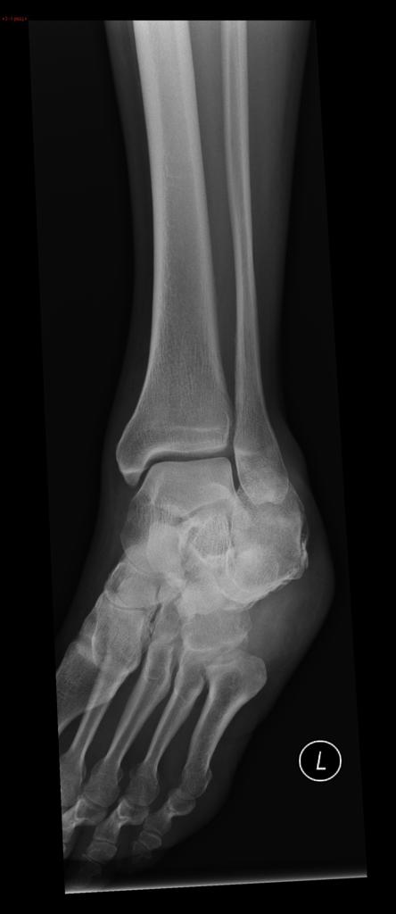
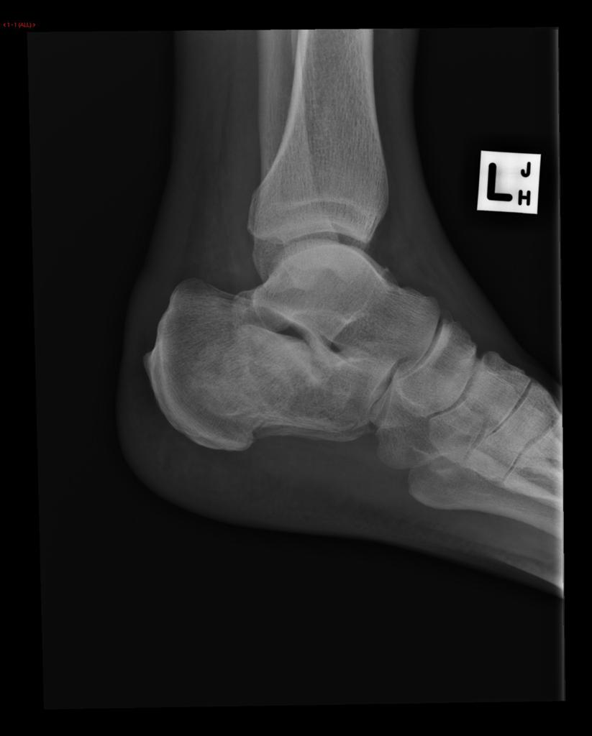
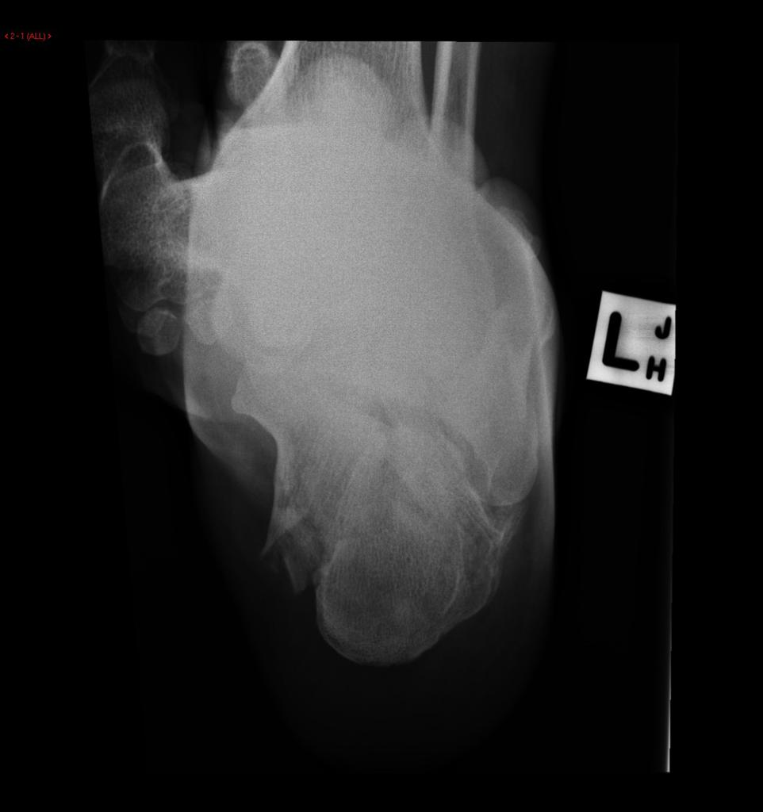

a) Describe the relevant positive and negative features of the XRays (3 marks)
4 views AP, lat and oblique ankle, plus calcaneal views
Intraarticular, comminuted calcaneal fracture
Flattening of bohlers angle on lateral
Ankle joint normal/no widening of the mortice

b) Describe the further investigations that you will perform (7 marks)
FAST scan
CXR and pelvis at the bedside to exclude major injuries prior to
Pan scan would be appropriate given patients age, haemodynamics and inability to convey more meaningful information – single area scans not appropriate given the context
Include calcaneal CT for surgical planning
Bloods – FBC/EUC/LFT/lipase/CMP
Cross Match
VBG
ECG
Urine dip ?haematuria/renal injury

c) List the management steps you will undertake whilst waiting for further imaging to be performed (8 marks)
Trauma call
IV access
Blood and fluid replacement as indicated by examination findings/haemodynamics
Cervical spine immobilisation if possible – may need to be MILS rather than collar
Spinal precautions – likelihood of lumbar injury high from mechanism and known calc fracture
Pelvic Binder
Analgesia – titrated IV opiates
Backslab or temporary splint to immobilise lower limb fracture
Discuss limits of care with wife ?advanced care directive/NFR
Contact trauma/ortho teams for admisison

Question 7

An 22 month old child has fallen from a change table (1m high) and hit their occiput on a concrete floor. They have been more quiet and clingy since the accident.

Observations

P 120
BP 80/60
Sats 99%
RR 28
T 37.1

Your decide to use the PECARN criteria to delineate whether this child should have immediate CT imaging of the brain.

a) List 5 exclusion criteria, where the PECARN criteria cannot be reliably used (5 marks)
GCS <14
Trivial mechanism – e.g fall from standing, walking into a stationary object
Penetrating Trauma
Known brain tumour
VP Shunt
Bleeding disorder
Known neurological disorder

b) Complete the table below for the 3 features you will seek on history and 3 on examination to allow you to specifically apply the PECARN criteria in this case (6 marks)

HISTORY | EXAMINATION

HISTORY | EXAMINATION
Anything suggestive of abnormal mental status | Palpable skull fracture
LOC > 5secs | Scalp Haematoma excluding frontal
“Not acting normally” as per parent | GCS <15
 | Agitation, somnolence, slow resp, repetitive

Mechanism is known so cant have “severe mechanism of injury”

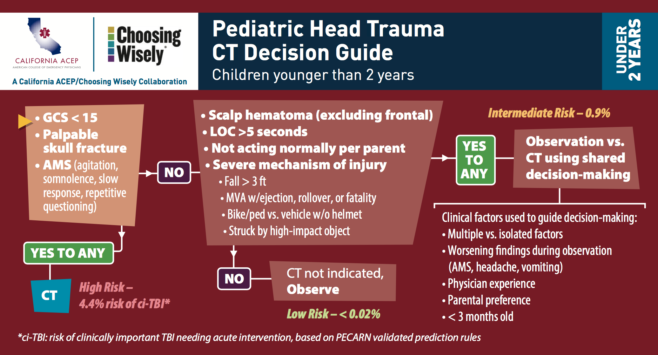

After careful consideration a CT if performed and it shows the following

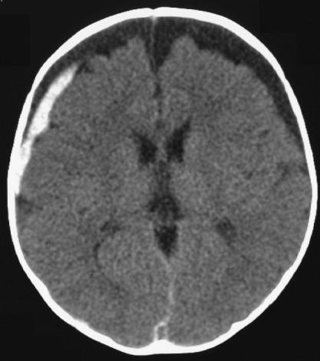

c) Describe 3 relevant positive findings on this CT slice (3 marks)
Bilateral frontal subacute/chronic subdurals (hydroma)
Acute right frontotemporal subdural
Blood in interhemspheric fissure

Concerns are raised for NAI as there have been 4 previous presentations to ED with trauma since birth

d) List 6 other injuries in this age group that might suggest NAI (6 marks)
Torso, Ear and Neck brusing < 4yrs (TEN4)
Head, cheeks, perineum, upper arms bruising
Broken bones multiple sites/multiple ages
Metaphyseal corner fractures
Immersion burns
Branding burns – cigarettes
Multiple, complex, occipital, depressed skull #s
Posterior rib fractures
Subdurals esp if bilateral and old
Retinal haemorrhages
Genital injuries
Avulsion of Thoracic/Lumbar vertebrae
Duodenal haematomas
Pancreatic trauma/pseudocysts

Question 8

A 34 year old female attends ED after being punched in the face by her domestic partner
She has an obvious left facial swelling with a cm gaping left eyebrow laceration, and is complaining facial pain and a headache. A CT scan has been performed

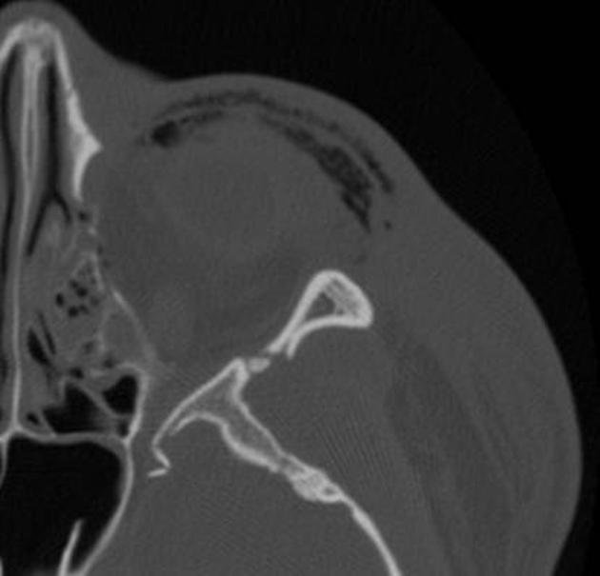

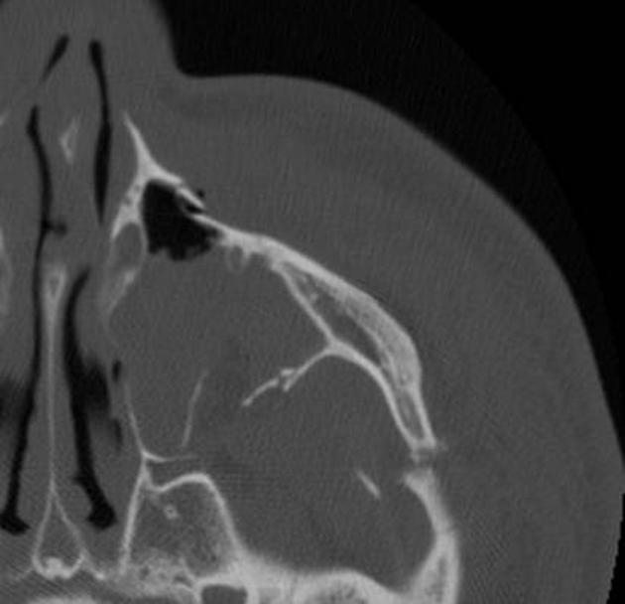
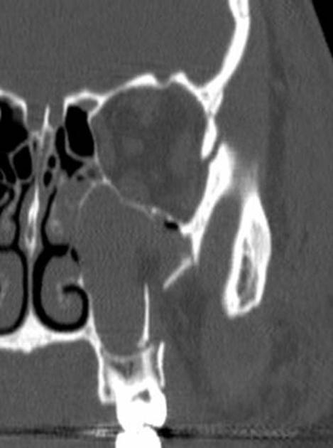

a) Describe the positive findings in the CT images shown (6 marks)
# Lateral orbital rim
# Zygomatic arch
# Inferior orbital rim
# Anterior and posterior maxillary sinus walls
Opacificaiton of the maxillary sinus (L)
Small amount of intraconal gas medially

b) List 4 potential complications to be aware of this type of injury (4 marks)
Infraorbital nerve injury – facial paraesthetia
Ruptured globe
EOM entrapment - diplopia
Retroorbital haematoma/ ischaemic optic neuropathy
Temporalis impingement – trisumus or difficultly with mastication
Infection as a result of sinus breach
Subcutaneous emphysema – particularly malignant orbital emphysema and orb comp syndrome

c) List the ED management for this patient (8 marks)
Contact Max Fax and Ophthalmology for admission
Analgesia – titrated IV opiates
IV fluids and NBM
Irrigate and debride wound – consider closure or if theatre likely within reasonable time frame can be closed in OT under anaesthetic
Antibiotics (evidence poor area) – if po ADF or clinda, IV cefazolin and metronidazole
Tetanus prophylaxis if not covered
Offer Social worker for domestic violence
Consider report to police if patient gives consent – mandatory reporting in the NT
Advise patient not to blow nose

Question 9

You are are ED physician on call in a rural hospital without CT capability. The nearest CT scanner is at a tertiary hospital 200km away.

A 17 year old boy has dived into a swimming pool whilst intoxicated. He is complaining of neck pain, with tingling and weakness in all four limbs. He has objective evidence of an incomplete quadriplegia.

He has a hard collar in situ, 2 IV lines and full non invasive monitoring

P 40
BP 70/60
Sats 91%
RR 12
Temp 36.6

His Cervical spine XRay is shown below

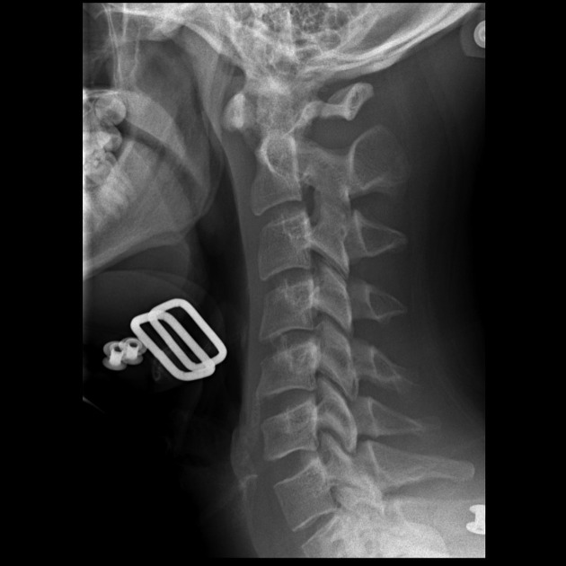

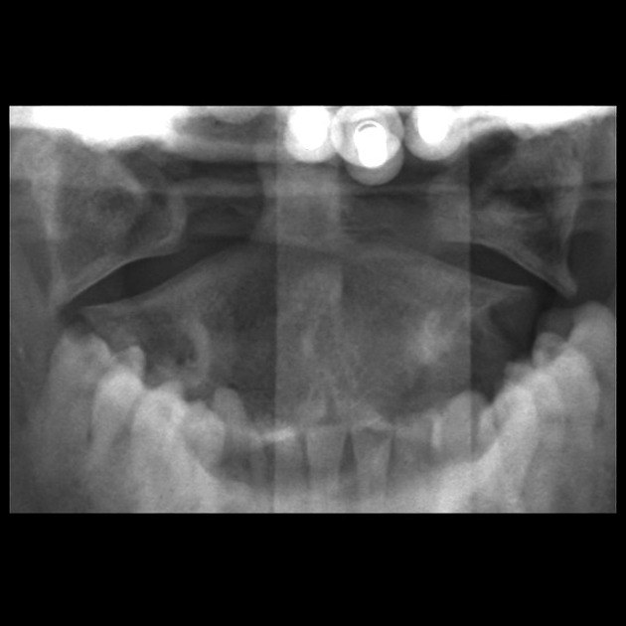

a) List the 3 most abnormal findings on this Xray and name the abnormality (3 marks)
Widened predental space >3mm
Overhanging lateral masses on the PEG view
Lucency traversing posterior arch of C1 on lateral
Suggest a Jeffersons/C1 burst fracture from axial loading injury

B) List the interventions you will undertake prior to transferring this patient to the nearest CT scanner
IV fluid bolus 1000mls NaCl
CVC and noradrenaline, metaraminol to temporize till line in situ
High risk for high cervical cord injury and significant respiratory compromise – needs airway protection and ventilation prior to transfer.
- needs MILS
- Use video laryngoscopy and most experienced operator
- Ketamine/Sux/Sensible sedation/Vt 4-5mls/kg/PEEP 5
- Size 8 ETT etc etc
2 part collar – e.g. aspen/Philadelphia
Full spinal precautions/rolls/minimal moving
IDC
Contact receiving centre/retrieval/family
Collate and copy notes

c) List 5 potential complications of prolonged cervical immobilization in a collar (5 marks)

