Resus and Anaesthetics Fellowship Questions
Q1.
A 55 year old woman presents by ambulance. This is her appearance upon arrival in ED
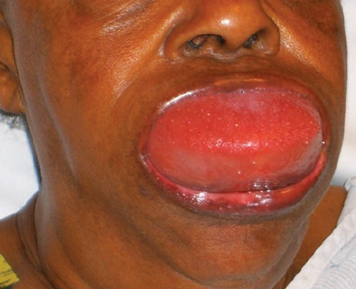
a)List three differential diagnoses (3 Marks)

b) List 5 features of her medical history that are particularly important to enquire about (5 Marks)

c) List your first 5 management steps (5 Marks)

Q2.
A 4 year old boy is brought to your Emergency Department having sustained a 4 cm eyebrow laceration following a fall at a playground. He is accompanied by his mother.
You plan to suture the wound under procedural sedation using ketamine.
a) List 8 contraindications to ketamine use in this setting (8 Marks)

b) List 4 potential side effects/complications associated with ketamine use in this setting (4 Marks)

c)Complete the following table regarding ketamine usage in paediatric procedural sedation by route of delivery (8 Marks)
 | Intra-muscular (i.m) | Intra-venous (i.v)
Initial dose
Top-up dose
Advantage
Disadvantage
Q3.
You have just intubated a 75 year old 60kg woman with deteriorating respiratory function after a fall causing isolated closed chest injuries. She has a history of asthma and COPD. She has become increasingly hypoxic and hypotensive since intubation. Your hospital does not have an intensive care unit.
a) List 8 potential causes for her deterioration (8 Marks)

Her hypotension resolves with fluids, although she has an ongoing high oxygen requirement and high ventilator peak pressures. Her flow time curve looks like this
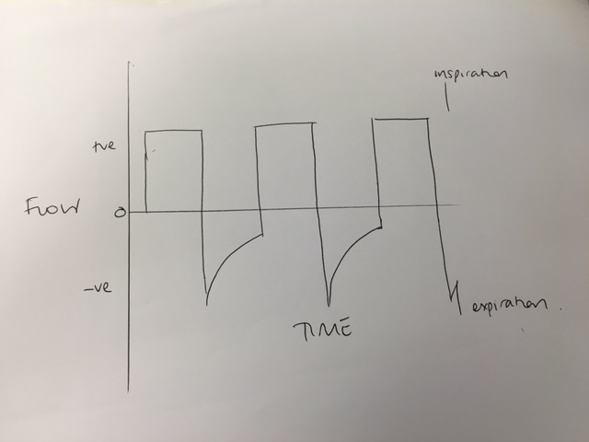
b) List the 2 types of lung trauma you are trying to avoid, and one measured parameter that you will allow to be abnormal with a lung protective strategy (as per ARDS Net Study) (3 Marks)

c) Outline your ventilator settings for this patient? (4 Marks)

The patient needs to be transferred to a tertiary hospital for ongoing management. A retrieval team will arrive in 2 hours to transfer her by fixed wing. You do not need to supply staff/transport equipment for the retrieval.
d) List how you would prepare for this transfer (4 marks)

Q4

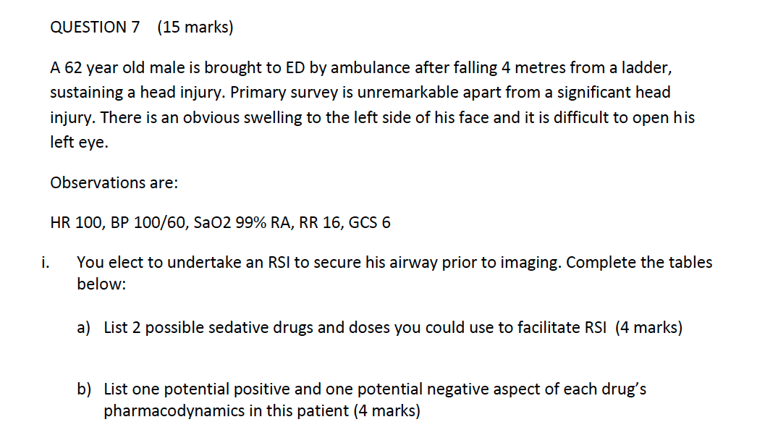
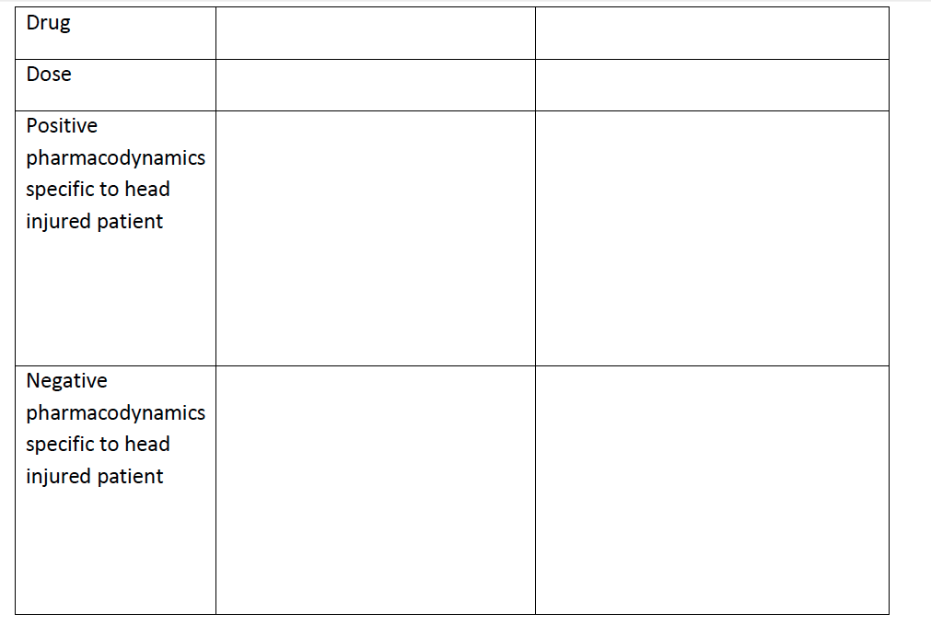

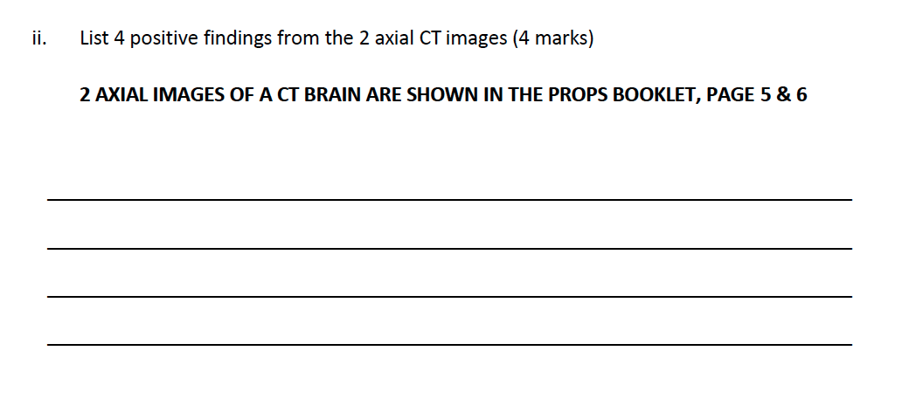
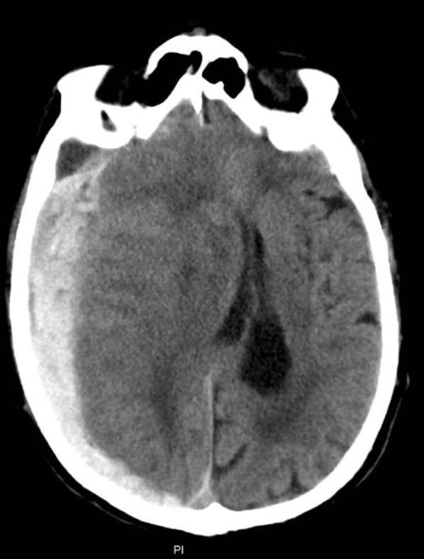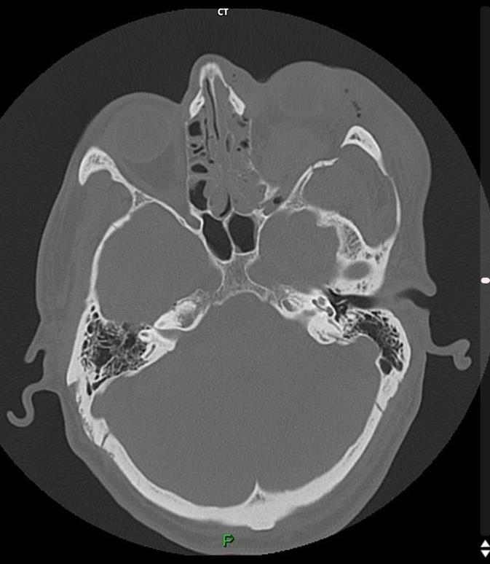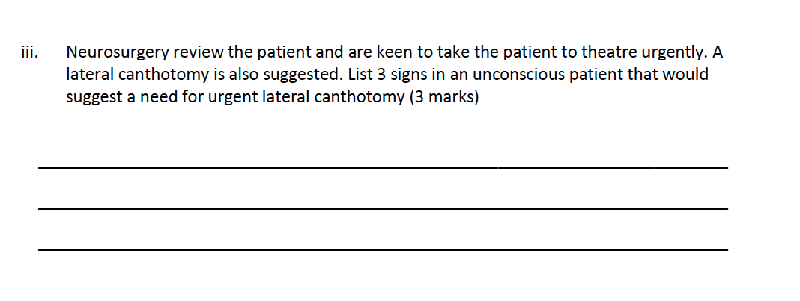
Q5
A 26 year old with a known history of anorexia presents to ED with a history of collapse. She has regained consciousness but is very weak and lethargic.
Her Obs are
P 100
BP 86/40
Sats 97% RA
Temp 32.1
RR 30
Her ECG is shown
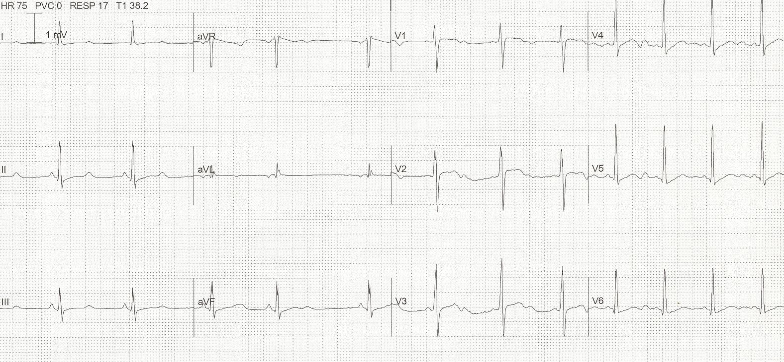a)

a)List the most relevant abnormal ECG findings (2 marks)

b) List 4 potential causes for this abnormality in this patient (4 marks)

c) List 3 other less likely causes of this abnormality (3 marks)

As you are talking to her she loses consciousness and has NO signs of life when you assess her. You see the following on her monitoring rhythm strip
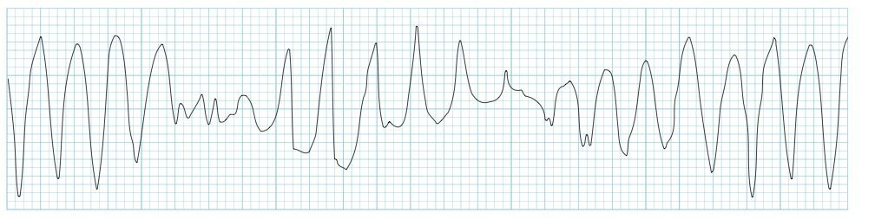

d) Outline your immediate management steps (7 marks)

Q6
You are working in a regional hospital ED. You receive a call from ambulance that a 4 year-old boy is en route after an apparent near-drowning accident in a family swimming pool. CPR is in progress. Estimated time of arrival is 10 minutes
a) List the steps you will take in preparing for the arrival of this patient (10 marks)

The child arrives and is in PEA with a ventricular rate of 50. He is not intubated and has no IV access. The parents have opted not to be present in the resus room.
b) List your immediate actions (6 Marks)

After 5 minutes you obtain ROSC with the following observations
P 90
BP 60/40
Sats 90% on 100% FIO2 on ventilator
RR 25 (per ventilator)

c) List the post ROSC management you will undertake within the next 30-60 minutes. (12 marks)

Q7
You are working in a tertiary level centre with a cardiac cath lab and cardiothoracic surgeon on site. You are called in the middle of the night by a junior registrar who is concerned about a patient who has had continuous chest pain for 3 hrs, who has become more hypotensive and diaphoretic. The patient has been treated with aspirin, GTN and morphine for a presumed NSTEMI. CXR NAD. He has 2 IV lines and is on 15L O2 via a NRB.
P 120
BP 60/40
Sats 97% NRB 15L
RR 30
Temp 37.2
The ECG taken 2 hrs ago has been faxed to you
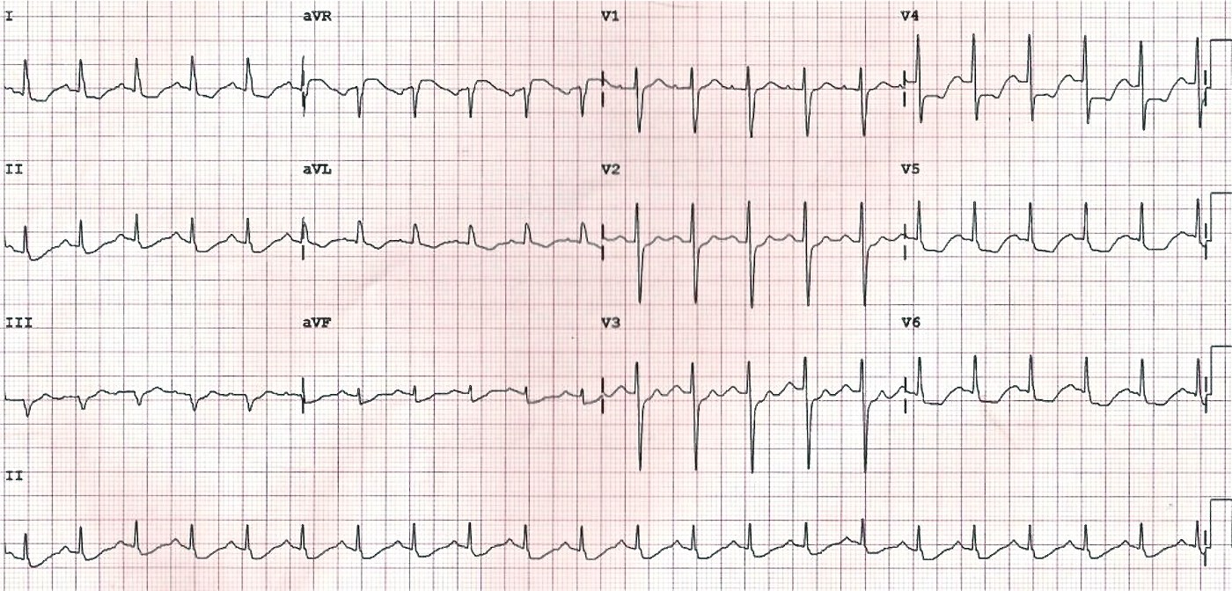
a) List the two most important abnormal features on this ECG (2 marks)

b) What is the likely underlying cause (1 mark)

c) List the phone advice that you will give to the registrar (6 marks)

When you arrive in ED the patient has a reduced level of consciousness, but has a pulse, and the monitor shows the following.
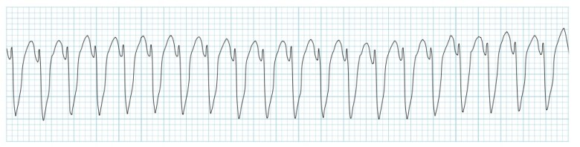

d) What are your options for cardioversion of this rhythm in order of preference (4 marks)

e) The nursing staff report that they had been concerned about the patient for several hours and that they felt ignored by the registrar, who kept stating that “he’s just had a NSTEMI, give more morphine and GTN”. List the steps you will take in managing this issue (5 marks)

Q8
An 65 year old female presents to a rural ED after a fall, she has a history of parkinsons disease and has fallen at home. She is complaining of a sore LEFT wrist where she has significant deformity.
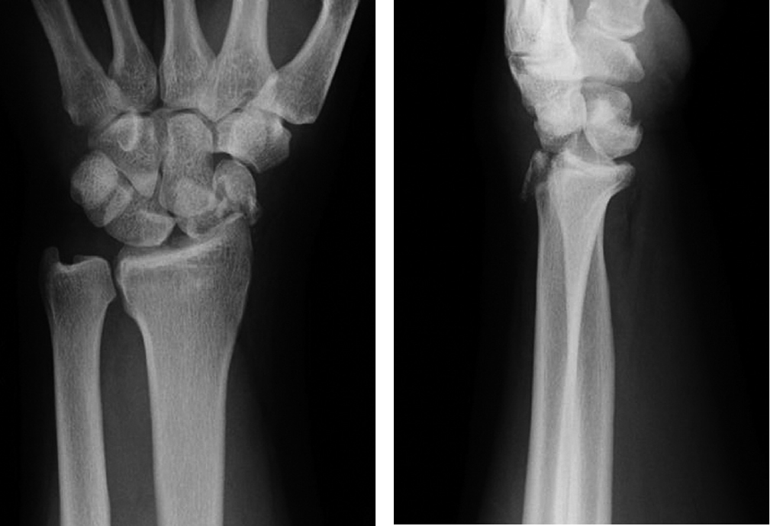

a) List the 2 most significant abnormal features on this XRay (2 marks)

A visiting orthopaedic surgeon has requested the provision of sedation or a Biers block in order to partially correct the injury pending formal operative management at the nearest tertiary centre.

b) Complete the table below listing the chosen drug, 2 pros, 2 cons and 2 potential complications of each (8 marks)
 | Procedural Sedation Method | Biers Block
Drug(s) used
inc route and dose
2 Pros
2 Cons
2 Complications

c) You decide to perform a Biers block. List the contraindications to a Biers Block (4 marks)

During the procedure the patient starts to complain that she has tingling around her mouth and becomes very confused. She is moved to resus, has observations performed, 2 IV lines and an ECG/VBG.
d) List the stepwise definitive interventions that you might use to treat the patient in this situation (4 marks)

Q9
A 42 year old man with a history of alcoholism and violence is currently intubated in the resus room of your tertiary ED. The previous night he had assaulted a staff member and required a code black call to restrain and chemically sedate him. The morning team have lightened his sedation with the hope of extubating him as there are no beds in the ICU.

a) List the medical and departmental factors that must be considered in order for him to be extubated safely (9 marks)

b) List the potential complications that could occur during extubation (6 marks)

The patient is awake and assessed as medically suitable for extubation. You have all of the necessary departmental requirements to perform extubation.
c) Outline the actual steps you will take in extubating this patient (6 marks)

