Resus and Anaesthetics Fellowship Questions_Feb 14th 2017
Q1.
A 55 year old woman presents by ambulance. This is her appearance upon arrival in ED

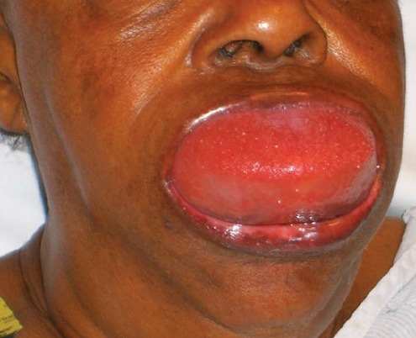

- List three differential diagnoses (3 Marks)

- List 5 features of her medical history that are particularly important to enquire about (5 Marks)

- State your first 5 management steps (5 Marks)

Answers

- Angioedema, Anaphylaxis, Trauma (haematoma)

- Allergy history, medication history, family history of similar events, previous episodes and how managed/if protocol

- Resus with full monitoring, Adrenaline neb(5mg) and/or IM (0.3-0.5mg), urgent airway call (anaesthetics/ICU), difficult airway and surgical airway kit at bedside, optimise current airway by positioning, IV access, supplemental O₂ if hypoxia, consider C1 esterase inhibitor/icatibant if Hx if specifically indicated by previous diagnosis of C1 esterase inh deficiency or hereditary angio-oedema

Q2.
A 4 year old boy is brought to your Emergency Department having sustained a 4 cm eyebrow laceration following a fall at a playground. He is accompanied by his mother.
You plan to suture the wound under procedural sedation using ketamine.

a. List 8 contraindications to ketamine use in this setting (8 Marks)

b. List 4 potential side effects/complications associated with ketamine use in this setting (4 Marks)

c. Complete the following table regarding ketamine usage in paediatric procedural sedation by route of delivery (8 Marks)
 | Intra-muscular (i.m) | Intra-venous (i.v)
Initial dose
Top-up dose
Advantage
Disadvantage

Answers
a. List 8 contraindications to ketamine use in this setting ? (4 Marks)
1/2 mark each up to 4 marks from the following:
Parental refusal
Procedural required unsuitable for ketamine sedation
Inadequate staffing / area / equipment
Previous adverse reaction to Ketamine
Altered conscious state
Unstable patient: seizures, vomiting, hypotension
Cardiovascular disease - heart failure, uncontrolled hypertension, congenital heart disease
Procedures involving stimulation of posterior pharynx
Known airway instability or tracheal abnormality
Psychosis
Thyroid disorder or medication
Porphyria
Risk of raised intraocular or intracranial pressure
Active pulmonary infection or disease including acute asthma and URTI
Full meal within 3 hours (relative contraindication only, balance risk against urgency of procedure)

b. List 4 potential side effects/complications associated with ketamine use in this setting (2 Marks)
1/2 mark each up to 2 marks from the following:

Airway obstruction
Nystagmus
Muscle rigidity
Random movements (can resemble seizure like activity)

Vomiting (during or after procedure)
Emergence phenomena
Apnoea
Failed procedure (need for a General Anaesthesia)
Hypersalivation

c. Complete the following table regarding ketamine usage in paediatric procedural sedation by route of delivery (4 Marks)

1/2 Mark for each correctly completed table cell - only 1 example for advantage / disadvantage by route required for mark - longer list of acceptable answers re: adv/disad examples only in table

 | Intra-muscular (i.m) | Intra-venous (i.v)
Initial dose | 4 mg/kg | 1 - 1.5 mg/kg
Top-up dose | 2 mg/kg | 0.5 mg/kg
Advantage | Nil iv required, as safe as iv  Longer action etc. | More predictable, easier top-up, quicker onset etc.
Disadvantage | Pain / distress on injection, less predictable etc. | iv line required, quicker offset etc.

Q3.

You have just intubated a 75 year old 60kg woman with deteriorating respiratory function after a fall causing isolated closed chest injuries. She has a history of asthma and COPD. She has become increasingly hypoxic and hypotensive since intubation. Your hospital does not have an intensive care unit.
- List 8 potential causes for her deterioration (8 Marks)

Her hypotension resolves with fluids, although she has an ongoing high oxygen requirement and high ventilator peak pressures. Her flow time curve looks like this
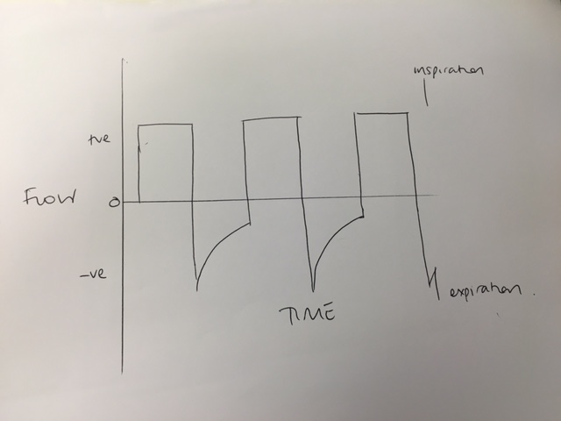

- List the 2 types of lung trauma you are trying to avoid, and one measured parameter that you will allow to be abnormal with a lung protective strategy (as per ARDS Net Study) (3 Marks)

- Outline your ventilator settings for this patient? (4 Marks)

The patient needs to be transferred to a tertiary hospital for ongoing management. A retrieval team will arrive in 2 hours to transfer her by fixed wing. You do not need to supply staff/transport equipment for the retrieval.
d) List how you would prepare for this transfer (4 marks)

Answers

1. List 8 potential causes for her deterioration (8 Marks)
Anaphylaxis _____________________________________________________________
Ventilator failure / O2 disconnect____________________________________________
ETT misplacement / blockage _______________________________________________
Pneumothorax (iatrogenic or traumatic)_______________________________________
Breath stacking / hyperinflation______________________________________________
Lack of synchronisation / need for paralysis_____________________________________
Haemothorax_____________________________________________________________
Worsening pulmonary contusions_____________________________________________

2. List the 2 broad types of lung trauma you are trying to avoid, and one parameter that you accept to abnormal with a lung protective strategy (as per ARDS Net Study) (3 Marks)
Avoid volutrauma ________________________________________________________
Avoid barotrauma ______________________________________________________
Accept permissive hypercapnoea. __________________________________________

3. Outline your ventilator settings for this patient? (4 Marks)
Use lowest FiO2 possible to avoid hypoxia.(0.25) ________
Rate 6-10 min (0.25)_________________________________________________________
TV 240-350mL (4-6mL/kg) (0.25)________________________________________________
PEEP 10cm H20 (or higher) (0.25)________________________________________________

This woman needs to be transferred to a tertiary hospital for ongoing management. A retrieval team will arrive in 2 hours to transfer her by fixed wing. You do not need to supply staff for the retrieval.
3. Outline how you would prepare for this transfer (4 marks)
Communicate with receiving team/family/SW – where is she going who will be responsible____
Prepare the patient – lines, medications, avoid pressure areas, ETT, catheter__________
Prepare notes / xrays/results____________________________________________________
Ongoing monitoring and care of patient while awaiting retrieval team __

Q4
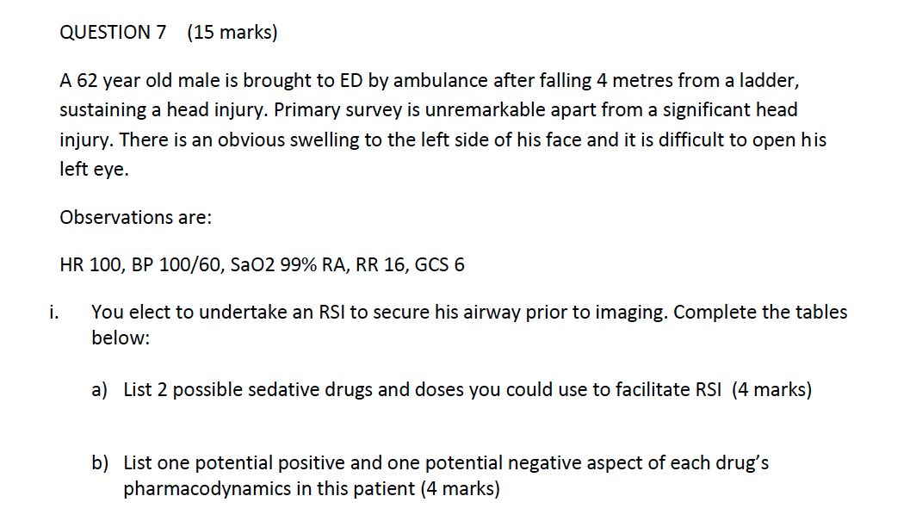
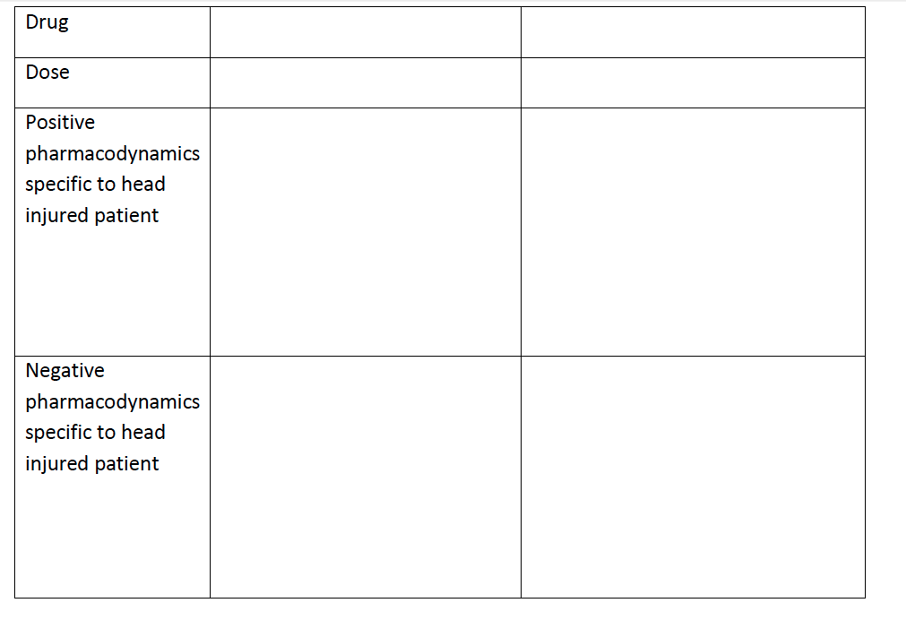
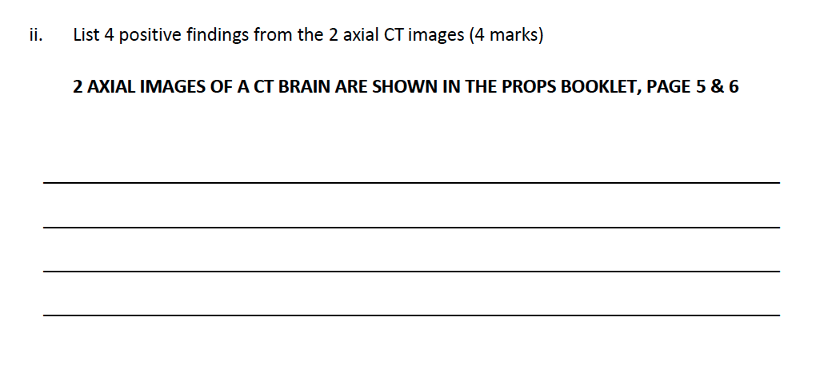
(Images Below)

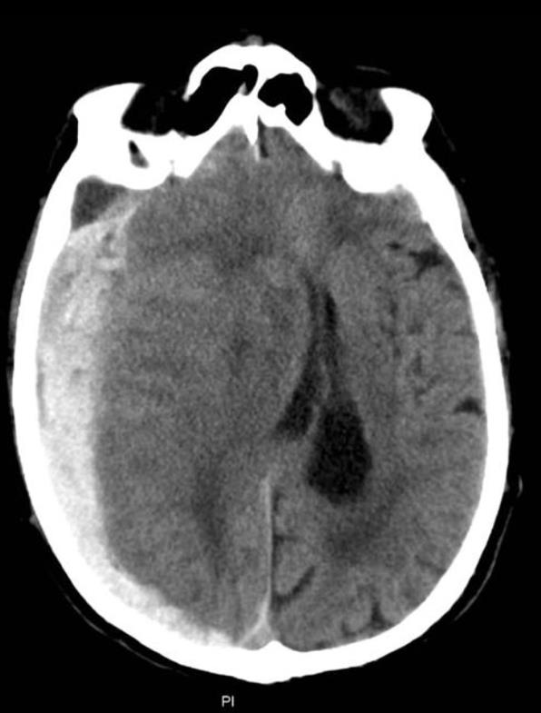

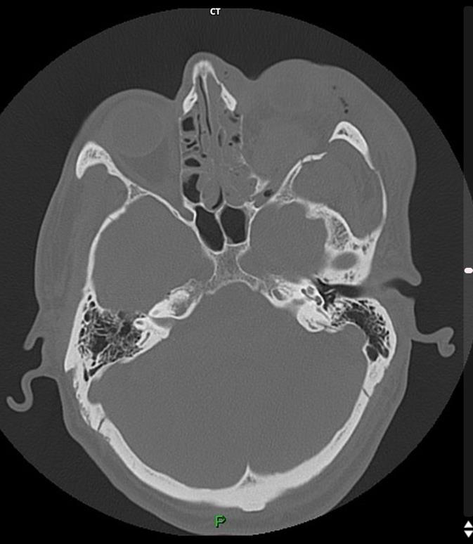

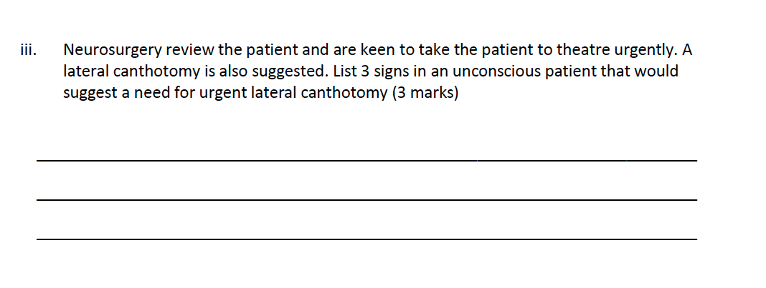
Answers

ii)
Large right sided SDH spanning frontal to occipital areas
Midline shift
Effacement of lateral ventricles and sulcal spaces
Left Orbital blowout # - medial and lat walls
Retroorbital haematoma with proptosed left eye
Gas in Left Orbit

iii)
Raised intra ocular pressure >40mmHg in unconscious patient with retrobulbar haemorrhage (normal pressure is 10-21)
RAPD
Significant Proptosis
Dilated pupil in absence of central cause and CT suggesting retrobulbar haematoma
(Normal indications of decreased acuity, significant pain and ophthalmoplegia – not appropriate answers for this question as patient has low GCS)

Q5
A 26 year old with a known history of anorexia presents to ED with a history of collapse. She has regained consciousness but is very weak and lethargic.
Her Obs are
P 100
BP 86/40
Sats 97% RA
Temp 32.1
RR 30
Her ECG is shown
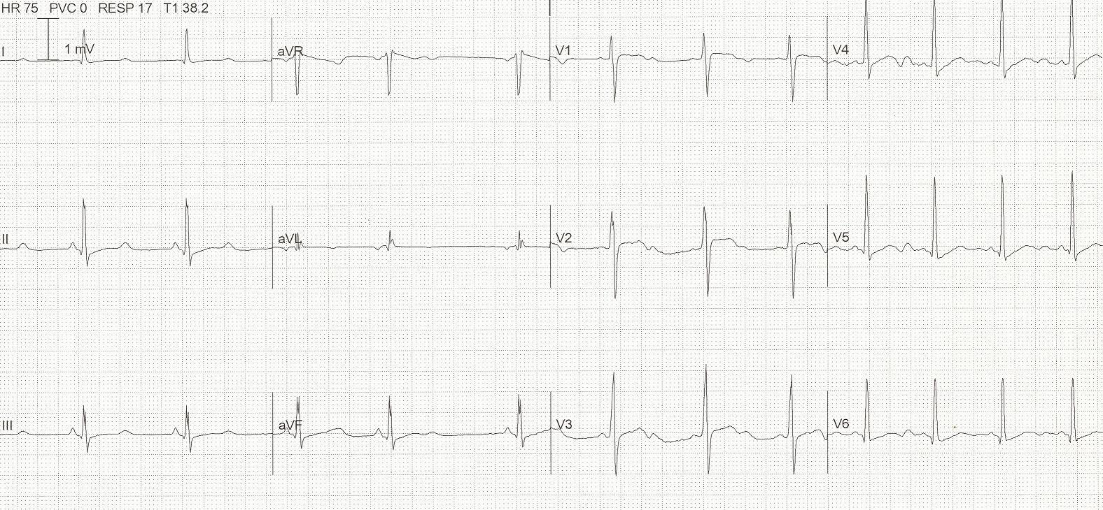

- List the most relevant abnormal ECG findings (2 marks)

- List 4 potential causes for this abnormality in this patient (4 marks)

- List 3 other less likely causes of this abnormality (3 marks)

As you are talking to her she loses consciousness and has NO signs of life when you assess her. You see the following on her monitoring rhythm strip
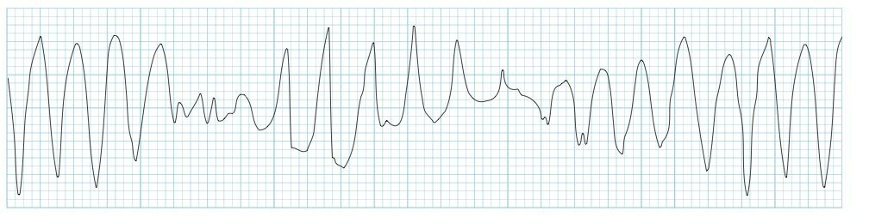
- Outline your immediate management steps (7 marks)

Answers

Long QT
U waves – T-U fusion
Non specific ST/T changes
b)
Hypokalaemia
Hypomagnesaemia
Hypocalcaemia
Hypothermia
c)
Myocardial ischemia
Post-cardiac arrest
Raised intracranial pressure
Congenital long QT syndrome
DRUGS

d)
Press cardiac arrest buzzer
Attach a defibrillator to patient and deliver immediate shock at 200J (as per ALS guidelines) – stacked shocks appropriate as witnessed arrest
Commence CRP at 30:2
Ensure IV/IO access
(Check VBG for K levels/Ca levels)
Administer Mg 2g as a bolus
Replace KCl 10mmol aliquots if K low – aim 4.0 – 4.5
Replace Calcium with Ca Gluconate or Chloride

Q6
You are working in a regional hospital ED. You receive a call from ambulance that a 4 year-old boy is en route after an apparent near-drowning accident in a family swimming pool.
CPR is in progress. Estimated time of arrival is 10 minutes
- List the steps you will take in preparing for the arrival of this patient (10 marks)

- The child arrives and is in PEA with a ventricular rate of 50. He is not intubated and has no IV access. The parents have opted not to be present in the resus room.
List your immediate actions (6 Marks)

After 5 minutes you obtain ROSC with the following observations
P 90
BP 60/40
Sats 90% on 100% FIO2 on ventilator
RR 25 (per ventilator)

- List the post ROSC management you will undertake within the next 30-60 minutes. (12 marks)

Answers – adapted from an old ACEM SCE question with adaptations

SPACE - Prepare resus bay/ensure family room free
PEOPLE – Trauma call, PICU/Paeds/Anaesthetics/SW/Remove redundant staff
ESTIMATE WEIGHT – (Age+4)2 = 16kg or (Agex2)+8 = 16kg
EQUIPMENT – 500ml BVM, FM, Mac or straight blade size 2, suction, O2, ETT size 5, IV and IO available,
DRUGS – Adrenaline 0.1mls 1:10 000/kg (10mcg/kg) = 1.6mls/160mcg
FLUIDS – 20mls/kg NaCl 0.9% = 320mls warmed
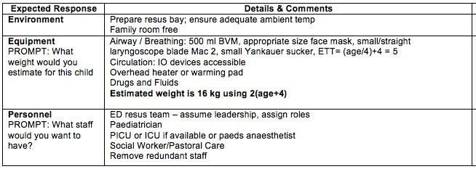

b)
Continue CPR at 15:2, O2 via BVM with adjunct if necessary, as per APLS
Intubation
IV access/IO access
Fluid Bolus
Adrenaline 3-5minutes 160mcg
Correct reversible causes – predominantly hypoxia and hypothermia. But consider others
VBG/Glucose
Ensure someone allocated to parents/invite into resus room

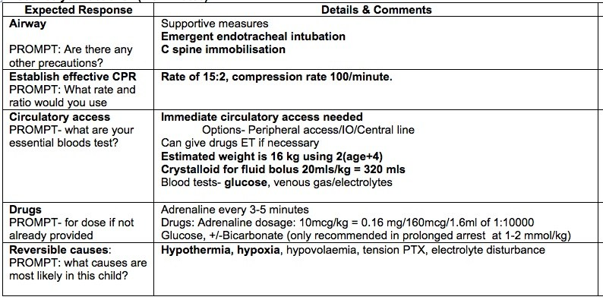

c)
Ensure ETT position correct – CXR/auscultate
Continuous monitoring – A line, ECG, RR, Temp probe rectally
Oxygenation – continue with 100% FIO2 as sats only 90%,
Ventilation – RR as per CO2/clinicals state, PEEP 5-10, VT 6-8mls/kg
Monitor ETCO2
IVF and noradrenaline infusion if BP remains low
IDC
NG
Avoid hyperthermia – don’t actively cool
Sedate and paralyse – any sensible choice of agent
ECG and bloods
Discuss with family/involve SW
Document
Debrief
Arrange transfer to a tertiary level centre

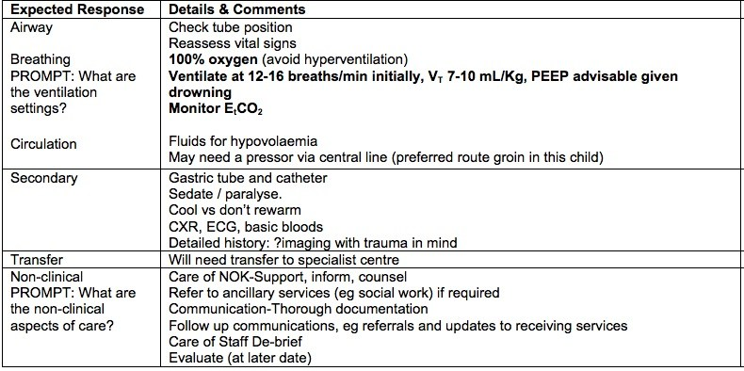

Q7
You are working in a tertiary level centre with a cardiac cath lab and cardiothoracic surgeon on site. You are called in the middle of the night by a junior registrar who is concerned about a patient who has had continuous chest pain for 3 hrs, who has become more hypotensive and diaphoretic. The patient has been treated with aspirin, GTN and morphine for a presumed NSTEMI. CXR NAD. He has 2 IV lines and is on 15L O2 via a NRB.
P 120
BP 60/40
Sats 97% NRB 15L
RR 30
Temp 37.2
The ECG taken 2 hrs ago has been faxed to you
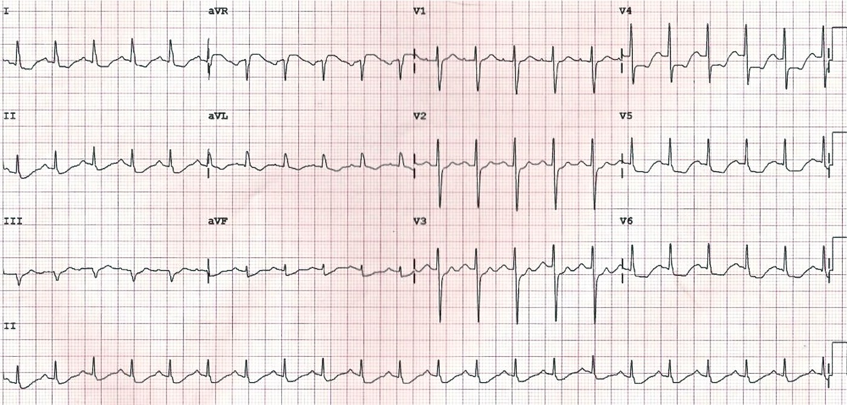

- List the most striking abnormal features on this ECG (2 marks)

- What is the likely underlying cause (1 mark)

- List the phone advice that you will give to the registrar (6 marks)

When you arrive in ED the patient has a reduced level of consciousness, but has a pulse, and the monitor shows the following.
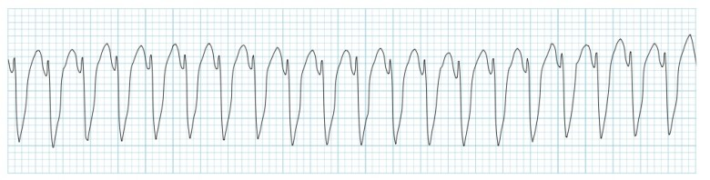
- What are your options for cardioversion of this rhythm in order of preference (4 marks)

- The nursing staff report that they had been concerned about the patient for several hours and that they felt ignored by the registrar, who kept stating that “he’s just had a NSTEMI, give more morphine and GTN”. List the steps you will take in managing this issue (5 marks)

Answers
a)
STE in aVR
Lateral and high lateral STD

b)
LMCA Occlusion
Or severe triple vessel disease/very high LAD lesion

c)
Contact cardiologist to discuss possible STE equivalent MI on ECG ?for cath lab, advise you will come in from home
Repeat ECGs and keep monitored/on defib pads
Treat pain with titrated opiates
Cautious IV fluids 250mls boluses for hypotension
Avoid GTN as currently too hypotensive
Consider pressors if fluids fail to resolve BP

Clexane 1mg/kg SC
Clopidogrel controversial as may need CABG and hence would have increased bleeding risk in surgery – to discuss with cardiologist prior to giving
d)
Defibrillation with sync shock/AP paddle position (preferred given LOC and hypotension)
Drugs – As per eTG
- amiodarone 150 to 300 mg IV infusion, over 20 to 30 minutes, followed by 900 mg IV infusion over 24 hours if required
- sotalol 0.5 to 1.5 mg/kg IV infusion, over 10 to 30 minutes, repeated once after 10 minutes if necessary and followed, if indicated, by 80 to 160 mg IV infusion over 12 hours
- lignocaine 1 to 1.5 mg/kg (usually 75 to 100 mg) IV, over 1 to 2 minutes followed, if successful, by IV infusion at 4 mg/minute for 1 hour, then 1 to 3 mg/minute

e)
Do not talk to registrar immediately post night shift when tired and sleep deprived – make an appointment to discuss the case when well rested
Gather information – from nursing staff, notes and the registrar
Explore understanding of the case and identify any knowledge gaps e.g. potential STE equivalent MIs on ECG

Explore systems reasons, e.g overcrowding/staffing issues etc for clinical error/bad experiences with calling consultants overnight for help
Reiterate the need to call FACEM at night for unstable patients or when there is valid concern from nurses
Risk Man
M&M case, relevant teaching session
Support junior doctor/involve DEMT for pastoral care

Q8
An 65 year old female presents to a rural ED after a fall, she has a history of parkinsons disease and has fallen at home. She is complaining of a sore LEFT wrist where she has significant deformity.
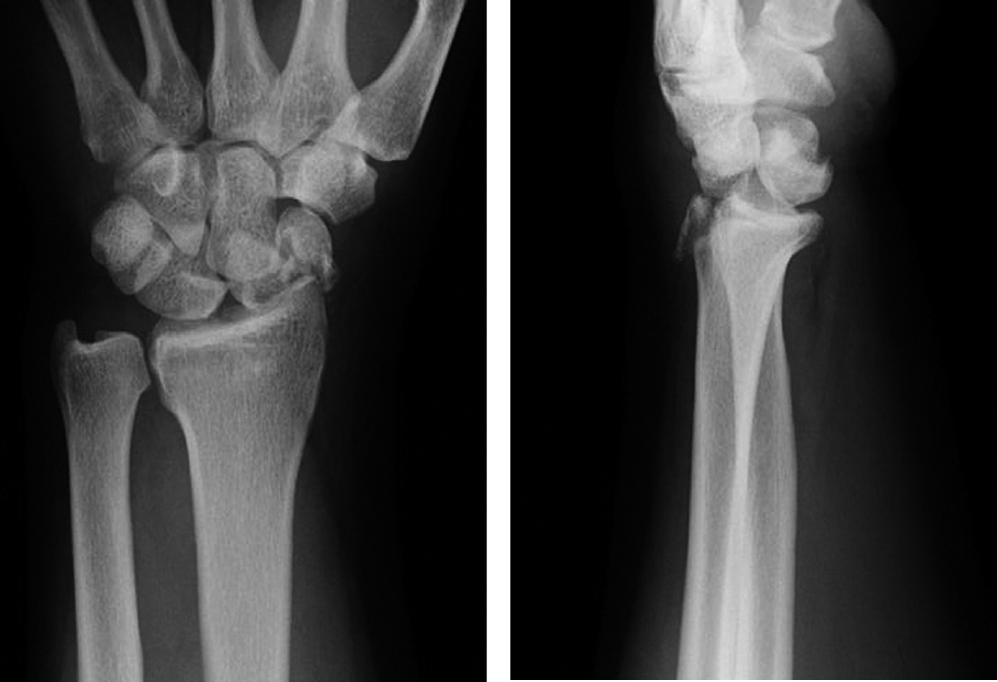

- List the 2 most significant abnormal features on this XRay (2 marks)

A visiting orthopaedic surgeon has requested the provision of sedation or a Biers block in order to partially correct the injury pending formal operative management at the nearest tertiary centre.
- Complete the table below listing the chosen drug, 2 pros, 2 cons and 2 potential complications of each (8 marks)
 | Procedural Sedation Method | Biers Block
Drug(s) used inc route and dose
2 Pros
2 Cons
2 Complications

- You decide to perform a Biers block. List the contraindications to a Biers Block (4 marks)

During the procedure the patient starts to complain that she has tingling around her mouth and becomes very confused. She is moved to resus, has observations performed, 2 IV lines and an ECG/VBG.
- List the stepwise definitive interventions that you might use to treat the patient in this situation (4 marks)

Answers

Scaphoid waist fracture
Perilunate dislocation
(transcaphoid perilunate dislocation)
b)
 | Procedural Sedation Method | Biers Block
Drug(s) used inc route and dose | Ketamine 0.5mg/kg – repeated up to max 2mg/kg | Prilocaine 0.5mls/kg 0.5% solution IV after
2 Pros | Maintain airway reflexes  Both sedative and analgesic in same agent  Amnestic | Less risk of adverse airway events  Quick, with fast recovery
2 Cons | Requires a resus bay and full monitoring/nursing input  Long recovery time | Requires compliant patient who can tolerate being awake during procedure  Requires 2x IV lines
2 Complications/SE | Laryngospasm  Vomiting/Aspiration  Emergence phenomena  Hypotension if given too quickly  Tachycardia and hypertension | LA toxicity with cardiac arrhythmias and seizures  Extravasation injury  Methhaemaglobinaemia

(other answers for sedation e.g ketofol/propofol also appropriate with suitable pros/cons/comps. Nitrous not enough for this degree of painful injury)
c)
uncooperative patient
compromised circulation to the limb
compartment syndrome in affected limb
sickle cell disease
fractured humerus on same side
soft tissue injury at tourniquet site
d)
Midazolam 5mg boluses to prevent seizures/heighten seizure threshold
Bicarbonate 1mg/kg – repeated – avoid acidosis
Lipid emulsion (20% intralipid)
- 1 mL\kg (over 1min) q3min x 3 then
- Infusion 0.25mL\kg\min
Intubate and hyperventilate with FIO2 1.0
If arrest defibrillate +/- amiodarone/bretyllium

Q9
A 42 year old man with a history of alcoholism and violence is currently intubated in the resus room of your tertiary ED. The previous night he had assaulted a staff member and required a code black call to restrain and chemically sedate him. The morning team have lightened his sedation with the hope of extubating him as there are no beds in the ICU.
- List the medical and departmental factors that must be considered in order for him to be extubated safely (9 marks)

- List the potential complications that could occur during extubation (6 marks)

- The patient is awake, on minimal respiratory support and no inotropes. He appears compliant and is able to obey commands. Outline the steps you will take in extubating this patient (6 marks)

Answers

a)

Resolution of intoxication/violent behaviour
Sedation and paralysis worn off appropriately – no need for reversal
Ensure that airway grade appropriate for level of skill e.g. grade 4 requiring anaesthetics should be extubated in OT or ICU
Well oxygenated on FIO2 <0.4/PEEP <10 and PS<15
Awake and alert, obeying commands and not aggressive
Haemodynamically stable with no inotropic support
Review of medical comorbidities to anticipate any issues on extubation

Staff skill mix and experience appropriate
Staff available if need to reintubate or manage complication
Appropriate departmental workload to allow safe extubation
Availability of equipment e.g intubation gear or NIV
Availability of safety officers/police/security if required

Sore throat and cough
Tachycardia and hypertension
Laryngospasm
Bronchospasm
Aspiration
Resp failure requiring reintubation

Prepare airway equipment/drugs in event of need to re-intubate
Explain to patient what will happen
Ensure that patient positioned appropriately 45 degrees??
Suction ETT and mouth, cut ties
Deflate cuff and pull ETT out
Encourage coughing
100% O2 via FM and observe closely

