Fellowship Questions_Respiratory Medicine

Q1
A 38 year old, previously well pregnant female presents with 1 hour of SOB and chest pain. She is 26 weeks pregnant. The registrar is concerned that she has a PE

She has the following observations.

P 130
BP 70/40
Sats 91%RA
T 37.2
RR 40

VBG
pH 7.52
pCO2 20
HCO3 12
Lact 6.0
Cr 67

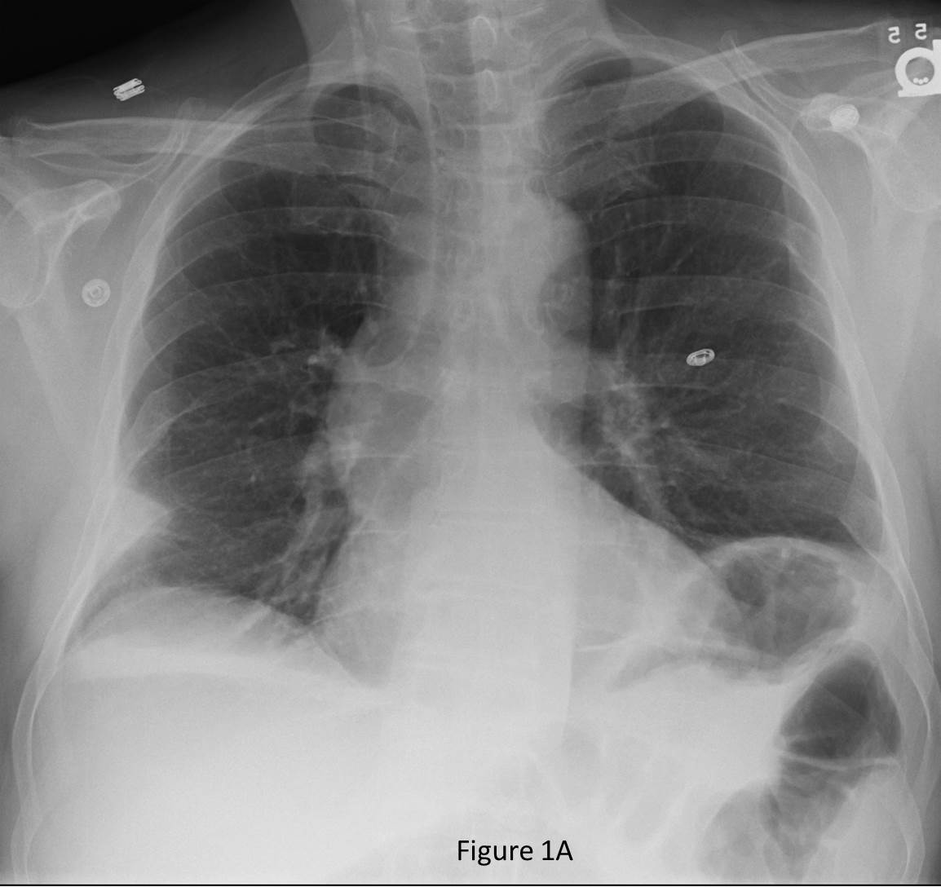

a) What does the VBG show (2 marks)

b) What is the most significant finding on the CXR (1 mark)

c)The RMO suggests that you could use the PERC rule to exclude a PE in this lady. How do you reply to his suggestion? (2 marks)

d) In the table below list 4 tests that you could use to risk stratify whether there is there is a PE, include 2 pros and 2 cons of each modality (20 marks)

TEST | PROS | CONS

Q2

A 54 year old man with a history of COPD and bronchiectasis presents to ED with SOB and chest pain. He has no wheeze, fever or cough.

P 130
BP 90/30
Sats 91%
RR 40
Temp 37.0

His Chest XRay is shown below

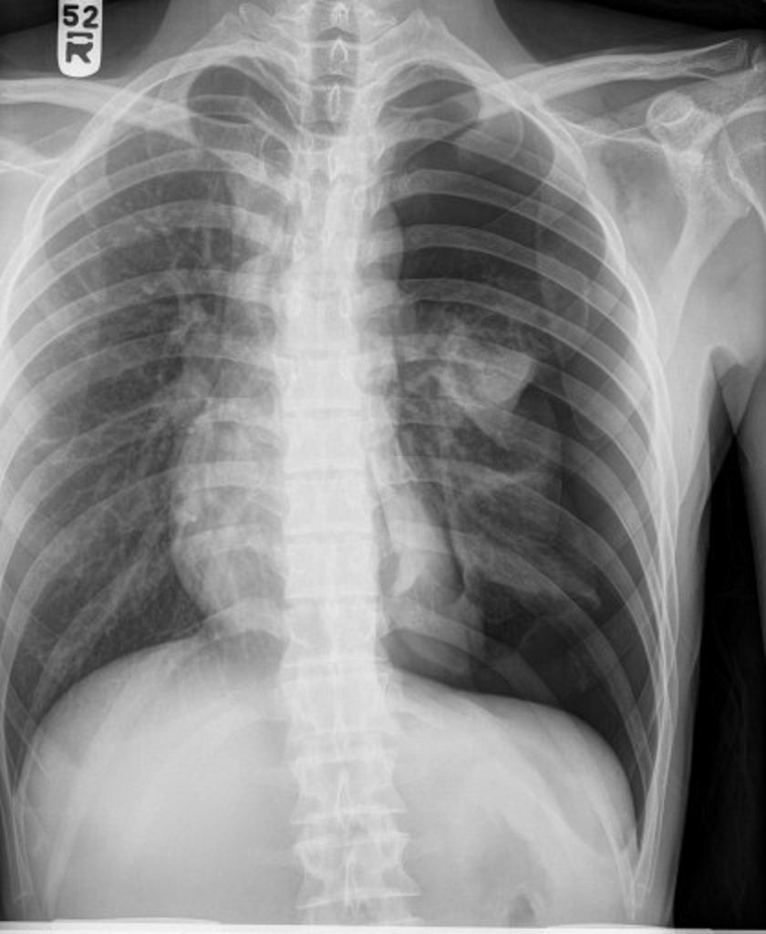

a) List the management steps you will perform for this patient (4 marks)

There are no beds in the hospital and the patient remains in the ED short stay area for 24hrs

b) What criteria must be met before this patient can be safely discharged home (3 marks)

c) Outline the discharge advice that you would give to this patient prior to him leaving the hospital (6 marks)

Q3

A 7 year old boy presents with worsening asthma for the past 12 hours.

a)List four features of life threatening asthma (4 marks)

On examination he has marked use of respiratory muscles, appears emotionally distressed and is only able to speak single words.
HR 150, RR 60, SaO2 88% on room air.

b)List your immediate management in the first 30 minutes, including drug doses (5 marks)

c) What other therapies might you consider if your first line medications fail (2 marks)
d) The patient’s condition worsens and despite appropriate escalation of therapy he is intubated in the ED.
Outline your ventilator settings with rationale (10 marks)
Parameter | Setting | Rationale
Respiratory Rate
Tidal volume
Peak insp pressure
PEEP
I:E ratio

Following intubation the patient becomes progressively more tachycardic and hypotensive.
e) List 4 possible causes (4 marks)

5. What is your immediate action in managing this situation? (1 mark)

Q4

A 54 year old homeless indigenous male presents to a tertiary ED with ½ cup of haemoptysis. He partner tell you he has been subjectively febrile and has an obvious cough and increased work of breathing. He is complaining of vague, non-specific chest pain. He is heavily intoxicated and unable to provide you with much history

P120
Sats 91% RA
RR 34
Temp 37.4
BP 90/70

- List the differential diagnosis for her condition (7 marks)
Her chest XRay is shown below

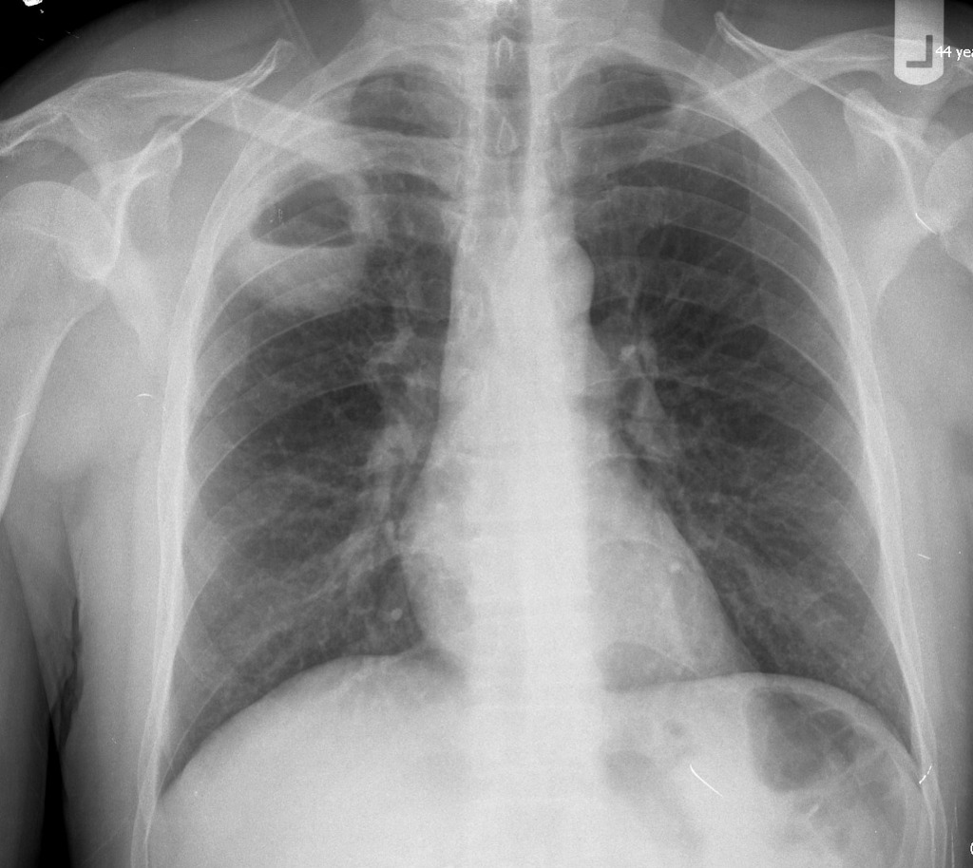
- List the positive abnormal findings on this CXR (2 marks)

- Excluding blood tests, list the 3 most important investigations you will order, give a reason for each (6 marks)
d) List your ED management steps for this patient (5 marks)

Q5
You are the morning consultant after a busy nightshift and are about to get handover from the team A 54 year old man from interstate has been placed onto CPAP via facemask. He has had some chronic worsening SOB but became acutely more SOB at 4am this morning. He has bilateral swollen legs.

You learn that the patient has become confused, has lashed out and punched the ED registrar in the face

P120
BP 90/50
Sats 89% on 100% FIO2 CPAP
RR 34
Temp 37.9

His CXR is shown below

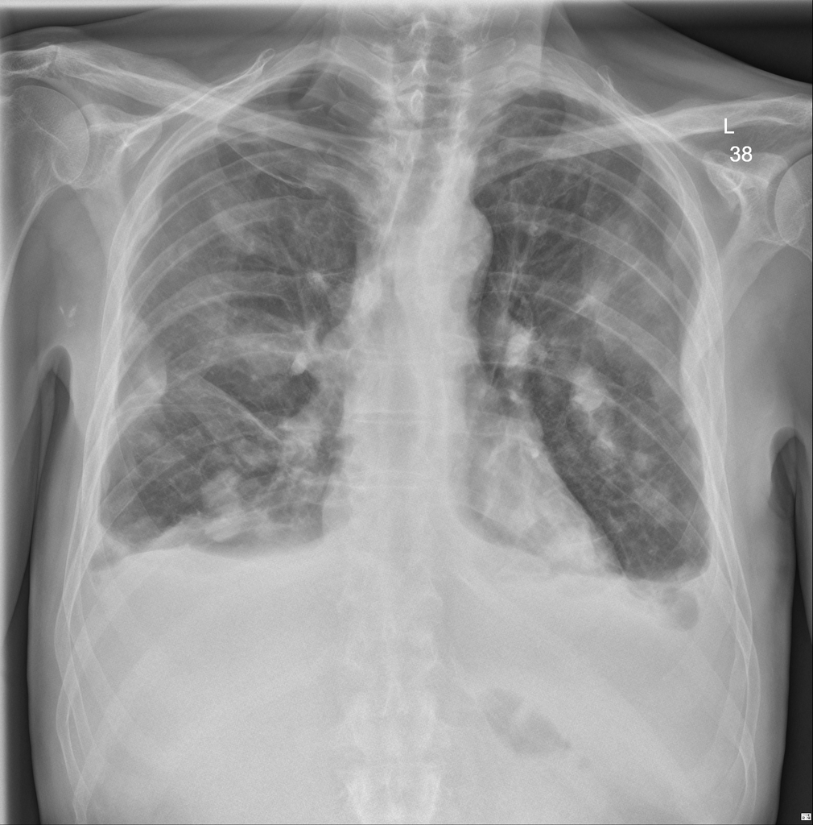

a) List the abnormal findings on this CXR (2 marks)

b)What is the most likely underlying cause for this? (1 mark)

His ECG is shown

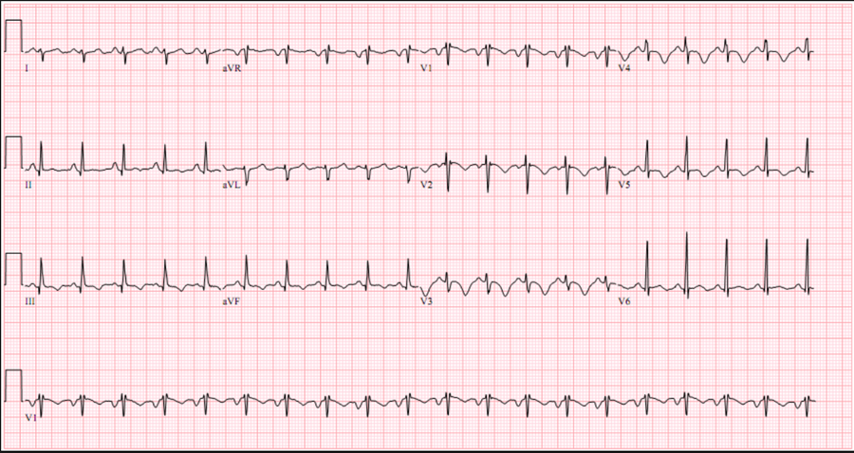

c) List the abnormal features in this ECG (5 marks)

- What acute diagnosis does this ECG suggest? (1 mark)
e) List the steps you will take to deal with the assault on the ED registrar (5 marks)

Q6

A 4 year old boy presents to ED with a 1 day history of refusal to eat. He is febrile, distressed and drooling. The RMO has placed an IVC prior to your arrival. Mum is very upset as this has distressed the child and now he has noisy breathing. You were not aware of the patient being in the department for the last 90 minutes.

P130
BP 90/60
Sats 99%
RR 24
Temp 39.1

a) List your differential diagnosis (5 marks)

The parent has some X-Rays from the GP of chest and lateral soft tissues – shown below

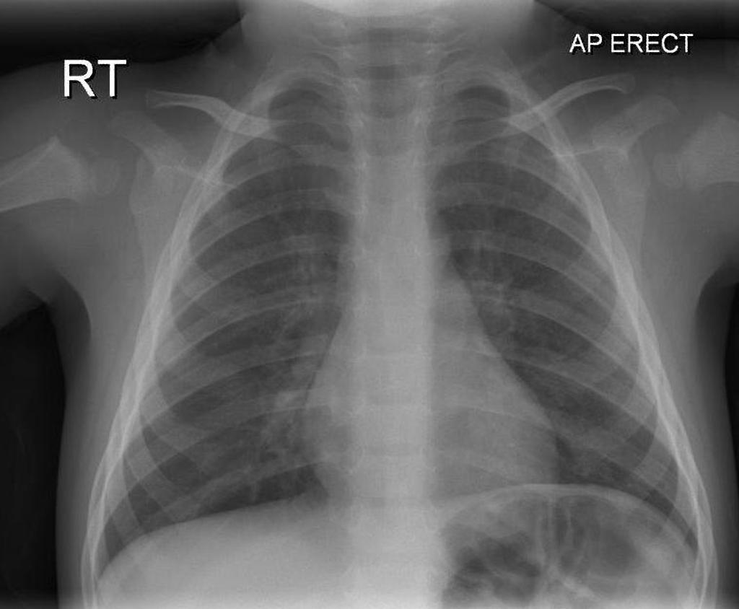

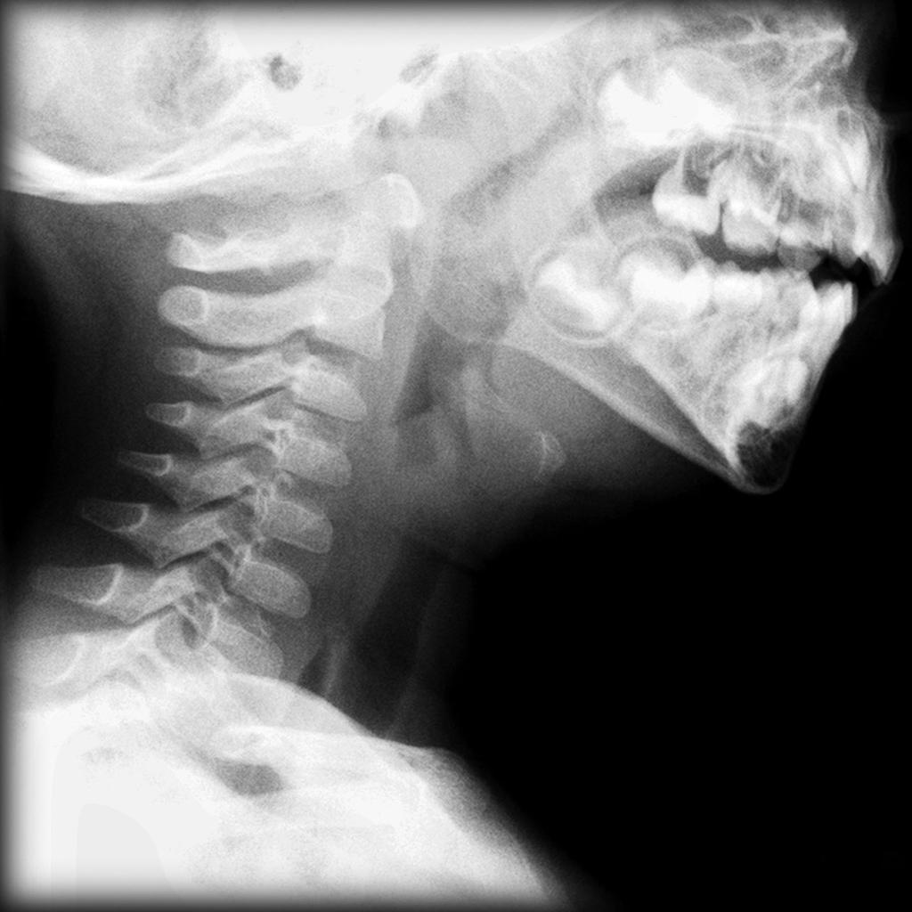

b) What does this CXR show? (1 mark)

c) What does the lateral soft tissue of the neck Xray show? (1 mark)

d) List the actions you will take in the next hour (6 marks)

e) List the likely causative organisms (4 marks)

Q6

A 74 year old man with known mild COPD presents with SOB. He was recently admitted to hospital with an exacerbation of COPD. He has been shown to have a left pleural effusion on CXR. He feels “terrible”. The registrar looking after the patient has performed a diagnostic pleural tap. The results are shown below.

P120
BP 100/80
Sats 91% RA
RR 30
Temp 37.9

Pleural Fluid Levels
5 mls cloudy yellow fluid
pH 7.1
WCC 6000/mm (neutrophils 80%)
Protein 32g/L
Albumin 34g/L
LDH 225 IU/L
Glucose 3.0mmol/L

Serum Levels
Protein 46g/L
LDH 260 IU/L (ref range 140-280)
Glucose 5.2mmol/L
Serum Albumin 35g/L

a) Does this represent transudative or exudative effusion, give 3 reasons? (4 marks)

b) What is the most likely cause for this result? (1 mark)

c) List your immediate actions over the next hour (5 marks)

d) List 5 other causes of a transudate and 5 of an exudate in the table below (10 marks)

TRANSUDATE | EXUDATE

Q7

You are designing an intubation checklist for your department, and are putting together a draft for review by the consultant group.

a) Complete the following template with your proposed checklist items, 7 items per column (28 marks)

Q8

A 2 year boy presents with stridor. Mum thinks it is croup and has had him in a steamy shower for 30 minutes without effect. He has moderate work of breathing and stridor at rest.

P 140
BP 80/50
Temp 37.6
Sats 98%
RR 40

a) Aside from croup, list the possible causes of stridor in this child (5 marks)

b) List the initial crucial medical management steps (2 marks)

The child deteriorates despite maximal medical therapy.

c) What are the indications for intubation (4 marks)

d) List the essential preparation steps, equipment and drugs that you will require should you need to intubate this child (15 marks)

Q9

A 52 year old lady is recovering in the resus bay after a closed reduction of an Colle’s fracture under Bier’s block. She had a fall from 1m earlier in the day, and also has a femoral shaft fracture that will be operated on within 24 hours, but there are currently no available theatre slots. She has a morphine PCA for ongoing analgesia

You have been asked to review her because she has become peripherally and centrally cyanosed. She has sats of 88% on a NRB mask at 15L and feels SOB.

a) List the possible differential diagnoses (5 marks)

The ICU registrar attends and takes an arterial blood gas

pH 7.46
pCO2 32
pO2 326
HCO3 22

c) What now is the most likely diagnosis? (1 mark)

d) What is the most appropriate definitive treatment

