Renal/Urology Questions – Fellowship SAQ
Question 1
A 17 year male presents with a 5 hour history of a painful left testicle and nausea. He has been playing football and thinks his testicle may have been “knocked” during the game, although doesn’t recall a specific event.
a) List the features on history and examination that make torsion of the testicle the most likely differential diagnosis above any other (5 marks)
Sudden onset
Severe and unremitting pain
High riding testicle
Transverse lie
Cremasteric Reflex Loss

b) List four additional differential diagnoses and for each a positive examination finding that would make this diagnoses most likely (8 marks)
Differential | Examination Finding

Differential | Examination Finding
Ruptured Testicle | Abnormal contour of testicle with hydrocele
Torsion of Appendage | Blue spot sign
Epididymo-orchitis | Tender epididymis/penile DC/fever
Incarcerated Inguinal Hernia | Cough impulse, hernia on exam passing superomedial to pubic tubercle
Renal Colic with referred pain loin-groin | Renal angle tenderness, absence of other testicular findings

The urology team available are currently operating on a critically unwell patient. They are likely to be 1 hour before they can see the patient.
c) How will you manage this patient (4 marks)
Contact the general surgeons as time critical at 5 hrs to get to theatre asap
Attempt manual detorsion with analgesia/sedation in ED if any delays to OT
Symptomatic treatment – titrated IV analgesia and antiemetics
NBM
An USS should not be performed if it is likely that this will slow down the progress towards getting definite management

Question 2
A 76 year old man presents to ED with right loin to groin pain. He has a history of hypertension, gout and hypercholesterolaemia. His observations are shown below:

P 130
Sats 99% RA
RR 30
BP 100/60
Temp 37.6

The RMO looking after the patient is keen to put the patient into the Short Stay area to await a CTKUB to exclude renal colic as a cause.
a) List 5 exclusion criteria you might include in a short stay renal colic protocol
Acute renal failure / worsening renal function
Infective Sx/Fevers/Sepsis criteria
Evidence of obstructed renal tract e.g. on bedside USS
Pain lasting >24 hrs or recurrent pain – suggests likely to be large and not pass
Stone >7mm if imaging already performed
The CTKUB is shown below

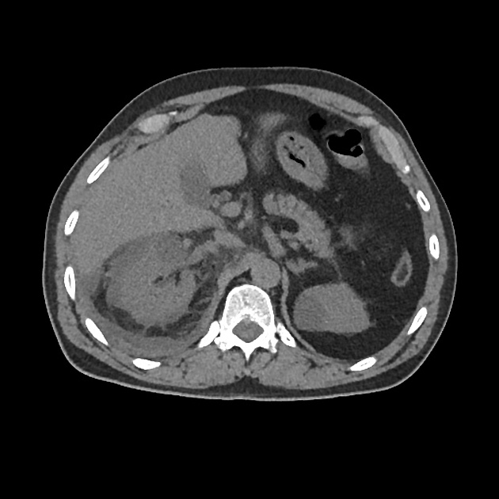
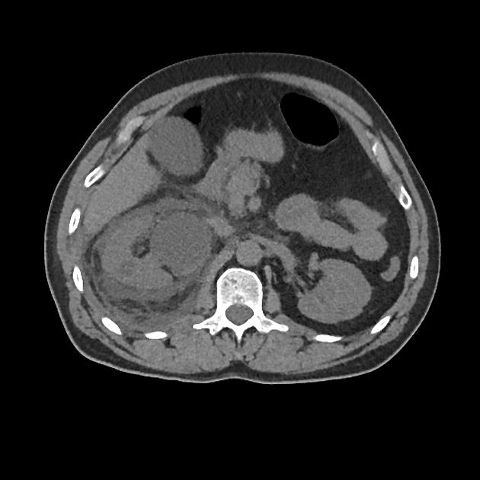
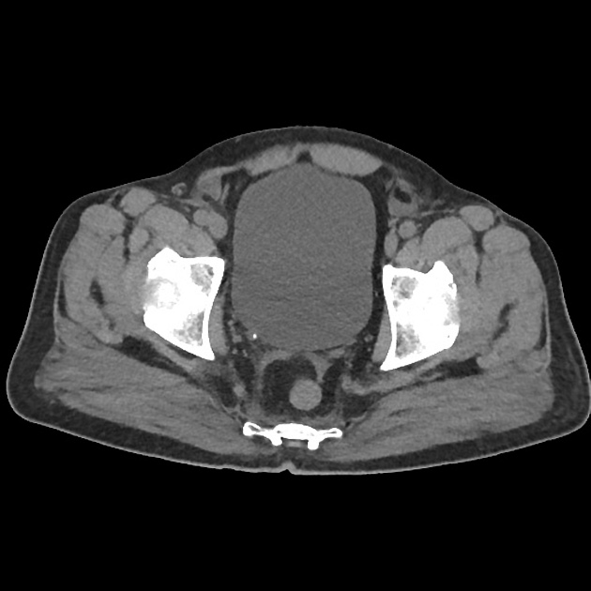
b) List the abnormal features on these CT slices (3 marks)
Right VUJ calculus
Right sided urinoma
Stranding around right kidney
c) How will you treat this patient in the ED (5 marks)
NBM
IV fluids
Antibiotics – Ampicillin 2g tds, Gentamicin 4-6mg/kg, (alternatives e.g ceftriaxone and gent)
Analgesia – titrated parenteral opiates and antiemetics
Urgent urology consult +/- drainage of uroma by interventional radiology

Question 3
A 32 year old man presents to ED with a swollen penis.
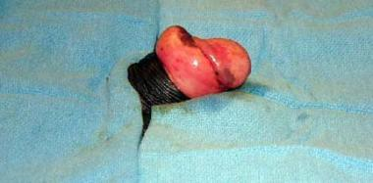
a) What is the diagnosis (1 mark)
Paraphimosis
b) List in the table the 3 strategies you might use to correct this problem with a short description of how to perform (in escalating order of use, assuming that the one prior has failed) (6 marks)
Technique | Description
Manual foreskin reduction | Analgesia, lube and lignocaine gel, hold penis with gauze, grip proximal to foreskin and maintain distal traction on foreskin for 1-2 mins. Ice or a cool towel can help to reduce the swelling
Dundee Perth Technique | Sterile technique, penile block, multiple puncture holes in glans with sterile needle to let out oedema, then reduce
Dorsal Slit to Foreskin | Penile block, cut through dorsal foreskin to release tight band
Formal Circumscision | In OT, by urology/surg

Technique | Description

c) What discharge advice will you give to the patient when the abnormality is sucessfully corrected? (4 marks)
Analgesia – Panadol and nurofen
Ensure that always pull foreskin back over penis
May need a formal circumcision, refer to urology for assessment as OP
Return to ED if any issues e.g. pain/infection/recurrence

Question 4
A 54 year old man presents to a rural ED with a persistent erection after taking several Viagra tablets at what he describes as a “swingers party”.
He has priapism and resolved chest pain
a) List the steps involved in managing his priapism (assuming no resolution after each step) (7 marks)
Penile block
Insert a 19-21G needle into corpora laterally
Aspirate 30mls blood
Irrigate with NaCl 0.9% up to 10 times (controversial)
1-2mls 1:100000 adrenaline every 5 mins or until 10mls given
Alternatives are phenylephrine or metaraminol but both are less successful than adrenaline
Surgical shunt if fails
b) List 5 causes of priapism (5 marks)
majority related to haematological diseases, idopathic or treatment for impotence
sildenafil, tadalafil
intracavernosal papaverine, PGE1
sickle cell disease
antipsychotic medications
stimulants
prazosin and hydralazine
procoagulant states
haematological malignancies
spinal cord disease
vasculidites

During the procedure he develops chest pain. His ECG is shown. There is no onsite cardiology service, the nearest is 3 hrs away. He is moved to resus, monitored and has 2 IV lines inserted
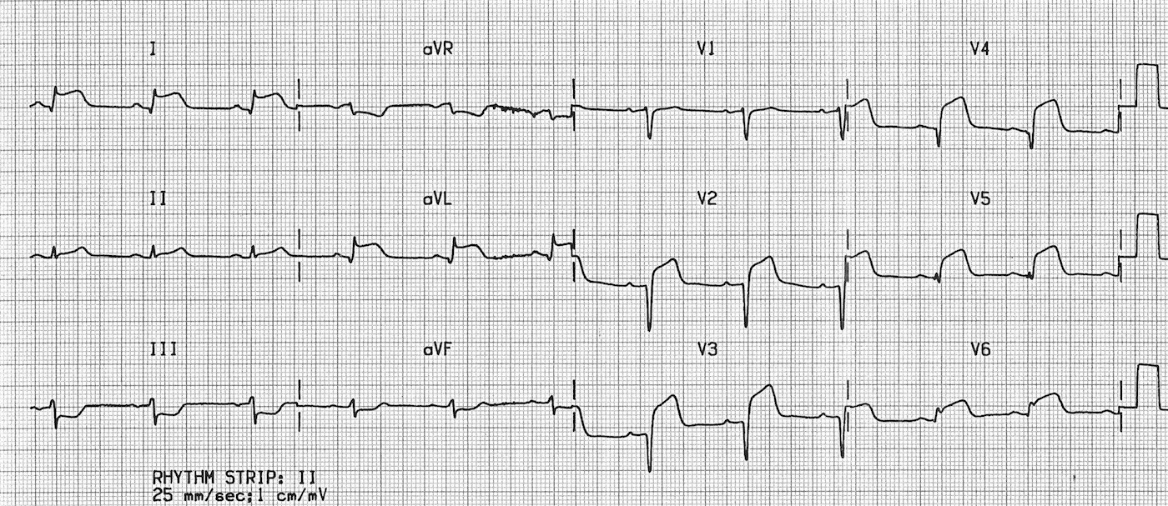
c) List the immediate management steps (6 marks)
Aspirin 300mg
Clopidogrel (300mg)
MUST AVOID NITRATES – fail if suggest to use or don’t mention need to avoid.
Morphine titrated
O2 if Sats <92%
Thrombolysis – dosing as per ETG
Consider Beta Blockade if no signs of heart failure

Question 5
A 43 year old lady with dialysis dependant diabetic nephropathy presents to a tertiary ED with lethargy and SOB. Her venous blood gas and observations are shown below
pH 7.1
pO2 64
pCO2 29
HCO3 15
K 7.1
Lact 4.3

P 120
BP 80/40
Sats 93% on 15L NRB
RR 30
Temp 37.9
BSL 30
She has a declining GCS and increased work of breathing necessitating urgent intubation.
a) In the table below list 4 potential complications you could encounter in the peri-intubation period specific to this patient, and for each, a specific measure that you will take to prevent the complication (8 marks)
Complication | Measure taken to prevent

Complication of Intubation | Measure taken to prevent
Hyperkalaemic Arrhythmia/Arrest | Avoid Sux, Treat with insulin dextrose, salbutamol and calcium gluconate
Worsening acidosis due to RSI apnoea | Bag gently through
Hypotension | Choose agents, suchas ketamine, less likely to cause hypotension, preload with fluid, push dose pressors/inotropes
Hypoxia as already desaturated on 15L | Preoxygenate on Bipap, Apnoeic oxygenation, most experienced intubator

When you attempt to intubate the patient this is the best view you can get with the video laryngoscope
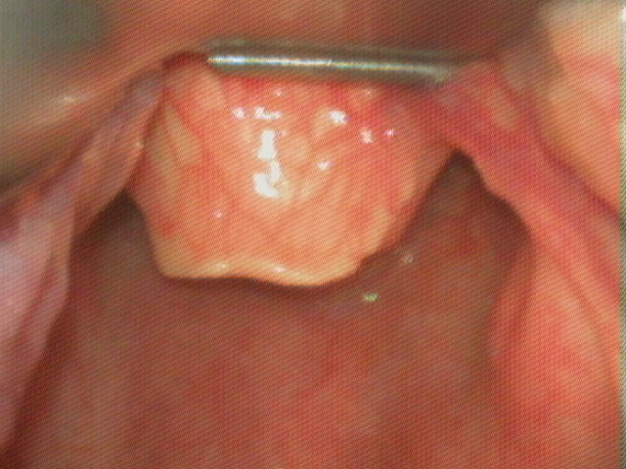
b) What is the Cormack-Lehane grade? (1 mark)
3
c) List the 5 differential diagnoses you will consider for this patients presentation (5 marks)
Missed dialysis with fluid overload
DKA
Pneumonia with T2 Resp failure
Cardiac Failure/Ischaemia
Other cause of sepsis

Question 6
A 28 year old renal transplant patient presents to the tertiary ED where you are working. He had a transplant 8 months ago after developing glomerulonephritis. His immunosuppression has recently been increased but he hasn’t been admitted to hospital since the transplant.
He presents with lethargy, weakness, mild abdominal/flank pain and nausea.
Obs
P110
BP 140/100
Sats 94% RA
Temp 37.5

a) List the 5 most important differentials you will consider in this patient
Transplant rejection
Uraemia/Renal Function
Sepsis – of any source but particularly UTI/pyelo/intraabdominal. Note: Signs can be subtle
Electrolyte disturbance e.g HyperK/Ca/, HypoMg
Recurrent glomerulonephritis
Other abdominal pathologies e.g pancreatitis/gallbladder pathology/diverticulitis
Side effects of tacrolimus or cyclosporine
His CXR is shown below
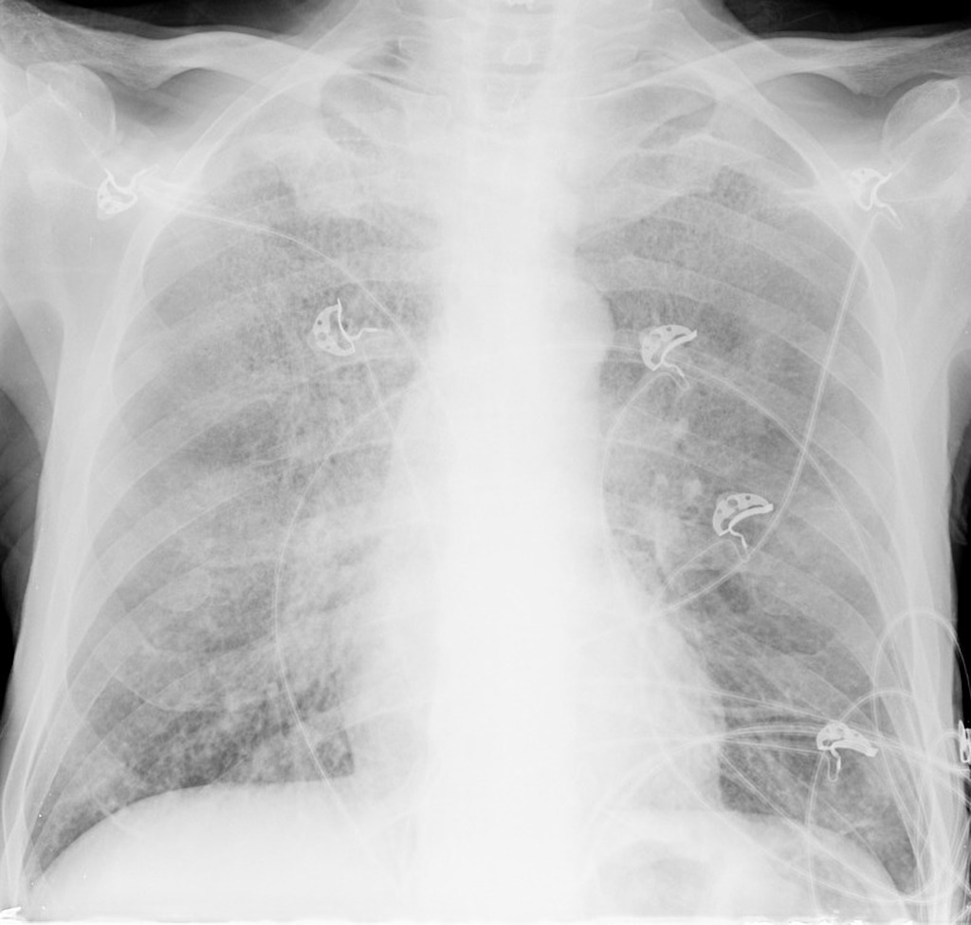
b) List the positive findings on this XRay (2 marks)
Hazy perihilar opacity
Slight blunting of right heart border ? early consolidation (silhouette sign)
c) List 5 potential organisms that could cause respiratory infection in this patient (5 marks)
Usual comm acquired bugs – Strep pneumo/haemophilus/
Atypicals – e.g. mycoplasma
Pneumocystis Jirovecii
Aspergillus
Cryptococcus
Candida
Viral organisms e.g influenza/RSV
The patients cyclosporin levels are low normal and the renal team decide to increase the dose. The patient is keen to know the adverse effects.
d) List the main side effects of cyclosporin (4 marks)
Renal – failure due to prerenal vasospasm
Neurological – anxiety, tremor, fasiculations, seizures
Metabolic - HyperK, Hyperuricaemia, HypoMg, Hyperglycaemia
Other – AF, hirsuitism, gingival hyperplasia/gingivitis

Question 7
The is a 42 year old patient in resus who has peritoneal dialysis. She presents with generalised abdominal pain and fever without associated symptoms . The VBG and observations are shown. IV access and monitoring are in situ. The RMO has sent FBC/EUC/LFT/CMP/CRP/Lipase.
UA is negative and a CXR and ECG are unremarkable
The RMO has asked you to review the patient as he is worried they have cholecystitis

pH 7.21 P 110
pO2 23 BP 90/60
pCO2 32 Sats 95% RA
HCO3 16 RR 25
Na 129 Temp 37.9
K 5.1
Cl 102
Lactate 2.1
Cr 340
Gluc 32
Ketones 0.9

a) List the abnormalities on the blood gas, show the calculations you have performed
NAGMA
AG = 129-(102+16) = 11
Complete resp compensation
(1.5 x 16) + 8 = 32 (exp CO2)

b) List your actions in the first hour of this patient’s presentation (6 marks)
Obtain clean PD fluid sample for cell count, gram stain and culture
Send blood cultures
Commence intra-peritoneal antibiotics – ceftazidime or cefazolin 20mg/kg +/- Vancomycin 50mg/kg up to 2g
Analgesia – titrated IV opiates
Start insulin therapy to reduce the hyperglycaemia – bolus actrapid or IV infusion
Arrange imaging if non cloudy effluent or localising signs.
Contact renal and endocrine to review/admit the patient

Later that day the nurses report that the patient is confused and is trying to leave the ward.
c) List the criteria that you use when assessing a person’s capacity to make decisions that are at odds with the medical opinion
>18 Years or >14 yrs and Gillick competent
Have the cognitive capacity to understand the medical condition, the options for treatment, what is recommended, the potential adverse outcomes, the likelihood of these
(usually have a MMSE score of > 20)
Patients should be able to
-accepted information as reality
-retain information provided
-paraphrase information
-explain the possible consequences
-indicate the major factors in their decisions and the importance assigned to them

d) List 4 likely causes for the patient’s delirium (4 marks)
Sepsis
Hypoglycaemia due to insulin therapy
Morphine/other medications
Electrolyte abnormality e.g hyponatraemia worsened
Unrelated intracranial event e.g stroke – patients more at risk of cerebrovasc disease on dialysis
Other medical cause e.g silent MI

Question 8
A 45 year old man with chronic renal impairment presents to ED with mild confusion. He has had longstanding haematuria and flank pain which has been worse recently. He has recently been treated with rivaroxaban for lower leg DVT.
Bedside ultrasound of his flanks shows the following
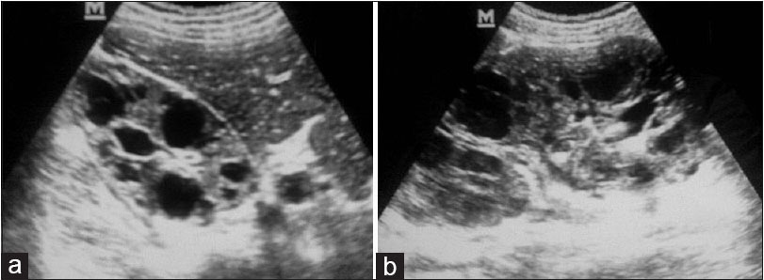
a) What is the abnormality on the bedside ultrasound and what condition does it likely represent (2 marks)
Bilateral renal cortical cysts
PCKD
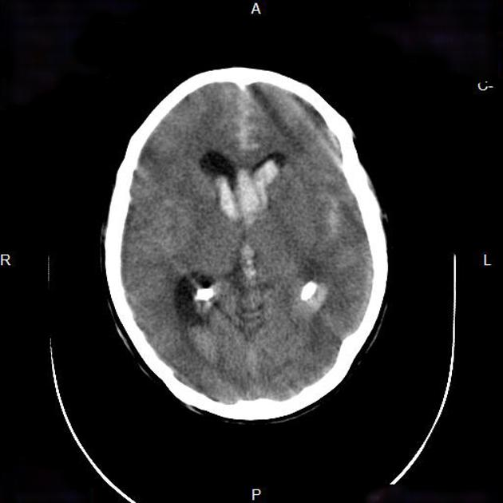
b) List the abnormal positive and relevant negative features on the CT scan (4 marks)
Lateral ventricles intraventricular haemorrhage
Frontal and temporal subarachnoid blood
Effacement of sulci
Some artefact ? movement
No midline shift
c) What is the underlying intracerebral pathology? (1 mark)
Berry Aneurism
c) Which other regions might the patient be likely to have cysts (3 marks)
Liver
Spleen
Pancreas
Seminal Vesicles

Question 9
A 17 year old soldier presents with nausea, vomiting and confusion post a 15km training run in Perth. He is dehydrated and has evidence of early shock. His observations are shown below:
P120
BP 90/60
Sats 97% RA
RR 32
Temp 39.9
The patient’s urine results are shown below
SG 1.050
Blood –large
Protein- +
Leucs – neg
Nitrites – neg

Microscopy
leucocytes – <10
erythrocytes – <10
Squamous epithelial cells - <10

a) In the table below outline the 5 most important tests (aside from urine analysis/microscopy) that you will order to determine the severity of the patients disease process (5 marks)
TEST | RATIONALE

TEST | RATIONALE
CK | ?rhabdo
EUC | Renal dysfuction related to rhabdo, hyperkalaemia secondary to muscle breakdown
LFT | ? haemolysis (bil), ?ischaemic hepatitis from hypoperfusion
Coags | ?DIC
CMP | Can have hypoCa/hyperphos in rhabdo

c) What condition do these urine findings suggest? (1 mark)
Rhabdomyolysis
d) List 5 potential complications of this condition (5 marks)
Acute renal failure
Metabolic derangements
- Hypercalcemia (late)
- Hyperkalemia
- Hyperphosphatemia
- Hyperuricemia
- Hypocalcemia
- Hypophosphatemia (late)
Disseminated intravascular coagulation
Mechanical complications
- Compartment syndrome
- Peripheral neuropathy

e) In the table below list 3 intravenous treatments that have been traditionally used to treat this condition, and one con/adverse effect of each (6 marks)

IV treatment | Con/Adverse Effect

IV treatment | Con/Adverse Effect
NaCl 0.9% - aim to maintain 2mls/kg/hr UO | Hyperchloraemia Acidosis with high volume saline use
Bicarbonate infusion | No evidence from prospective controlled trials  Risk of met alkalosis and hypokalaemia
Mannitol | No evidence from prospective controlled trials  Risk of osmotic diuresis and hypotension/volaemia

