Fellowship 2017:2_Psychiatry

Question 1

A 44 year old man presents with “bizarre behaviour”. He was seen initially by the Mental Health Assessment Team who were concerned that his presentation may have an underlying organic cause.

i) List 5 symptoms or signs that might suggest the presentation is more likely to be due to an underlying organic cause (5 marks)

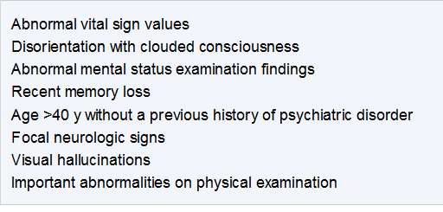

ii) List five (5) different categories of diagnosis, that can mimic psychiatric behavioural disturbances, for each type give a very specific example and an investigation that would be useful to prove that diagnosis. An example is given in the first row. (15 marks)

Diagnosis Type (5 marks) | Specific Diagnosis (5 marks) | Investigation (5 marks)
Metabolic | Hypercalcaemia due to pancoast tumour/PTHrp secretion | CMP/CXR

Diagnosis Type | Specific Diagnosis | Investigation
Sepsis | Any source e.g.UTI | Septic screen –BC/UA/MCS
Head Injury | Subdural, Concussion, SAH, Extradural | Imaging – CT/MRI
Toxic | Serotonin syndrome, Carbamazepine OD | Drug levels/tox screen
SOL | Any brain tumour, AVM | CT/MRI
Endocrine | Thyroid Storm, Addisions crisis, | TSH, cortisol
Hypoxia/Hypercarbia | Pneumonia, PE, hypoventilation due to opiates, COPD exac etc | Sats/ABG
Drug Induced | Illicit drugs, prescription drugs SE, intentional OD – as long as appropriate specific drug | Urine drug screen, ECG, VBG
Neoplastic | Brain tumour – primary or mets | Imaging – CT/MRI
Intracranial infection | Encephalitis due to HSV | LP

Many other examples are appropriate.
Must be different diagnosis types- cant be 2 marks for 2 endocrine causes

Question 2

A 76 year old man with early cognitive decline presents to emergency with confusion. He has not had any assessment of his dementia for several years and lives alone. The RMO is unsure whether he has progressive cognitive decline, delirium or a psychiatric presentation

i) Complete the table below with the characteristic clinical features of each potential cause

Clinical Feature | Delerium | Dementia | Psychiatric
ONSET
COURSE OVER 24H
CONSCIOUSNESS
ATTENTION
COGNITION
HALLUCINATIONS
DELUSIONS
BODY MOVEMENTS

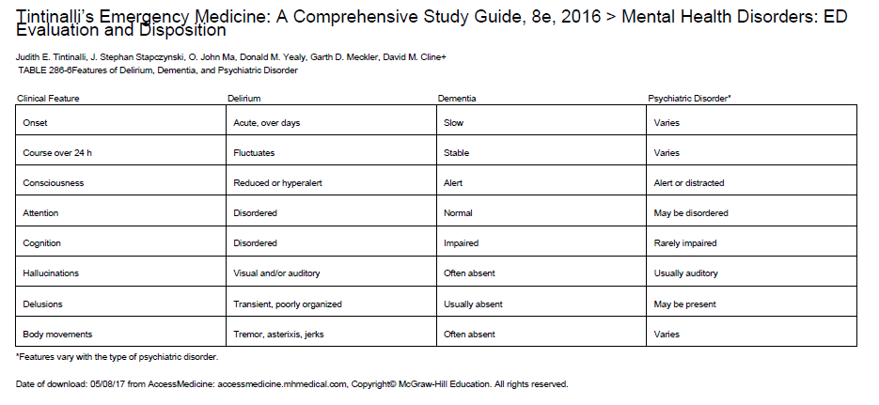

ii) He is climbing out of bed and has a high risk of falling. List the measures that you can take to reduce the risk of harm caused by falling

Higher nursing ratio
Provision of a

Question 3

A 27 year old female presents after spending the weekend at a dance festival. She admits to the use of illicit drugs and alcohol. She has a history of depression and has been an antidepressant for 7 months. She feels like she is having a “come down” after a big weekend. She appears anxious and her face is flushed.

P 120
BP 170/110
Sats 97%
RR 32
Temp 38.1

i) Complete the table below outlining the differences between the serotonic syndrome, NMS and anticholinergic syndrome (24 marks)

 | Serotonin Syndrome | Neuroleptic Malignant Syndrome | Anticholinergic Syndrome
Prescribed drug class responsible
Example of drug
Onset
Pupils
Skin
Neuromuscular Tone
Reflexes
Mental Status

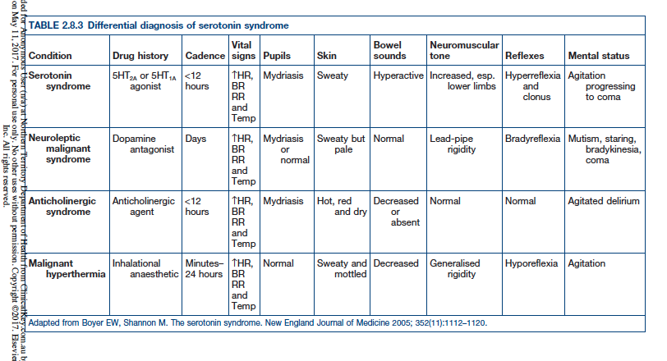

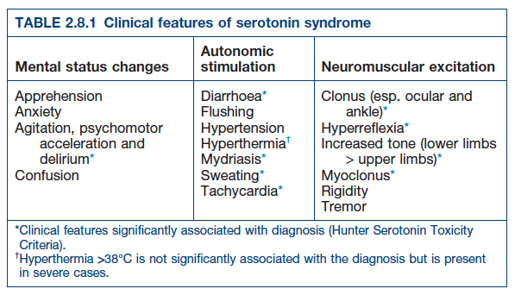

ii) List three (3) potential complications of severe serotonin syndrome (3 marks)
Rhabdomyolysis
Renal Failure
DIC

Question 4

A 21 year old man with a recent diagnosis of schizophrenia presents with a behavioural disturbance. He has been found wrapped in tin foil lying in a neighbours shed. He is agitated in the triage area where there are several children waiting to be seen. Verbal de-escalation has failed and he is refusing to come to the psychiatric assessment room or take any oral medications.

i) For each facet of the mental state exam in the table below, give one (1) finding that could suggest acute psychosis in the context of a known schizophrenic patient.

Mental State Exam Category | Findings
Appearance
Behaviour
Mood
Perceptions
Thought
Congnition
Insight

Mental State Exam Category | Findings
Appearance | Inappropriately dressed, unkempt
Behaviour | Tics, stereotypes, psychomotor agitation, restless, mannenisms
Mood | Inappropriate affect, elated mood, frightened
Thought | Thought insertion/withdrawal, delusions, loosening of associations, tangential, neologisms, paranoia
Hallucinations | Responding to AUDITORY hallucinations
Cognition | Impaired planning, impaired memory
Insight | Lacking

ii) The patient requires chemical sedation for his own, and the safety of others. In the table below list 6 measures you will take to increase the safety of this procedure, giving details for each

Safety Measure | Details

Safety Measure | Details
Call a CODE | Gets appropriately trained help and numbers of people required for a 5 point restraint
Ensure all staff participating have appropriate training and no impediments to participating | Reduces risk of physical harm to all if everyone knows the techniques
Use a specific room | Mattress, O2, safe space from other patients
Remove other people from the area | Prevents injuries
Ensure patients record is checked for ADRs | Could have dystonic/anaphylactic/Long QTc previously
Check current meds | To ensure patient has no interactions with proposed medications to be used
Briefing outside of room | To ensure everyone is aware of the process and has an opportunity to ask questions
Administer drugs IM rather than IV | Less likely to get a needle stick as takes less time
Check Obs immediately afterwards then continuous monitoring | To ensure no
Provide 1-1 nursing and a special afterwards | To detect when patient is waking
Use sedation score | To detect oversedation, risk of aspiration and hypoxia
Manage supine | Less likely to asphyxiate

Question 5

A 72 year old man is brought in by police after his neighbours found him intoxicated in a barn with a gun. He has longstanding untreated depression.

i) List five (5) major risk factors for suicidal behaviour in the elderly that you will explore in your assessment of this man (5 marks)

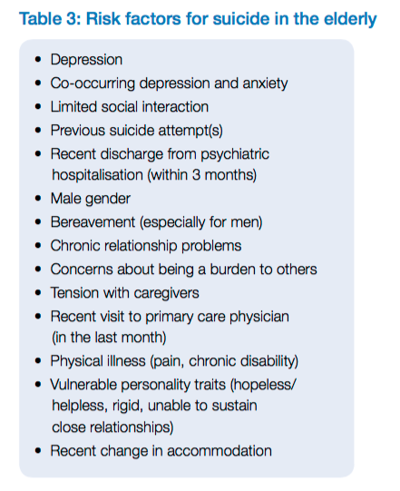

https://acem.org.au/getattachment/4f3dec74-84a1-4cad-97d4-d5dbf4c236d1/Victorian-Government-Department-of-Health.aspx
(READ THIS ACEM ENDORSED DOCUMENT!)

ii) The man claims that he feels better and wants to go home, you are concerned that he requires assessment under the mental health act. List the four (4) criteria he must meet to be legally involuntarily detained on the grounds of mental illness (4 marks)

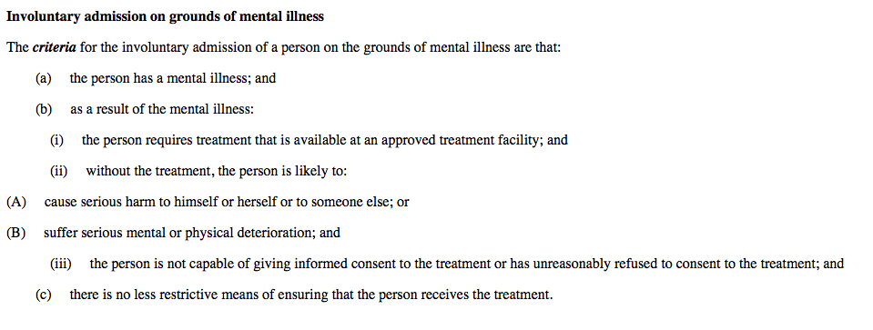

iii) After an overnight stay in the Short Stay Unit, he is assessed by the mental health team who feel his suicide risk is low. List five (5) factors that need to be considered in term of safe discharge planning for this man (5 marks)

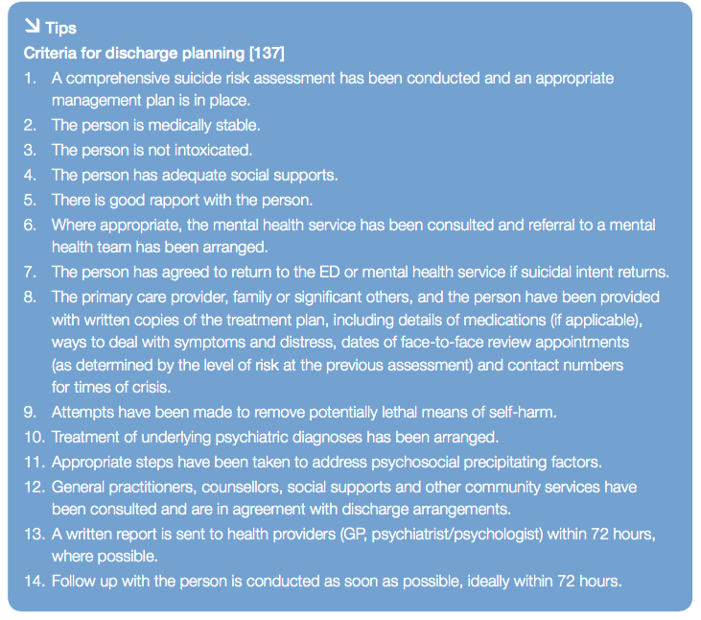

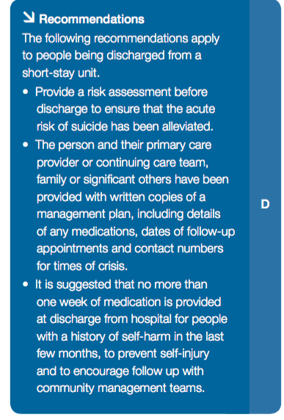

Question 6

A 12 year old girl presents with her schoolfriend. She has been cutting her thighs with a razor blade and is covered in blood. She doesn’t want her parents to be called. She states that she hasn’t seen them for 2 weeks and “they won’t care anyway”. She has multiple bruises and appears to have subtle jaundice. She has a flat affect and won’t make eye contact.

P 120
BP 90/60
Sats 99%
T 37.2
RR 24

i) List the 4 (four) broad priority issues that you need to address (4 marks)
Lacerations - ?haemodynamic instability – potential for deeper arterial cuts
Cause of Jaundice - ??panadol overdose vs other causes eg sepsis
Suicidal ideation – need for mental health act and involuntary admission of a minor
Contact with parents and ?FACS involvement as patient is a minor

ii) List six (6) features that you will seek on physical examination to risk stratify this child’s presentation (6 marks)

Depth of lacerations and any arterial bleeding/damage to neurovascular or tendinous structures
Evidence of hypoperfusion suggesting shock
Amount of blood seen on clothing
Evidence of coagulopathy – extent of bruising, bleeding gums, other bleeding sites
Other traumatic injuries that might suggest assault/NAI
RUQ tenderness that suggests hepatitis ?panadol OD

iii) List six (6) features you will seek in the mental health assessment that would indicate a high risk for suicide (6 marks)

- Stating her intent was suicidal
- Plan for killing herself including planning (i.e. notes, sorting out affairs)
- Previous suicide attempts
- Lethality of attempts
- Family Hx of suicide, conflict
- Friends/associates that have suicided
- Trouble at school
- Drug/alcohol abuse
- Hx of mental illness
- Feeling hopeless, helpless
- Flat/inappropriate affect
- Hard to engage
- Poor insight
Lack of support

Question 7

A 15 year old girl presents after not eating for 3 days, she states that she is trying to starve herself to death because someone has repeatedly physically and sexually assaulted her. She is tearful and withdrawn. Her father is a single parent and she has a younger sibling. Her father is en route to the hospital. She won’t disclose who assaulted her. The sexual assault team have been called

i) List the ten (10) issues that will need to be addressed in this child by the ED and sexual assault team (10 marks)

Determine if there are any immediate life threats/serious injuries that need to be treated
Provide food and water – may need to be IV
Provide support and reassurance that she is safe
Determine if she is pregnant
Determine the need for post coital contraception
Determine the need for PEP for HIV/immunisation for Hep B
Screen for STDs
Determine the risk posed by immediate family members to her and her sibling - ??need to involve FACS
Adolescent Mental Health Assessment +/- admission – assess suicide risk
Ensure chain of evidence – brown bag all clothes, encourage her not to shower till seen by Sexual Assualt team
Involvement of paediatrics
Contact police to report assault of a minor

ii) When her father arrives he wants to take her home. She refuses to see him “because she is embarrassed”. How will you manage the father (4 marks)
Don’t allow him to see the child in accordance with her wishes and for her mental and physical safety
Remain non judgemental, as he may not be the perpetrator
Explain the situation to him as the childs guardian
Gather information from the father about recent events and the child’s medical and mental health history
Open disclosure that you will need to refer to the police and child services who will investigate

iii) The child attempts to run from the department but has been blocked by the safety officer and is sitting on the waiting room floor crying. List 5 steps you will take in managing this situation (6 marks)
Needs to be returned to the department as not safe for discharge
Keep under common law or mental health act depending on the details of the situation
Verbal de-escalation and coaxing back to a safe place by someone trusted by the child
Ask her if there is another family member of friend that she would like to be contacted.
Take to a quiet, private room when can offer comfort measures such as comfortable bed, food and drink, TV etc.
Provide one on one nursing and a security officer to prevent her from leaving
Explain the reasons why she needs to stay in hospital and guarantee to her that she will be made safe
Contact paediatrics to try and arrange immediate review and a safe bed in a secure and private area away from the ED.
Only use physical and chemical restraint as an absolute last measure

Question 8

A 45 year old man presents to ED requesting alcohol detox. His GP has given him some diazepam tablets but he wants to be admitted to hospital. He is 140kg.

ii) List six (6) features on assessment that will help you to risk assess his potential for dangerous alcohol withdrawal which will help you to determine whether he needs inpatient management (6 marks)

Any current signs of alcohol withdrawal
Amount drank per day and duration of drinking
History of withdrawal when stops drinking – any booze free days usually
Current BAL
History of withdrawal seizures
Social supports/friends/carers
Whether has a home or place to stay, and where it is in relation to help
Comorbid conditions that will impact on his withdrawal, e.g. cardioresp disease, T1 DM
Evidence of complications e.g Wernicke’s

ii) The patient absconds from ED after waiting for 3 hours in the waiting room, to be seen. He is found with a reduced level of consciousness in the car park a few hours later. His observations are within normal limits. List the six (6) MOST LIKELY differentials that you will consider with reasoning for each (6 marks)

Intoxication – high likely
Seizure- from withdrawal
Benzodiazepine side effects – known to have this medication
Head Injury due to fall/ataxia – potentially ataxic from chronic etoh/cerebellar degen with often low platelets so high likelihood of ICH
Overdose of another substance – high risk of mental health problems in patients with alcoholism
Arrhythmia – must relate to ETOH use e.g torsades from low Mg
Hypoglycaemia

Note: Sepsis unlikely with normal obs
Others may be appropriate

iii) He has a GCS of 6 and is currently in the resus room with 2 lines and non invasive monitoring. List your eight (8) actions in the next hour

Oxygenation – NRB 15L to preox
Intubation - must anticipate difficult and get help/use VL/call anaesthetics/ramp/apnoeic oxygenation etc
Check bloods/ECG/VBG/BSL to look for a cause/toxidrome etc
Provision of thiamine 300mg IV
Anticipate likelihood of seizures
Imaging – CT when stable to determine if ICH
CXR – to check ETT and look for signs of aspiration
Keep sedated with midazolam to manage risk of seizures
Contact ICU
Contact Family

