Paediatrics Fellowship SAQ
Question 1

You have received notification that a term baby has been born in an ambulance en route to ED.
APGAR currently 5 at 5 minutes.

a) What are the 5 components of the APGAR scoring system (5 marks)

b) List 3 anatomical and 2 physiological differences between a neonate and an adult. For each difference state how the difference might impact upon your management of this childs airway or breathing. (10 marks)

On arrival the child has poor tone and respiratory effort. There has been no cry since birth despite continuous stimulation. Guedel in situ. Several attempts at canulation have failed.

P 100
BP 50/30
Sats 60% RA
RR 13
Temp 34.2

c) List an action/interventions you will perform on this child for each category in the table below, giving details of each (e.g equipment sizes/doses/steps). This excludes calling for external help (10 marks)

Category of Intervention | Intervention | Details
AIRWAY
BREATHING
CIRCULATION
DISABILITY
OTHER

Question 2

A 4 year old male has been brought in my ambulance after being found face down in the backyard pool. His observations are shown below

P 40
BP 60/50
Sats 67% on 15L NRB
RR 8
Temp 34.2

a) List 4 factors that predict a poor outcome in drowning patients (not specifically relating to THIS patient) (4 marks)

b) In the table below, list 4 potential acute complications of intubation, and the steps that you will take when preparing to minimise the risk of each complication. (8 marks)

Complication | Measure to Prevent

The child’s CXR is shown.

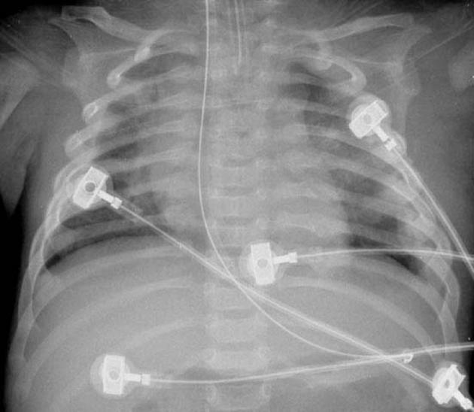

c) Describe the positive and negative findings (5 marks)

Question 3

A 20 day old neonate is brought in by parents due to poor feeding and being “floppy”. The birth was uncomplicated and child discharged from hospital at 24 hours.

Observations
P 170
BP 69/50
Sats 87%
RR 50
Temp 37.3

a) List 3 broad categories of differential diagnosis for this presentation and give a specific example of each (6 marks)

A CXR is performed as the child appears tachypnoeic.

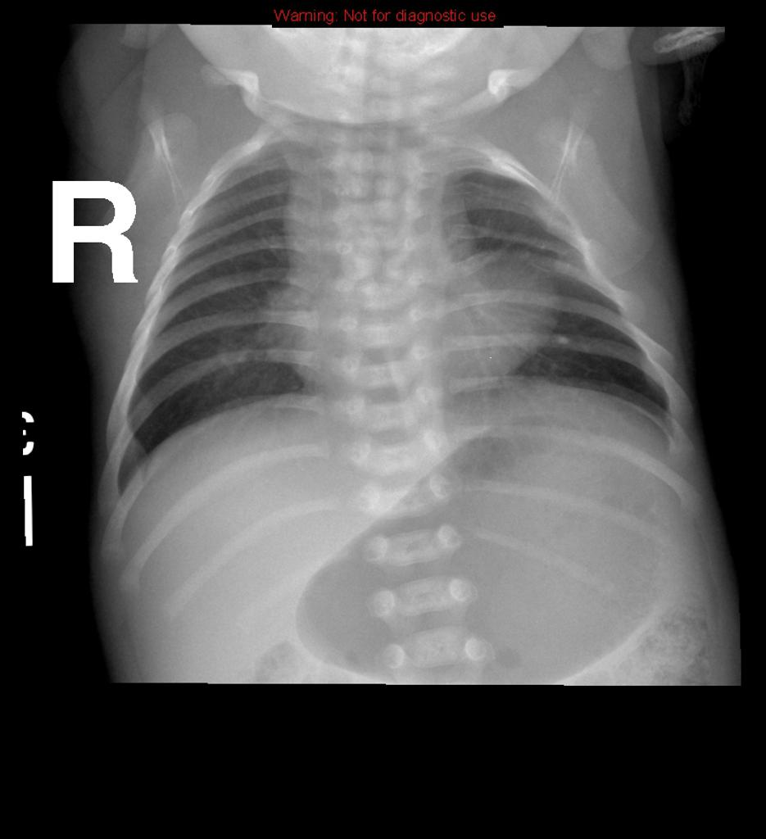

b) What sign does this CXR show and what condition does this suggest (1 marks)

The child becomes upset and on crying mum points out that the child has developed the following sign. Sats drop to 78% but other obs remain the same.

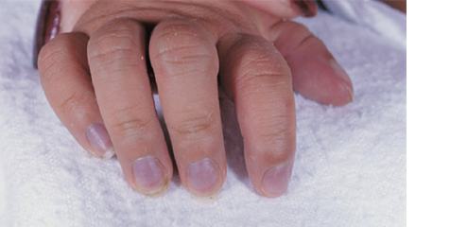

c) Outline your approach to management of this episode (6 marks)

Question 4

A 3 year old boy has been brought to ED by his parents as he has a fever and rash. Mum is concerned that he has measles.

P 130
BP 80/50
Sats 99%
RR 25
Temp 37.7

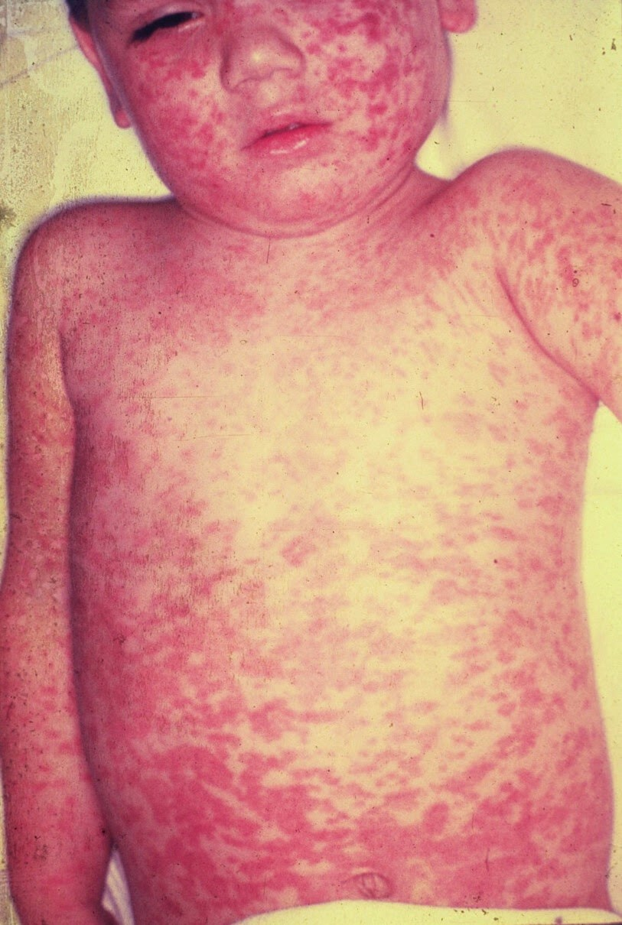

a) Other than measles, list 4 other differentials should you should consider for this rash (5 marks)

b) What features on examination, other than rash and fever, might you expect to find in a patient with measles (4 marks)

c) What are the key actions with regards to infection control (6 marks)

Question 5

A 7 day, term born neonate presents to ED with jaundice. Mum is not sure when it started. The child has been exclusively bottle fed and was born by elective C-Section.

a) Complete the table below with the potential causes of conjugated and unconjugated jaundice IN THIS NEONATE (10 marks)

Unconjugated | Conjugated

b) What broad features on examination will you seek to determine the cause of the jaundice (4 marks)

c) Aside from LFTs and conjugated/unconjugated bilirubin, list 5 laboratory tests you might perform to investigate the cause. Give your rationale for each (10 marks)

Question 6
A 3 month old, 5kg baby presents with PR bleeding. The child has vomited twice today. The child is seen in ED by the RMO. Mum has brought you a dirty nappy

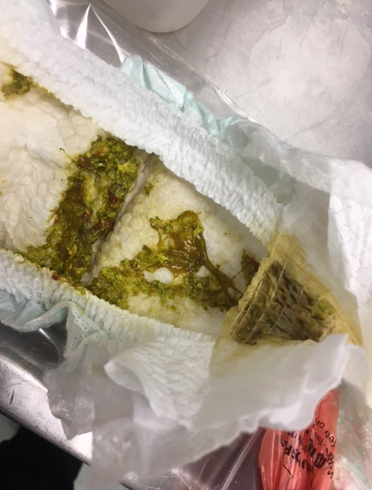

a) What are the likely causes of PR bleeding will you consider in your assessment of this child?

The child is initially well and is discharged from hospital, to follow up with the GP. 48 hrs later the child returns with copious diarrhoea, is floppy and has a fever of 40 degrees. You estimate them to be 10% dehydrated.

P 160
BP 60/40
RR 50
Sats 99%
Temp 37.9

pH 7.19
pCO2 24
HCO3 12
Lact 4.3
Na 132
K 3.1

b) List the intravenous fluid management that you will institute for this child over the next 24 hrs

c) What other management will you commence assuming that the childs haemodynamics and VBG improve with fluid therapy (2 marks)

The mother writes a complaint expressing her displeasure that the child’s illness was not picked up and treated when they originally presented to the ED.

d) Outline the steps you will take in addressing this complaint (6 marks)

Question 7
A 3 month old girl presents with fever and malodorous urine. She looks well, is feeding and has good hydration.

P 100
BP 110/70
Sats 99%
RR 30
Temp 37.6

a) In the table below list the options do you have for the collection of a urine specimen, with 1 pro and 1 con of each

Method | Pro | Con

A clean, reliable urine sample shows the following

Leuc ++
Prot normal
Nitrites pos
Blood ++

b) List the ED management and follow up plans for this child (5 marks)

You notice when you are checking results that the patient has grown pseudomonas in their urine

c) Outline how you will deal with this now (4 marks)

Question 8
An 8 year old indigenous girl presents to ED with a sore left knee. She has poor English language skills and is very quiet and shy. Her mother was present but popped out and has been gone for 20 minutes. Nobody is sure where she has gone and when she will return.

The girl is crying whenever you try to examine her

P 100
BP 130/90
Sats 99%
RR 12
Temp 37.3

a) In the table below outline 4 possible causes of her knee pain, and 2 examination findings and 2 tests that you may order to add weight to the diagnosis

Diagnosis | Examination | Tests

Her left knee Xray is shown

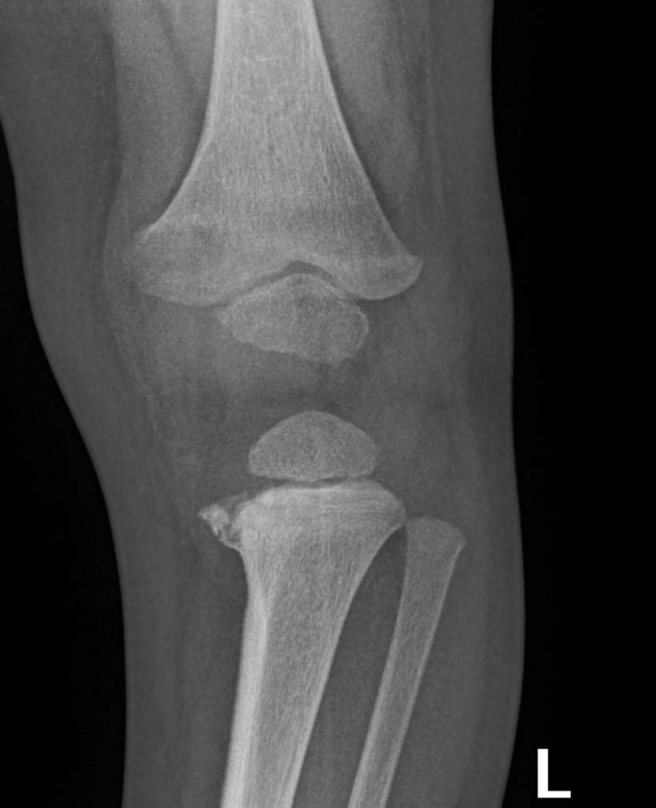
b) Describe the abnormality shown in this XRay (1 mark)

c) What is the significance of this injury (1 mark)

d) How will you further investigate and manage the patient (6 marks)

Question 9

A 3 year old boy presents with a rash. He was been ‘cranky’ according to mum for the last few days. He is off his food and has been crying in ED for the whole time. He had 2 days of diarrhoea last week but normal stools for 5 days now.

Obs are normal, no fever recorded

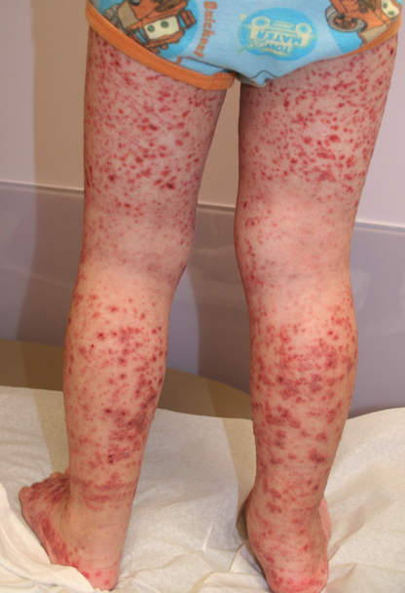

a) Describe the rash (3 marks)

c) List your diferential for this rash (4 marks)

d) What other features on examination will you seek out to narrow your differential? (10 marks)

c) List the initial tests you will order in ED and give a reason for each (6 marks)

