Paediatrics Fellowship SAQ
Question 1

You have received notification that a term baby has been born in an ambulance en route to ED.
APGAR currently 5 at 5 minutes.

a) What are the 5 components of the APGAR scoring system (5 marks)
Appearance/Colour
Pulse
Grimace/Reflex Irritability
Activity
Respiration

b) List 3 anatomical and 2 physiological differences between a neonate and an adult. For each difference state how the difference might impact upon your management of this childs airway or breathing. (10 marks)

Large head – position in neutral not sniffing, towel under shoulders
Short trachea – potential for accidental extubation/RM intubation
Narrowest at cricoid – need for uncuffed/need to use high vol low press cuff/risk of stenosis
Small airways – increased risk obstruction, must suction regularly
Large floppy epiglottis – use a straight blade on top of epi
Soft tissues easily compressed – care during BVM
Easily damaged soft palate – guedel in right way up
Low FRC – fast desat
High Met rate – fast desat
Faster RR – need to ensure match the rate
High Ant Larynx – anticipate difficulty, use VL, straight blade, get help
Straight Ribs – limits VT
Reliance of diaphragmatic breathing – need to ensure stomach decompressed

On arrival the child has poor tone and respiratory effort. There has been no cry since birth despite continuous stimulation. Guedel in situ. Several attempts at canulation have failed.

P 100
BP 50/30
Sats 60% RA
RR 13
Temp 34.2

c) List the immediate action/interventions you will perform on this child for each category in the table below, giving details of each (e.g equipment sizes/doses/steps). This excludes calling for external help (10 marks)

Category of Intervention | Interventions | Details of Interventions
AIRWAY | Airway opening manoeuvres and adjuncts  Suction  Intubation | Head in neutral, chin lift, guedel, BVM in time with resps plus additional  Small gauge soft suction catheter under direct vision  Straight blade, ETT approx. 3.5, 11cm depth, check CO2
BREATHING | PPV with neopuff  Ventilation | Resuscitaire/Neopuff 5-10 PEEP, plus 5-10 IPAP  Vt 6mls/kg (approx. 20mls for term baby), PEEP 5,
CIRCULATION | Insert IO  Insert Umbi Line  IV fluid bolus | Into proximal tibia medial border 1cm below TT  Sensible description of procedure  20mls/kg NaCl
DISABILITY | Check BSL | If low, 2mls/kg 10% dextrose
OTHER | Warm child | Overhead heater in resuscitaire/

Category of Intervention | Intervention | Details
AIRWAY
BREATHING
CIRCULATION
DISABILITY
OTHER

Question 2

A 4 year old male has been brought in my ambulance after being found face down in the backyard pool. His observations are shown below

P 40
BP 60/50
Sats 67% on 15L NRB
RR 8
Temp 34.2

a) List 4 factors that predict a poor outcome in drowning patients (not specifically relating to THIS patient) (4 marks)

CPR ongoing in ED
Asystole at any time
>10/15 mins submersion (Tintinalli/Dunn)
Non reactive pupils and GCS <5 when arrive to ICU are best predictors of survival
Quality of CPR

Orlowski Scale (>3 = 5% surv, <3 90%)
Coma
No attempted resus
>5mins submerged
Age <3
Met Acidosis <7.1

b) In the table below, list 4 potential acute complications of intubation, and the steps that you will take when preparing to minimise the risk of each complication. (8 marks)
Complication | Measures to prevent
Hypoxia | Preoxygenation with BVM, 100%,
Worsening acidosis | Ventilate with BVM pre and during intubation if acidotic
Hypotension | Preload with fluid bolus 20mls/kg NaCl, mataraminol or other push dose pressor/noradrenaline infusion
Aspiration | Insert NGT pre intubation and aspirate stomach, ?cricoid pressure (controversial)
Failure | Most experienced intubator to attempt first, VL,

Complication | Measure to Prevent

The child’s CXR is shown.

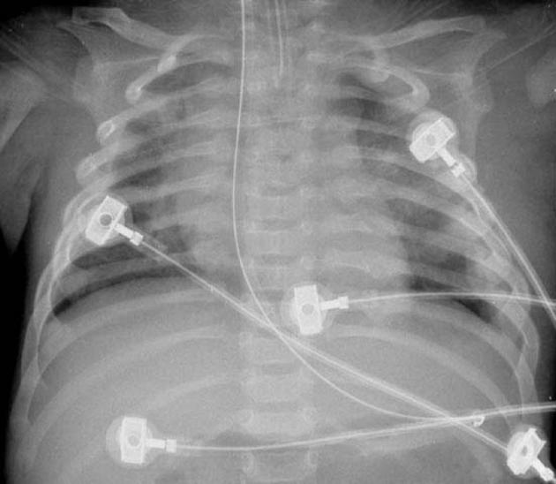

c) Describe the positive and negative findings (5 marks)
Intubated – appropriate depth of ETT
NGT in stomach
5 lead monitoring leads in situ
Multiple bilateral healing rib fractures raising concern for NAI or prior traua
No signs of aspiration or pulmonary airspace opacity that would be consistent with submersion

Question 3

A 20 day old neonate is brought in by parents due to poor feeding and being “floppy”. The birth was uncomplicated and child discharged from hospital at 24 hours.

Observations
P 170
BP 69/50
Sats 87%
RR 50
Temp 37.3

a) List 3 broad categories of differential diagnosis for this presentation and give a specific example of each (6 marks)

Sepsis – e.g EColi, GBS, Listeria, Staph/Meningitis/pneumonia
Metabolic – PKU, jaundice
Cardiac – e.g Tetralogy of Fallot Tricuspid Atresia, Truncus Arteriosus, Transposition, TAPVR

A CXR is performed as the child appears tachypnoeic.

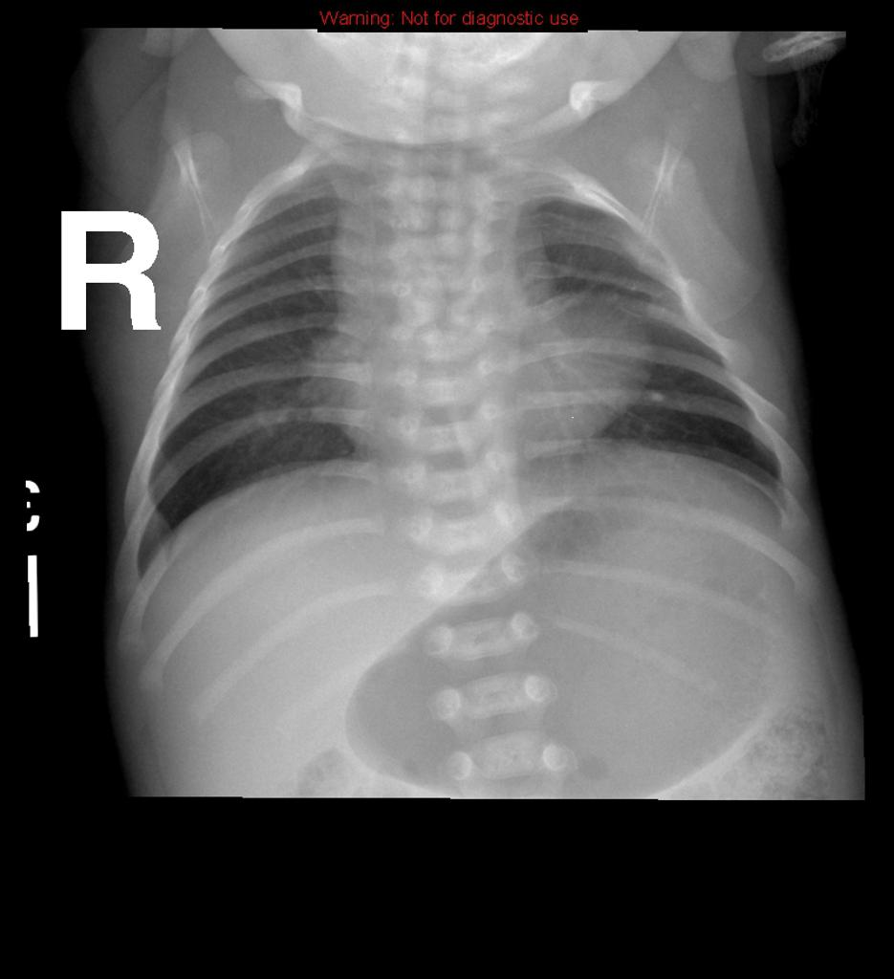

b) What sign does this CXR show and what condition does this suggest (1 marks)
Boot shaped heart - ?TOF

The child becomes upset and on crying mum points out that the child has developed the following sign. Sats drop to 78% but other obs remain the same.

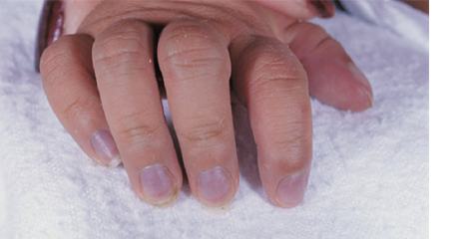

c) Outline your approach to management of this episode
100% O2
Position of calm and comfort with mother
Knees to chest
Opiates – morphine 0.1-0.2mg/kg
20mls/kg fluid bolus

If fails:
NaHCO3 2mEg/kg bolus
Propranol 0.2mg/kg iv
Pheylephrine 2-10mcg/kg/min

If unsure RE: sepsis administer broad spectrum abx – cefotaxime 50mg/kg and ampicillin 50mg/kg

Question 4

A 3 year old boy has been brought to ED by his parents as he has a fever and rash. Mum is concerned that he has measles.

P 130
BP 80/50
Sats 99%
RR 25
Temp 37.7

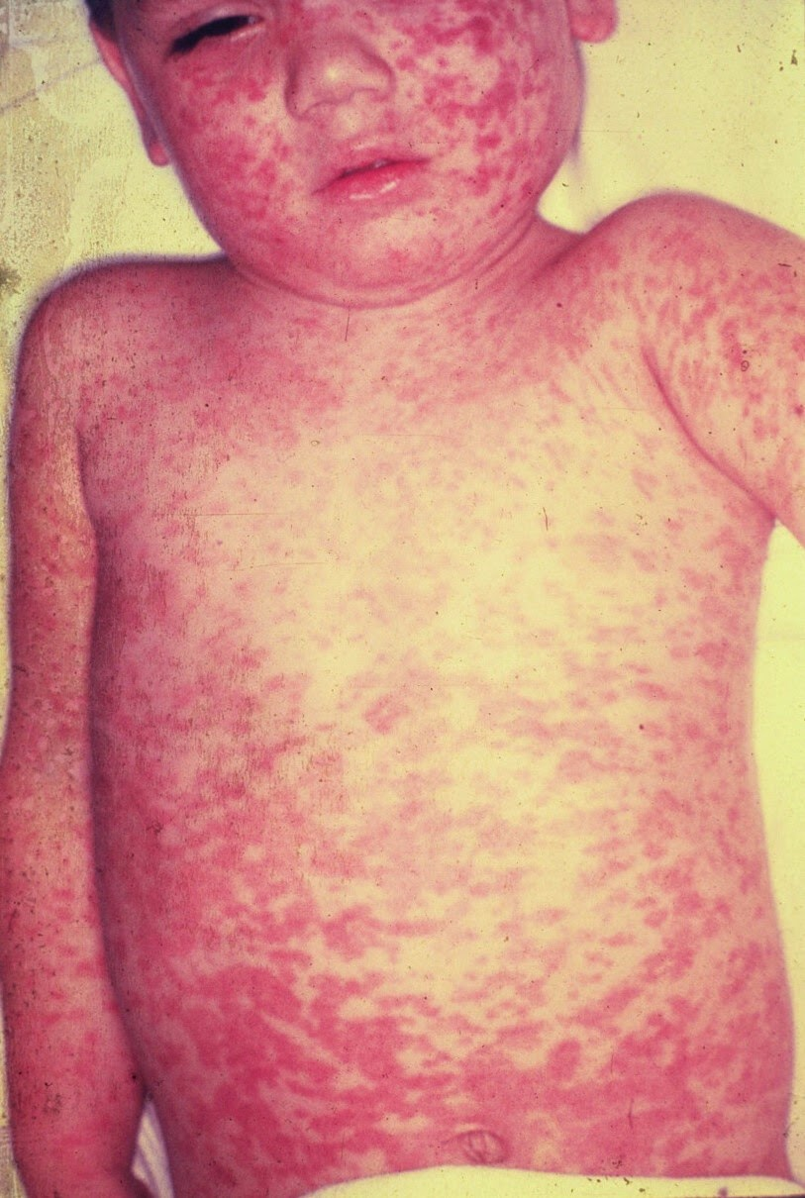

a) Other than measles, list 4 other differentials should you should consider for this rash (5 marks)
Rubella
Parvo
Enterovirus
Adenovirus
HHV-6
Morbilliform Drug eruption

b) What features on examination, other than rash and fever, might you expect to find in a patient with measles (4 marks)
Conjunctivitis
Coryza
Cough (95%)
Kopliks spots
Generalised lymphadenopathy

c) What are the key actions with regards to infection control (6 marks)
Double bag specimens
Don’t use the pneumatic chute
Isolation of child in a single room with negative pressure if possible, decant non essential equipment, requires door closed and must not be used for other patients for 2 hrs and be high cleaned
Patient to wear a mask at all times
Awareness that child was infectious from 5 days before and till 4 days after the appearance of the rash – avoidance of other vulnerable people
Vaccination of unvaccinated contacts/family
To inform CDC – notifiable disease
Contact tracing via CDC
Not to present to the GP/avoid waiting areas/public places/schools etc

Question 5

A 7 day, term born neonate presents to ED with jaundice. Mum is not sure when it started. The child has been exclusively bottle fed and was born by elective C-Section.

a) Complete the table below with the potential causes of conjugated and unconjugated jaundice IN THIS NEONATE (10 marks)

Unconjugated | Conjugated

Unconjugated | Conjugated
Physiological | Sepsis
Haemolysis | Biliary abnormality
Sepsis | TORCH
Hypothyroidism | Hepatitis
Inborn Errors – CN, Gilberts | CF
Breast Milk Jaundice – NOT this – bottle fed | Alpha 1 antitrypsin deficiency
 | Inborn errors – DJ and ROTOR

b) What features on examination will you seek to determine the cause of the jaundice (4 marks)
Signs of systemic sepsis- dehydration/reduced cap refill/reduced activity level/fever
Localising signs of infection – chest signs/skin rashes/full fontanelle in meningitis
Evidence of easy bruising/haematomas
Evidence of bowel obstruction – distended/vomiting

c) Aside from LFTs and conjugated/unconjugated bilirubin, list 5 laboratory tests you might perform to investigate the cause. Give your rationale for each (10 marks)
Blood group – mother and baby
CRP and WCC for ? infection
Septic screen if febrile or signs infection
TSH – congenital hypothyroidism
Coombs or elution test (detects antiA or antiB on red cells) – to detect haemolysis
Blood film – for signs of haemolysis/fragmented red cells

Question 6
A 3 month old, 5kg baby presents with PR bleeding. The child has vomited twice today. The child is seen in ED by the RMO. Mum has brought you a dirty nappy

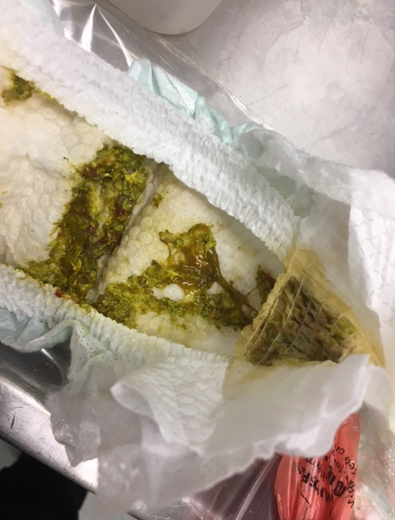

a) What are the likely causes of PR bleeding will you consider in your assessment of this child?
Local trauma/fissures/constipation
Gastroenteritis - bacterial
Meckels
Intussusception
Polyps
Cows Milk Protein Allergy
Vascular lesions
Clotting disorders/thrombocytopenia
Swallowed mothers blood from breast feeding – less likely than in neonates

The child is initially well and is discharged from hospital, to follow up with the GP. 48 hrs later the child returns with copious diarrhoea, is floppy and has a fever of 40 degrees. You estimate them to be 10% dehydrated.

P 160
BP 60/40
RR 50
Sats 99%
Temp 37.9

pH 7.19
pCO2 24
HCO3 12
Lact 4.3
Na 132
K 3.1

b) List the intravenous fluid management that you will institute for this child over the next 24 hrs
Resus
10-20mls NaCl 0.9% - repeated till signs of shock resolved (max 60mls/kg)
Defecit replacement
10 x 10% x5kg = 500mls
Maintainence = 5 x 100 = 500mls
Replace deficit plus maintainence over 24 hrs = 1000mls per 24 hrs = 42mls per hr of NaCl plus 20mmol KCL/L
Can replace the defecit over a quicker period depending on the state of the child.

c) What other management will you commence assuming that the childs haemodynamics and VBG improve with fluid therapy (2 marks)
Paracetamol for distress/fever
Antibiotics –
For GI Source - Amp 50mg/kg, Gentamycin 7mg/kg, Metronidazole 12.5mg/kg (Best answer)
OR
Empirical ? focus – Cefotax/Gent/Vanc (less good answer)
OR
Ceftrixone alone if convinced that gastroenteritis only

The mother writes a complaint expressing her displeasure that the child’s illness was not picked up and treated when they originally presented to the ED.

d) Outline the steps you will take in addressing this complaint (6 marks)
Acknowledge the complaint and agree a timeframe to investigate and report back in 72 hrs
Gather information – review case from notes, parent, doctors etc
Review departmental policy and other guidelines
Rapidly respond and feedback to parent
Meet back with parents to discuss/open disclosure if deficiencies in care found
Pastoral care of those involved
M&M/feedback of learning points
Institute any changes to departmental practice
Keep record of complaint/document
Audit to close the loop

Question 7
A 3 month old girl presents with fever and malodorous urine. She looks well, is feeding and has good hydration.

P 100
BP 110/70
Sats 99%
RR 30
Temp 37.6

a) In the table below list the options do you have for the collection of a urine specimen, with 1 pro and 1 con of each

Method | Pro | Con

Method | Pro | Con
Bag Urine | Requires little parental input, passive and easy | Takes time, unclean and usually contaminated. Only helpful if dipstick completely negative
Midstream | Clean if collected properly, non invasive, usually acceptable and painless | Takes time, messy, easily missed, requires parental attentiveness
Catheter | Cleaner than other above methods, quick | Can be distressing and may need sedation to achieve in older baby
SPA | Very clean | Requires a full-ish bladder, invasive, risk of damage to surrounding bowel, may need sedation to achieve with N2O or IN midaz

A clean, reliable urine sample shows the following

Leuc ++
Prot normal
Nitrites pos
Blood ++

b) List the ED management and follow up plans for this child (5 marks)
Antibiotics orally
- Trimethoprim 4mg/kg/Bactrim 4/20mg/kg 12hrly or Ceflex 12.5mg/kg 6 hrly, 10 days duration as per RCH/5 days as per eTG
Paracetamol 15mg/kg for pain and fevers
USS renal tract within 6 weeks
Follow up for MSU result with GP
Note that BP high – needs to be rechecked in ED and if remains high needs a more urgent USS and paed follow up/discussion

You notice when you are checking results that the patient has grown pseudomonas in their urine

c) Outline how you will deal with this now (4 marks)
Call back child / call GP
Ensure that child remains clinically well – if so GP can follow up
If clinical concerns needs to come to ED
Is an atypical organism so needs more urgent USS in 48hrs
Change abx to Norfloxacin 10mg/kg 12 hrly

Question 8
An 8 year old indigenous girl presents to ED with a sore right knee. She has poor English language skills and is very quiet and shy. Her mother was present but popped out and has been gone for 20 minutes. Nobody is sure where she has gone and when she will return.

The girl is crying whenever you try to examine her

P 100
BP 130/90
Sats 99%
RR 12
Temp 37.3

a) In the table below outline 4 possible causes of her knee pain, and 2 examination findings and 2 tests that you may order to add weight to the diagnosis

Diagnosis | Examination | Tests

Diagnosis | Examination Findings | Tests
Trauma/Fracture or soft tissue injury/NAI | Localised tenderness, ligamentous laxity, effusion | XRay, ultrasound if suspect ligamentous injury
Juvenile arthritis | Swollen and tender joint | ESR, CRP, ANA, RhF, Anti CCP,
Rheumatic Heart Disease | Murmur, chorea, erythema marginatum, subcut nodules, Fever | ECG, ASOT, antiDNAase B, ESR
Septic Joint | Extreme tenderness and limited ROM, heat and redness, effusion, features of sepsis | Aspirate >100 000 WCC, CRP and WCC elevated

Her Xray is shown

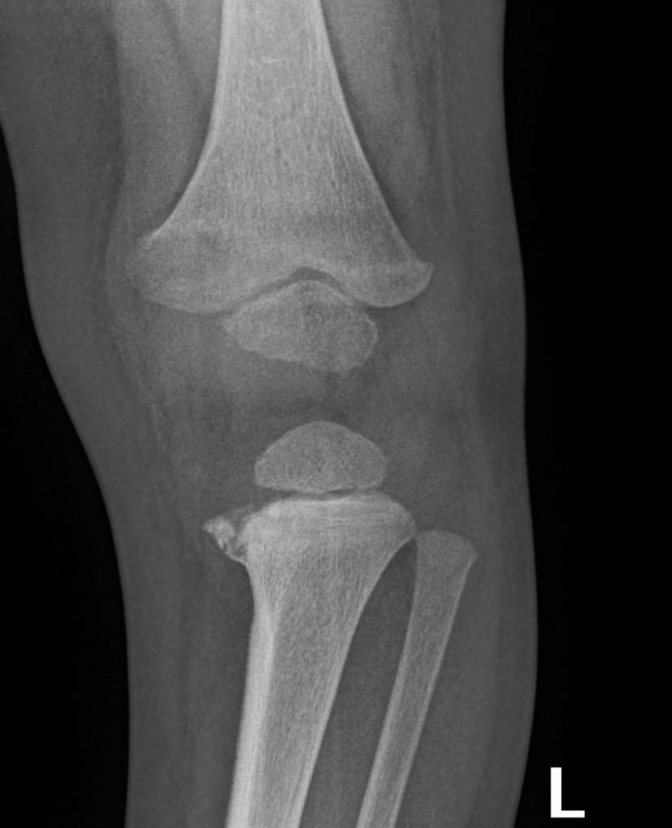
b) Describe the abnormality shown in this XRay (1 mark)
Metaphyseal corner fracture of the medial proximal tibia

c) What is the significance of this injury (1 mark)
Likely NAI – highly specific for

d) How will you further investigate and manage the patient (6 marks)
Provide analgesia – panadol and nurfofen
POP/splint for pain
Try to contact parents and relatives to get more information
Contact paediatrics/ortho to assess and admit the patient
Contact FACS to make a report
Involve social worker
Skeletal survey – ideally with the consent of a parent first
Assess for other signs of NAI

Question 9

A 3 year old boy presents with a rash. He was been ‘cranky’ according to mum for the last few days. He is off his food and has been crying in ED for the whole time. He had 2 days of diarrhoea last week but normal stools for 5 days now.

Obs are normal, no fever recorded

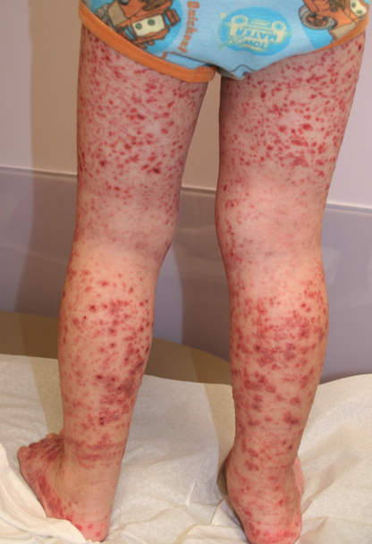

a) Describe the rash (3 marks)
Raised red macular/purpuric rash to bilateral lower limbs
Relative sparing of the popliteal fossa creases
Only extensor surfaces shown
Some areas of crusting/scabs on lower legs

c) List your diferential for this rash (4 marks)
HSP
Meningococcal disease
ITP
Leukaemia
Drug reactions e.g to NSAID

d)What other features on examination will you seek out to narrow your differential? (10 marks)
Well or sick child/behaviour – active and alert vs subdued
Fevers/sepsis features - Meningococcal
Abdo tenderness, joint pains – HSP
Lymph nodes and organomegaly
Other areas of bruising/bleeding e.g mucus membranes/epistaxis/rectal bleeding
Confusion/neurological signs of HUS

c) List the initial tests you will order in ED and give a reason for each (
FBC - ?low platelets of TTP, anaemia with haemolysis, WCC with meningococcal
Coags - ?DIC
Blood cultures ? sepsis/meningococcal
EUC - ?renal dysf in HUS/HSP/Sepsis
Urine Dip – protein in HSP/Blood in HUS
Haemolysis screen inc retics/haptos/bili – HUS
Stool sample - ? HUS strain of EColi
Blood film - ?leukaemia

