OSCE_Teach Procedure

Candidate Information
Single Station
3 minutes reading/7 minute station

Domains Tested
Medical Expertise
Teaching and Scholarship

Clinical Stem
An intern is keen to suture a patient with a simple laceration on the back of his neck. The patient’s wound has been assessed by you as being a simple injury to the skin layers only. You want to place vertical mattress sutures. The patient is fully consented. It has already been locally anaesthetised, thoroughly irrigated with 500mls sterile saline, and the aseptic field is set up.

This station utilises a TASK TRAINER

Tasks:
- Explain the suturing technique to the intern
- Place the first 2 sutures yourself as a demonstration
- Supervise the intern placing 2 further sutures
- Answer any questions that the intern asks you

You do not need to take any further Hx from the intern about the injury or the patients past history

Role Player Information
You are a new intern, only qualified for a month. You are very keen to learn some new suturing techniques. You feel comfortable placing simple interrupted sutures but have never tried any other techniques. You have heard of a vertical mattress suture but don’t know what it is used for or how to do it.

You would like to have a demonstration and then try yourself.

The candidate should explain to you the preparation needed for the procedure, and when this type of suture is useful

If they don’t explain the type of suture you should ask
“When do you use this particular closure technique”
“What size suture is best for the trunk and neck”

When you go to place your first suture you must do it incorrectly by starting far too close to the wound edge. The candidate should ideally correct your mistake and ask you to do it again.

After the sutures are placed ask the following questions (if not addressed already)

“How long do they need to stay in for”
“What are the potential complications”

Examiner Information

The candidate must explain to the intern the procedure of placing a vertical mattress suture for areas of high tension skin on the back of the neck. They must demonstrate the closure method then guide the intern through placing the sutures including correcting their mistakes. They must answer the intern’s questions and provide follow up/disposition advice

See below for full Assessment Criteria

Marking Scheme

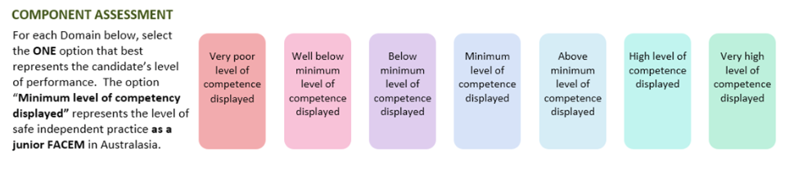

Medical Expertise

Scholarship/Teaching

DETAILED ASSESSMENT CRITERIA
Please use the following criteria to inform your ratings

Medical Expertise
- Explains vertical mattress
  - For areas of high tension/more supportive than interrupted
  - Useful for places such as the back of the neck and shins
  - Closes deep and superficial layers together
  - Good eversion and vertical opposition
  - Decreases dead space
  - Not to be used where superficial structures are present

- Demonstrates correct technique (Dunn)
  - Introduce the needle 5-10mm from the wound edge
  - Take a deep bite of tissue before exiting the skin in the same position on the opposite wound edge
  - Reverse the needle position in the needle holder
  - Reintroduce the needle 1-3mm from the second side of the wound
  - Take a smaller bite of tissue before exiting on the first side of the wound
  - Tie a knot with the loose end of the sutures on the same side of the wound

- Answers questions
  - Size 3’0 Best
  - Sutures to stay in approx. 10 days on the trunk and neck
  - Complications – infection, damage to other structures, bleeding, pain, haematoma, collection

Scholarship and Teaching
- Checks training level and prior experience
- Explains stepwise approach
- Demonstrates technique slowly/in stages
- Allows trainee to
- Gently corrects technique

