OSCE_Teach Me Nerves

Candidate Information

Domains Assessed
- Medical Expertise
- Teaching and Scholarship
- Communication

Clinical Stem
A medical student in final year has come to ask you if you can teach him a slick way to do a cranial nerve examination for his upcoming OSCE exam. He has found a healthy volunteer to be examined.

Tasks
- Demonstrate to the medical student the basics of examining all 12 CRANIAL NERVES. It must be yourself, and not the student, that examines the patient.
- Answer any questions that the student may during and at the end of the demonstration

- NOTE: You can omit the tuning fork tests

Role Player Information – 5th Year Medical Student
You have been practicing neurological exam for your upcoming OSCE, but you are struggling to develop a slick way to do a full CN exam within a reasonable time frame. You know the names of the cranial nerves and what they do, but you want to see how an expert does it in the emergency department when time is limited. State that “I have an ENT tutorial on tuning fork tests tomorrow so we can miss that bit out”

If the candidate starts to examine a non-cranial nerve part of the neurological system you must state “Which cranial nerve are you examining now?”

There are some questions for you to ask at each stage:

At the appropriate CN you must ask
CN 1 – “How do you normally assess this in ED?”
CN 2 – “I read about RAPD but didn’t really get it –what does it mean?”
CN 7 – “How can I tell the difference between a facial palsy from a stroke and a Bell’s palsy”
CN 12 – “If the tongue deviates to the left what does that mean”

At the end of the demonstration of cranial nerves ask the following questions:

“I saw a patient the other day who wasn’t able to abduct his left eye. Everything else was normal. I was a bit confused about what was going on. Can you explain it to me”
If asked any questions about the patient, he was a 65 year old man with diabetes and no other comorbidities. No trauma, no other neurological findings. He had a normal scan, CXR and bloods.

If they don’t tell you the causes of a 6th nerve palsy you should ask
“What are the things that can cause it?”

Role Player Information- Volunteer
You are well person who has been asked by a medical student to be a pretend patient. You will be examined by the consultant who will explain to the student what (s)he is doing as they go.
You do not have anything wrong with you. Answer the questions you are asked as if everything is normal.

Examiner Information
The candidate is to demonstrate a slick way of examining the cranial nerves within a short time frame to a 5th year medical student. The volunteer is a healthy person with no positive findings

The student has theoretical knowledge of the CNs and a basic understanding of the examination sequence, but wants to see a “slick” way of doing the exam in a short time frame.

The candidate doesn’t need to demonstrate tuning fork tests

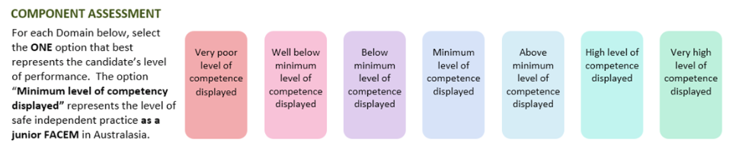

Medical Expertise

Communication

Scholarship/Teaching

DETAILED ASSESSMENT CRITERIA
Please use the following criteria to inform your ratings

Medical Expertise (50%)
-Demonstrates appropriate CN examination
- CN1 – Mentions to question about smell but not formally tested
- CN2 – Pupils, RAPD, Opthalmoscopy, VF by confrontation
- CN 3/4/6 – Eye movements, diplopia, gaze palsy, good candidates might give an example of an abnormal finding
- CN 5 – Facial sensation 3 divisions, muscles of mastication, jaw jerk (not usually done)
- CN 7 – Facial movements, ant 2/3 tongue sensation
- CN 8 – Gross test of hearing, Tuning Forks omitted
- CN 9/10 – Voice, palate, cough, uvula, posterior tongue
- CN 11 – SCM/trapezius
- CN 12 – Tongue

- Answers questions correctly (25%)
- CN1 – not usually formally tested in ED
- CN 2 – explains that RAPD signifies a problem with the afferent limb of the 2nd CN e.g. optic neuritis or other pathology
- CN 7 – Forehead sparing in stroke vs full face in Bell’s
- CN 12 – Tongue deviates towards the side of the lesion
- Clear explanation of lateral rectus/6th nerve palsy and likely causes
  - Diabetes, Trauma, Tumour, Cav Sinus Thrombosis, Ischaemia, Meningitis, Idiopathic, Raised ICP, MS

Communication (25%)
- Introduces self

- Develops rapport
- Communicates clearly with the student
- Gives clear instructions to the volunteer

Scholarship and Teaching
- Identifies level of experience/understanding
- Information taught in a structured format 1-12CN
- Invites questions
- Checks understanding
- Emphasises important points
- Summarises
- Provides resources/follow up tasks

