OSCE _My Hand Hurts

Candidate Information

Double station
4 minutes reading time
16 minutes station

Domains Tested
Medical Expertise
Communication

Clinical Stem
You are about to see a 56 year old patient in the minors area of your tertiary level Emergency Department.
The triage information says “Intermittent pain in hand for 3 weeks, no trauma, tried panadol without resolution, feels generally lethargic and cold”

Observations:
P 50
Sats 98%
RR 16
BP 160/100
T 36.1

Tasks
- Take a focussed history and examine the patient
- Explain the likely diagnosis
- Explain the investigations, treatment and follow up

Role Player Information

You are a 65 year old retired man who lives with his wife. You are right handed ex chef
Over the last few months you have developed some pain in your right hand, a friend told you to come to the hospital in case you are having mini-strokes but you don’t think that is the case
It seems to be worse at night and wakes you up from sleep
The pain seems to be in the whole hand, and is hard to localise
It comes and goes, and sometimes happens in the daytime as well

Only if specifically asked:
Onset was insidious, but getting worse
Becoming severe
Precipitants - occurs more when you are riding your bicycle/at night
Weakness – none, but very lethargic and slow
Sensory change – tingling in thumb and first 2 fingers
No trauma or injuries
Had weight gain 6kg, been feeling really cold and tired
No pain anywhere else
All other systems normal – no CP, SOB, infective sx, urinary or bowel sx, no headaches, no speech/vision issues etc
Noticed a bit of fullness in neck
No past medical history, medications, allergies
It isn’t really limiting what you do, but is an annoyance and is getting worse

At the 10 minute mark, if not already asked, you must state
“its really odd actually, I’ve gained about a 6 kilos and I’ve been really tired lately”

When examined
Sensation feels tingly in the thumb, first and second fingers
Normal power, relexes, tone, coordination if tested
Normal pulses
Normal colour
Normal skin
No tenderness anywhere in neck/limbs

Tinels test – if the doctors taps on your wrist the tingling and pain get worse
Phalens test – if the doctors asks you flex your wrists the tingling and pain get worse

No focal neuro signs/CN signs

If the candidate examines your thyroid ask
“What are you checking for”
“Do you think I’ve got cancer”

Examiner information

The candidate has been asked to take a focussed history and examine a 65 year old man with pain in his right hand.

His clinical presentation is in keeping with carpal tunnel due to new undiagnosed hypothyroidism. Better candidates will not only identify the cause of the pain but also the underlying reason (thyroid disease)

Detailed assessment criteria below

Marking Sheet

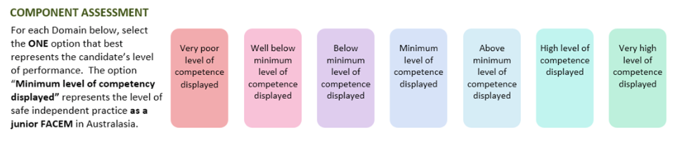

Medical Expertise

Communication

DETAILED ASSESSMENT CRITERIA
Please use the following criteria to inform your ratings

Medical Expertise – History
- Focused history to establish
- Pattern of symptoms – intermittent, progressive, nocturnal especially
- Precipitants – riding bike
- Sensory change in median nerve distribution
- Lack of suggestion of spinal cause – no neck pain, no weakness, isolated to hand
- Hypothyroid symptoms – slowing/lethargy/cold intol/wt gain/goitre/depression
- PMH/Meds/Allergies
- Explores functional limitation
- No sig PMH/Meds/Allergies
Medical Expertise – Examination
- Vital signs – Bradycardia, hypothermia and hypertension noted
- Systematic examination including inspection, palpation, UL power (including median, radial, ulnar)
- Sensory exam identifies median distribution sensory change
- Differentiates from C6 radiculopathy
- Tinel’s
- Phalen’s
- Thyroid Exam
  - Goitre
  - Skin and hair
  - Reflexes – slow relaxing ankle jerks
  - Proximal myopathy
  - Pretibial myxoedema
Medical Expertise - Explanation
- Carpal tunnel
  - Explanation of pathophysiology
  - Electrophysiology can confirm as OP, but not necessary as diagnosis very clear
  - Treatments – splints, analgesia (NSAIDS/Panadol/gabapentin), cortisone injections, operative
- Possible hypothyroidism
  - Need TFTs to prove first then once confirmed other investigations
  - Not necessary to explain all Ix till proven
  - Need for replacing thyroxine if proven
- Follow up with GP or hand clinic/physio/OT for splinting

Communication
- Introduces self
- Establishes rapport
- Clear instructions
- Explains without jargon
- Allows questions
- Checks understanding
- Offers written handout

