Orthopaedics/Rheumatology SAQ

2017: 2 Fellowship Exam Group

Question 1
A 74 year old man presents after a fall. He is complaining of left hip pain. He has mild dementia and currently lives alone and has been refusing services. Has a history of gout, hypertension and resected melanoma.

P 130
BP 90/60
Sats 92%
RR 20
Temp 37.4

His X-ray imaging is shown below

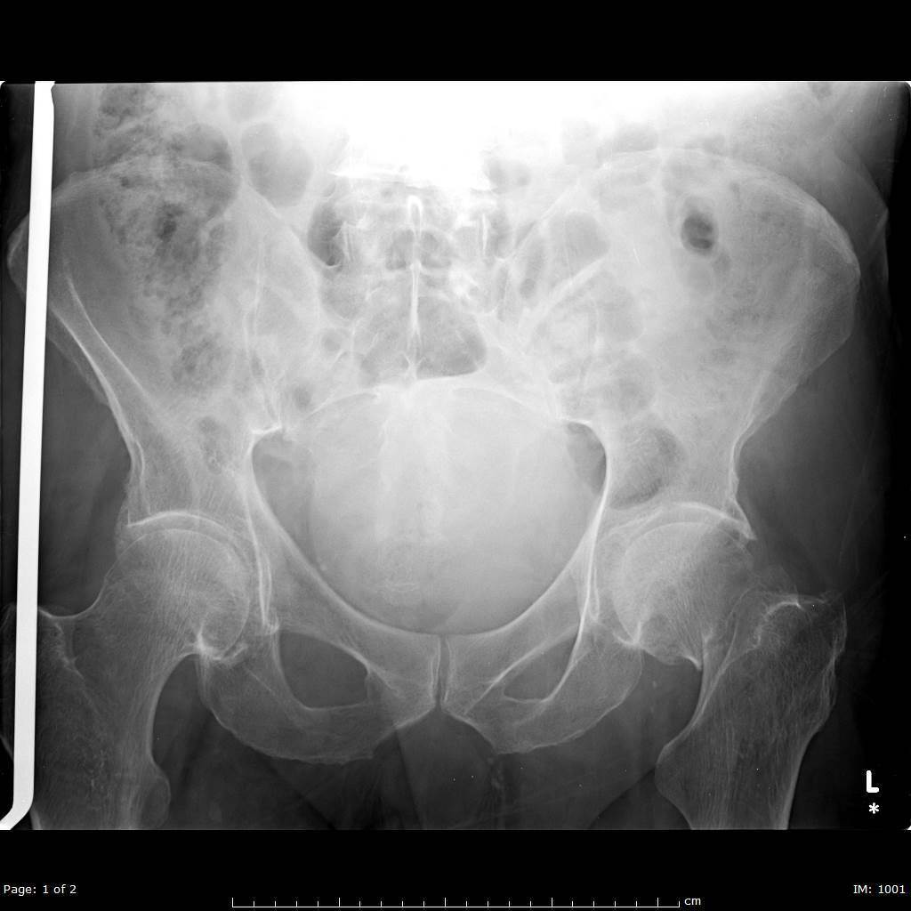

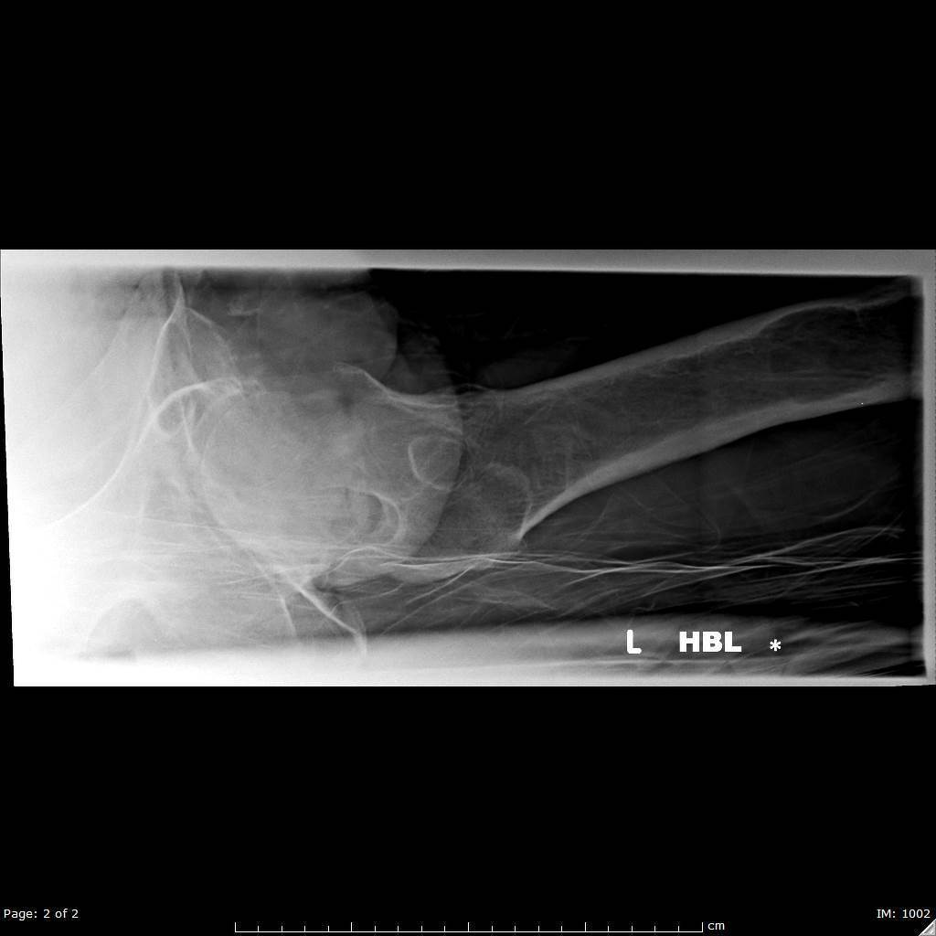

i. List the two (2) most important abnormal findings on this X-Ray (2 marks)

ii) Name the classification system for this type of injury and state which type this injury represents (2 marks)

iii) List six (6) factors that may have contributed to his presentation with a fall (6 marks)

iv) In the table, list three (3) different modalities for acheiving of analgesia with one (1) pro and one (1) con of each (9 marks)

Modality inc doses/route if appropriate (4 marks) | Pro (4 marks) | Con (4 marks)

Question 2

A 24 year old man has represented to ED after an injury to his knee 7 days ago. He was seen in your department 6 days ago and told he had a “sprained knee”, and that he should follow up with his GP and arrange a physio appointment

His knee X-Ray is shown

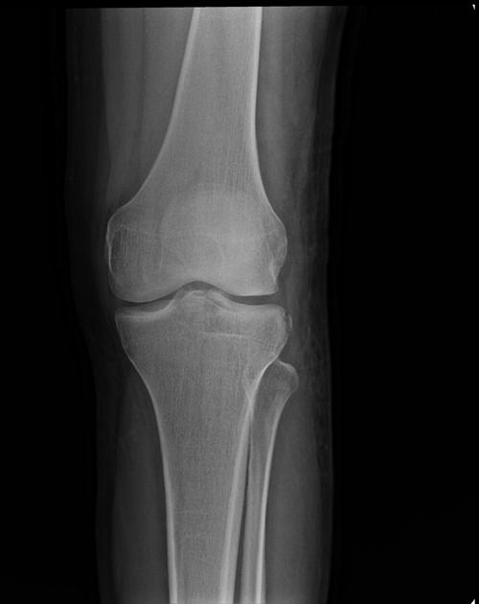
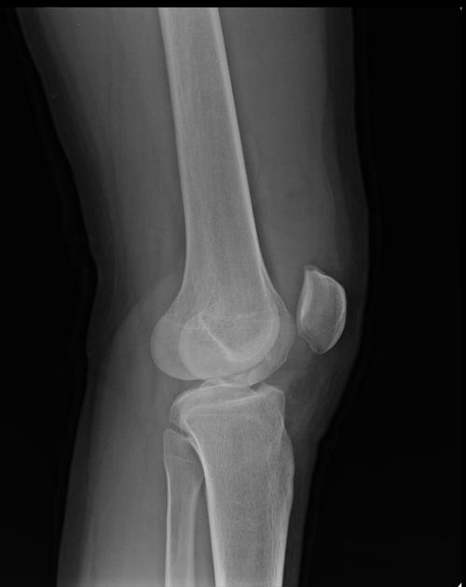
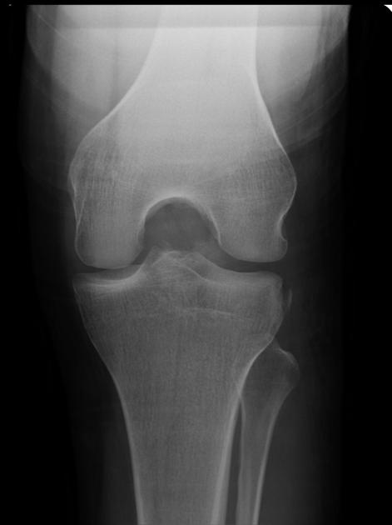

i) List the five (5) Ottowa Knee Rules for assessing need for imaging (5 marks)

ii) List the two (2) MOST significant findings on the X-Rays shown (2 marks)

iii) List two (2) MOST likely associated injuries (2 marks)

iv) List five (5) important aspects of the investigation and management of this injury (5 marks)

Question 3

A 12 year old boy presents after a fall with a sore elbow. He has some swelling and reduced range of movement. There are no skin breaches. He is crying.

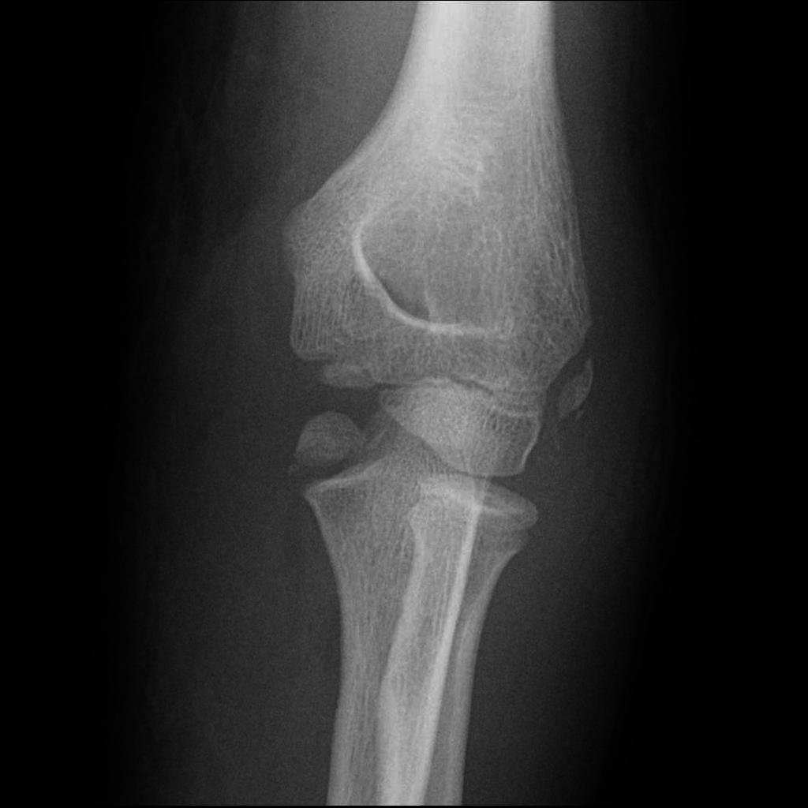
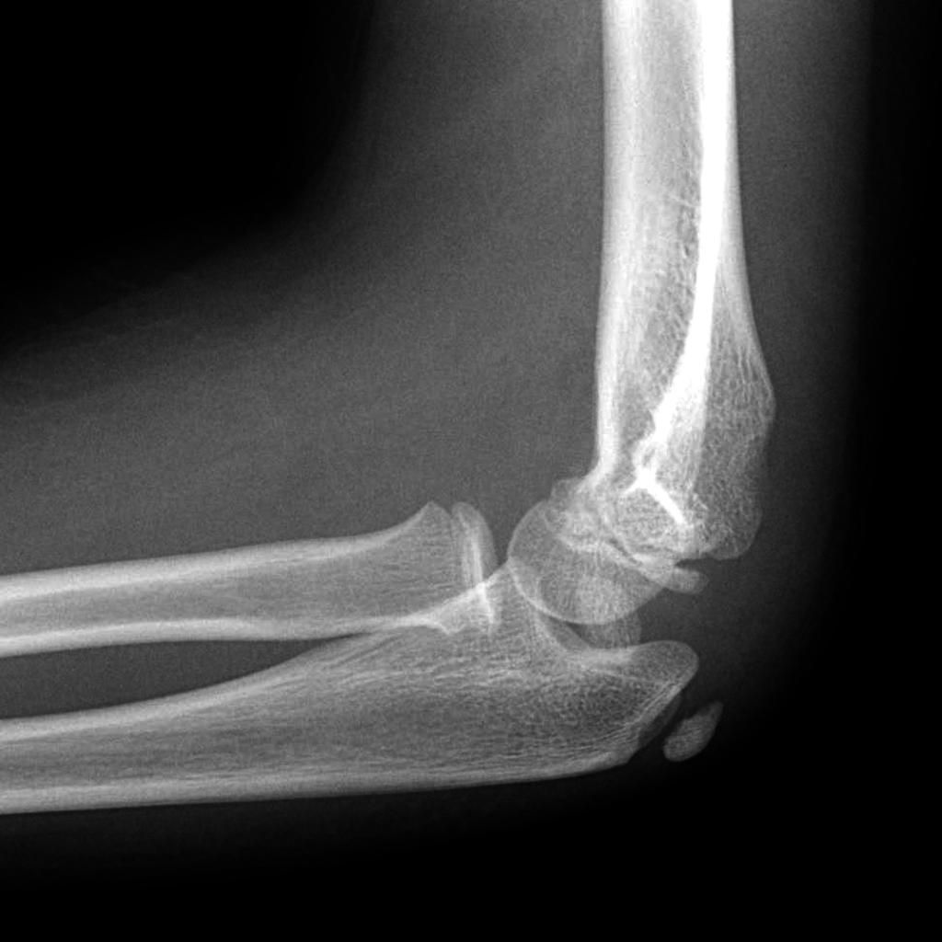

i) List the one (1) most significant abnormality on this elbow XRay (1 mark)

ii) In the table below complete the names of the six (6) elbow ossification centres and the approximate ages that they appear in a normal child (12 marks)

Elbow Ossification Centre (6 marks) | Age Appears ( 6 marks)

iii) List the three (3) MOST important management steps, including the definitive management (3 marks)

Question 4

A 30 year old female presents with wrist pain after falling during a netball game. She has pain in her right wrist.
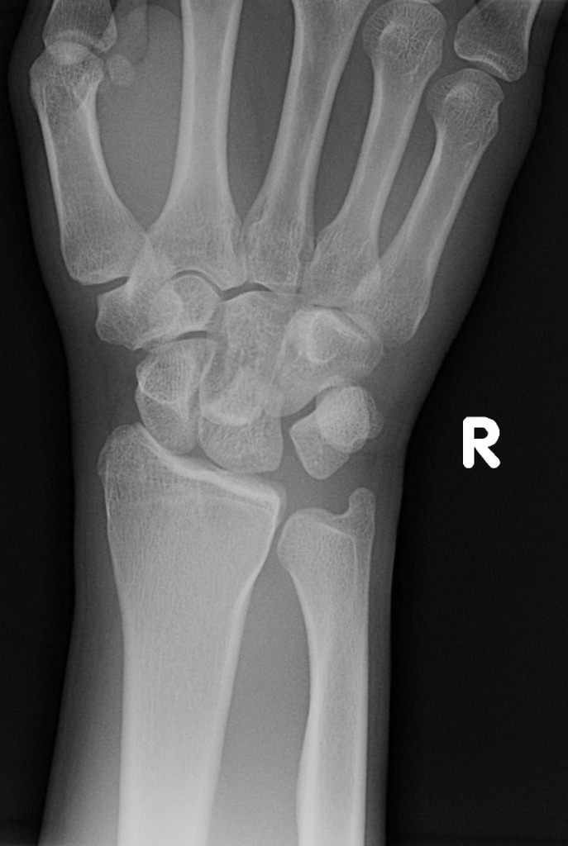
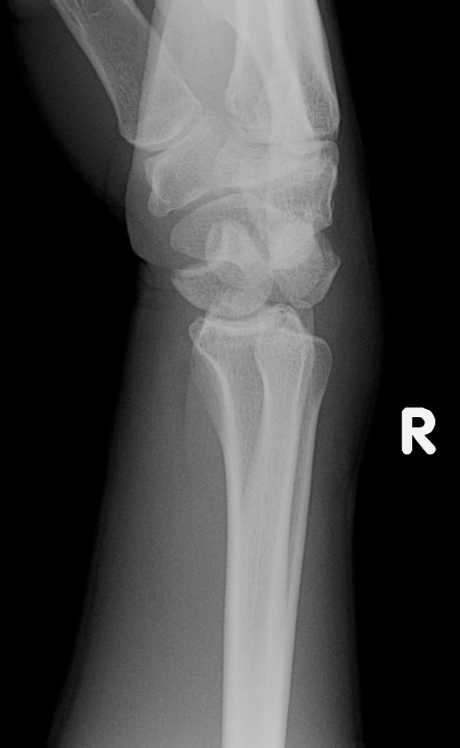
i) List three (3) abnormal appearances and the one (1) MOST relevant negative finding (3 marks)

ii) The orthopaedic registrar plans a temporising closed reduction in ED as there is no available theatre. In the table outline three (3) different modalities that YOU could use to provide adequate analgesia for this (6 marks)

Method of Analgesia (3 marks) | Details inc drugs, doses, equipment considerations (3 marks)

iii) List two (2) potential complications of this injury (2 marks)

Question 5

A 76 year old man presents with a unilateral painful right knee and an obvious large effusion. He has a history of harmful alcohol use, obesity and hypertension.

i) In the table below list the four (4) MOST likely differential diagnoses, one test used to prove each differential and the result of that test in the condition stated. (12 marks)

Differential diagnosis | Tests | Test Result in this condition

ii) You are reasoning whether to admit the patient to the ward or to the Short Stay Unit. List 5 criteria that this patient must fulfil to be suitable for the short stay unit (5 marks)

Question 6

A 15 year old male, who has recently arrived as a refugee from East Africa, presents with severe lower back pain. He denies any history of trauma. He is ambulating with great difficulty, and only with the support of his father. Both have some difficulties with communication in English.

i) In the table below list five (3) back pain red flags (in history or examination), and a diagnosis that each red flag could represent in this patient (6 marks)

Red Flag from History or Examination (5 marks) | Potential Diagnosis (5 marks)

ii) After assessment you are concerned that the patient has an imminently life threatening diagnosis. His father appears agitated and they are trying to leave. List four (4) escalating measures you will employ in this situation to get them to stay for investigation and treatment (Assuming that at each stage the measure fails) (4 marks)

Question 7

A 63 year old diabetic indigenous man has a non healing ulcer on his foot. He was discharged 3 weeks ago after a month long stay in hospital for management of multiple comorbidities. He is confused. He is currently in a resus bed with intravenous access and non invasive monitoring ongoing. He has had 3L of IV NaCl 0.9%.

Observations

P 130
BP 80/50
Sats 97% on 2L O2 via NP
RR 32
Temp 37.8

BSL 27.0
Ketones 1.0

His XRay is shown
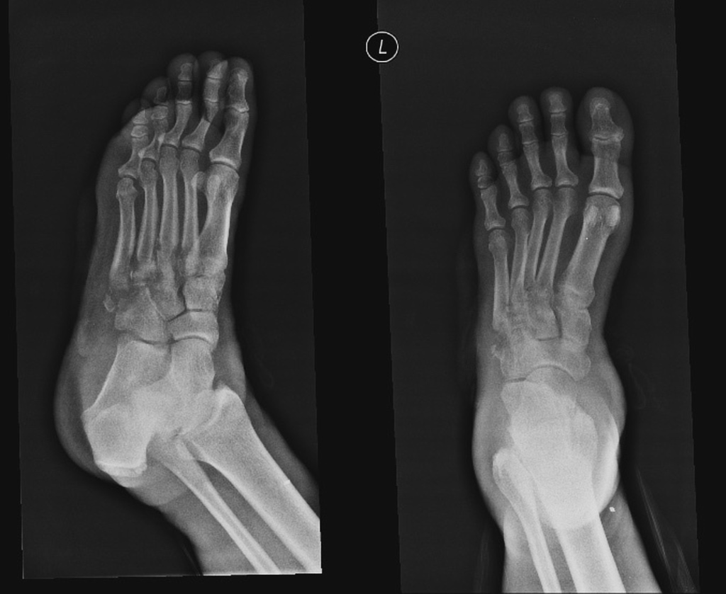

i) In regard to the XRay

a) Which three (3) bones are MOST affected by this process (3 marks)

b) What pathologic condition does this represent (1 mark)

ii) List the immediate management of this patient (9 marks)

iii) The patient is trying to leave the Emergency department. List four (4) elements that this patient MUST be present to demonstrate that he has capacity to refuse treatment (4 marks)

Question 8
A 19 year old man presents with pain in his right hand and left wrist. He is complaining of some dysuria and feels generally lethargic and unwell. He has recently returned from Peru and Bolivia after a back packing trip for 6 months. He did not visit any other countries
A photo of his hand is shown

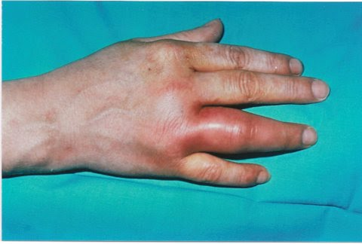
i) The are no other joints involved what pattern of arthritis does this suggest (1 mark)

ii) List five (5) features in the history that you will use to try and differentiate the cause of his symptoms, and give justification for each (5 marks)

iii) List five (5) investigations you will perform with justification (excluding FBC/EUC/LFT/CMP/CRP/ESR)
(5 marks)

Question 9

A 23 year old man presents to ED. He has a history of heavy alcohol intake but has been unwell and hasn’t had a drink for 48 hours. He woke on the bathroom floor this morning with a sore shoulder. He cannot recall the events of the last 3 hours.

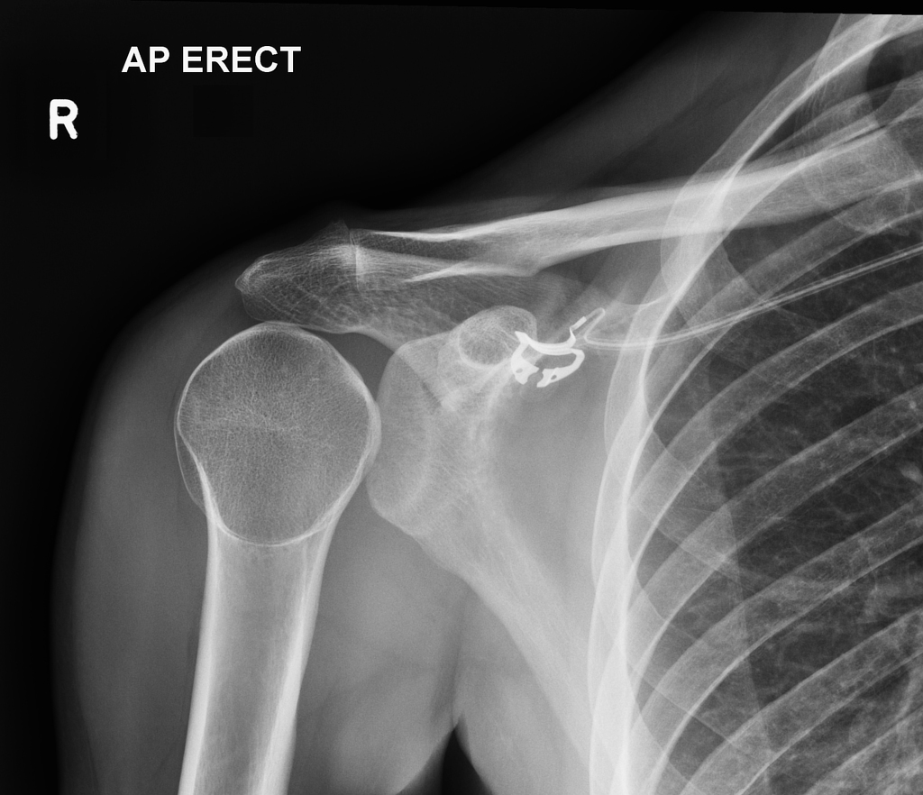
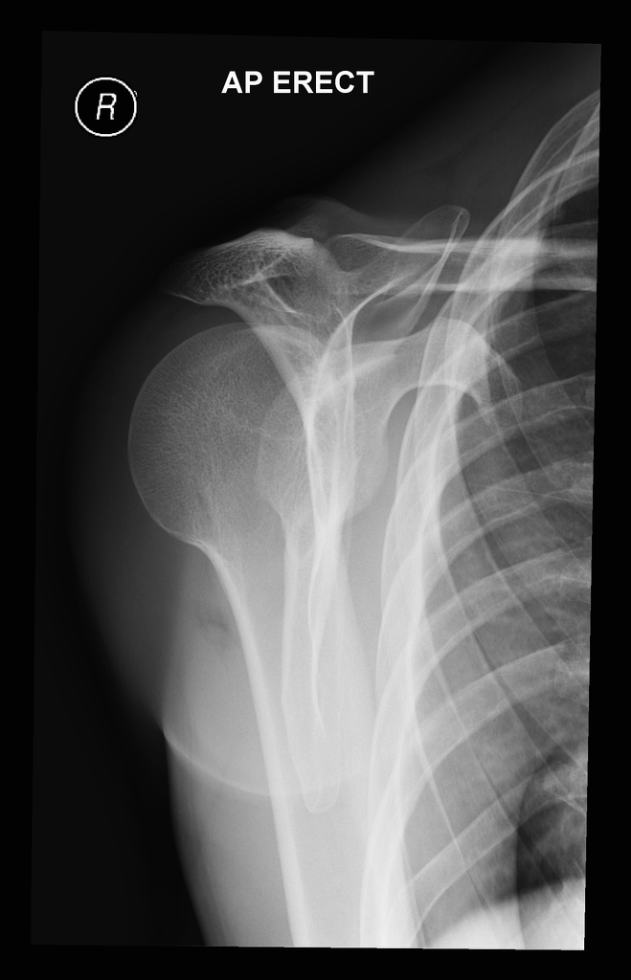
i)

a) List the two (2) most abnormal features present on this series of XRays (2 marks)

b) What is the diagnosis (1 mark)

ii) List three (3) underlying causes/mechanisms for this type of injury (3 marks)

iii) List the steps in correcting this injury, assuming the patient already has adequate analgesia and sedation (3 marks)

iv) List the three (3) MOST likely associated fractures you might find with this injury (3 marks)

