Orthopaedics/Rheumatology SAQ

2017: 2 Fellowship Exam Group

Question 1
A 74 year old man presents after a fall. He is complaining of left hip pain. He has mild dementia and currently lives alone and has been refusing services. Has a history of gout, hypertension and resected melanoma.

P 130
BP 90/60
Sats 92%
RR 20
Temp 37.4

His X-ray imaging is shown below

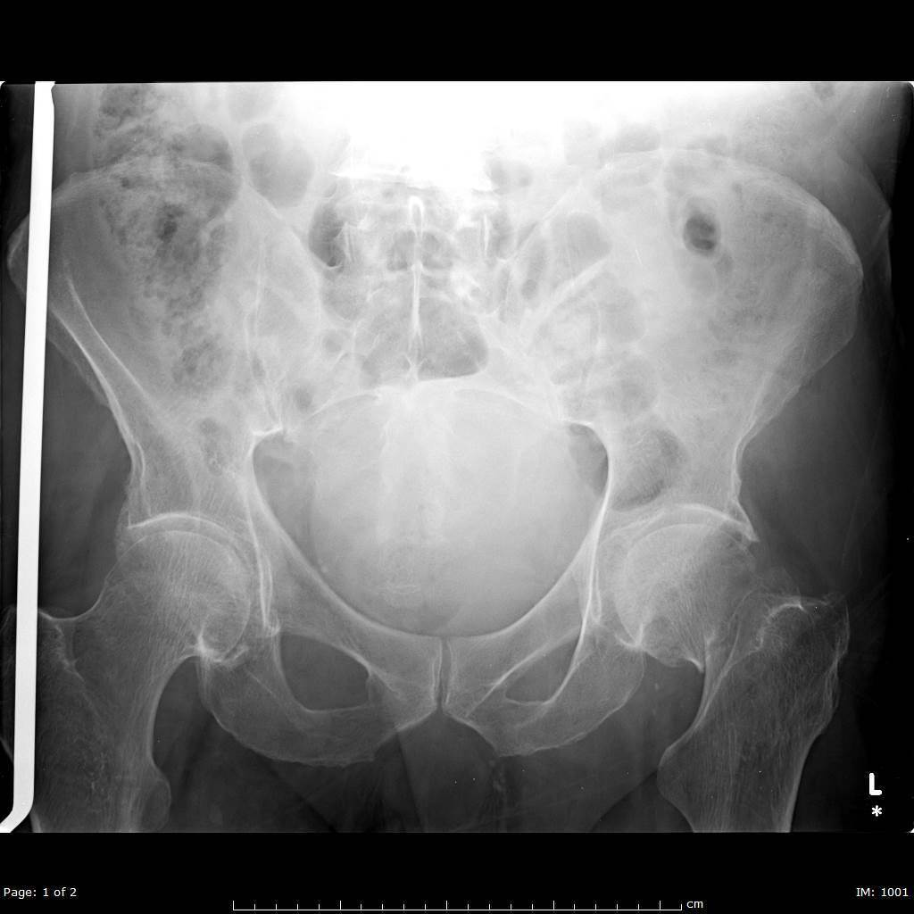

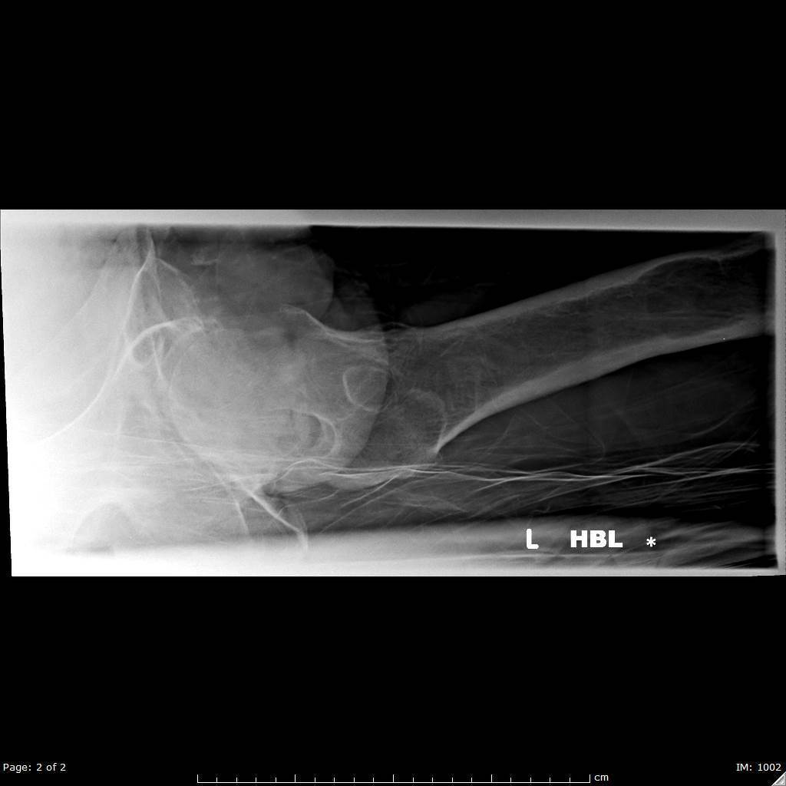

i. List the two (2) most important abnormal findings on this X-Ray (2 marks)
Left sided neck of femur fracture
Subtrochanteric lytic lesion on lateral projection

ii) Name the classification system for this type of injury and state which type this injury represents (2 marks)
Garden Classification – Garden 3

iii) List six (6) factors that may have contributed to his presentation with a fall (6 marks)
Age related issues – dementia, eyesight, poor mobility
Lacking support as refused services
Sepsis/Infection of
GI bleeding
Brain mets –has lytic lesion
Lack of support
AF/other arrhythmia

Or any other sensible answer

iv) In the table, list three (3) different modalities for acheiving of analgesia with one (1) pro and one (1) con of each (9 marks)

Modality inc doses/route if appropriate (4 marks) | Pro (4 marks) | Con (4 marks)

Modality (4 marks) | Pro (4 marks) | Con (4 marks)
Oral Analgesia – panadol, nurofen, panadeine forte, endone | Easy to administer, | Likely to be inadequate in isolation, patient is sick ?ileus, NBM pre op, takes time to work
IV analgesia – morphine, ketamine, fentanyl | Faster, doesn’t rely on gut absorption | May cause SE e.g resp depression, confusion, constripation, delirium, aspiration etc
Nerve block – e.g femoral nerve block, Fascia Iliaca Block.  Lignocaine | Less systemic side effects | Only partially effective in high fractures as contributions of obturator and sciatic nerves, risk of vascular puncture, minor risk of infection,

Question 2

A 24 year old man has represented to ED after an injury to his knee 7 days ago. He was seen in your department 6 days ago and told he had a “sprained knee”, and that he should follow up with his GP and arrange a physio appointment

His knee X-Ray is shown

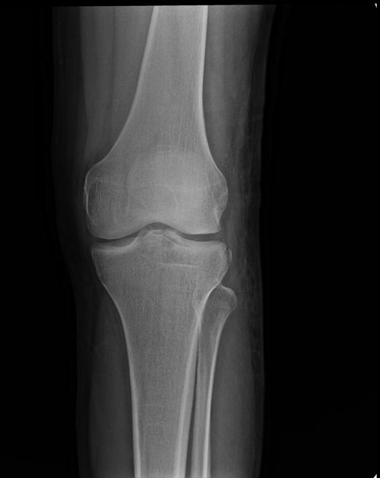
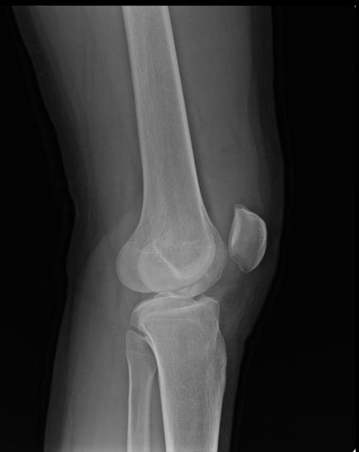
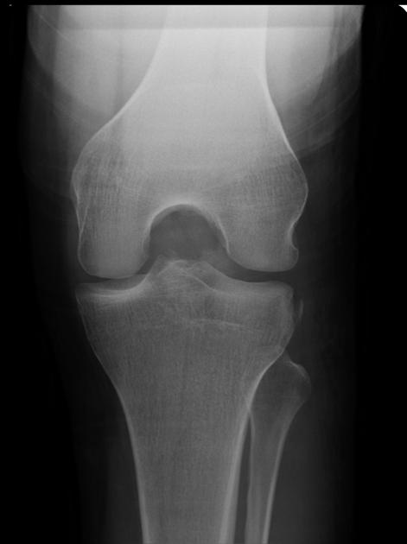

i) List the five (5) Ottowa Knee Rules for assessing need for imaging (5 marks)

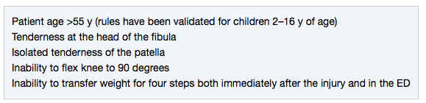

ii) List the two (2) most significant findings on the X-Rays shown (2 marks)
Segond fracture – bony avulsion fragment from lateral tibial condyl
Bony fragment in the intercondylar area representing an avulsion of the tibial spine at distal ACL attachment

iii) List two (2) most likely associated injuries (2 marks)
ACL tear
Meniscal tears
MCL tears

iv) List five (5) important aspects of the investigation and management of this injury (5 marks)
Need MRI to check for meniscal and anterior cruciate tears
Splinting – range of motion brace or zimmer splint
Crutches to aid mobility
Analgesia – panadol and nurofen +/- stronger
Orthopaedic follow up in an outpatient setting

Added post session: Mention of need for open disclosure around missed injury and follow up with doctor involved also good for a mark

Question 3

A 12 year old boy presents after a fall with a sore elbow. He has some swelling and reduced range of movement. There are no skin breaches. He is crying.

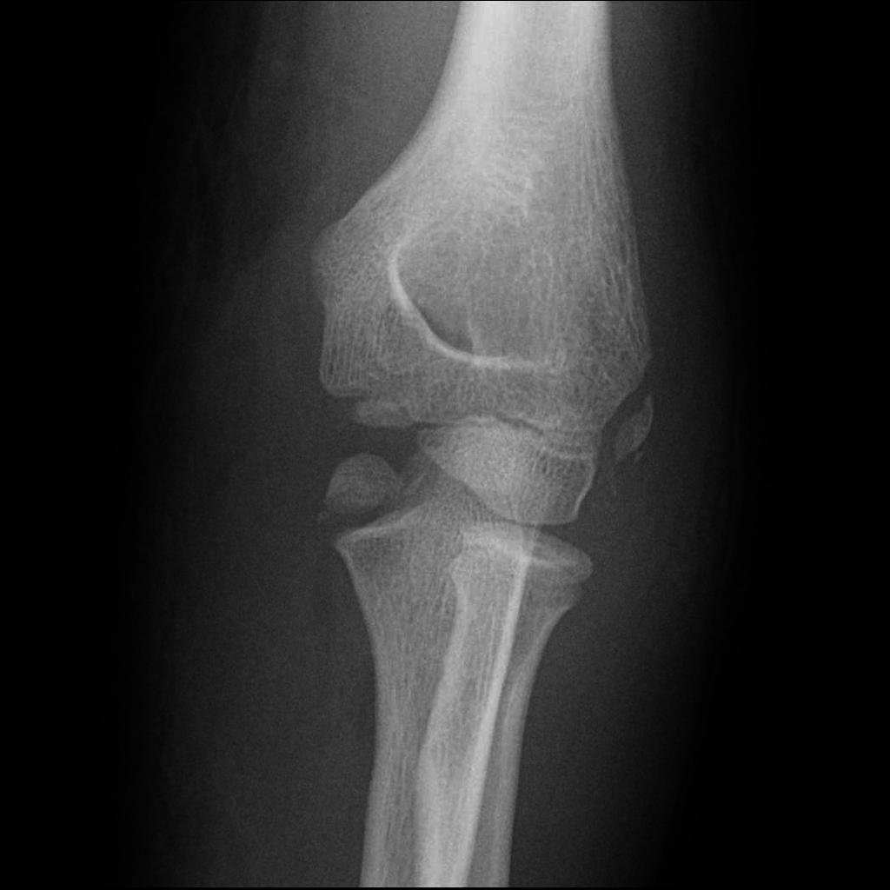
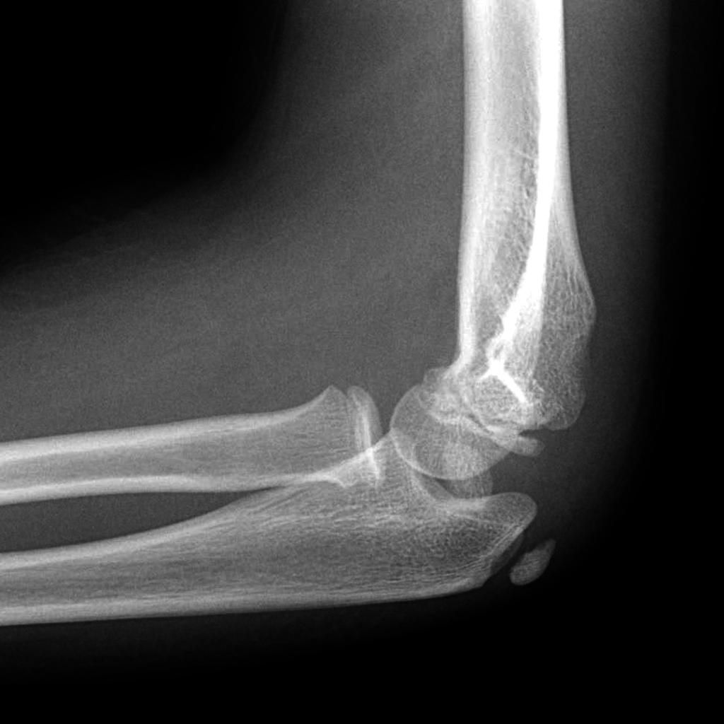

i) List the one (1) most significant abnormality on this elbow XRay (1 mark)
Displaced/avulsed medial epicondylar ossification centre – located inferiorly just next to coronoid

ii) In the table below complete the names of the six (6) elbow ossification centres and the approximate ages that they appear in a normal child (12 marks)

Elbow Ossification Centre (6 marks) | Age Appears ( 6 marks)

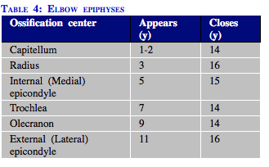

iii) List the three (3) MOST important management steps, including the definitive management (3 marks)
Analgesia – IN fentanyl/other IV opiate plus panadol/nurofen
Splinting for pain (backslab – above elbow)
Definitive – call orthopaedics as requires open reduction to reposition the medial epicondylar ossification centre

Question 4

A 30 year old female presents with wrist pain after falling during a netball game. She has a painful wrist.
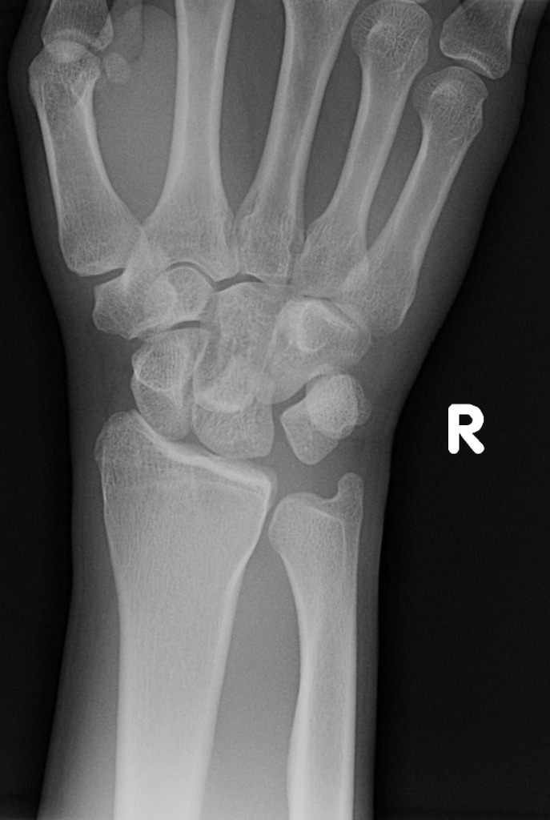
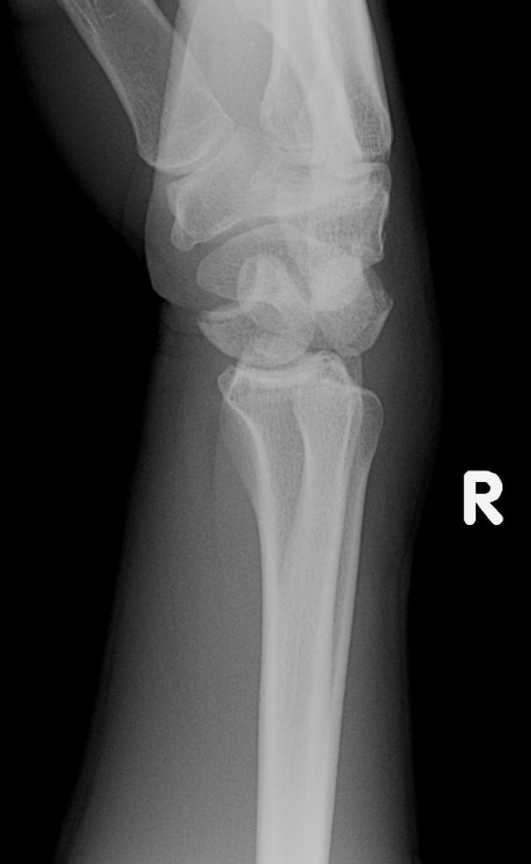
i) List three (3) abnormal appearances and the one (1) MOST relevant negative finding (3 marks)
Disruption of the palmar arcs on the AP view
Perilunate dislocation with posterior displacement of capitate relative to the hamate on lateral
Increased and irregular distance between lunate and triquetrum

No scaphoid fracture seen

ii) The orthopaedic registrar plans a temporising closed reduction in ED as there is no available theatre. In the table outline three (3) different modalities that YOU could use to provide adequate analgesia for this (6 marks)

Method of Analgesia (3 marks) | Details inc drugs, doses, equipment considerations (3 marks)

Method of Analgesia | Details (drugs, doses, equipment)
IV sedation | Ketamine 0.5mg/kg  Propofol titrated  Ketofol
Biers Block | Prilocaine 0.5mls/kg 1% solution  Biers cuff 100mmHg above systolic
Nitrous Sedation plus Fentanyl | Up to Max 70% nitrous  100mcg IN or IV fentanyl

iii) List two (2) potential complications of this injury (2 marks)
Carpal instability and arthritis
Median nerve compression (neuropraxia)

If the scaphoid were fractured – which it isn’t then risk of AVN/malunion/non union/delayed union – these don’t score a mark

Question 5

A 76 year old man presents with a unilateral painful right knee and an obvious large effusion. He has a history of harmful alcohol use, obesity and hypertension.

i) In the table below list the four (4) MOST likely differential diagnoses, one test used to prove each differential and the result of that test in the condition stated. (12 marks)

Differential diagnosis | Tests | Test Result in this condition

Differential diagnosis  (4 marks) | Tests  (4 marks) | Test Result in this condition  (4 marks)
Trauma | Xray knee  Ultrasound | Lipohaemarthrosis, fractures  Tendinous, ligamentous injuries, bursae etc
OA | XRay knee | Joint space narrowing, sclerosis, osteophytes, subchondral bone cysts
Gout/Pseudogout  (crystal arthropathy) | Knee aspirate  Urate levels is INCORRECT - | Crystals of uric acid/calcium pyrophosphate, elevated WCC 2000-50000,
Septic joint | WCC, CRP, Knee aspirate | Elevated WCC and CRP, joint fluid organisms or WCC > 50000
Bursitis | Ultrasound | Enlarged bursa seen

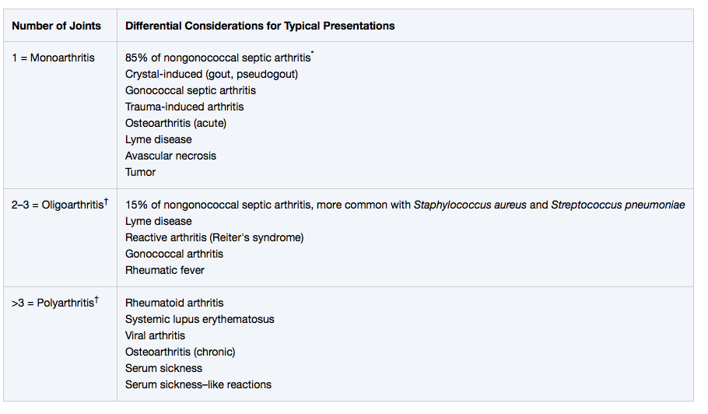

ii) You are reasoning whether to admit the patient to the ward or to the Short Stay Unit. List 5 criteria that this patient must fulfil to be suitable for the short stay unit (5 marks)

Defined diagnosis/differential and management plan
Serious diagnoses, requiring admission to a ward, have been outruled or highly unlikely e.g. septic joint/significant fracture requiring orthopaedic admission
Patient has anticipated length of stay <24 hrs
Able to self care, ambulate, toilet, etc
Predicted that with analgesia/physio the patient will be physically and socially set up for dc.
Favourable social setting that will not impede discharge planning
Able to weight bear/walk when previously could (LR failure if cant is +4.8)
No complex or multiple medical issues

Question 6

A 15 year old male, who has recently arrived as a refugee from East Africa, presents with severe lower back pain. He denies any history of trauma. He is ambulating with great difficulty, and only with the support of his father. Both have some difficulties with communication in English.

i) In the table below list five (3) back pain red flags (in history or examination), and a diagnosis that each red flag could represent in this patient (6 marks)

Red Flag from History or Examination (5 marks) | Potential Diagnosis (5 marks)

Red Flag from History or Examination (5 marks) | Potential Diagnosis (5 marks)
Fevers | Epidural abscess, spinal TB,
Incontinence/retention of urine or erectile dysfunction | Cauda Equina syndrome – secondary to mass lesion, abscess
Weight Loss | Malignancy, TB
Weakness or sensory changes in legs | Spinal cord compression – including large disc bulges, masses, abscesses
Long term Steroid Use (less likely in child) | Osteoporosis

Others may also be appropriate but must be relevant to this patient who is 15 years old.

ii) After assessment you are concerned that the patient has an imminently life threatening diagnosis. His father appears agitated and they are trying to leave. List four (4) escalating measures you will employ in this situation to get them to stay for investigation and treatment (Assuming that at each stage the measure fails) (4 marks)
Interpreter – phone or in person
Use of Social worker or relatives that can be contacted ? mother
Provide explanation reassurance and comfort measures – private space, food, drinks
Can keep minor under common law as risk to life/function – need to contact DEM and Hosp Exec
Restraint and sedation, plus removal of father only at a last resort and only in case of imminent danger to child – use of security and police required potentially.

Question 7

A 63 year old diabetic indigenous man has a non healing ulcer on his foot. He was discharged 3 weeks ago after a month long stay in hospital for management of multiple comorbidities. He is confused. He is currently in a resus bed with intravenous access and non invasive monitoring ongoing. He has had 3L of IV NaCl 0.9%.

Observations

P 130
BP 80/50
Sats 97% on 2L O2 via NP
RR 32
Temp 37.8

BSL 27.0
Ketones 1.0

His XRay is shown
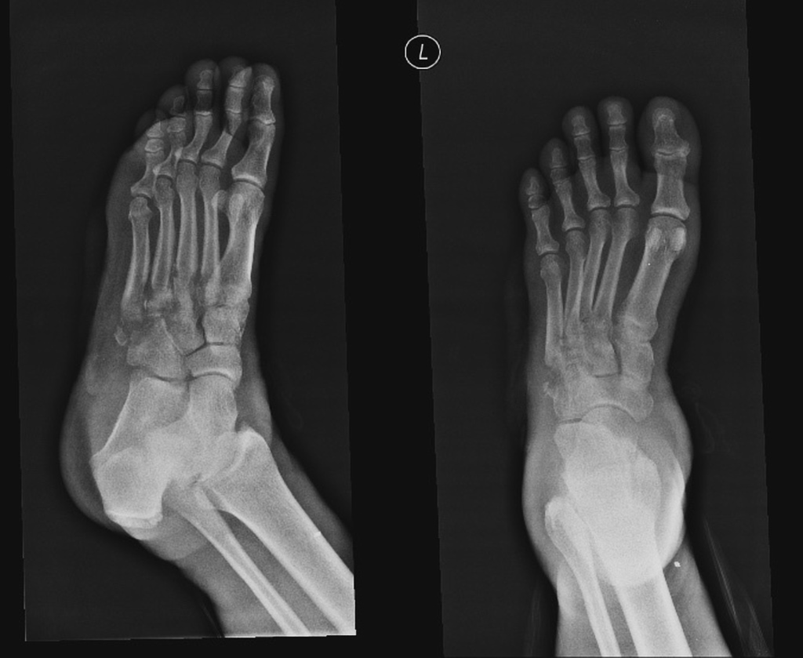

i) In regard to the XRay

a) Which three (3) bones are MOST affected by this process (3 marks)
Base of 5th metatarsal
Cubiod
Cuneiforms –lateral

b) What pathologic condition does this represent (1 mark)
Ostomyelitis

ii) List the immediate management of this patient (9 marks)
Antibotics – Tazocin 4.5 g and Vancomycin 25m/kg
In NT would get Mero and Vanc potentially for sepsis – both ok answers
(Cefazolin or Fluclox PLUS Vanc is NOT appropriate for a patient with a diabetic foot source)
Inotropes – Noradrenaline via central line
Ongoing IV fluids guided by response/UO – aiming to achieve a MAP of >65

Apropriate analgesia – titrated IV opiates +/- sedation for agitation e.g haloperidol/lorazapam to facilitate lines etc
Insertion of CVC/Arterial Line/IDC (max one mark for one or all of these)
Glucose control with titrated insulin/sliding scale
Discussion with family members/Early consideration of limits of care and any pre-existing advanced care plans
Contact orthopaedics/surg for likely need for source control
ICU/HDU disposition

iii) The patient is trying to leave the Emergency department. List four (4) elements that this patient MUST be present to demonstrate that he has capacity to refuse treatment (4 marks)

Recognises that there is a decision to be made,
Understands the relevant risks,
Understands the treatment options,
Understands the likely consequences of each option (i.e. risks, burdens, and benefits),
Can rationally manipulate the information to come up with a decision consistent with his or her values.
Definition: “sufficient understanding and memory to comprehend in a general way the situation in which one finds oneself and the nature, purpose, and consequence of any act or transaction into which one proposes to enter”
Notes:
- i) assesses diagnostic reasoning. Note the specific instructions to the candidate regarding
how many diagnoses per row, and the use of prioritisation within the answer. Note that the categories are given to the candidate, rather than the candidate creating their own categories, to assist the candidate to write the correct answers.
- ii) assesses professionalism knowledge. Note the bolded elements are required for full marks, thus if the candidate only writes two of the bolded elements in their full answer, the maximum mark awarded is 3. Most candidates will only get three of these, but four are requested to test for excellence. The definition is given in italics to inform examiners. Candidates are not required to quote this in their answer.
https://cbhd.org/content/competence-capacity-and-surrogate-decision-making

Question 8
A 19 year old man presents with pain in his right hand and left wrist. He is complaining of some dysuria and feels generally lethargic and unwell. He has recently returned from Peru and Bolivia after a back packing trip for 6 months. He did not visit any other countries
A photo of his hand is shown

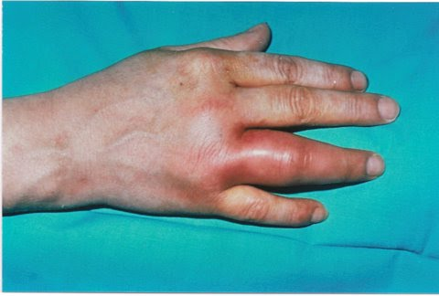
i) The are no other joints involved what pattern of arthritis does this suggest (1 mark)
Oligoarthritis (2-3 joints)
ii) List five (5) features in the history that you will use to try and differentiate the cause of his symptoms, and give justification for each (5 marks)
Pattern of other joint involvement – differing causes for oligo vs poly
Bites from mosquitos – Zika virus
Unprotected sex, urethral discharge, sx of epididymoorchitis etc - ?Reactive
Hx of rheumatological disorders in patient or family ??RhA
Ocular Sx of uveitis
Fevers and sweats – Zika/disseminated gonno/septic arthritis e.g staph
Constitutional Sx – Lyme disease, Rheumatoid
Hx gout – can be polyarticular
Rashes – suggestive of lyme, psoriasis, rheumatic fever
Nail changes – psoriatic
IV drug use – embolic phenomenon/endocarditis
Malaria prophylaxis -
etc

iii) List five (5) investigations you will perform with justification (excluding FBC/EUC/LFT/CMP/CRP/ESR)
(5 marks)
Urethral swab - ? gonnococcal, chlamydia
First catch urine - ?STI/UTI
Zika/Chikungunya serology
ECG- evidence of rheumatic fever – PR prolongation etc
Blood cultures – disseminated staph
CXR - ?pneumonia
Malaria screening

Question 9

A 23 year old man presents to ED. He has a history of heavy alcohol intake but has been unwell and hasn’t had a drink for 48 hours. He woke on the bathroom floor this morning with a sore shoulder. He cannot recall the events of the last 3 hours.

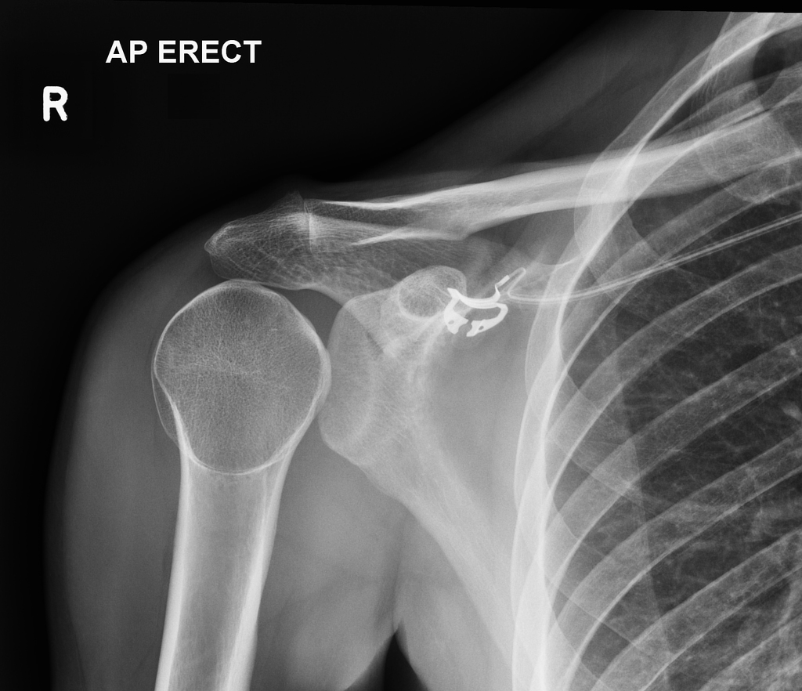
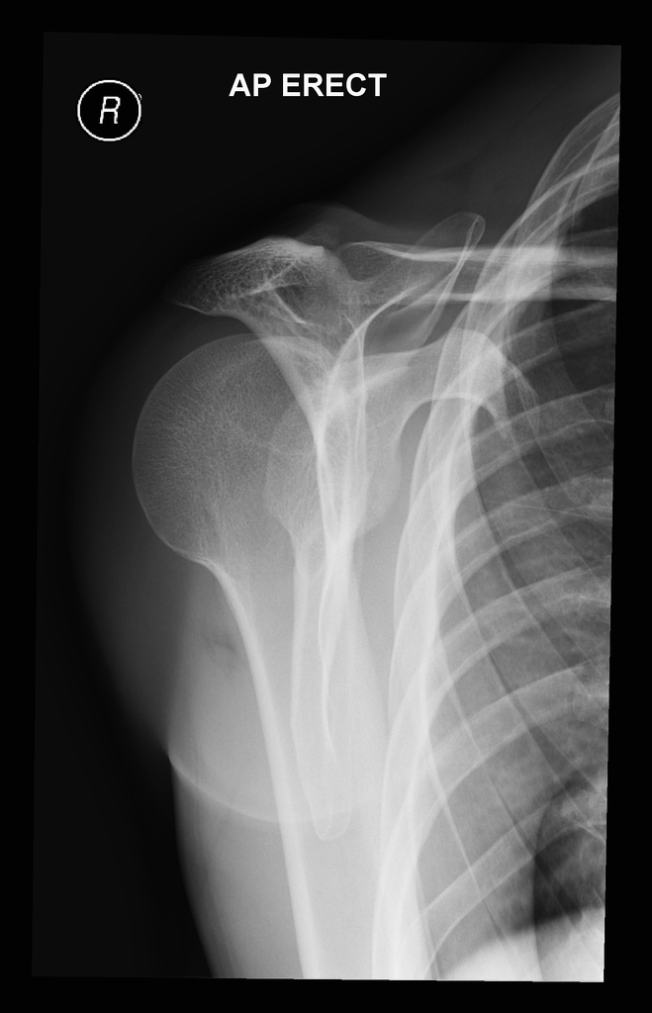
i)

a) List the two (2) most abnormal features present on this series of XRays (2 marks)
Lightbulb sign
Humeral head sitting posterior to the glenoid on scapular Y view

b) What is the diagnosis (1 mark)
Posterior Shoulder Dislocation

ii) List three (3) underlying causes/mechanisms for this type of injury (in general) (3 marks)
Seizures
Electrocutions
High energy trauma to anterior shoulder e.g MBA

iii) List the steps in correcting this injury (assuming the patient already has adequate analgesia and sedation) (3 marks)

Lie supine

De Palma method
- Adduct
- Internally rotate
- Traction
- Medial Upper arm pushed laterally
- Arm Extended

OR
- Adduct
- Internally rotate
- Traction
- Assistant pushes humeral head anteriorly into the glenoid

iv) List the three (3) MOST likely associated fractures (3 marks)
# Post glenoid rim
Reversed Hill-Sachs
Humeral Head Fractiure
Lesser Tuberosity Fracture

Tintinalli - Fractures of the posterior glenoid rim, humeral head (reversed Hill-Sachs deformity), humeral shaft, or lesser tuberosity are common complications. Neurovascular and rotator cuff tears are less common than in anterior dislocations

