Neurology Questions_ACEM Fellowship 2017

Question 1
A 52 year old female presents with a symptom of “the room spinning”. She has no significant PMH and has taken no recent medications. She is a non-smoker and drinks no alcohol.

Observations are within normal limits

a) In the table below, tick for each feature whether a peripheral or central cause is a more likely (10 marks)

Feature of Vertigo | Peripheral | Central
Extremely severe vertigo
Able to tolerate head movements, including Dix Hallpike
Severe associate nausea and vomitting
Tinnitus and hearing loss
Headache and neck pain
Rotational nystagmus
Horizonatal Nystagmus
Truncal Ataxia
Dysdiadochokinesis
Positive Rhombergs

You decide to perform a HINTS exam to help determine if the vertigo is peripheral or central in origin

b) Outline in the table below what HINTS stands for, and what response would be suggestive of a posterior circulation stroke rather than a peripheral cause (6 marks)

 | Examination Test Name | Response suggestive of posterior circulation stroke
HI =
N =
TS =

c) List 3 drugs that might be used to relieve the symptom of vertigo, assuming BPPV is the cause (3 marks)

d) List the steps in performing an Epley Manoevre for a Left Posterior Canal BPPV (5 marks)

Question 2

A 61 year old man presents with weakness and difficulty speaking.

a) List 6 features in the history will you seek to determine if he is a candidate for stroke thrombolysis? (6 marks)

b) List the potential laboratory investigation findings that will preclude the use of thrombolysis (3 marks)

The patient has a BP of 210/100

c) List 3 agents, with doses, you could use to reduce the blood pressure (3 marks)

The patient has a severe fresh red lower GI bleed, with haemodynamic instability after administration of Alteplase

BP 60/30
P 130
Sats 99%
RR 30
Temp 37.2

d) Outline 4 medications/products you will administer to manage this situation (4 marks)

Question 3

A 34 years old obese (140kg), diabetic woman presents after having a seizure at home. She had been complaining of headaches for several weeks.

Her fundi and CT are shown below image are shown below
She has an IV line and his bloods including FBC/EUC/LFT/CMP/Coag are all normal

BP 200/110
P 60
Sats 99%
RR 14
Temp 37.7
GCS 9

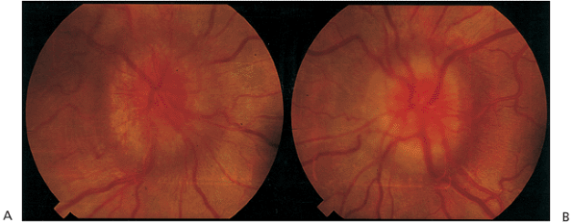

a) What does the photo of the fundi demonstrate (1 mark)

b) List the differential diagnosis for this finding (5 marks)

She has a further tonic clonic seizure that is not terminated after 5 mins by 5mg midazolam IV.

c) List your stepwise approach to pharmacologically managing her seizures, assuming at each stage the seizure is not terminated (4 marks)

d) List 3 other bedside or point of care tests you would like to perform urgently in this patient, with your rationale for each (6 marks)

Question 4

A 19 year old female presents with headache and a sore neck. She works as a nanny in a childcare centre and but has been absent from work for 24 hrs as she thought she had flu.

Obs
T 38.1
P 120
BP 100/60
Sats 99%
RR 25

a) What features on examination would mean that an LP should be considered as part of your workup (4 marks)

You opt to do an LP after assessment of the patient

b) List, with details, the potential adverse effects that you will discuss with the patient when you consent them for the procedure (4 marks)

The patient gets upset just prior to the LP, and tries to leave the department. Despite your best efforts she is insistent upon signing herself out

c) What criteria do you need to assess to ensure she has capacity to make the decision to leave. (4 marks)

Eventually she is persuaded to have the LP. Initial microscopy results suggest meningococcal meningitis.

d) What drug will you choose as chemoprophylaxis for adult household contacts? (1 mark)

Question 5

A 42 year old male presents with a history of weakness in his legs. There is no history of trauma and he has no pain. His GP has performed a CT of his thoracolumbar spine that is normal, and blood tests for FBC/EUC/LFT/CMP are normal.

The GP referral letter states a differential diagnosis of Motor Neurone Disease, Multiple Sclerosis or Guillan Barre Syndrome.

The patient is understandably anxious and has printed out information from the internet on all of the above diagnoses.

a) In the table below list 2 history and 3 exam features would be suggestive of each condition, and help to distinguish from one or both of the differentials (15 marks)

 | MND | MS | GBS
History 1
History 2
Exam 1
Exam 2
Exam 3

In this patient the clinical features turn out to be consistent with GBS. The patient has a severely reduced FEV1

b) List 3 criteria for intubation of a patient with GBS (3 marks)

c) List the induction agent and paralytic that you will utilize if intubation is required (2 marks)

Question 6
A 75 year old man presents from a nursing home after a short lived syncope associated with a head strike. He has been generally unwell for 3 days and has been refusing to take his medications. He is confused.

He has AF, LBBB, PMR, COPD and dementia associated with Parkinsons Disease. He takes warfarin, ramipril, donepezil, frusemide, allopurinol, prednisolone and panadol osteo.

Observations
P130
BP 90/60
Sats 90%
RR 24
GCS 12
Temp 36.1

His CT is shown below

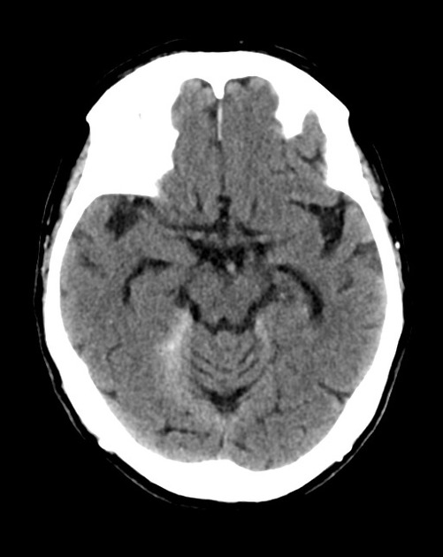
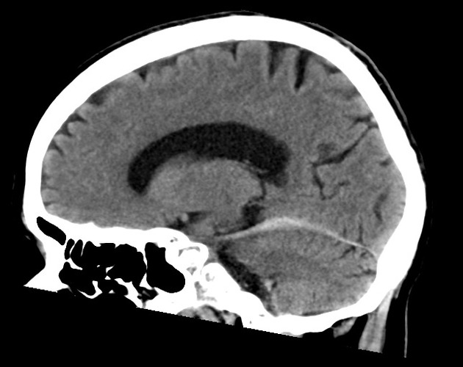

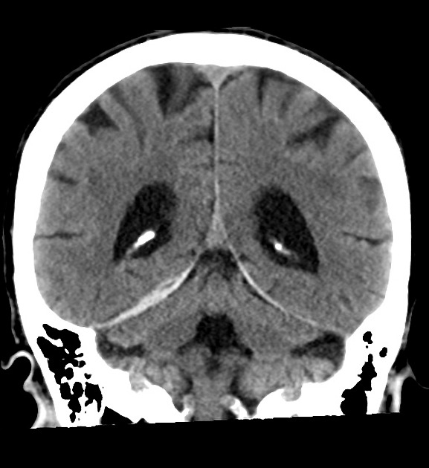

a) List the positive finding in the set of CT images (1 mark)

b) List the management you will institute in the Emergency Department (6 marks)

c) In the table, list 6 potential precipitating causes for the collapse in this patient, with a risk factor for each and the confirmatory tests you will perform in ED (18 marks)

Reason for Fall | Risk Factor | Tests

Question 7

You are in a rural hospital. A 24 year old man has sustained an injury to his neck during a rugby tackle. He has neck pain and is complaining of weakness to his upper limbs.

His Cervical Spine X Ray is shown

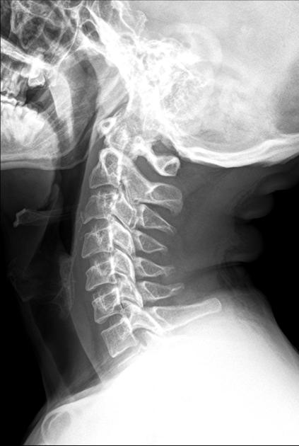

a) Describe the cervical spine X ray, including relative negatives (3 marks)

b) What is the likely directional mechanism for this injury (1 mark)

The neurosurgical registrar from the nearest tertiary centre is on the phone, he has seen the films and is keen to know if there are any signs of a central cord syndrome.

c) What signs would you expect to see in a central cord syndrome (3 marks)

d) List 5 potential adverse consequences of being in a cervical spine collar during transfer to the tertiary centre (5 marks)

Question 8

A 6 year old boy presented to ED earlier in the day after falling from the monkey bars. He was discharged after being observed for 1 hour with panadol and verbal advice to the parents on head injury management.

He has had 4 vomits since discharge and has become confused and lethargic

His CT is shown

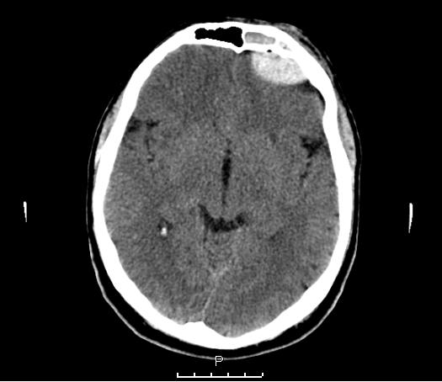

a) Describe the CT, including relevant positives and negatives (7 marks)

The child drops their GCS to 5. They are moved to resus, have full non invasive monitoring applied and 2 IVC inserted.

b) List the management that you will undertake in the next hour to stabilise the child including measures to minimise risk of further brain injury (12 marks)

The child becomes bradycardic and hypertensive, with unequal pupils.

c) List 3 potential actions that can be used in ED in this situation whilst awaiting neurosurgical intervention. Give doses where appropriate (3 marks)
You decide to run a teaching session for your registrars on decision rules for imaging in paediatric head injury.

d) List 3 well known decision rules that you will discuss during this teaching session (3 marks)

Question 9

A 40 year old man presents with a history of an asymmetrical face and drooling when trying to eat or drink.

His photo is shown below

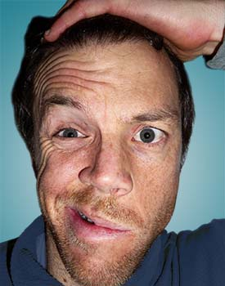

a) What is the most likely diagnosis for this finding in this man? (1 mark)

b) How can you differentiate UMN from LMN causes of facial weakness (1 mark)

c) List, in the table below 2 other causes of UMN facial weakness and 5 causes of LMN facial weakness (7 marks)

LMN | UMN

c) Assuming your most likely diagnosis is correct, outline the management (3 marks)

The patient is very distressed that they will “be like this forever”

d) What will you tell the patient about their likely recovery is to be complete and follow up arrangements (4 marks)

