Neurology Questions_ACEM Fellowship 2017

Question 1
A 52 year old female presents with a symptom of “the room spinning”. She has no significant PMH and has taken no recent medications. She is a non smoker and non drinker.

Observations are within normal limits

a) In the table below tick for each whether a peripheral or central cause is a more likely cause (10 marks)

Feature of Vertigo | Peripheral | Central
Extremely severe vertigo
Able to tolerate head movements, including Dix Hallpike
Severe associate nausea and vomitting
Tinnitus and hearing loss
Headache and neck pain
Rotational nystagmus
Horizonatal Nystagmus
Truncal Ataxia
Dysdiadochokinesis
Positive Rhombergs

Feature of Vertigo | Peripheral | Central
Extremely severe vertigo | X
Able to tolerate head movements, including Dix Hallpike |  | X
Severe associate nausea and vomiting | X
Tinnitus and hearing loss | X
Headache and neck pain |  | X
Rotational nystagmus | X
Horizontal nystagmus | X
Truncal Ataxia |  | X
Dysdiadochokinesis |  | X
Positive Rhombergs |  | X

You decide to perform a HINTS exam to help determine if the vertigo is peripheral or central in origin

b) Outline in the table below what HINTS stands for, and what response would be suggestive of a posterior circulation stroke rather than a peripheral cause (6 marks)

 | Examination Test Name | Response suggestive of posterior circulation stroke
HI =
N =
TS =

Mnemonic | Stands for….. | Response suggestive of posterior circulation stroke
HI = | Head Impulse | Impulse negative – no saccades present
N = | Nystagmus | Fast (Phase) Alternating i.e. direction changing nystagmus when gaze in opposite directions
TS = | Test of Skew | Refix on Cover Test – must be vertical refixation

c) List 3 drugs that might be used to relieve the symptom of vertigo, assuming BPPV is the cause (3 marks)
Any sedating antihistamine with H1 activity e.g diphenhydramine (phenergen) 35-50mg 4 hrly
Metoclopramide 10mg tds
Promethazine 25mg IM/PO tds
Ondansetron 4mg qid or 8mg bd
Nimodipine 30mg bd po

d)List the steps in performing an Epley Manoevre for a Left Posterior Canal BPPV (5 marks)
Start sitting and perform a Dix Hallpike to the left – head below the horizontal and turned to the left
Hold this position for minimum 1 min
Rotate the head to the right with the head still below the horizontal – min 1 min
Roll patient onto their right side or front with a further 45 degree head rotation to the right so facing the floor – 1 min
Sit patient up facing forwards on the edge of the bed – 1 min
May need to repeat several times

Question 2

A 61 year old man presents with weakness and difficulty speaking.

a) List 6 features in the HISTORY will you seek to determine if he is a candidate for stroke thrombolysis? (6 marks)
Onset time within 3-4 hrs (institution dependant and changing)
Presence of syncope, seizures or other features of stroke mimicks – neuro-glycopaenic Sx in a diabetic on insulin,
Presence of stroke symptoms – as per Rossier Scale below
Presence of contraindications to thrombolysis – head trauma/stroke <3m, recent surgery, anticoagulation/coagulopathy/active bleeding/brain tumour/non compressible arterial puncture <7d, LP within 7d

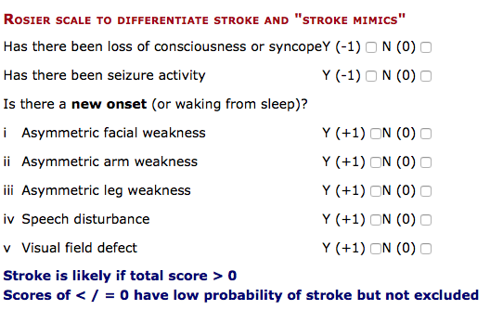

b) List the potential blood investigation findings that will preclude the use of thrombolysis (3 marks)
plt <100,
Raised aPTT in context of heparin use
INR >1.7
BGL <2.7

The patient has a BP of 210/100

c) List 3 agents, with doses, you could use to reduce the blood pressure (3 marks)
Labetolol 10-20mg IV repeated at 10 mins – can also be given by infusion at 1-2mg
SNIP
GTN
Hydralazine
Any sensible drugs allowed

The patient has a severe fresh red lower GI bleed, with haemodynamic instability after administration of Alteplase

BP 60/30
P 130
Sats 99%
RR 30
Temp 37.2

d) Outline the medications and products you will administer in managing this situation (4 marks)
Packed Red Cells as per MTP
FFP
Cryoprecipitate
TXA 1g, then 1g over 8hrs
Consideration of other factors e.g. factor VII/PCC – in consultation with haematology

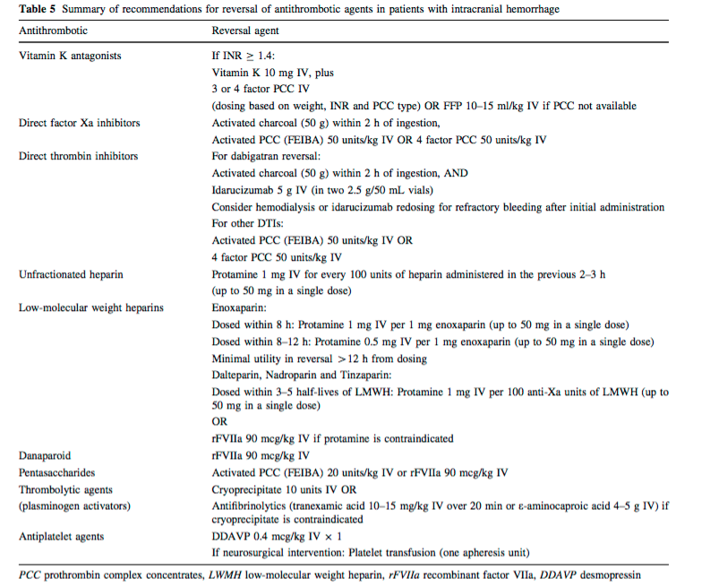

Question 3

A 34 year old obese (140kg), diabetic woman presents after having a seizure at home. She had been complaining of headaches for several weeks.

Her fundi and CT are shown below image are shown below
She has an IV line and his bloods including FBC/EUC/LFT/CMP/Coag are all normal

Obs

BP 200/110
P 60
Sats 99%
RR 14
Temp 37.7
GCS 9

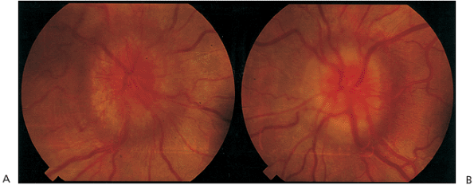

a) What does the photo of the fundi demonstrate (1 mark)
Bilateral papilloedema

b) List your differential diagnosis for this finding (5 marks)
Brain Tumor with raised ICP
Venous sinus thrombosis
ICH with mass effect
Any other cause of rasied ICP – malignant hypertension including preeclampsia/Vit A tox /methanol/intracerebral infections/hypoxic brain injury post seizure
Eye causes – CRVO/Optic neuritis/Ischaemic neuropathy
Benign Intracranial Hypertension

She has a further tonic clonic seizure that is not terminated after 5 mins by 5mg midazolam IV.

c) List your stepwise approach to pharmacologically managing her seizures, assuming at each stage the seizure is not terminated (4 marks)
Check BSL and administer 50mls 50% dextrose if low
Further dose of mizadolam 5mg IV
Phenytoin 20mg/kg or Leviteracetam 2-4g
Induction and intubation/ventilation
-Propofol 1-2mg/kg then infusion
-Ketamine 2mg/kg then infusion
-Phenobarbitone 20mg/kg (max 50-75mg/min rate)
-Midazolam – 0.2mg/kg then infusion 0.05-2mg/kg/h

Plus appropriate paralytic –e.g sux 1-2mg/kg or rocuronium 1-1.4mg/kg

Infusion doses not necessary for full marks

d) List 3 other bedside or point of care tests you would like to perform urgently in this patient, with your rationale for each (6 marks)

BHCG – potential for eclampsia in undiagnosed pregnancy – note pt 140kg, hard to clinically tell if advanced preg
VBG – adequacy of ventilation, check electrolytes as cause for seizure e.g. Na.
ECG – exclude toxicological causes/arrhythmias e.g TCA OD with terminal R in aVR
Bedside USS – look for a fetus
Urine dipstick - ?eclampsia – however is diabetic so a negative result for protein is more useful than +ve

Question 4

A 19 year old female presents with headache and a sore neck. She works as a nanny in a childcare centre and but has been absent from work for 24 hrs as she thought she had flu.

Obs
T 38.1
P 120
BP 100/60
Sats 99%
RR 25

a) What features on examination would mean that an LP should be considered as part of your workup (4 marks)
Positive Kernigs/Brudzinskis/Meningism
Abnormal GCS
Photophobia
Peticheal Rash
Absence of signs that suggest an alternative, benign, non intracranial cause for her Sx

You opt to do an LP after assessment of the patient

b) List, with details, the potential adverse effects that you will discuss with the patient when you consent them for the procedure (4 marks)
The risk of damage to the spinal cord and nerve roots – rare and minimised by choosing an appropriate position below the cord at L4/5
The risk of post LP headache, and that it can be long lasting and severe – minimised by needle size and type, the need for a blood patch in a small number
The risk of infection – minimised by aseptic technique/skin cleaning etc
The risk of bleeding/epidural haematoma

The patient gets upset just prior to the LP, and tries to leave the department. Despite your best efforts she is insistent upon signing herself out

c) What criteria do you need to assess to ensure she has capacity to make the decision to leave. (4 marks)
Must be conscious, not confused and not sig affected by sedatives/alcohol
Able to understand the information you given them with regards to the illness, investigations, alternatives and outcome of not having the proposed treatment
Be able to retain that information long enough to weigh it up and make a decision
Be able to communicate that decision to the care giver.

Eventually she is persuaded to have the LP. Initial microscopy results suggest meningococcal meningitis.

d) What drug will you choose as chemoprophylaxis for adult household contacts?
Ciprofloxacin 500mg po
Ceftriaxone 250mg IM
(Rifampicin is a less suitable alternative if the above are CI)

Question 5

A 42 year old male presents with a history of weakness in his legs. There is no history of trauma and he has no pain. His GP has performed a CT of his thoracolumbar spine which is normal, and blood for FBC/EUC/LFT/CMP are all normal.

The GP referral letter states a differential diagnosis of Motor Neurone Disease, Multiple Sclerosis or Guillan Barre Syndrome.

The patient is understandably anxious and has printed out information from the internet on all of the above diagnoses.

a) In the table below out line 2 history and 3 exam features that if present would help to distinguish between these 3 conditions

 | MND | MS | GBS
History 1
History 2
Exam 1
Exam 2
Exam 3

MND
Hx –
- Rapidly progressive disease
- No sensation changes
- Can have breathing difficulties

Exam -
- Mixed UMN/LMN (any of the signs eg atrophy and fasiculations with weakness, spasticity, bulbar dysfn for example
- Cramps – common
- No other CNS dysfunction – sensation preserved, proprioception intact, vibration intact
- Hypoventilation, resp muscle weakness (diffs from MS )

MS
Hx
- Recurrent episodes affecting different parts of CNS
- Can be motor/sensory/cerebellar/visual eg ocular pain and red VA/CN symptoms
- Lower>Upper limbs usually
- Lhermittes sign – pain, vibration, electric shock on neck flexion
- Difficulty with urination or sexual function
- Worse Sx with raised body temp
Exam
- All UMN signs – not lower
- Sensory Loss (unlike MND)
- Fundi changes/VA/RAPD in optic neuritis
- Bilateral internuclear ophthalmoplegia
- Signs of urinary retn
-

GBS
Hx
- Ascending symptoms, symettrical
- Preceding viral/bacterial illess
-

Exam
- LMN syndrome, ascending weakness with hyporeflexia
- Resp weakness (unlike MS)
- Usually no sensory sx except if rare motor-sensory form
-

Spared cognition for example is a poor answer – not distinguishing between the 3 as happens in all of these conditions

In this patient the clinical features turn out to be consistent with GBS. The patient has a severely reduced FEV1

b) List 3 criteria for intubation of a patient with GBS (3 marks)

Vital capacity <15 mL/kg
Declining one breath count
Pao2<70 mm Hg on room air
Bulbar dysfunction (difficulty with breathing, swallowing, or speech)
Aspiration

c) List the induction agent and paralytic that you will utilize if intubation is required (2 marks)
Any sensible sedative agent with appropriate dosing
Non depolarizing NMB – risk of hyperkalaemia with suxamethonium

Question 6
A 75 year old man presents from a nursing home after a short lived syncope associated with a head strike. He has been generally unwell for 3 days and has been refusing to take his medications. He is confused.

He has AF, LBBB, PMR, COPD and dementia associated with Parkinsons Disease. He takes warfarin, ramipril, donepezil, frusemide, allopurinol, prednisolone and panadol osteo.

Observations
P130
BP 90/60
Sats 90%
RR 24
GCS 12
Temp 36.1

His CT is shown below

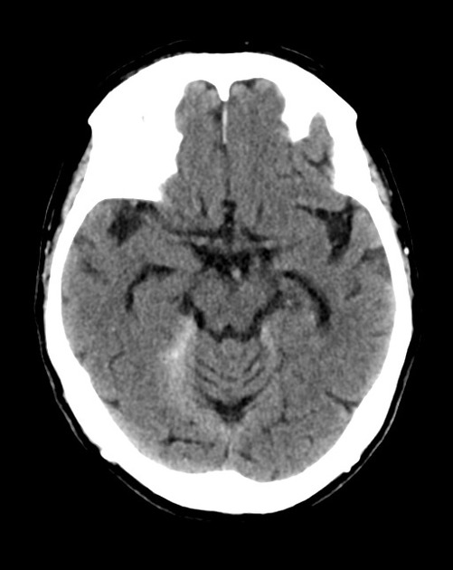
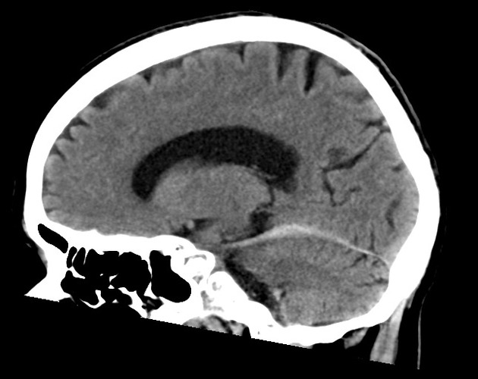

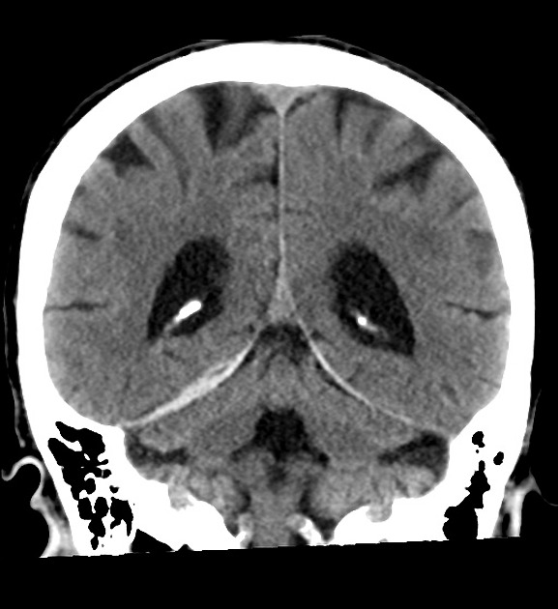

a) List the positive finding in the set of CT images (1 mark)
Acute right sided subdural on superior portion of the tentorium
(must get side/chronicity and type of haemorrhage to score the mark)

b) List the management you will institute for this during the patients stay in emergency (6 marks)
Stop Warfarin and reverse with PCC 25IU/kg (or FFP if no PCC available) and Vitamin K 5mg IV
Oxygen – to titrate Sats>95%
IV fluids to aim for a MAP 65 – in titrated doses of 250mls at a time
Stop antihypertensives
Analgesia – parenteral, any sensible dosing regime
Dose of IV hydrocortisone 200mg – as not taken for several days
Establish if any advanced care directive and contact family/nursing home for collateral history

c) In the table, list 6 potential precipitating causes for the collapse in this patient, with a risk factor for each and the confirmatory tests you will perform in ED (18 marks)

Reason for Fall | Risk Factor | Tests

Reason for Syncope | Risk Factor | Examination/Tests
Postural Hypotension | Ramipril use/poor intake/?steroid deplete/autonomic instability of parkinsons | Postural BP’s
Cardiac Arrhythmia | Pre-existing cardiac arrhyth | ECG/Telemetry
Silent MI and | Age/Cardiac disese/?smoker as has COPD | ECG/Troponin
Sepsis e.g. Urinary/Chest | Prednisolone | Septic Screen/UA/CXR/Blood Cultures
PE | Immobility likely | CTPA
GI Bleed | Warfarin use | PR/CT Angiogram/Hb/Urea
CVA | GCA/Age | CT Brain (already had)/MRI
Steroid depletion | On steroid and not been taking them | Cortisol levels

Question 7

You are in a rural hospital. A 24 year old man has sustained an injury to his neck during a rugby tackle. He has neck pain and is complaining of weakness to his upper limbs.

His CSpine XRay is shown

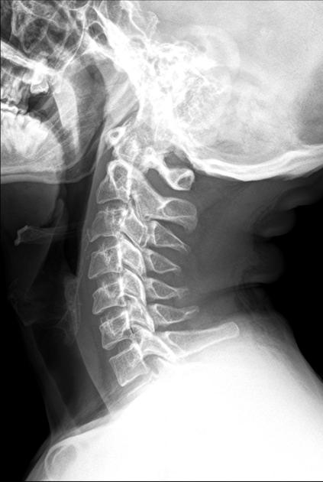

a) Describe the Cervical spine XRay, including relative negatives
Adequate lateral CSpine XRay – included upper border of T1
Teardrop fracture to anteroinferior border of C3 – extension type
No soft tissue swelling

b) What is the likely directional mechanism for this injury
Hyperextension

The neurosurgical registrar from the nearest tertiary centre is on the phone, he has seen the films and is keen to know if there are any signs of a central cord syndrome.

c) What signs would you expect to see in a central cord syndrome (3 marks)
Weakness arms>legs, distally>proximally
Sensory deficits – proximally
Frequent bladder dysfunction/urinary retention

d) List 5 potential adverse consequences of being in a cervical spine collar during transfer to the tertiary centre (
Increased intracranial pressure
Reduces access
Patient discomfort
Impairs patient head movement
•cannot see treating staff
•may contribute to increased anxiety
Cutaneous pressure ulceration
Requirement for log rolling
•manpower issues
•cross infection risk
Aspiration risk
DVT risk
Potential worsening of neurological injury
•cervical collars may cause worsening neurological function in displaced fractures and in patients with pre-existing cervical deformities (e.g. ankylosing spondylitis)

Question 8

A 6 year old boy presented to ED earlier in the day after falling from the monkey bars. He was discharged after being observed for 1 hour with panadol and verbal advice to the parents on head injury management.

He has had 4 vomits since and has become confused and lethargic

His CT is shown

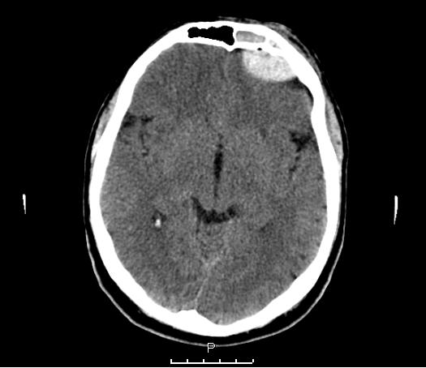

a) Describe the CT, including relevant positives and negatives (7 marks)
Extradural Haematoma left anterior cranial fossa 1.5 x 4cm
No significant midline shift or MINIMAL is acceptable
Left frontal lobe slightly compressed
Fluid in left frontal sinus
Air locule within blood collection
Extraaxial haematoma
No skull fracture seen but not correct window to interpret

The child drops their GCS to 5. They are moved to resus, have full non invasive monitoring applied and 2 IVC inserted.

b) List the management that you will undertake in the next hour to stabilise the child including measures to minimise risk of further brain injury (12 marks)
Protect airway
- RSI with ketamine 1-2mg/kg and sux 1-2mg/kg or rocuronium 1.4mg/kg
- ETT 5.5, depth 15cm
Ventilate to keep CO2 low normal. Vt 4-6mls/kg
Titrate O2 to keep PO2 at 100mmHg
Avoid hypotension – IV fluids +/- noraderenaline if required to maintain BP
Head up 30 degrees
Tube taped not tied
Sedate and Paralyse
Consider phenytoin 20mg/kg or keppra – (prevents early seizures within 7d but no overall mortality effect or change in longterm seizures)
IDC
NG
Maintain euglycaemia
Contact surgical team/ICU/anaesthetics ASAP
Discussion with family

Based on old SCE Q
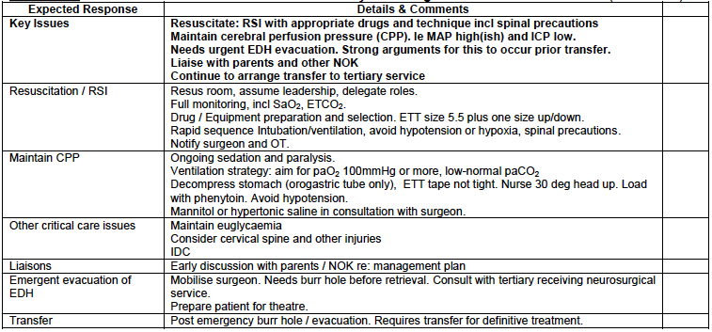

The child becomes bradycardic and hypertensive, with unequal pupils.

c) List 3 potential actions that can be used in ED in this situation whilst awaiting neurosurgical intervention. Give doses where appropriate (3 marks)
Hyperventilate with BVM
Mannitol 1g/kg
Hypertonic saline 3% 3-5mls/kg

You decide to run a teaching session for your registrars on decision rules for imaging in paediatric head injury.

d) List 3 well known decision rules that you will discuss during this teaching session (3 marks)
PECARN
CHALICE
CATCH

Question 9

A 40 year old man presents with a history of an asymettrical face and drooling when trying to eat or drink.

His photo is shown below

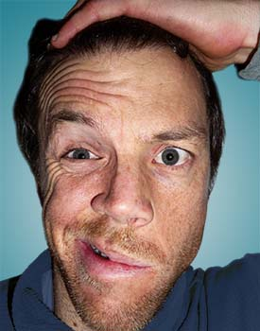

a) What is the most likely cause of this finding in this man? (1 mark)
Bells Palsy

b) How can you differentiate UMN from LMN causes of facial weakness (1 mark)
Frontalis/forehead sparing in UMN due to bilateral cortical representation

c) List, in the table below 2 other causes of UMN facial weakness and 5 causes of LMN facial weakness (7 marks)

LMN | UMN

LMN | UMN
Vascular – CVA/Aneurism/ICH | Ramsay Hunt
SOL - Tumours | Trauma/# to petrous temp bone
 | Pontine lesions e.g syringomyelia/
 | Acoustic Neuroma
 | Meningitis
 | OM
 | MS
 | Tick
 | Parotid Tumour
 | Diphtheria

d) Assuming your likely cause is correct, outline the management (3 marks)
Eye care, lubricant drops and follow up in eye clinic
Prednisolone 50mg daily for 5d
- If started within 3 days results in 10% greater complete recovery rate (NNT10)
Antivirals 5-7 days
- Famciclovir 50mg/d
- Aciclovir 400mg 5x per day

The patient is very distressed that they will “be like this forever”

e) What will you tell the patient about their likely recovery is to be complete and follow up arrangements (4 marks)
Completely resolves in 75% in patients given steroids
-65% without steroids
-95% chance of full recovery, in patients without complete paralysis at presentation
-60% chance of complete recovery even in those with complete paralysis

-occasionally incomplete or is associated with synkinesis (mass facial motion)

-resolution begins several weeks after onset and may take months
Follow up with GP initially +/- eye clinic

