Fellowship 2017:2_GI/Liver/GastroSurg

Q1
A 56 year old female presents to your rural ED with haematemesis and is actively vomiting. She is heavily intoxicated and unable to give a clear history of events. She has known Childs Pugh C liver cirrhosis. She is in the resus bay with full non-invasive monitoring attached. There is no endoscopy service at your hospital

BP 70/40
P 120
Sats 90%
RR 32
Temp 35.2
GCS 13

a) List the 4 most likely causes of her haematemesis (4 marks)

She has a large volume bright red vomit of estimated volume 1000mls.
Her VBG is shown
pH 7.1
pCO2 31
HCO3 15
Hb 56
Na 137
K 3.1

b) List the management steps you will undertake within the next 30 minutes (8 marks)

The patient becomes aggressive and is attempting to leave the department.

c) List the strategies you will use, in escalating order, to manage this situation (4 marks)

Q2
An 84 year old man presents to your tertiary ED with a 2 week history of worsening jaundice and abdominal pain. He is a nursing home resident and has moderate dementia. He is sweaty, confused and distressed. He has had a very low alcohol intake throughout his life. His only comorbidity is hypertension.

a) List the most likely differentials you will consider (6 marks)

b) Complete the table below for the 5 most important tests that you will order, giving a reason for each (10 marks)

Test | Reason

The patient expresses a wish NOT to have any further tests and is distressed and aggressive when you attempt to take blood.

c) What factors will you consider when deciding whether to palliate vs actively manage this patient? (4 marks)

Q3
A 15 year old female presents with weight loss and pallor. Her family are concerned that she has been purposefully withholding food and inducing vomiting over a period of 6 months because she was bullied at school for “being chubby”. Her BMI is 14

a) What positive features on examination might suggest that she has a purging disorder rather than another medical reason for her weight loss? (2 marks)

b) List the immediate investigations you will perform, and the results that you might expect to find should your suspicion of anorexia nervosa with purging be correct. (7 marks)

She tries to leave the department as “there is nothing wrong” and states “you can’t keep me here”. Her parents are distressed and want to know whether she can be kept in hospital against her will to be re-fed via NG tube

c) What is the legal standpoint on consenting to and refusing treatment for this patient (3 marks)

Q4
An 84 year old man presents with a painful distended abdomen. He has vomited several times over the last 24 hrs

His AXR is shown
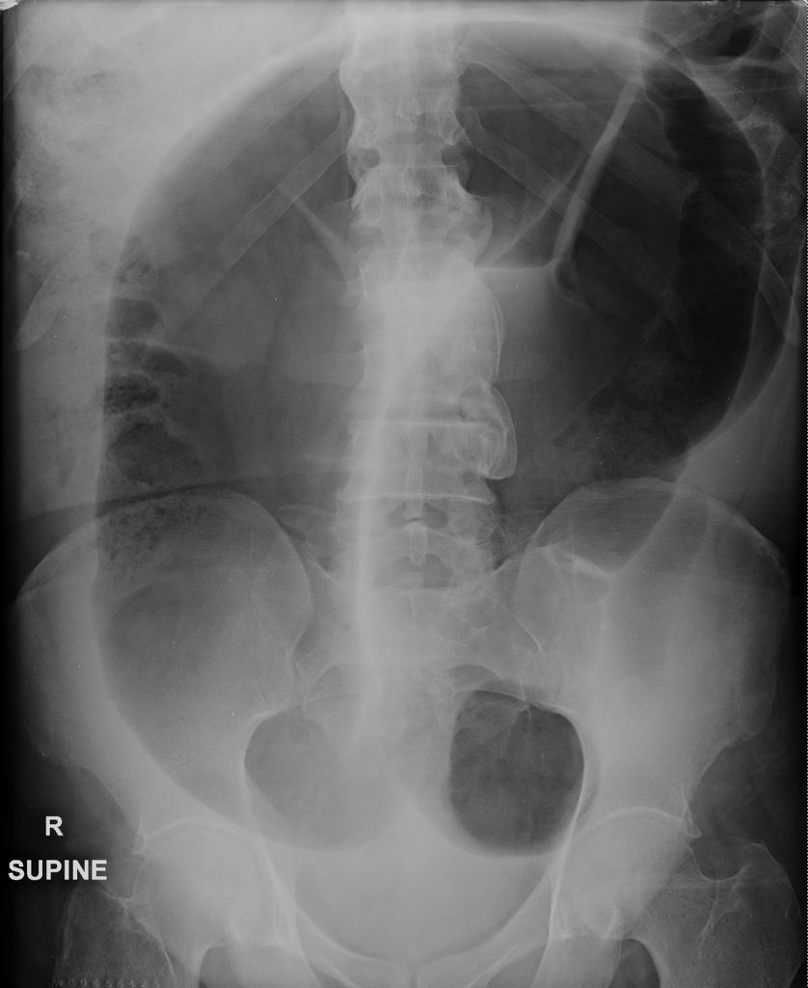
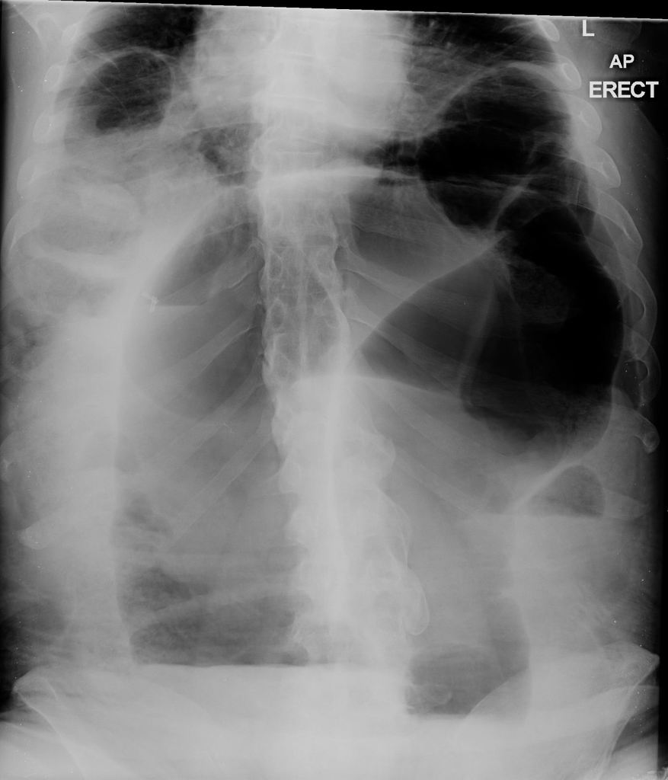

a) List the abnormal features on this XRay (2 marks)

c) What is the diagnosis? (1 mark)

The medical student that you are supervising asks you how you can tell the difference between large and small bowel on an Xray.

d) Complete the table below outlining the features of large versus small bowel obstruction as seen on a plain abdominal film (6 marks)

Large Bowel | Small Bowel

Q5
A mother brings her two year old child to ED and states that the child may have swallowed a battery from a toy. The child put the battery in her mouth, then fell over, and now the battery cant be found

a) List the 4 most relevant points to obtain from the history (3 marks)

CXR is performed, demonstrating a 20mm diameter battery, which appears to be in the stomach. The child is for discharge.

b) What advice should be given to the mother regarding the ongoing care? (2 marks)

c) If the battery was smaller (10mm) and seen to be beyond the pylorus how would the discharge advice have changed? (1 mark)

The Child returns after 3 days with abdominal pain, dark stools and refusal to eat or drink for 12 hours.

c) List and justify your 6 actions in the Emergency Department (6 marks)

Q6
A 25 year old female presents with 3 months of non-bloody diarrhoea without vomiting or fevers. Her GP has sent 2 stool samples, which have been negative. She has lost 5 kilos is weight and is currently 45kg (BMI 17). She is lethargic, weak and mildly dehydrated. He has no history of medical conditions and takes no medications.

BP 130/70
P 100
Sats 99% RA
RR 16
Temp 37.1

a) In the table below list 5 potential differential diagnoses and 2 features in the history you will ask relating to each differential

Differential | History

The nurses perform an ECG “as a baseline”.

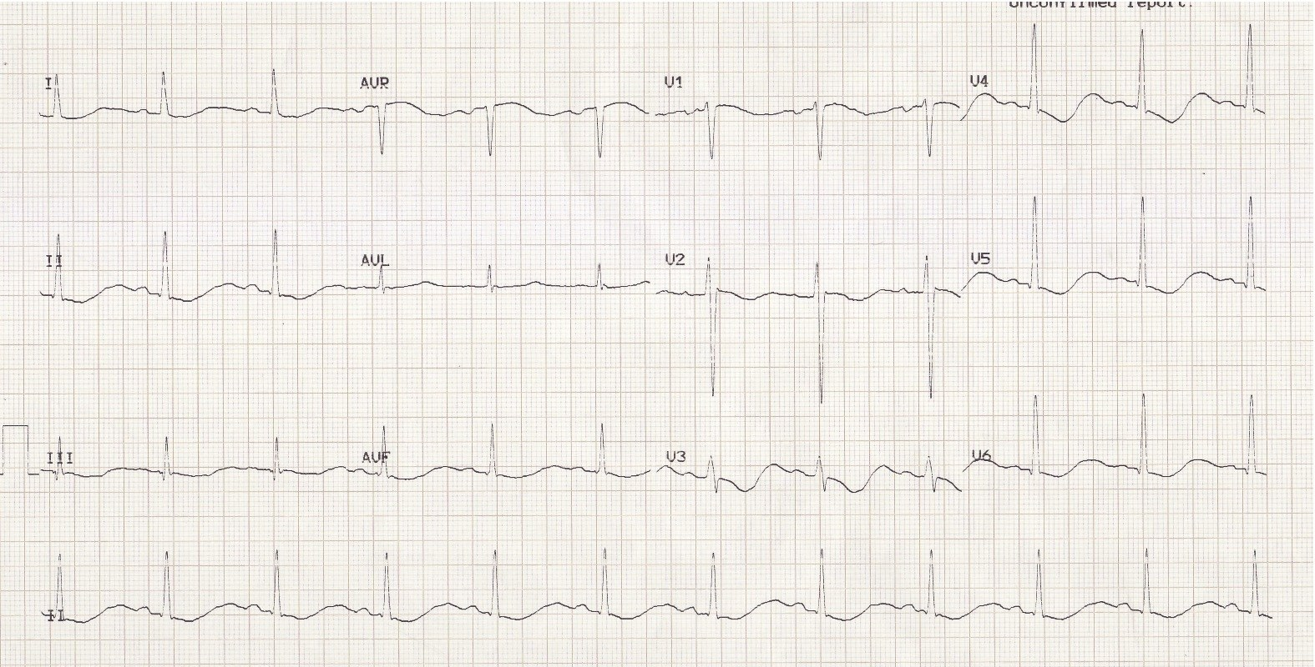

b) List the positive findings on the ECG (4 marks)

c) What is the likely cause of this ECG abnormality (1 mark)

d) What 8 blood investigations would you consider ordering in ED to narrow your differential - with justification for each (16 marks)

Q7
A 5 week old child presents to ED with vomiting. The mother brought her child to ED 3 days earlier and was sent home with a diagnosis of “overfeeding and reflux”. Mum states that the child has been very hungry but has become lethargic over the last 24 hrs and has only had 1 wet nappy. The child weighs 4kg. You estimate that they are moderately dehydrated (5%). The venous gas performed shows the following:

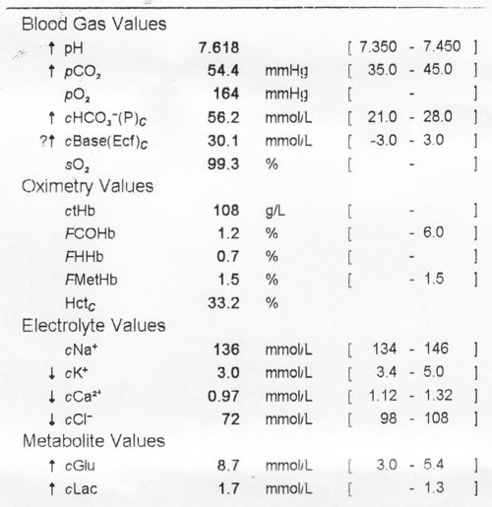

a) What abnormality does this VBG show? (4 marks)

b) What is the likely cause? (1 mark)

c) List 2 other surgical differentials (2 marks)

d) What examination findings might you expect to see if your first differential is correct? (3 marks)

e) Outline the fluid management for this child (assuming they are to be nil by mouth) (3 marks)

Q8

A 56 year old male presents with fresh red PR bleeding and a lump that can’t be “pushed back in anymore”. He is crying with pain. On inspection of the anus you see the following.

He is unable to tolerate PR due to pain. He has no medical comorbidities and takes no medications.

a) What is the abnormality (3 marks)

b) Outline the steps you would take to surgically manage this condition in the ED (5 marks)

c) Outline the discharge advice you will provide post procedure (6 marks)

d) List 3 patient groups in whom it is NOT appropriate to manage surgically in the ED (3 marks)

Q9

An 82 year old man presents with weight loss and jaundice. He is in the resus bay with full non invasive monitoring. His observations, CT scan and blood results are shown below:

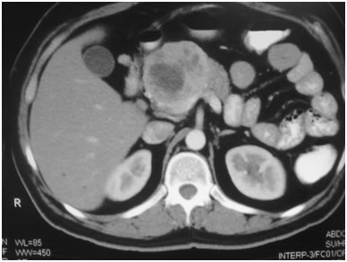

P110
BP 90/70
RR 26
Temp 38.9
Sats 90% RA

Hb 107
Plt 189
WCC 17.9

Bil 98
AST 74
ALP 367
GGT 620
Alb 23

Cr 378
Ur 13.5
K 6.4
Na 131

a) What is the most likely diagnosis (2 marks)

b) List the immediate actions you will undertake in the emergency department to manage and investigate this patient.(12 marks)

The nurse calls you 2 hours later to say that the patient has become confused, has pulled out his drips and is trying to climb out of bed.

a) List 3 pharmacological options for managing this mans agitation (without him being intubated), with one pro and one con for each (9 marks)

Agent/dose/route | Pro | Con

d) List 5 things that may be contributing to this mans confusion (5 marks)

