Fellowship 2017:2_GI/Liver/GastroSurg

Q1
A 56 year old female presents to your rural ED with haematemesis and is actively vomiting. She is heavily intoxicated and unable to give a clear history of events. She has known Childs Pugh C liver cirrhosis. She is in the resus bay with full non-invasive monitoring attached. There is no endoscopy service at your hospital

BP 70/40
P 120
Sats 90%
RR 32
Temp 35.2
GCS 13

a) List the 4 most likely causes of her haematemesis (4 marks)
Oesophageal/Gastric Varices
Peptic Ulcer disease
Oesophagitis
Mallory Weiss Tear

She has a large volume bright red vomit of estimated volume 1000mls.
Her VBG is shown
pH 7.1
pCO2 31
HCO3 15
Hb 56
Na 137
K 3.1

b) List the management steps you will undertake within the next 30 minutes (8 marks)
2 large bore IV lines
Blood products/MTP guided by haemodynamic parameters/FBC/coags/Fib/Ca etc. Start with O neg blood. Avoid overtransfusion at risk of dislodging clot. Permissive hypotension
Ceftriaxone 1g IV
Contact retrieval PLUS Urgent surgical/gastro involvement at nearest tertiary hospital for arranging UGI scope
Terlipressin 1.7mg 6hrly or octreotide (50-100mcg bolus then 25-50mcg/kg/hr)
PPI infusion – pantoprazole 80mg stat and 8mg/hr IVI
Consider Sengstaken Blakemore tube for transfer – will likely need to be intubated for this is needs
Arterial and central lines for transfer if time permits
NOTE: Lactulose not appropriate given current vomiting

The patient becomes aggressive and is attempting to leave the department.
c) List the strategies, in order of escalation, that you will use to manage this situation (4 marks)
Verbal de-escalation
- Explanation of seriousness of condition
Use of family members or friends to try and talk patient into staying
Common law to restrain patient as has no capacity to make decisions – GCS 13 and hypotensive
- Sedation with ketamine e.g. DSI 1mg/kg – more haemodynamically stable agent that others. Other options include small titrated doses of droperidol or midazolam
- Likely will need I&V for safe transfer to definitive care.
- Mechanical restraint less appropriate

Q2
An 84 year old man presents to your tertiary ED with a 2 week history of worsening jaundice and abdominal pain. He is a nursing home resident and has moderate dementia. He is sweaty, confused and distressed. He has had a very low alcohol intake throughout his life. His only comorbidity is hypertension.

a) List the most likely differentials you will consider (6 marks)
Gallstones with biliary obstruction
Cholecystitis
Cholangitis
Malignancy e.g cholangiocarcinoma/pancreatic malignancy
Secondary malignancy - liver mets
Infectious hepatitis – e.g Hep A
All other causes e.g chronic hep/autoimmune causes etc are less likely

b) Complete the table below for the 5 most important tests that you will order, giving a reason for each (10 marks)

Test | Reason
LFTs | To determine if obstructive vs hepatitis cause
Coags | To determine if synthetic function of liver
BSL | Exclude hypoglycaemia – sweaty and confused ?neuroglycopenic
USS | ?biliary obstruction ? parenchymal lesion
FBC | Exclude anaemia/haemolysis, WCC as marker of infection

The patient expresses a wish NOT to have any further tests and is distressed and aggressive when you attempt to take blood.

c) What factors will you consider when deciding whether to palliate vs actively manage this patient? (4 marks)
Diagnosis and whether reversible cause
Anticipated course and invasiveness of proposed Rx e.g surgical vs abx
Quality of life e.g cognitive function, mobility, ability to carry out own ADLs, pain
Capacity of the patient to make decisions
Preexisting wishes documented in a living will/advanced directive
Discussions with family members/carers

Q3
A 15 year old female presents with weight loss and pallor. Her family are concerned that she has been purposefully withholding food and inducing vomiting over a period of 6 months because she was bullied at school for “being chubby”. Her BMI is 14

a) What positive features on examination might suggest that she has a purging disorder rather than another medical reason for her weight loss? (2 marks)
Evidence of erosive changes to teeth
Marks on knuckles due to induced vomiting
Parotid gland swelling

b) List the immediate investigations you will perform, and the results that you might expect to find should your suspicion of anorexia nervosa with purging be correct. (7 marks)
EUC – Hypokalaemia, Increased Urea
CMP – HypoCa/Mg
LFT’s – Hypoalbuminaemia
FBC – Anaemia, thrombocytopenia, Low WCC
ECG – Sinus brady, long QTc due to electrolytes, signs hypoK
BSL – hypoglycaemia
VBG – Hypochloraemic metabolic alkalosis

She tries to leave the department as “there is nothing wrong” and states “you can’t keep me here”. Her parents are distressed and want to know whether she can be kept in hospital against her will to be refed via NG tube

c) What is the legal standpoint on consenting to and refusing treatment for this patient (3 marks)
If <16 and Gillick Competent can CONSENT TO treatment
But cannot refuse treatment – treat as per the parents wishes
If there is disparity between the parents and the medical team opinion on correct course of action needs to be referred to the guardianship board/via hospital legal team

Q4
An 84 year old man presents with a painful distended abdomen. He has vomited several times over the last 24 hrs

His AXR is shown
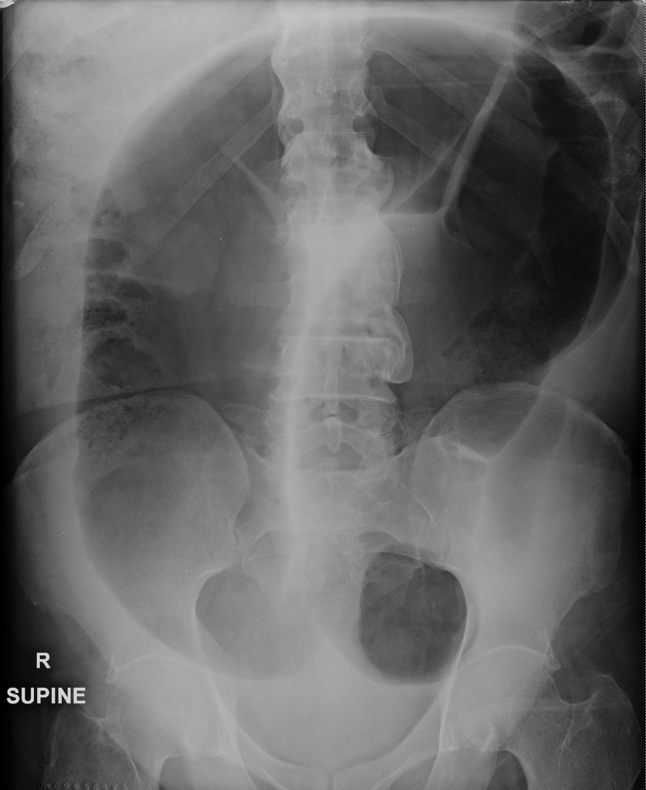
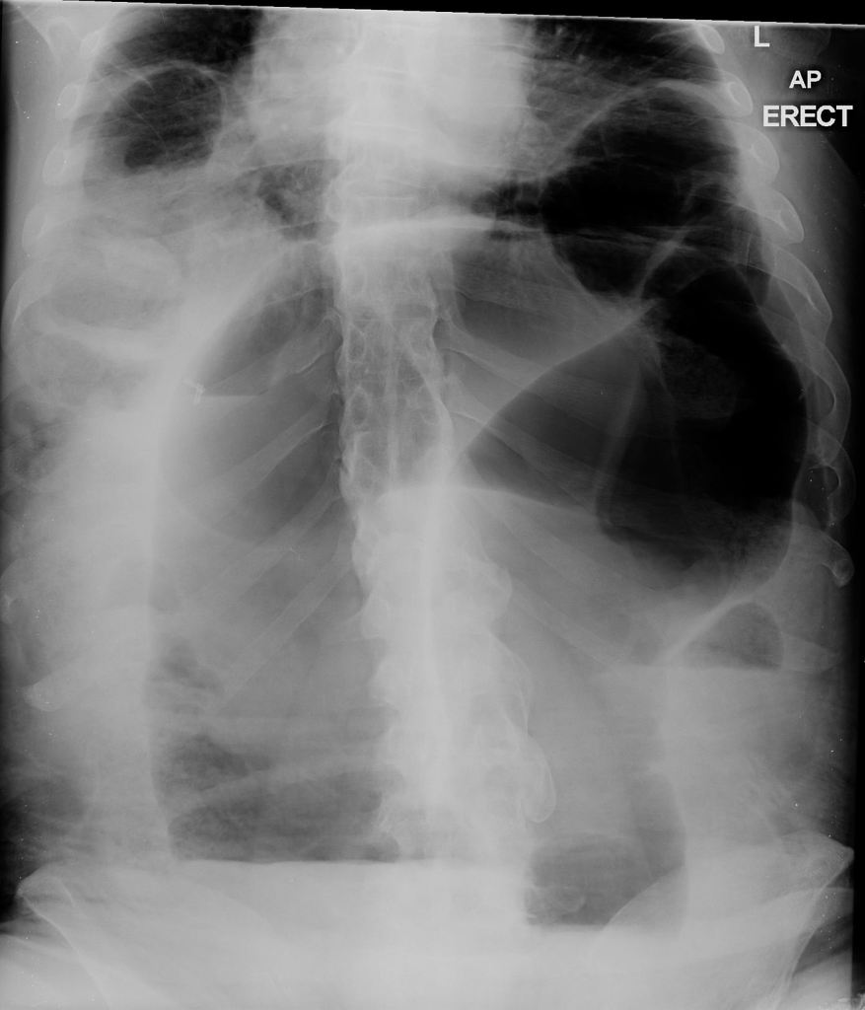
a) List the abnormal features on this XRay (2 marks)
“Coffee Bean Sign” – dilated large bowel
Air fluid levels on erect film
c) What is the diagnosis? (1 mark)
Sigmoid Volvulus

The medical student that you are supervising asks you how you can tell the difference between large and small bowel on an Xray.

d) Complete the table below outlining the features of large versus small bowel obstruction as seen on a plain abdominal film (6 marks)

Large Bowel | Small Bowel

Large Bowel | Small Bowel
Upper limit of Normal 6-9cm | Upper limit of normal 3cm
Haustra Pattern (across part lumen) | Valvulae Coniventes (across whole lumen)
Peripherally placed | Centrally placed
Contains faeces | Contains liquid

Q5
A mother brings her two year old child to ED and states that the child may have swallowed a battery from a toy. The child put the battery in her mouth, then fell over, and now the battery cant be found

a) List the 4 most relevant points to obtain from the history (3)
Size of battery
Time of ingestion
Symptoms e.g drooling, pain, vomiting, abdo pain, unable to swallow, choking, irritability
?Magnet coingestion possible

CXR is performed, demonstrating a 20mm diameter battery, which appears to be in the stomach. The child is for discharge.

b) What advice should be given to the mother regarding the ongoing care? (2)
Watch for sx and return immediately if any
Repeat XRay in 48 hrs with endoscopic removal if not passed

c) If the battery was smaller (10mm) and seen to be beyond the pylorus how would the discharge advice have changed?
No need for Xray

The Child returns after 3 days with abdominal pain, dark stools and refusal to eat or drink for 12 hours.

c) List and justify 5 actions in the Emergency Department (5)
IV line and IV fluids, keep fasted
Bloods inc cross match/VBG/FBC/EUC/LFT
Analgesia – titrated IV opiates
Erect CXR for free gas – consider CT imaging if free gas seen
Contact gastro/surgery to arrange an urgent endoscopy/surgery if perforation discovered

d)
http://www.poison.org/battery/guideline

Q6
A 25 year old female presents with 3 months of non-bloody diarrhoea without vomiting or fevers. . Her GP has sent 2 stool samples, which have been negative. She has lost 5 kilos is weight and is currently 45kg (BMI 17). She is lethargic, weak and mildly dehydrated. He has no history of medical conditions and takes no medications.

BP 130/70
P 100
Sats 99% RA
RR 16
Temp 37.1

a) In the table below list 5 potential differential diagnoses and 2 features in the history you will ask relating to each differential

Differential | History

Differential | History
Hyperthyroidism | Heat intolerance, tremor, eye changes, palps etc
Coeliac Disease | Relationship to gluten/wheat,
IBD | Mouth ulcers, FH, rashes,
Parasitic Infection e.g. giarda | Travel history, eating unclean street food
Irritable bowel syndrome | Bloating, alternating constipation
Eating disorder/laxative abuse | Hx of food withholding/purging, previous eating issues, parental concerns
GIST/Carcinoid | Flushing,
??Subacute SB obstruction | H/O abdo surgery, distension,

The nurses perform an ECG as she complains of some vague epigastric pain

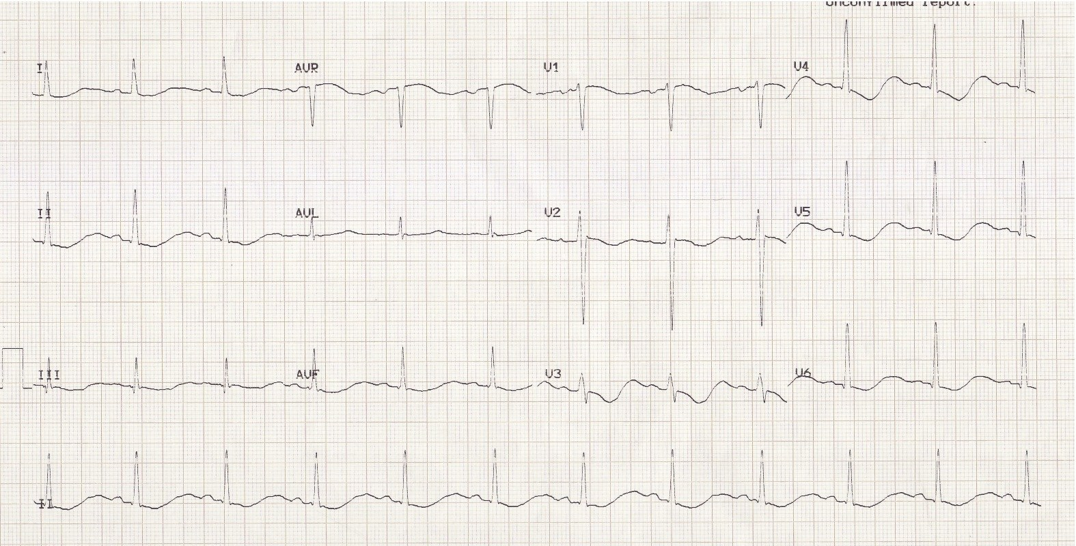

b) List the positive findings on the ECG (4 marks)
ST depression
T wave Inversion
U wave
Long QU /QT interval

c) What is the likely cause of this ECG abnormality (1 mark)
Hypokalaemia

d) What blood investigations would you consider ordering in ED to narrow your differential - with justification for each (16 marks)
FBC
EUC
LFT
CMP
TSH/T4/T3
VBG
Inflammatory markers
Coeliac screen

Q7
A 5 week old child presents to ED with vomiting. The mother brought her child to ED 3 days earlier and was sent home with a diagnosis of “overfeeding and reflux”. Mum states that the child has been very hungry but has become lethargic over the last 24 hrs and has only had 1 wet nappy. The child weighs 4kg. You estimate that they are moderately dehydrated (5%). The venous gas performed shows the following:

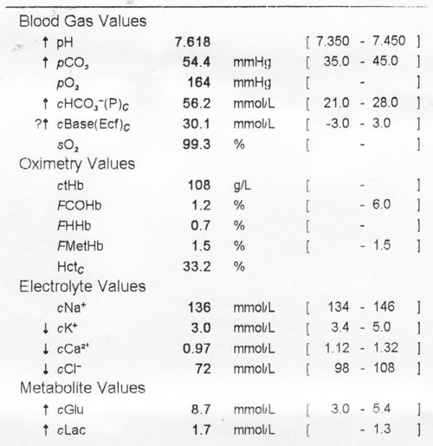

a) What abnormality does this VBG show? (4 marks)
Hypochloraemic Hypokalaemic Metabolic Alkalosis
0.7(56) +20 = expected CO2 = 59 – so approximately ok

b) What is the likely cause? (1 mark)
Pyloric stenosis

c) List 2 of surgical differentials (2 marks)
Intussusception
Malrotation with volvulus
NEC
Incarcerted Hernia

c) What examination findings might you expect to see if your first differential is correct? (3 marks)
Prominent gastric waves
Palpable “olive”
Hungry baby
Witnessed projectile vomiting

d) Outline the fluid management for this child (assuming they are to be nil by mouth) (3 marks)
RESUS 20mls/kg (80mls) NaCl fluid bolus (optional depending on fluid status of child)

DEFICIT and MAINTAINENCE
- NaCl 0.9% plus 5% dextrose plus 20mmol/L KCl

Deficit – 5% x 4000g = 200mls
Maintainence – depending on what the child is managing to take orally and not vomit
- total = 400mls/day

600mls/24hrs = 25mls/hr

Q8

A 56 year old male presents with fresh red PR bleeding and a lump that cant be “pushed back in anymore”. He is crying with pain. On inspection of the anus you see the following.

He is unable to tolerate PR due to pain. He has no medical comorbidities and takes no medications.

a) What is the abnormality (3 marks)
Grade IV thrombosed and non thrombosed haemorrhoids

b) Outline the steps you would take to surgically manage this condition in the ED (5 marks)
Position on side or prone
Infiltrate local anaesthetic – lignocaine 1% plus adrenaline (+/- bicarb buffer) or bupivacaine 0.5% with adrenaline
Elliptical inscision in skin overlying the haemorrhoid
Expose and remove the thrombus
Control bleeding – small piece of gauze can be left tucked into would for a few hrs
Pressure dressing

c) Outline the discharge advice you will provide post procedure (6 marks)
Analgesia – can use panadol and nurofen, opiates can cause constripation
Laxatives – bulk and stool softners, micralax or glycerin suppositories when can tolerate
High fibre and low fat diet, plenty of water, exercise
Avoid constipating medications e.g. codeine
Warm baths – after 6-12 hrs
Return to ED if heavy bleeding or infection symptoms/signs
Review with GP in 24-48 hrs
If ongoing problems will need referral for haemorrhoidectomy/banding

d) d) List 3 patient groups in whom it is NOT appropriate to manage surgically in the ED (3 marks)
Immunocompromised
Children
Pregnant
Anticoagulated/Coagulopathy

Q9

An 82 year old man presents with weight loss and jaundice. He is in the resus bay with full non invasive monitoring His observations, CT scan and blood results are shown below:

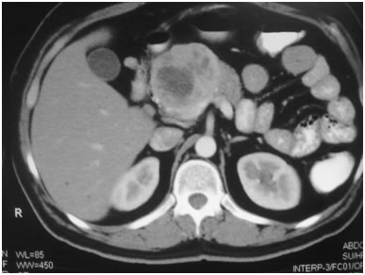

P110
BP 90/70
RR 26
Temp 38.9
Sats 90% RA

Hb 107
Plt 189
WCC 17.9

Bil 98
AST 74
ALP 367
GGT 620
Alb 23

Cr 378
Ur 13.5
K 6.4
Na 131

a) What is the most likely diagnosis (2 marks)
Pancreatic head mass/malignancy, leading to biliary obstruction and ascending cholangitis

b) List the immediate actions you will undertake in the emergency department to manage and investigate this patient.(12 marks)
Fluid resuscitation with NaCl ( without KCl)
IDC with strict fluid balance
O2 to get sats >95%
CXR (mobile)
Analgesia as required
Antibiotics to cover cholangitis – e.g. ampicillin 1g, gentamicin 7mg/kg, metronidazole 500mg iv.
ECG to check for signs of hyperkalaemia
Calcium gluconate 10mls 10%
Salbutamol 20mg nebulised
Insulin and dextrose 10units in 50mls 50%
Check Coags, VBG and Cultures
Urgent surgical consult
Consider admission to HDU as anticipation
Discuss whether patient has pre-existing wishes around active treatment/advanced directive/ICU as likely to deteriorate with potentially incurable malignancy

The nurse calls you 2 hours later to say that the patient has become confused, has pulled out his drips and is trying to climb out of bed.

a) List 3 pharmacological options for managing this mans agitation (without him being intubated), with one pro and one con for each (9 marks)

Agent/dose/route | Pro | Con

Agent/dose/route | Pro | Con
Analgesics – any appropriate suggestion | Also treat man, minimally sedating if used correctly | Opiates can cause resp depression (has sats of 90%)
IV Benzodiazepines e.g midazolam 5mg titrated | Rapidly works if given IV
IM Benzodiazepines e.g. midazolam 5mg | No canula required, | Painful, unreliable unpredictable
PO Benzodiazepines e.g. lorazepam 1mg | No drip needed, safe side effect profile | Patient may not take it when confused, patient
Ketamine, 0.5-1mg/kg IV or 2-5mg/kg IM | Haemodynamically more stable | Emergence, laryngospasm, vomiting
Propofol infusion titrated | Quick onset | Requires an infusion/IV line/HDU. High risk of oversedation/aspiration/haemodynamic upset
Typical antipsychotics e.g haloperidol 0.5-1mg po or im | Readily available, can be given IM if no IV, | Extrapyramidal, hypotension, tardive dyskinesia, anticholinergic SEs
Atypical antipsychotics e.g olanzapine 2.5-5mg | Less dystonic reactions/hypotension/antichol | Take time to work  Less dystonic reactions/hypotension/antichol

There are many options here that are not included in this model answer

d) List 5 things that may be contributing to this mans confusion (5 marks)
Preexisting cognitive impairment
Pain
Full bladder/need to defaecate
Sepsis
Brain Mets
Medications e.g opiates
Hypoxia

