Fellowship SAQ 2017_Eyes ENT Derm
Question 1

A 72 year old man presents with painless loss of vision.

P 100
BP 190/99
Sats 99%
RR 18
T 37.1

i) List six (6) potential causes of his visual loss you will consider (6 marks)

________________________________________________________________________________
________________________________________________________________________________
________________________________________________________________________________
________________________________________________________________________________
________________________________________________________________________________
________________________________________________________________________________

His fundi is shown in the image below

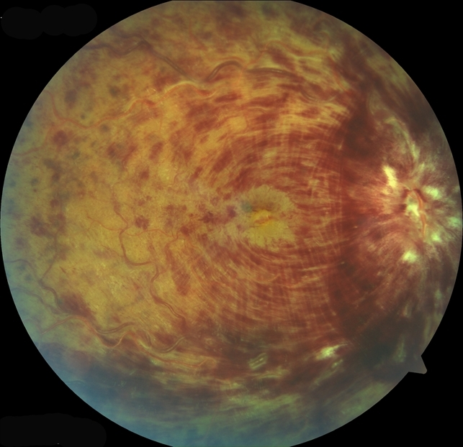

ii) List three (3) abnormal features on this fundal image (3 marks)

________________________________________________________________________________
________________________________________________________________________________
________________________________________________________________________________
iii) List four (4) risk factors for developing this condition (4 marks)

________________________________________________________________________________
________________________________________________________________________________
________________________________________________________________________________
________________________________________________________________________________

Question 2

A 32 year old man presents intoxicated. He is complaining of visual loss, eye pain and a headache. He cannot recall the events of the last 24 hrs. V/A 6/60 RIGHT, 6/9 LEFT. No correction with pinhole. He has no other obvious external injuries

His clinical photo is shown below

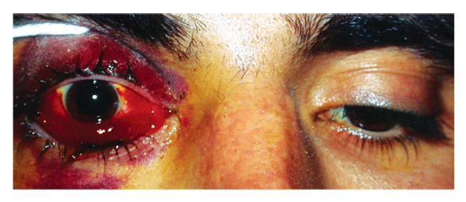

i) In the table list five (5) diagnoses or complications that you need to exclude, with the expected additional clinical examination findings for each diagnosis (if any) (10 marks)

Diagnosis/Complication (5 marks) | Clinical Findings (5 marks)

ii) His Intraocular pressure is 50mmHg. List the name and technical steps of the procedure you will perform. Excluding explanation and consent (8 marks)

________________________________________________________________________________
________________________________________________________________________________
________________________________________________________________________________
________________________________________________________________________________
________________________________________________________________________________
________________________________________________________________________________
________________________________________________________________________________
________________________________________________________________________________

Question 3

A 62 year old female presents with a painful red eye and a headache

Her clinical photograph is shown below

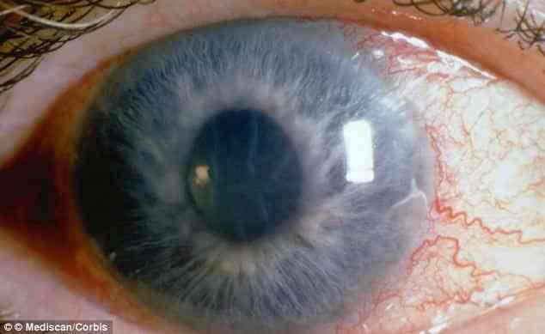

i) List the MOST likely diagnosis (1 mark)

________________________________________________________________________________

ii) Outline four (4) classic examination findings (4 marks)

________________________________________________________________________________
________________________________________________________________________________
________________________________________________________________________________
________________________________________________________________________________

iii) In the table list four (4) pharmacological treatments (with dose and route) that you can employ in this setting to correct the underlying pathological process (12 marks)

Pharmacological Agent | Drug Class | Dose and Route

iii) List three (3) potential precipitants for this condition (3 marks)

________________________________________________________________________________
________________________________________________________________________________
________________________________________________________________________________

Question 4

A 76 year old obese man presents with epistaxis. He is awaiting investigation for 10kg of weight loss in the last 6 months. He has AF and is on rivaroxaban and metoprolol. He has been in the resus room with a nurse effectively pinching his soft septum for the last 15 minutes, without effect.

P 90
BP 100/60
Sats 92%
RR 26
T 37.0

i) List five (5) stepwise treatments you will employ IN THE EMERGENCY DEPARTMENT to stop the bleeding (5 marks)

________________________________________________________________________________
________________________________________________________________________________
________________________________________________________________________________
________________________________________________________________________________
________________________________________________________________________________

ii) All measures fail and the heavy bleeding continues, the patient requires intubation due to haemodynamic instability and an inability to protect his airway. There is insufficient time to wait for ENT or anaesthetics to attend.
List six (6) measures you can employ during intubation to minimise peri-intubation complications (5 marks)

________________________________________________________________________________
________________________________________________________________________________
________________________________________________________________________________
________________________________________________________________________________
________________________________________________________________________________
________________________________________________________________________________

Question 5

A 4 year old boy presents to ED with neck pain and refusal to eat for 3 days. There is no history of trauma. He has no respiratory distress. He has IV access in place and appropriate pathology tests have been sent. Maintenance iv fluids are running.

P 120
BP 100/60
Sats 100% RA
RR 26
T 37.9

His lateral CSpine XRay is shown
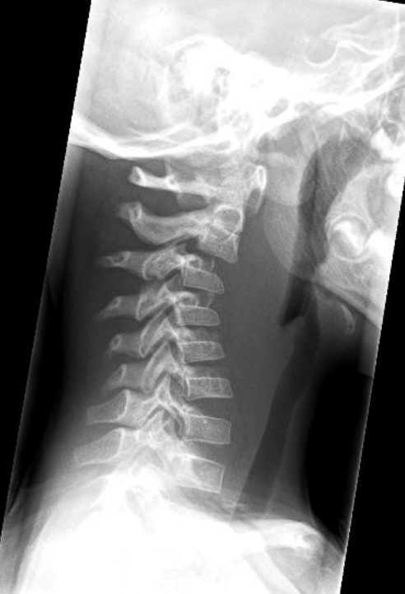

i) List the two (2) MOST abnormal features on this XRay

________________________________________________________________________________
________________________________________________________________________________
________________________________________________________________________________
________________________________________________________________________________

ii) List your MOST LIKELY diagnosis and two (2) differential diagnoses (3 marks)

MOST LIKELY _________________________________________________________________________
DIFFERENTIAL ________________________________________________________________________
DIFFERENTIAL_________________________________________________________________________

iii) List your next actions in ED (5 marks)

________________________________________________________________________________
________________________________________________________________________________
________________________________________________________________________________
________________________________________________________________________________
________________________________________________________________________________

Question 6

A 23 year old female with schizoaffective disorder presents with difficulty swallowing. She is refusing to talk and is trying to leave the department. She appears to be in pain. She has evidence of auditory hallucinations. She has an IV canula and maintainence fluids running.

P 130
BP 100/60
Sats 96%
RR 30
Temp 38.1

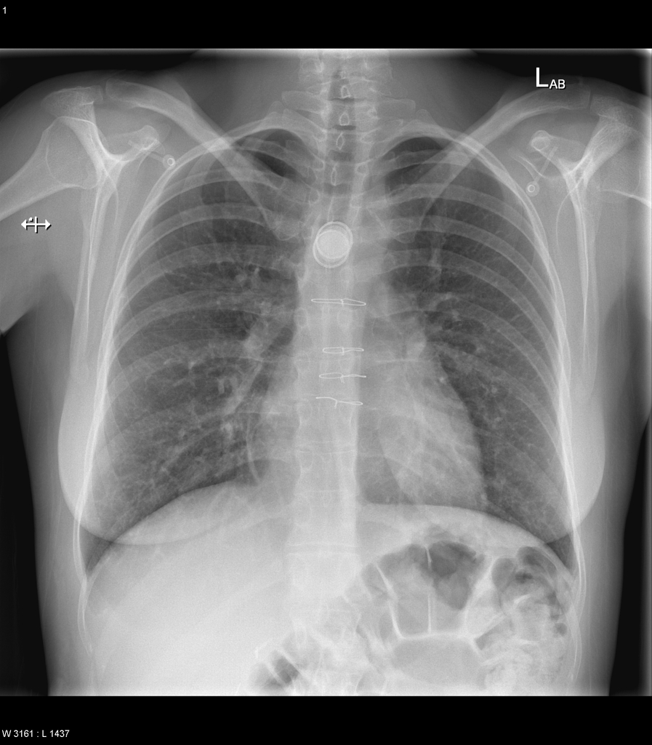
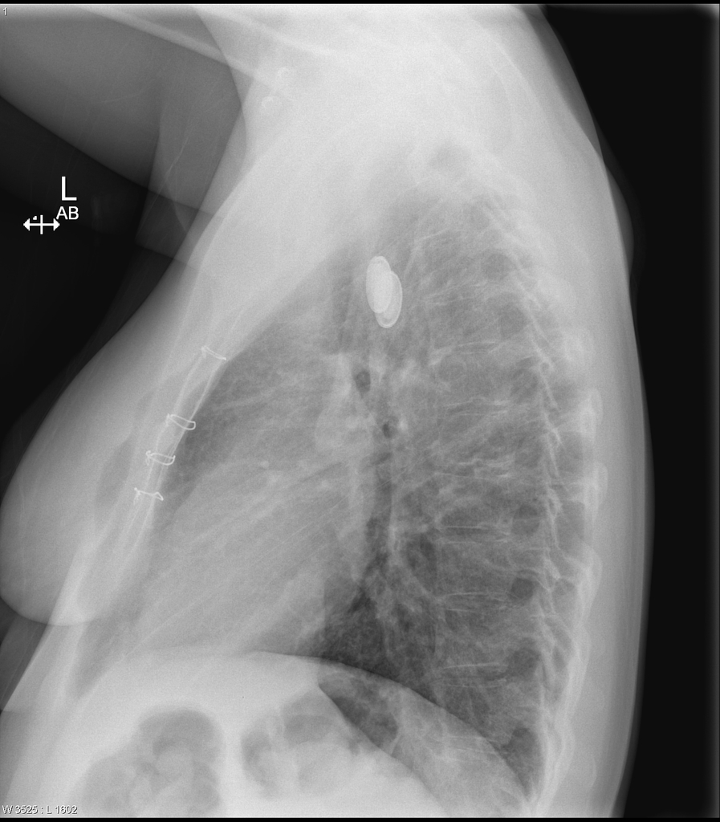

i) List three (3) abnormal radiological features and their significance (3 marks)

________________________________________________________________________________
________________________________________________________________________________
________________________________________________________________________________

ii) List four (4) potential complications associated with this presentation (4 marks)

________________________________________________________________________________
________________________________________________________________________________
________________________________________________________________________________

iii) The patient is trying to leave the department, list the actions you will take in the further management of this patient (5 marks)

________________________________________________________________________________
________________________________________________________________________________
________________________________________________________________________________
________________________________________________________________________________
________________________________________________________________________________

Question 7

A 5 year old girl presents to ED with a rash and a sore mouth.

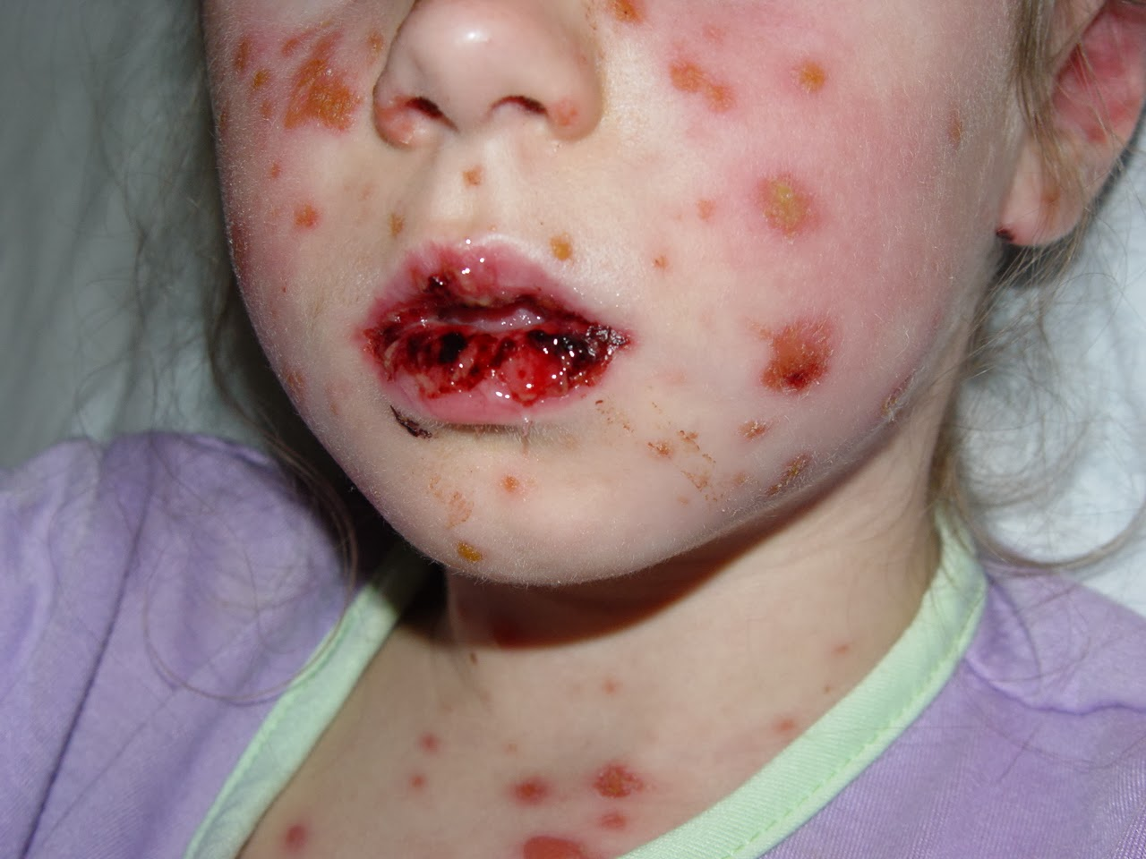
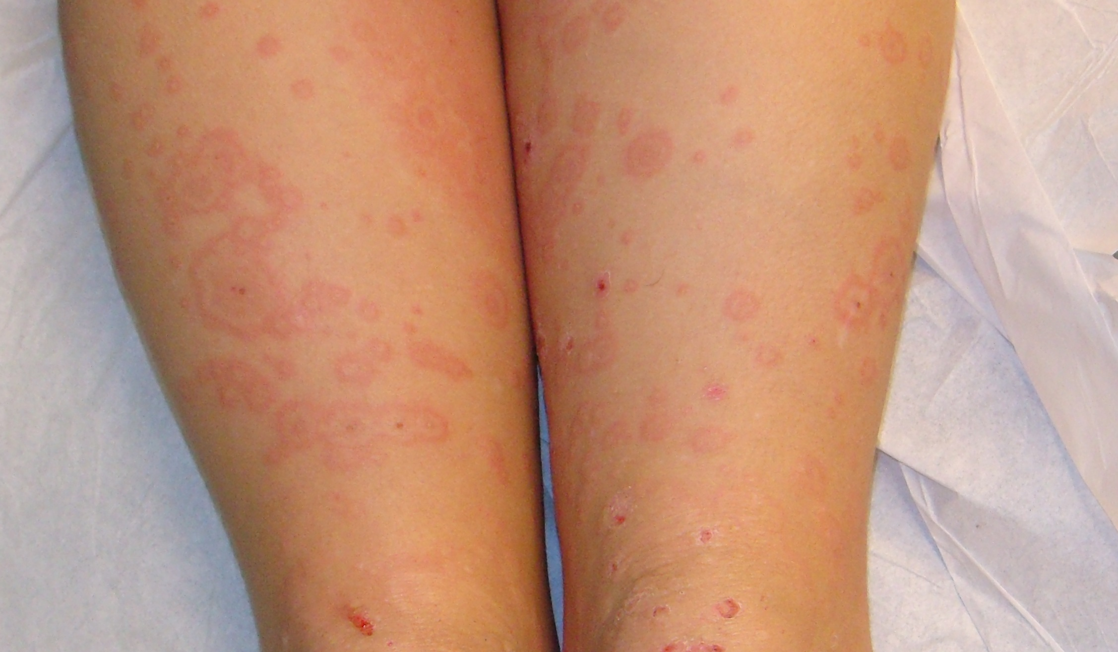

i) Describe the abnormalities seen in the clinical photographs (3 marks)

________________________________________________________________________________
________________________________________________________________________________
________________________________________________________________________________

ii) In the table below list the 3 variants of the condition shown in the photograph, from least to most severe, with the defining skin and mucus membrane characteristics, and the treatment (12 marks)

Condition | Skin involvement/BSA% | Mucosal Involvement | Treatment

ii) List four (4) potential categories of precipitant for the condition seen in the clinical photos, with an example of each (8 marks)

________________________________________________________________________________
________________________________________________________________________________
________________________________________________________________________________
________________________________________________________________________________

Question 8

An 8 year old boy presents with a rash. The working diagnosis from the GP is Henoch-Schoenlein Purpura

P 100
Sats 99%
RR 22
Temp 37.0

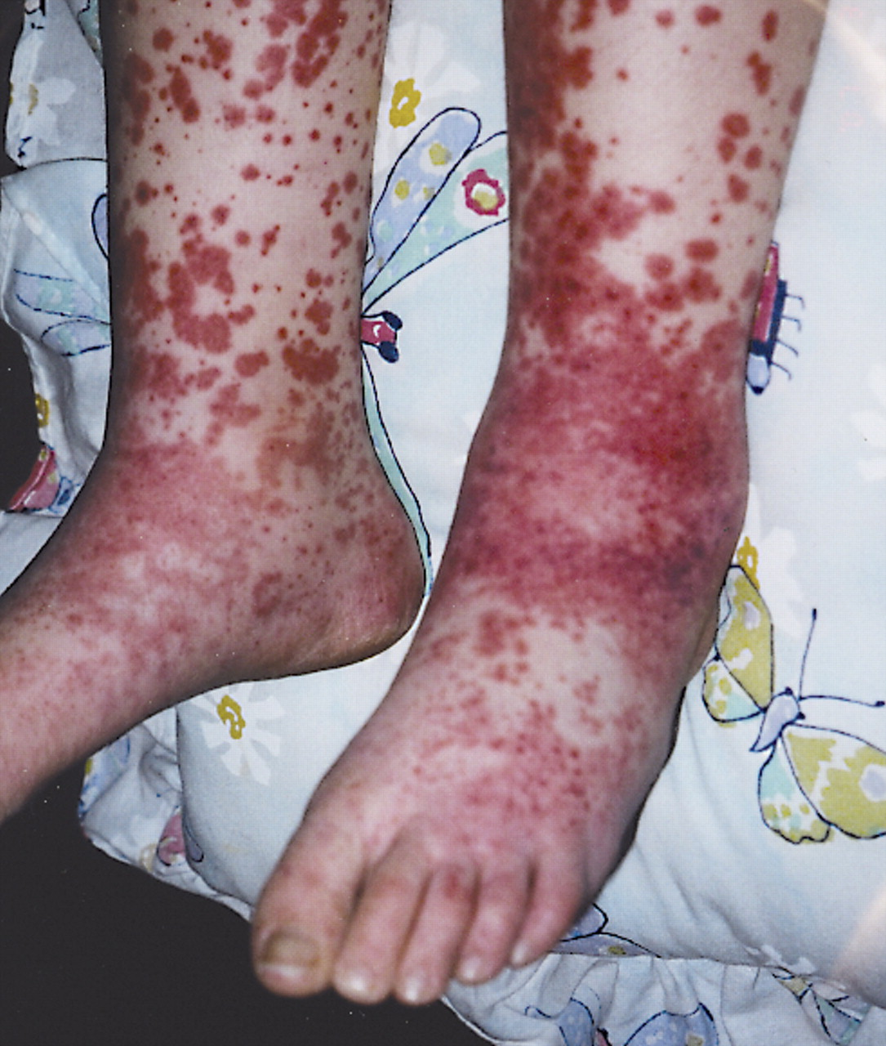

i) List five (5) differential diagnoses for this rash (5 marks)

________________________________________________________________________________
________________________________________________________________________________
________________________________________________________________________________
________________________________________________________________________________
________________________________________________________________________________

ii) Complete the table below with the defining features of HSP for each system (7 marks)

System | Exam Findings or Complications
Vitals | N/A
Joints

GIT

Skin

Neurological

Renal/Urinalysis

Respiratory

iii) After review you believe the child has HSP. What criteria must the child meet to be appropriate for outpatient management (3 marks)

________________________________________________________________________________
________________________________________________________________________________
________________________________________________________________________________
________________________________________________________________________________

Question 9

A 23 year old pregnant female presents to ED with her 2 year old daughter who has an itchy rash. She “doesn’t believe in vaccinations” and neither herself or her child are vaccinated.

i) List the MOST LIKELY diagnosis (1 mark)

________________________________________________________________________________

ii) List five (5) topics you will cover and advice that that you will give to the parent regarding this presentation (5 marks)

________________________________________________________________________________
________________________________________________________________________________
________________________________________________________________________________
________________________________________________________________________________
________________________________________________________________________________

iii) The woman becomes angry and leaves the department in the middle of your conversation, she refuses to return. The nurse in charge wants to report the woman to DCF.
List five (5) measures you will take to manage this situation (5 marks)

________________________________________________________________________________
________________________________________________________________________________
________________________________________________________________________________
________________________________________________________________________________
________________________________________________________________________________

