Fellowship SAQ 2017_Eyes ENT Derm
Question 1

A 72 year old man presents with acute painless loss of vision.

P 100
BP 190/99
Sats 99%
RR 18
T 37.1

i) List six (6) potential causes of his visual loss you will consider (6 marks)

________________________________________________________________________________
________________________________________________________________________________
________________________________________________________________________________
________________________________________________________________________________
________________________________________________________________________________
________________________________________________________________________________

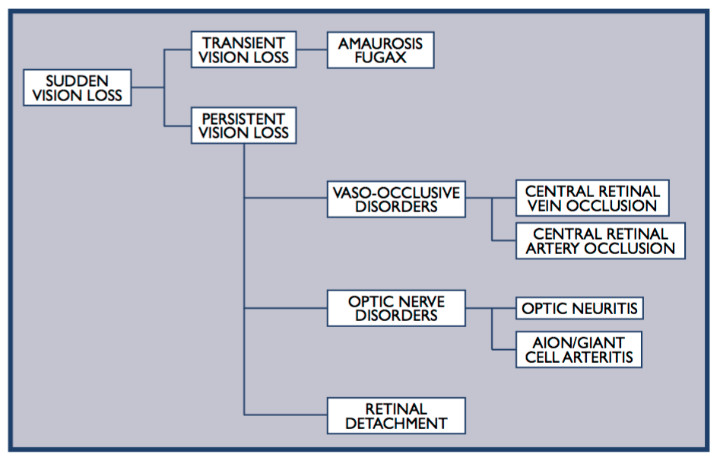

Methanol Toxicity
Hysterical Blindness ??

His fundi is shown in the image below

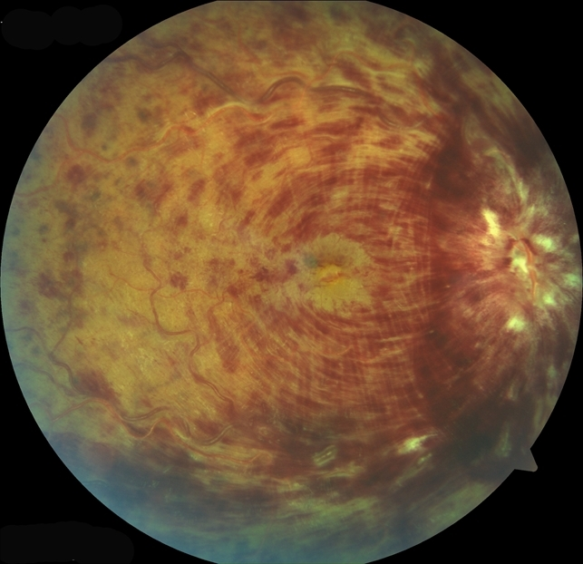

ii) List three (3) abnormal features on this fundal image (3 marks)

________________________________________________________________________________
________________________________________________________________________________
________________________________________________________________________________
Cotton Wool Spots
Superficial Flame Haemorrhages in 4 quadrants
Dot and Blot Haemorrhages
Optic disc oedema
Macular oedema

iii) Aside from advancing age, list four (4) risk factors for this condition (4 marks)

________________________________________________________________________________
________________________________________________________________________________
________________________________________________________________________________
________________________________________________________________________________

Hypertension
Hyperviscosity e.g. FV leiden/protein c/s def/hyperhomocysteine/myeloproliferative disorders
DM
Atherosclerosis
Glaucome/Increased IOP
OCP

Possibly smoking - although not proven

Question 2

A 32 year old man presents intoxicated. He is complaining of visual loss, eye pain and a headache. He cannot recall the events of the last 24 hrs. V/A 6/60 RIGHT, 6/9 LEFT. No correction with pinhole. He has no other obvious external injuries

His clinical photo is shown below

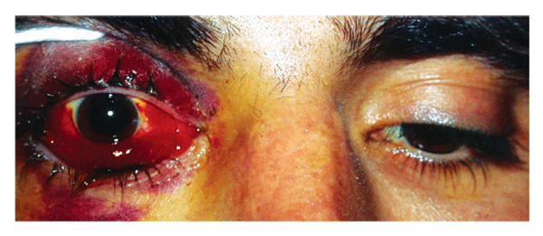

i) In the table list five (5) acute diagnoses or complications that you need to exclude, with the expected additional clinical examination findings for each diagnosis (if any) (10 marks)

Diagnosis/Complication (5 marks) | Clinical Findings (5 marks)

Diagnosis/Complication (5 marks) | Clinical Findings (5 marks)
Orbital Compartment Syndrome | Proptosis, hard/firm eyeball, raised IOP (>40mmHg), RAPD
Retro-orbital Haematoma | Sometimes proptosis or above signs if raised IOP
Blowout fracture/other facial fractures | Entrapment of EOM – diplopia, paralysis of gaze esp upward, facial bone tenderness, sunken eye/enophthalmos
Ruptured Globe | Sunken or misshaped eye, positive seidel test,
ICH | GCS lowered, focal neurological defecits, papilloedema and cushings if raised ICP
Skull/BOS fractures | Palpable defect, haemotympanum, racoon eyes, battle’s sign
Infraorbital Nerve Damage | Reduced sensation to the maxillary area
CSpine Injury | Neuro defecits (state which), midline tenderness
Corneal Laceration | Slit lamp findings with fluorescein
Hyphema
Lens Dislocation
Traumatic Iritis

ii) His Intraocular pressure is 50mmHg. List the name and technical steps of the procedure you will perform. Excluding explanation and consent (8 marks)

________________________________________________________________________________
________________________________________________________________________________
________________________________________________________________________________
________________________________________________________________________________
________________________________________________________________________________
________________________________________________________________________________
________________________________________________________________________________
________________________________________________________________________________

Lateral Canthotomy

Asepsis, position supine
Lateral canthal lignocaine infiltration +/- sedation +/- topical amethocaine
Crush lateral canthus with forceps for haemostasis
Cut the lateral canthus with small scissors towards orbital rim
Find inferior canthal ligament by feel or direct vision and cut
Recheck IOP
Repeat with superior crus if pressure remains high

Question 3

A 62 year old female presents with a painful red eye and a headache

Her clinical photograph is shown below

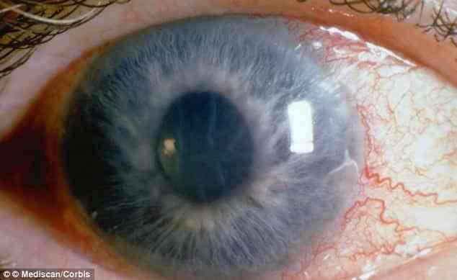

i) List the MOST likely diagnosis (1 mark)

________________________________________________________________________________

Acute Angle Closure Glaucoma
Cannot just state “glaucoma”

ii) Outline four (4) classic examination findings (4 marks)

________________________________________________________________________________
________________________________________________________________________________
________________________________________________________________________________
________________________________________________________________________________

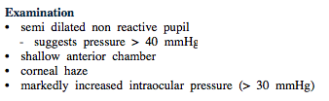 Ref: Dunn

iii) In the table list four (4) pharmacological treatments (with dose and route) that you can employ in this setting to correct the underlying pathological process (12 marks)

Pharmacological Agent | Drug Class | Dose and Route

Pharmacological Agent | Drug Class | Dose and Route
Acetazolamine | Carbonic Anhydrase Inhib | 500mg stat IV then 250mg po tds
Mannitol | Osmotic diuretic | 1g/kg IV
Pilocarpine 2% | Cholinergic Agent | 1 drop every 5 mins for 1 hr
Timolol 0.5% | BBlocker | 1 drop every 30-60mins
Latanoprost | Prostaglandin analogue
Brimonidine/Apraclonidine | Alpha-2 agonist | 1-2 drops stat

Cant have analgesics/antiemetics as don’t correct the raised IOP

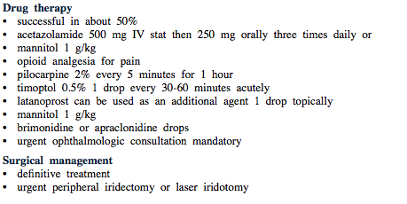
iii) List three (3) potential precipitants for this condition (3 marks)

________________________________________________________________________________
________________________________________________________________________________
________________________________________________________________________________
Topical Mydriatics - tropicamide
Anticholinergic drugs/Sympathomimetic agents
Emotional stimulation
Accomodation – reading
Dim lights – e.g cinema

Question 4

A 76 year old obese man presents with epistaxis. He is awaiting investigation for 10kg of weight loss in the last 6 months. He has AF and is on rivaroxaban and metoprolol. He has been in the resus room with a nurse effectively pinching his soft septum for the last 15 minutes, without effect.

P 90
BP 100/60
Sats 92%
RR 26y
T 37.0

i) List five (5) stepwise treatments you will employ IN THE EMERGENCY DEPARTMENT to stop the bleeding (5 marks)

________________________________________________________________________________
________________________________________________________________________________
________________________________________________________________________________
________________________________________________________________________________
________________________________________________________________________________
Add co-phenelcaine spray as a vasoconstrictor and to anaesthetise in preparation for rapid rhino/packing
ICE
Cautery of any visable bleeding vessels with silver nitrate
Topical tranexamic acid
Procoagulant foams/gels
Rapid rhino – anterior and posterior sizes available
Formal packing – UNILATERAL THEN BILATERAL IF FAILS (requires opiate analgesia +/_ sedation)
Foley Catheter – 7mls + 7mls in balloon of 10-14F, with anterior traction

Note – reversal of rivaroxaban is not possible

ii) All measures fail and the heavy bleeding continues, the patient requires intubation due to haemodynamic instability and an inability to protect his airway. There is insufficient time to wait for ENT or anaesthetics to attend.
List six (6) measures you can employ during intubation to minimise peri-intubation complications (5 marks)

________________________________________________________________________________
________________________________________________________________________________
________________________________________________________________________________
________________________________________________________________________________
________________________________________________________________________________
________________________________________________________________________________

Ramping/positioning upright until ready to pass ETT
Apnoiec oxygenation with HFNP
2 suction catheters/yannkeurs in the airway during attempts to intubate
Most experienced operator
Use of fluid preloading
Use of metaraminol to prevent hypotension
Appropriate dosing of hypotensive agents e.g. reduced dose propofol
Use of ketamine to avoid hypotension
Use of intubation checklist
Suction blood from stomach with NG prior to intubation

Cricoid (controversial) – this answer is best avoided
Use of VL – can be problematic in ++airway bleeding as camera gets bloody and obscures view

Question 5

A 4 year old boy presents to ED with neck pain and refusal to eat for 3 days. There is no history of trauma. He has no respiratory distress. He has IV access in place and appropriate pathology tests have been sent. Maintenance iv fluids are running.

P 120
BP 100/60
Sats 100% RA
RR 26
T 37.9

His lateral CSpine XRay is shown
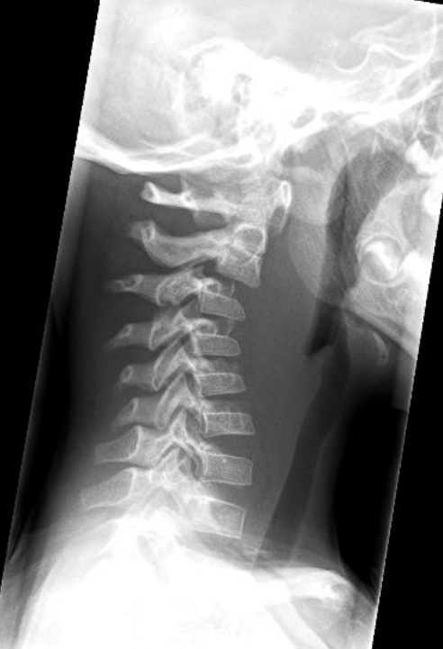

i) List the two (2) MOST abnormal features on this XRay

________________________________________________________________________________
________________________________________________________________________________
________________________________________________________________________________
________________________________________________________________________________

Abnormal alignment with pseudosubluxation C2/3
Soft tissue swelling in retropharyngeal space

ii) List your MOST LIKELY diagnosis and two (2) differential diagnoses (3 marks)

MOST LIKELY _________________________________________________________________________
DIFFERENTIAL ________________________________________________________________________
DIFFERENTIAL_________________________________________________________________________

Retropharyngeal Abscess

Retropharyngeal mass – benign or malignant tumours – Adenopathy/lymphoma
Occult trauma/NAI with spinal cord injury

iii) List your next actions in ED (5 marks)

________________________________________________________________________________
________________________________________________________________________________
________________________________________________________________________________
________________________________________________________________________________
________________________________________________________________________________

Immediate ENT/anaesthetics referral – needs drainage in theatre
Arrange CT scan ONLY if the patient is able to lie flat without airway compromise
Sit up / position of comfort
Symptom control - analgesia, antipyretics,
Antibiotics – Ceftriaxone 50mg/kg (up to 1g) IV
Disposition to HDU/PICU pending operative management

Doesn’t need immediate airway intervention in ED given the stem – appropriate to mark the neck/involve anaesthetics but shouldn’t be intervening in ED given high risk airway that is better managed with a gas induction in OT when the time for surgery comes.

Question 6

A 23 year old female with schizoaffective disorder presents with difficulty swallowing. She is refusing to talk and is trying to leave the department. She appears to be in pain. She has evidence of auditory hallucinations. She has an IV canula and maintainence fluids running.

P 130
BP 100/60
Sats 96%
RR 30
Temp 38.1

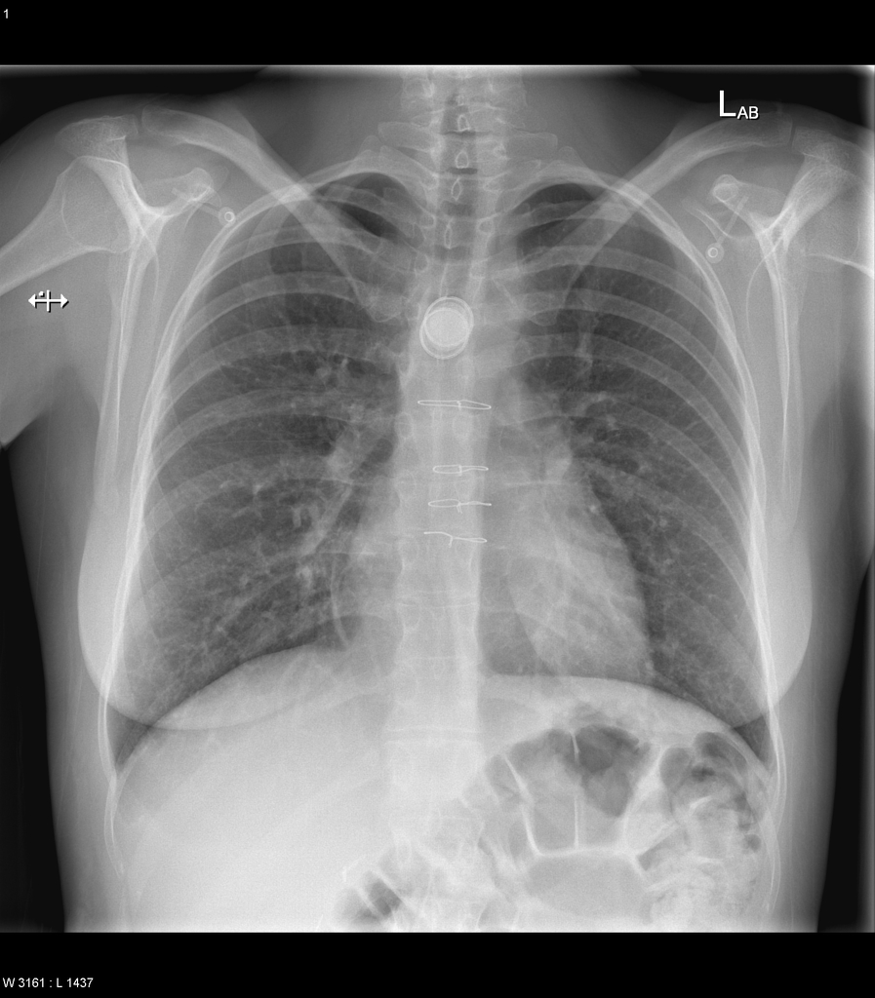
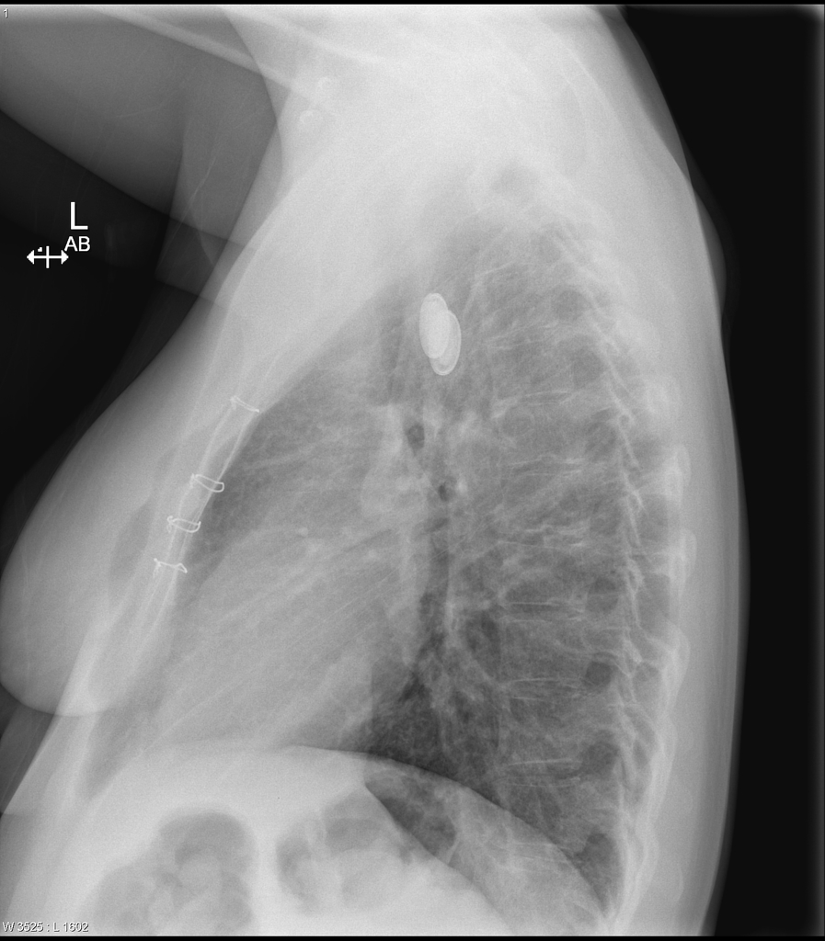

i) List three (3) abnormal radiological features and their significance (3 marks)

________________________________________________________________________________
________________________________________________________________________________
________________________________________________________________________________
2 metallic FBs in the mid oesophagus – double ring sign c/w button batteries
Likely oesophageal as oriented in coronal plane
Sternal wires c/w previous sternotomy

ii) List four (4) potential complications associated with this presentation (4 marks)

________________________________________________________________________________
________________________________________________________________________________
________________________________________________________________________________

Mucosal burns
Perforation – can lead to sepsis/mediastinitis
Tracheoesophageal fistula
GI or resp Obstruction
Respiratory compromise due extrinsic pressure on trachea
Stricture

iii) The patient is trying to leave the department, list the actions you will take in the further management of this patient (5 marks)

________________________________________________________________________________
________________________________________________________________________________
________________________________________________________________________________
________________________________________________________________________________
________________________________________________________________________________

1. Manage psychiatric disturbance - Attempt to verbally deescalate - Involve security/patient safety officer/family - Section under the mental health act/detain under common law
May require sedation/take down to avoid patient leaving - e.g. droperidol/midazolam

2. Plan to remove button battery - Urgently contact anaesthetics and ENT or general/GI surgeons – button battery needs to be removed asap

3. Symptomatic relief - Analgesia - titrated IV opiates and antiemetics

4. Prepare or OT – NBM – IV fluids – pre-op safety with ECG/VBG/panadol

5. Antibiotics - Amp/Gent/Metronidazole – high risk of perforation/mediastinitis

Question 7

A 5 year old girl presents to ED with a rash and a sore mouth.

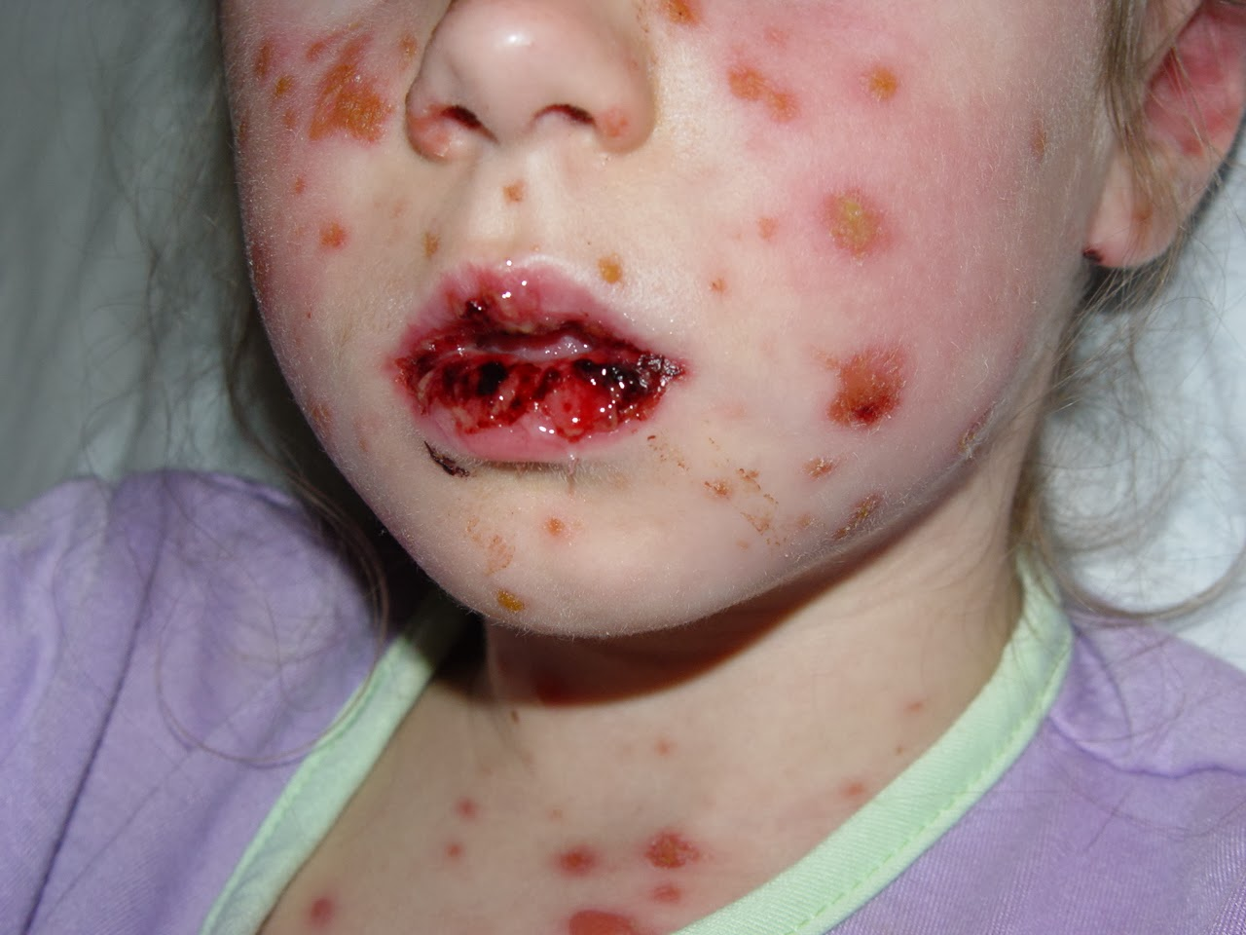
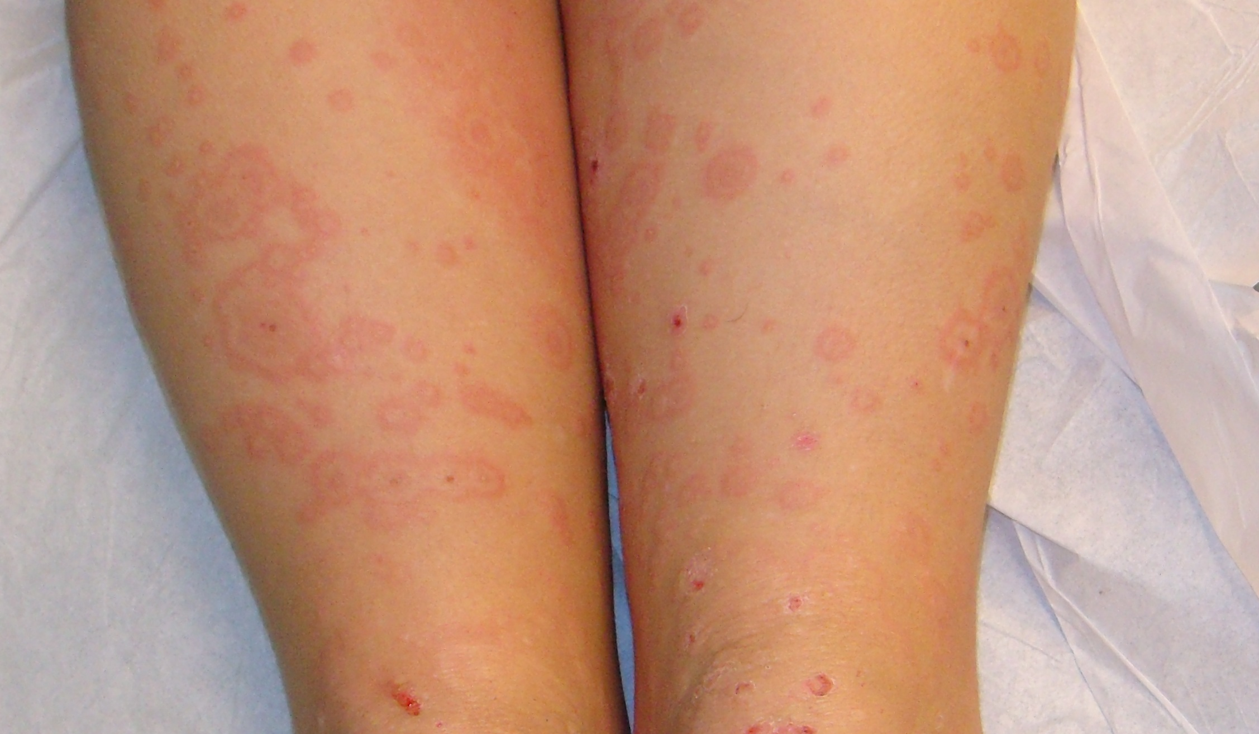

i) Describe the abnormalities seen in the clinical photographs (3 marks)

________________________________________________________________________________
________________________________________________________________________________
________________________________________________________________________________
Mucosal ulceration to the mouth
Multiple well defined, shallow erosions to the face and upper chest with some crusting
Target lesions on lower legs

ii) In the table below list the 3 variants of the condition shown in the photograph, from least to most severe, with the defining skin and mucus membrane characteristics, and the treatment (12 marks)

Condition | Skin involvement/BSA% | Mucosal Involvement | Treatment

Condition | Skin Features/BSA% | Mucosal Involvement | Treatment
Erythema Multiforme | Target lesions, absence of epitheial loss | Single mucus membrane inv. | Nil specific  Withdraw offending agent
SJS | <10% BSA, target lesions, epithelial loss | >1 Mucus membrane | Saline MW  Topical steroids (betamethasone)  Burns care  Avoid systemic steroids
TEN | >30% BSA, epithelial loss | Often involved | Burns Care  IVIg  Ciclosporin  Avoid parenteral steroids

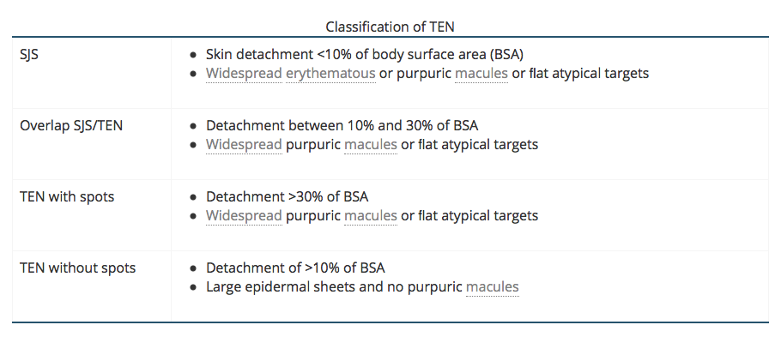

ii) List four (4) potential categories of precipitant for the condition seen in the clinical photos, with an example of each (8 marks)

________________________________________________________________________________
________________________________________________________________________________
________________________________________________________________________________
________________________________________________________________________________

Drugs – NSAIDS, penicillins, cephalosporins, sulphonamides, phenytoin, carbamazepine, allopurinol, lamotrigine
Infections – Herpes, Mycoplasma, HIV
Cancer – lymphoma, leukaemia
Immunisations – measles, Hep B

Question 8

An 8 year old boy presents with a rash. The working diagnosis from the GP is Henoch-Schoenlein Purpura

P 100
Sats 99%
RR 22
Temp 37.0

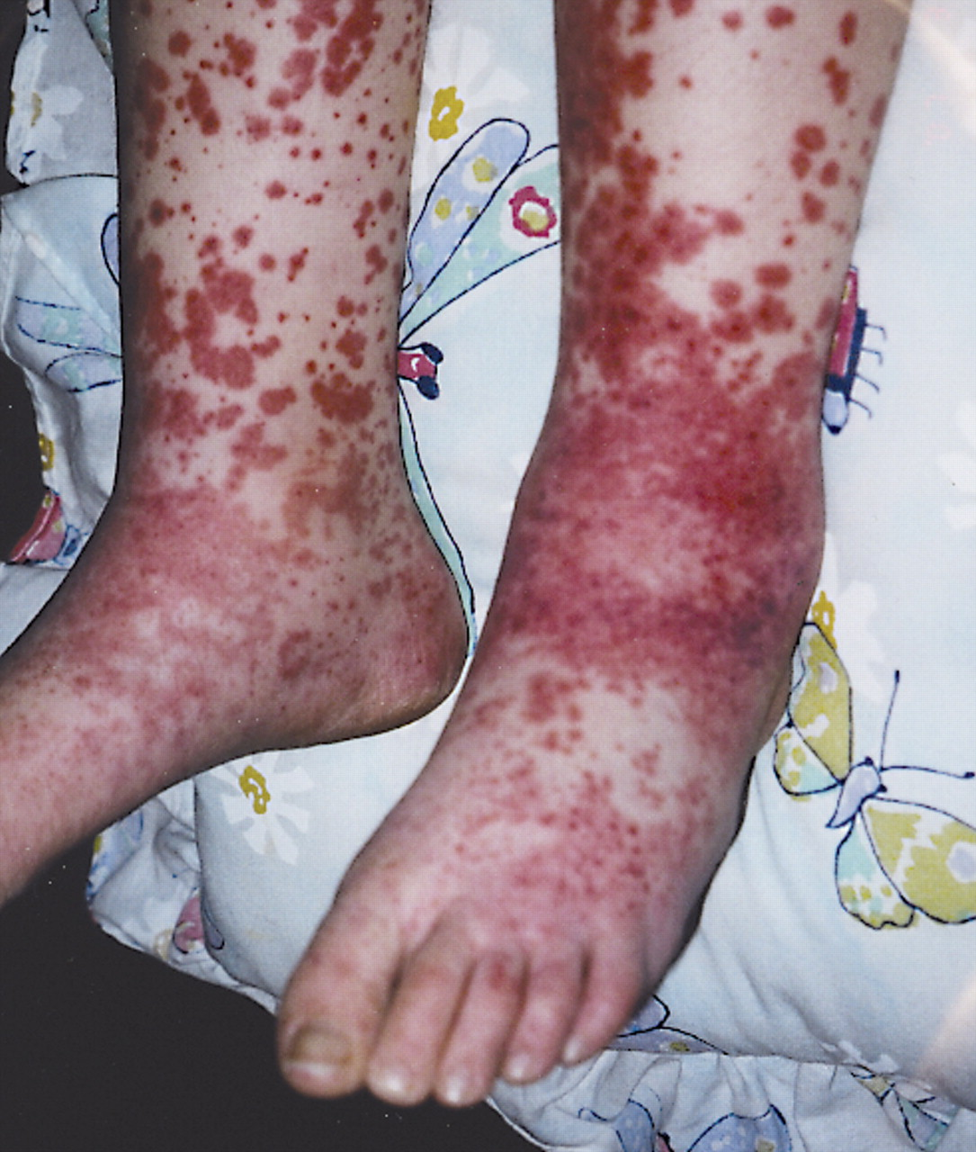

i) List five (5) differential diagnoses for this rash (5 marks)

________________________________________________________________________________
________________________________________________________________________________
________________________________________________________________________________
________________________________________________________________________________
________________________________________________________________________________

Meningitis/Meningicoccal sepsis
Other infections – strep, H.Inf, IE, influenze, measles, parvo
DIC secondary to sepsis
Platelet disorders – ITP, TTP, HUS
Leukaemia –

ii) Complete the table below with the defining features of HSP for each system (7 marks)

System | Exam Findings or Complications
Vitals

Joints

GIT

Skin

Neurological

Renal/Urinalysis

Respiratory

System | Exam findings or Complications
Vitals | Hypertension
Joints | Arthritis/Arthralgias – large joints lower limbs
GIT | Intussusception – abdo pain, signs of obstruction
Skin | 1 - Palpable purura/petichiea/ecchymosis gravity and pressure dep areas e.g lower limbs and buttocks,  2 – Subcutanous oedema – periorbital, hands, feet and scrotum
Neurological | Altered mental status, labile mood, apathy, encephalopathy, FNS
Renal/Urinalysis | Haematuria/Proteinuria, nephrotic/nephritic syndrome
Respiratory | SOB/WOB/crackles, diffuse alveolar oedema
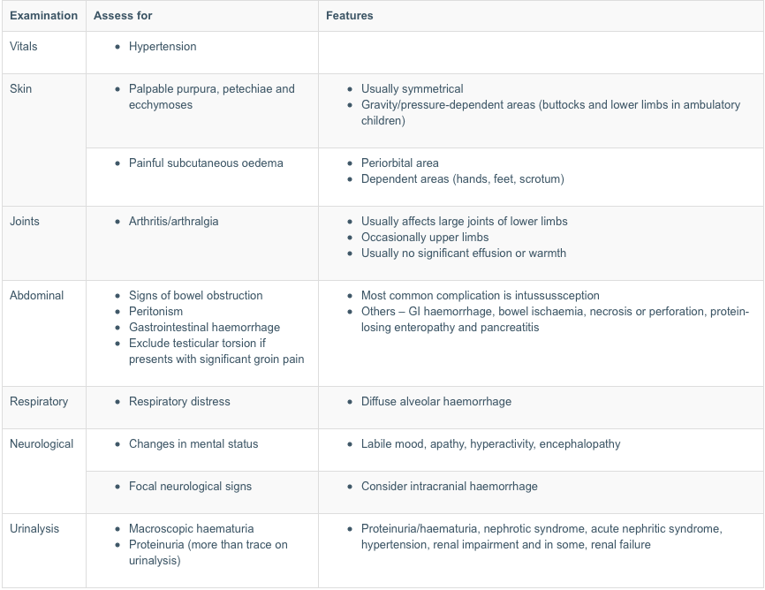

iii) After review you believe the child has HSP. What criteria must the child meet to be appropriate for outpatient management (3 marks)

________________________________________________________________________________
________________________________________________________________________________
________________________________________________________________________________
________________________________________________________________________________

Mild disease
No renal involvement/hypertension/haematuria – this requires a renal biopsy
Pain controlled with simple analgesia
Appropriate follow up for BP and urinalysis monitoring – GP or paediatrician weekly or first month
No signs of intussusception or resp/neuro compromise suggesting DAH/ICH

Question 9

A 23 year old pregnant female presents to ED with her 2 year old daughter who has an itchy rash. She “doesn’t believe in vaccinations”.

i) List the MOST LIKELY diagnosis (1 mark)

________________________________________________________________________________
Chicken Pox or Varicella zoster

ii) List five (5) topics you will cover and advice that that you will give to the parent regarding this presentation (5 marks)

________________________________________________________________________________
________________________________________________________________________________
________________________________________________________________________________
________________________________________________________________________________
________________________________________________________________________________

Advise that usually a self limiting condition but that can have complications –bacterial superinfection, pneumonitis, encephalitis.
Can be managed at home
Risk to any other children particularly neonates, and preg women – inc. period of 10-21 days
Return to school only when all lesions crusted or 7 days after the onset of the rash
Recommend symptomatic management with analgesics/antipyretics e.g. panadol, antihistamines, calamine lotion, keep nails short to avoid scratching
Address non vaccination – discuss herd immunity, offer vaccine advice, recommend re-entry into vaccine program via the GP
Assess her risk – pregnant, if unvaccinated and never had CP then she is at risk and needs VZ Ig to prevent

http://www.rch.org.au/kidsinfo/fact_sheets/Chickenpox_Varicella/

iii) The woman becomes angry and leaves the department in the middle of your conversation, she refuses to return. The nurse in charge wants to report the woman to DCF. List five (5) measures you will take in this situation

__________________________________________________________________________________________
__________________________________________________________________________________________
____________________________________________________________________________________________________________________________________________________________________________________
__________________________________________________________________________________________

No grounds to call police/DCF etc as childs risk is low
Send a discharge letter to the GP and the parent explaining the situation
Send a fact sheet to the parent
Attempt to call the parent to explain the management of the child and the potential need for VZ Ig to protect her unborn child
Record the child s unvaccinated on the hospital medical alerts
Notifiable

