Cardiology Questions 2017_2
Question 1

You are the consultant in charge at a Tertiary Referral Hospital with PCI capability. You receive a call from a registrar who is working at a Rural Hospital. He has a patient with the following ECG.

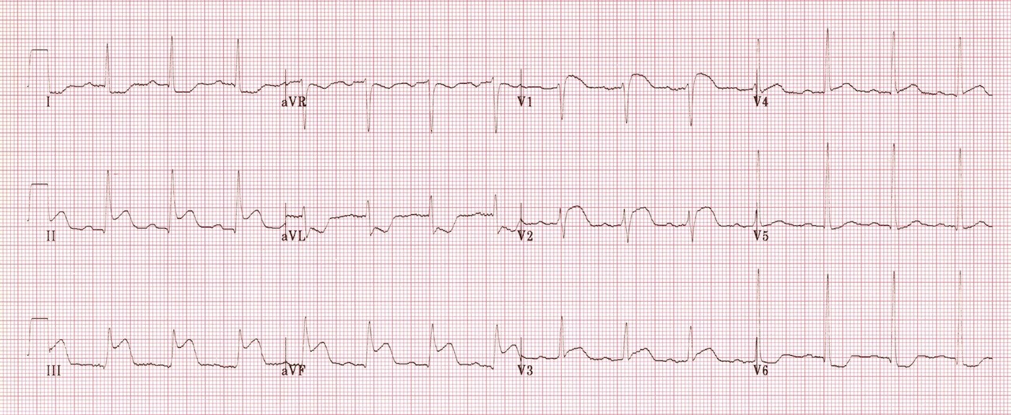

The helicopter has been tasked to retrieve the patient with an ETA of 120 minutes to get the patient to your centre.

1. What is the diagnosis (1)
- Inferior and RV infarction

2. What features on the ECG back up this diagnosis (4)
- STE in inferior leads II/III/aVF
- STE in rightward leads V1 and V2
- STD in reciprocal leads laterally V6/aVL
- STE III>II

3. What advice would you give to the rural doctor managing this patient?

- Thrombolyse – 120mins is beyond the 90min cut off for acceptable transport time for PCI
- Titrated parenteral analgesia e.g. morphine – but care as risk of preload reduction and hypotension
- O2 not necessary unless sats < 94%
- Aspirin
- Clopidogrel
- Clexane IV 30mg pre thrombolysis then 1mg/kg post sc
- IV lines x2 – proximal
- Continuous monitoring and defib applied
- AVOID nitrates – preload sensitive
- IV fluids as 250mls boluses if BP drops/cardiac output low clinically
- (BB controversial as higher risk of AV block in Inf/Right MI, plus risk of hypotension)

Question 2

An 18 month old boy is BIBA. He is currently in the paediatric resus bay of your tertiary centre. He has an IV line, O2 NRB 10L and full non-invasive monitoring applied. He is pale, lethargic and not behaving normally. He was well until 90 minutes ago.

BP 78/40
Temp 37.1
Sats 97% RA

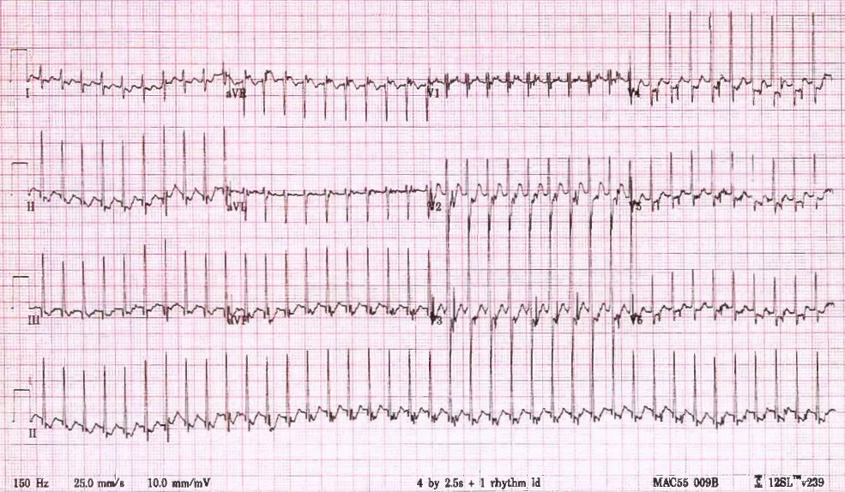

a) List the 5 most likely differential diagnoses, with most likely first (5 marks)
AVNRT (orthodromic)
AVRT eg WPW, LGL
Atrial Flutter 2:1 Block or AF
Paroxysmal Atrial Tachycardia
Sinus Tachycardia

b) List the first 2 separate strategies that you will utilise in an attempt to correct this condition. You must include doses and routes for any drugs given. (4 marks)
Vagal Manoeuvres – Application of Ice/cold water to face (Diving reflex) or carotid massage or hanging upside down
- do not “dunk”/invert in water
- Too young for valsalva
Adenosine – 0.1mg/kg iv, can increase dose to 0.2mg/kg then 0.3mg/kg at 5-10mins if unsuccessful, fast push via large vein with high volume flush

Must mention vagal manoeuvres with at least one example and then one pharmacological method – adenosine preferable but alternatives can include verapamil/BB/Amiodarone/digoxin

c) The ECG doesn’t change after you have attempted these 2 therapeutic manoeuvres. BP drops to 40/30 and the child appears more drowsy and pale. Pulses are palpable but thready
List the most important details of your definitive management now (5 marks)

Apply AP Pads
Administer IV benzodiazepine – weight estimate (age x2) + 8 = 11kg – dose midazolam 0.15mg/kg = 1.65mg (1-2mg ok)
DC Cardioversion
Synchronised
1 J/kg = 11J

Question 3
A 42 year old man with a history of prior SVT presents to ED with palpitations, he has been drinking heavily for 3 days and is very intoxicated. His ECG is shown below. He is known to a cardiologist and recently had a normal cardiac echo and angiogram.

P – variable 130-180
BP 100/70
Sats 99% RA
RR 20
T 37.2

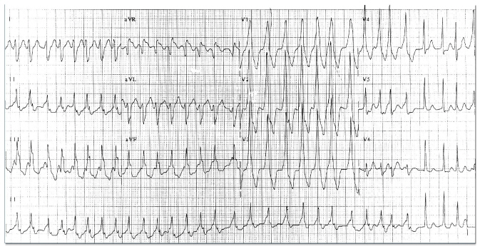

a) List the most important abnormal features on this ECG (4 marks)

WCT 180bpm
Irregularly Irregular (AF)
Slurring of QRS upstroke (delta wave)
aVR elevation (suggests accessory pathway)
Dominant R in V1 – left sided pathway

b) What is the diagnosis (2 marks)
AF with RVR
Underlying preexcitation secondary to accessory pathway/WPW

c) You decide to administer a rate controlling drug because he is intoxicated, unfasted and has vomited. Which drug will you use, with doses and route? (3 marks)
Flecainide 2mg/kg over 30 mins IVI
Ia, Ic and III agents are all safe – e.g. Ia – Procainamide, Ic - III - amiodarone/ibutilide/bretylium

d) You chart your chosen agent, but when you return from seeing another patient you find that the cardiology registrar has crossed out your order and is giving a loading dose of 500mcg of digoxin instead. The infusion is ¾ finished. Outline the steps you will take as a result of this (6 marks)

Stop the digoxin infusion - risk of AV blockade and precipitation of very fast ventricular rates (VT/VF)
Reasess the patient – obs/exam/ ECG
Discuss directly with cardiology reg – explain reasons for avoiding AV nodal blocking drugs in AF with WPW
Explain that it is inappropriate to cancel another senior physicians order without discussion
Call cardiology consultant to explain situation and need for education of registrar
Open disclosure to the patient
Risk Man the incident
M&M
Teaching session for ED registrars
Keep patient monitored/on CCU/In ED till drug likely to have no further clinical risk.

Question 4
A 29 year old indigenous lady presents with increasing SOB over 3 days. She had a mitral valve replacement 3 weeks ago and was started on warfarin. She has not had an INR check for 2 weeks but states that she has been taking her medication.
She has a history of rheumatic fever and a snake bite 3 years ago but no other comorbidities or medications.

BP 70/60
P 130
Sats 82%
RR 30
Temp 37.5

a) In the table below, list the 5 most likely causes for her presentation and 1 ultrasound finding that would be for each if this were the correct diagnosis (10 marks)

Diagnosis | Positive USS Finding
Massive PE | Large RV>LV
Pericardial Effusion with tamponade | Pericardial effusion with RV/RA diastolic collapse
Pneumonia | Hepatisation of the lung
Haemothorax/Pleural Effusion | Pleural fluid seen on USS
Cardiac Failure | B lines/pleural fluid/poor contractility/wall motion abnormalities
Endocarditis/Valve clot | Vegetation/clot on valve
Valve dehiscence/failure | Mitral Regurgitation

Other answers may be possible if explained well e.g trauma and bleeding internally in the context of a high INR with a positive FAST – although less likely as there is no hint of this in the stem

b) The medical student wonders if she has a high INR, because she “bled a lot” when he put in a cannula. He wants to know what the options are (in general not just for this patient) for lowering a supratherapeutic INR. Complete the table below with methods, pros and cons for each.

Method | Pros | Cons
Withhold doses of warfarin | Requires no medication | INR may be rising, takes a long time  Risk of overcorrection and then hard to re warfarisnise
Vitamin K po or IV | Cheap | IV can cause anaphylaxis  Takes >8hrs
FFP | Quick  Doesn’t take INR back to 1.0 for those that need ongoing anticoag (factors back to 30% of Normal or INR 1.7-1.8)  Available in most hospitals | Fluid overload  Transfusion reactions  TRALI
Prothrombin Complex Concentrate – 3 or 4 factors | Complete reversal when life threatening bleed  Quick and easy to give  No transfusion reaction | Expensive  More complex dosing depending on weight and INR
Recombinant Factor 7 | As above | As above
Question 5

A 26 year old man is brought the ED after several syncopal episodes in the preceding 3 months. He is very keen to leave and he “feels better now”. He is an international student and doesn’t have any health insurance.

BP 120/70
P 100
Sats 99% RA
RR 20
Temp 37.2

His ECG is shown

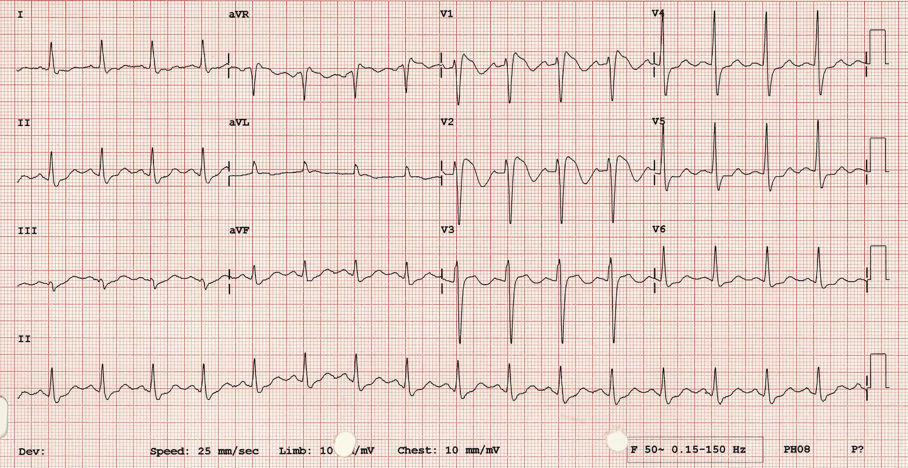

a) List the most important abnormalities seen in the ECG (2 marks)
Coved type STE in V1-3
Flat/upsloping lateral STD

b) What is the most likely diagnosis? (1 mark)
Brugada Syndrome

c) What are the most serious consequences of this condition? (3)
Syncope
Ventricular arrhythmias
Sudden death

d) List 5 factors that can unmask this condition (5 marks)
Fever
Ischaemia
Multiple Drugs
Sodium channel blockers eg: Flecainide, Propafenone
Calcium channel blockers
Alpha agonists
Beta Blockers
Nitrates
Cholinergic stimulation
Cocaine
Alcohol
Hypokalaemia
Hypothermia
Post DC cardioversion

e) List the steps you take next in the management of this patient (5 marks)

Explain likelihood of sudden death and attempt to persuade patient to stay – utilise relatives if necessary
IV access in case of arrhythmia
Monitored area +/- defib paddles if symptomatic
Check electrolytes +/- trop
Discuss patient with cardiologist for admission as potential need for ICD

Question 6

A 32 year old man presents following a syncopal episode. He has had previous problems with syncope and had a dual chamber pacemaker/defibrillator inserted 6 months previously. On arrival at the ED he reports having felt his defibrillator “fire” several times over the preceding hours.

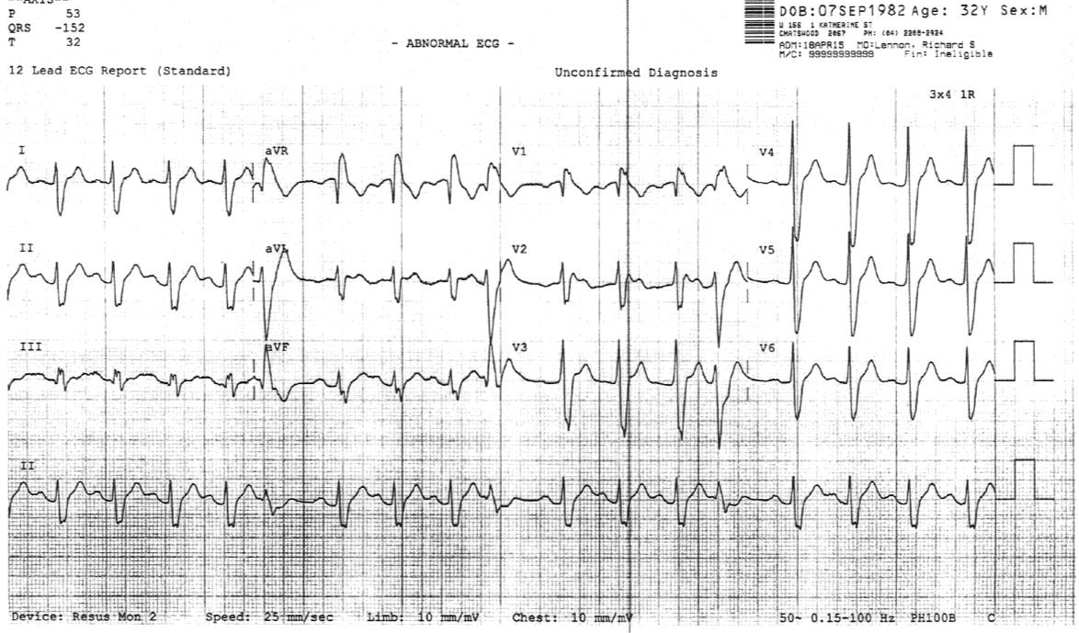

a) List 3 abnormalities in this ECG (3 marks)
Tachycardic 100-110bpm
Broad/prolonged PR interval
ST segment elevation V1-2, saddleback
J-point elevation
T wave inverted V1 – biphasic V2
PVCs

The patients CXR is shown
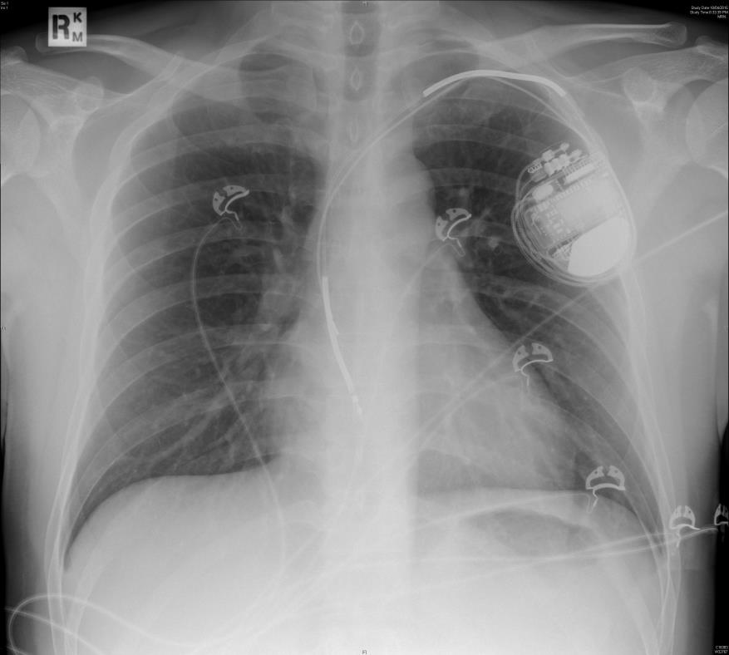

b) List the most relevant finding (1 mark)
Dual chamber pacemaker evident. Ventricular lead has displaced – tip lying near tip of atrial lead

c) Complete the following table identifying causes of pacemaker/defibrillator malfunction. Provide two examples/causes for each category (9 marks)

Catergory of PPM Malfunction | ECG Findings | Example/Cause
Failure to Sense
Failure to Pace
Oversensing

Catergory of PPM Malfunction | ECG Findings | Example/Cause
Failure to Sense | Pacing (or at least pacing spike) occurring in middle of normal P waves or QRS complexes | Voltage of intrinsic cardiac activity too low to detect  Battery failure  Mechanical problem with lead (fracture/displacement)
Failure to Pace | No pacing spikes for atria/ventricles or both seen | Mechanical problem with lead(s)  Battery failure  Fibrosis at electrode/tissue interface  Oversensing
Oversensing | Pacing spikes not appearing (inhibited) where they should occur – abnormal pauses – or appearing when they shouldn’t (inappropriate triggering) | External electromagnetic field interference  Detection of intrinsic electrical activity not assoc with atrial or ventricular contraction (e.g. muscle potentials, T wave)  Inappropriate interaction between elements of pacing system

Circular magnets can be used to alter the function of implanted devices.

d) What is the usual effect of placing a magnet over a pacemaker? (1 mark)
Initiates “magnet mode” – effect can vary b/w devices but most commonly puts in asynchronous pacing mode

e) What is the usual effect of placing a magnet over a defib? (1 mark)
Stops defibrillator from firing

Question 7
A 56 year old presents with a SOB and chest pain. He has recently been diagnosed with hypertension and started on perindopril and amlodipine. He presents to ED because he has measured a BP of 210/110 at home. He is convinced that he is going to have a stroke. You are concerned that he is having an aortic dissection.

BP 230/120
P 130
Sats 99% RA
RR 26
T 36.9

a) Complete the table below outlining the other acute serious consequences of uncontrolled hypertension and the signs or bedside investigations you will employ to rule them in or out. State nil of no relevant diagnostic bedside test. (15 marks)

Acute Consequence | Possible Signs | Potentially Diagnostic Bedside Investigations

Acute Consequence | Possible Signs | Potentially Diagnostic Bedside Investigations
Stroke or ICH or SAH | FND, meningism, LOC | Nil
Renal Failure | Abdominal bruit | Urine dip for protein, VBG creatinine
Acute Pulmonary Oedema | Creps on chest, low sats, high RR,
Encephalopathy | Confusion, papilloedema, seizures | Nil/Fundoscopy
Myocardial Infarction | Sweating, tachycardia, Hypo/hypertension, pallor, distress, | ECG, POC troponin

His chest pain worsens and you decide to send him for a CT Aortagram

c) List 2 drugs that you will choose to lower his BP assuming that this study is positive for aortic dissection. List them in the order you will chose to give them (4 marks)

1st - Beta blockade –Esmolol (loading 0.5 mg/kg over 2–5 min, followed by a drip of 10–20 μg/kg/min) OR Labetolol infusion 0.5-2mg/min or boluses 20mg up to total 300mg
2nd - Vasodilation – SNIP 0.25-0.5mcg/kg/min or GTN 5-200mcg/min

ACEi or nicardipine/amlodipine/diltiazem can be used in place of vasodilators and are probably easier to use with less adverse effects
Avoid hydralazine as increases wall stress

Q8
A 37 year old refugee from South Sudan has been brought to ED from a detention centre with SOB and dizziness. He has been in Australia for 2 weeks and can only speak a few words of English. He only takes panadol PRN. He is in the resus bay with full non-invasive monitoring attached, 2 IVCs and has had an ECG, obs and BSL performed. Bloods have been sent for FBC/EUC/LFT/CRP/CMP/Troponin

P 150
BP 70/40
Sats 99% RA
Temp 36.3
RR 38
GCS 15
BSL 5.2

He has an ECG that shows the following.

a) What is the most striking abnormality on this ECG and what diagnosis does it indicate (2)
Electrical Alternans
Large Pericardial effusion +/- Tamponade

b) List additional 5 clinical findings specific to this diagnosis that you might expect to find? (5 marks)
Raised JVP/Kussmauls sign
Muffled heart sounds
Absent of palpable apex beat
Signs of hypoperfusion - Slow capillary return, skin turgor,

c) List the 3 most important immediate investigations that you will perform and state what you are looking for on each (6 marks)
Bedside Ultrasound - pericardial effusion, signs of RA/RV collapse to indicate tamponade,
VBG – severe acidosis, creatinine indicative of end organ failure due to hypotension, lactate, rapid Hb result
CXR – for mass lesion, TB, heart size, alternative causes for SOB e.g pneumonia/PTX

b) List 5 possible underlying causes for him pathology
TB
HIV
Pericarditis
Malignancy e.g lymphomas/small cell lung Ca

LESS LIKELY - Autoimmune disease, Post MI – Dresslers syndrome,

Q9

A 53 year old presents to the emergency department with lethargy. She underwent orthotopic cardiac transplant for idiopathic dilated cardiomyopathy 2 years ago. There have been no recent changes to her immunosuppressant medication.

a) List four diagnoses that should be excluded when assessing this unwell cardiac transplant patient. (4 marks)
Infective focus/sepsis due to immunosurpressed state (bacterial/CMV/herpes/fungal/PCP/Toxoplasmosis)
Cardiac Failure due to transplant failure e.g dehiscence
Myocardial Ischaemia – due to progressive coronary artery stenosis, without CP as patient has a denervated heaty
Rejection
Renal Failure – common post transplant (30%)

b) List the 6 most important initial ED investigations and state a reason for each (12 marks)
ECG – Looking for silent ischaemia, heart is denervated so wont feel chest pain in ischaemia
CXR – signs of infection, cardiac failure, malignancy,
FBC – For signs if infection in high WCC – unlikely to have classic sepsis signs when immunocompromised (e.g. fever/pain – so need to check for very high WCCs)
EUC – For renal failure (common post transplant 30%) and electrolyte abnormalities
Immunosurpressant levels e.g. ciclosporin to check for toxicity
LFT’s – can be elevated in CS toxicity
Troponin – Can indicate ischaemia or rejection, both of which are clinically hard to delineate in the transplant patient

c) What

Differential of Chest Pain
Acute Pulmonary Oedema/BiPap
Aortic Stenosis
Pericarditis
Tamponade and Pericardiocentesis
Hypertensive Emergency
AF
VT
Heart Block
PPM
Pacing
PE with CVS collapse
Endocarditis
Rheumatic Fever

