Cardiology Questions 2018_1
Question 1

You are the consultant in charge at a Tertiary Referral Hospital with PCI capability. You receive a call from a registrar who is working at a Rural Hospital. He has a patient with the following ECG.

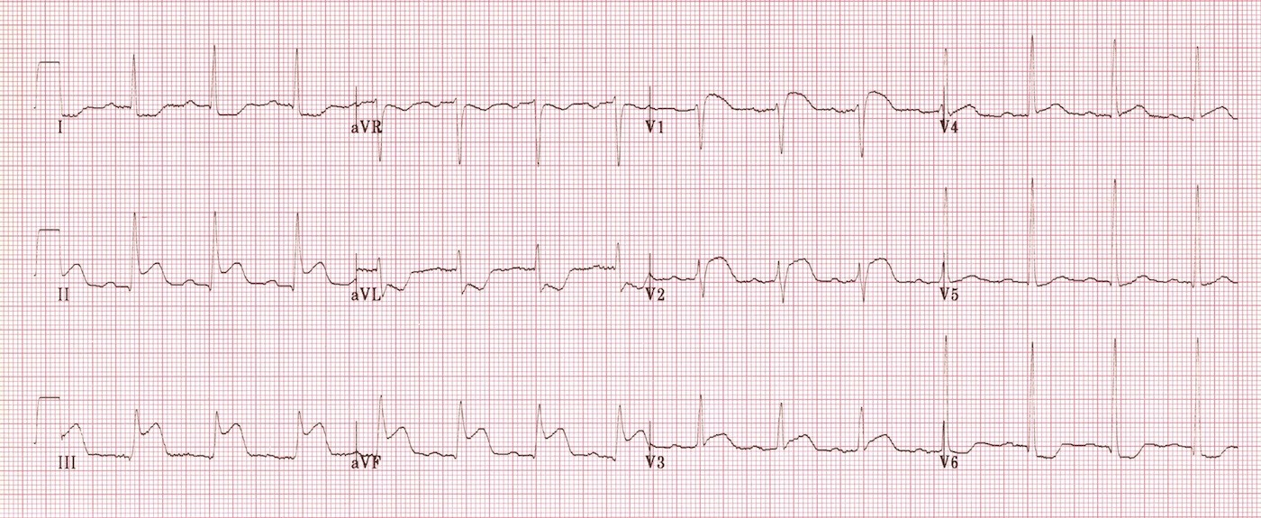

The helicopter has been tasked to retrieve the patient with an ETA of 120 minutes to get the patient to your centre.

1. What is the diagnosis (1)

_______________________________________________________________________________

2. What features on the ECG back up this diagnosis (4)

_______________________________________________________________________________

_______________________________________________________________________________

_______________________________________________________________________________

_______________________________________________________________________________

3. What advice would you give to the rural doctor managing this patient? (7 Marks)

_______________________________________________________________________________

_______________________________________________________________________________

_______________________________________________________________________________

_______________________________________________________________________________

_______________________________________________________________________________

_______________________________________________________________________________

_______________________________________________________________________________

Question 2

An 18 month old boy is BIBA. He is currently in the paediatric resus bay of your tertiary centre. He has an IV line, O2 NRB 10L and full non-invasive monitoring applied. He is pale, lethargic and not behaving normally. He was well until 90 minutes ago.

BP 78/40
Temp 37.1
Sats 97% RA

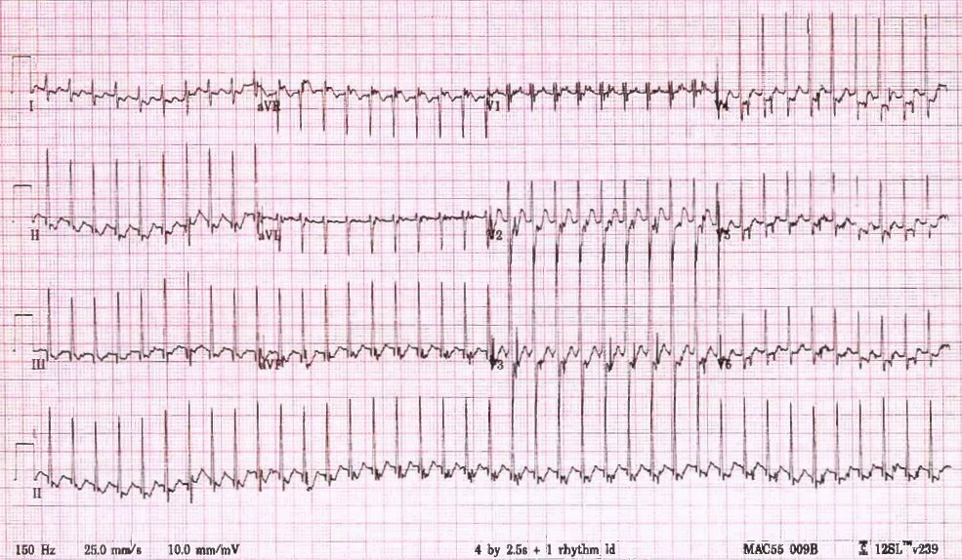

a) List the 5 most likely differential diagnoses, with most likely first (5 marks)
_
______________________________________________________________________________

_______________________________________________________________________________

_______________________________________________________________________________

_______________________________________________________________________________

_______________________________________________________________________________

b) List the first 2 separate strategies that you will utilise in an attempt to correct this condition. You must include doses and routes for any drugs given. (4 marks)

_______________________________________________________________________________

_______________________________________________________________________________

_______________________________________________________________________________

_______________________________________________________________________________

c) The ECG doesn’t change after you have attempted these 2 therapeutic manoeuvres. BP drops to 40/30 and the child appears more drowsy and pale. Pulses are palpable but thready.
List the most important details of your definitive management now (5 marks)

_______________________________________________________________________________

_______________________________________________________________________________

_______________________________________________________________________________

_______________________________________________________________________________

_______________________________________________________________________________

Question 3
A 42 year old man with a history of prior SVT presents to ED with palpitations, he has been drinking heavily for 3 days and is very intoxicated. His ECG is shown below. He is known to a cardiologist and recently had a normal cardiac echo and angiogram.

P – variable 130-180
BP 100/70
Sats 99% RA
RR 20
T 37.2

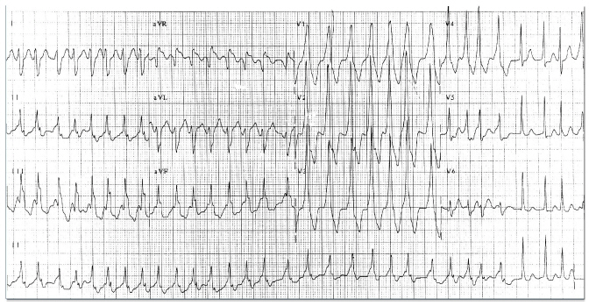

a) List the most important abnormal features on this ECG (4 marks)

_______________________________________________________________________________

_______________________________________________________________________________

_______________________________________________________________________________

_______________________________________________________________________________

b) What is the diagnosis (2 marks)

_______________________________________________________________________________

_______________________________________________________________________________

c) You decide to administer a rate controlling drug because he is intoxicated, unfasted and has vomited. Which drug will you use, with doses and route? (3 marks)

_______________________________________________________________________________

_______________________________________________________________________________

_______________________________________________________________________________

d) You chart your chosen agent, but when you return from seeing another patient you find that the cardiology registrar has crossed out your order and is giving a loading dose of 500mcg of digoxin instead. The infusion is ¾ finished. Outline the steps you will take as a result of this (6 marks)

_______________________________________________________________________________

_______________________________________________________________________________

_______________________________________________________________________________

_______________________________________________________________________________

_______________________________________________________________________________

_______________________________________________________________________________

Question 4
A 29 year old indigenous lady presents with increasing SOB over 3 days. She had a mitral valve replacement 3 weeks ago and was started on warfarin. She has not had an INR check for 2 weeks but states that she has been taking her medication.
She has a history of rheumatic fever and a snake bite 3 years ago but no other comorbidities or medications.

BP 70/60
P 130
Sats 82%
RR 30
Temp 37.5

a) In the table below, list the 5 most likely causes for her presentation and 1 ultrasound finding that would be for each if this were the correct diagnosis (10 marks)

Diagnosis | Positive USS Finding

b) The medical student wonders if she has a high INR, because she “bled a lot” when he put in a cannula. He wants to know what the options are (in general not just for this patient) for lowering a supratherapeutic INR. Complete the table below with methods, pros and cons for each.

Method | Pros | Cons

Question 5

A 26 year old man is brought the ED after several syncopal episodes in the preceding 3 months. He is very keen to leave and he “feels better now”. He is an international student and doesn’t have any health insurance.

BP 120/70
P 100
Sats 99% RA
RR 20
Temp 37.2

His ECG is shown

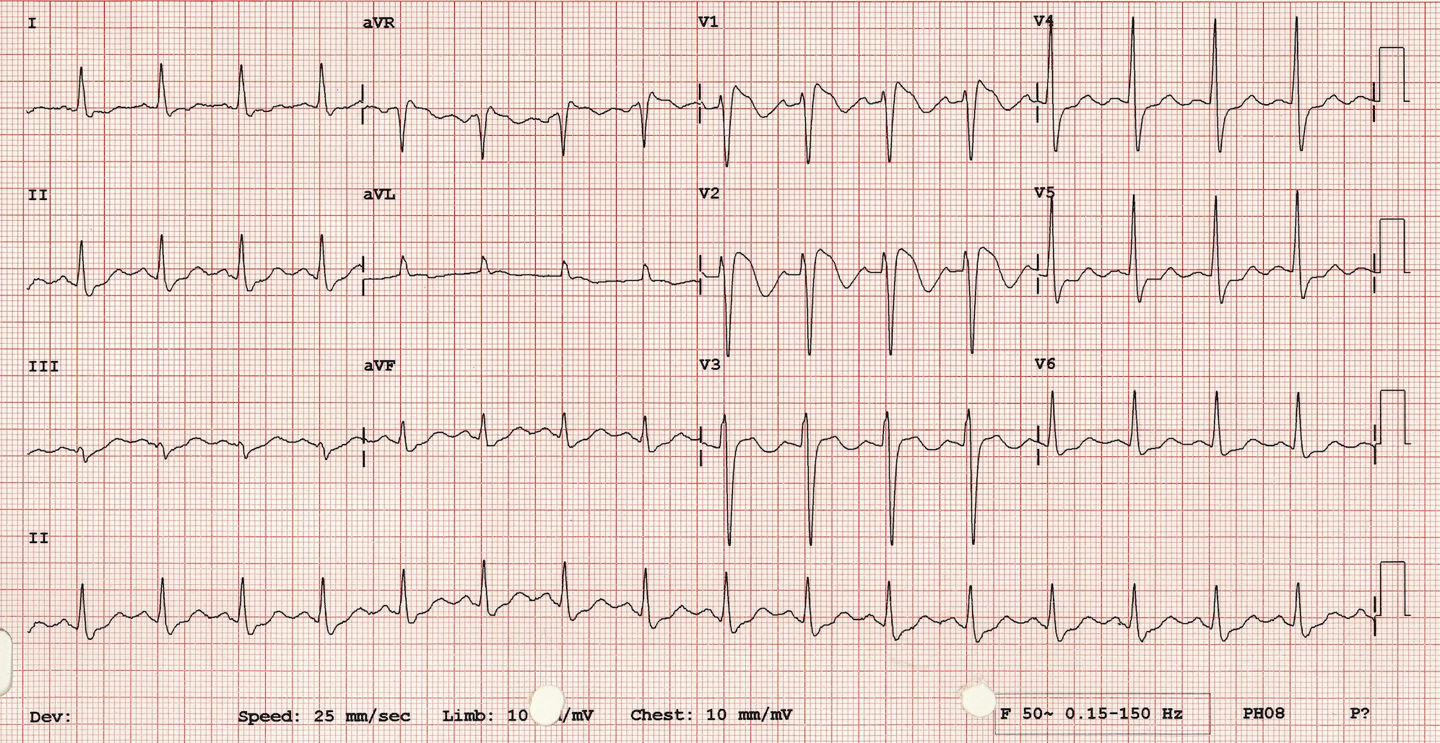

a) List the most important abnormalities seen in the ECG (2 marks)

_______________________________________________________________________________

_______________________________________________________________________________

b) What is the most likely diagnosis? (1 mark)

_______________________________________________________________________________

c) What are the most serious consequences of this condition? (3)

_______________________________________________________________________________

_______________________________________________________________________________

_______________________________________________________________________________

d) List 5 factors that can unmask this condition (5 marks)

_______________________________________________________________________________

_______________________________________________________________________________

_______________________________________________________________________________

_______________________________________________________________________________

_______________________________________________________________________________

e) List the steps you take next in the management of this patient (5 marks)

_______________________________________________________________________________

_______________________________________________________________________________

_______________________________________________________________________________

_______________________________________________________________________________

_______________________________________________________________________________

Question 6

A 32 year old man presents following a syncopal episode. He has had previous problems with syncope and had a dual chamber pacemaker/defibrillator inserted 6 months previously. On arrival at the ED he reports having felt his defibrillator “fire” several times over the preceding hours.

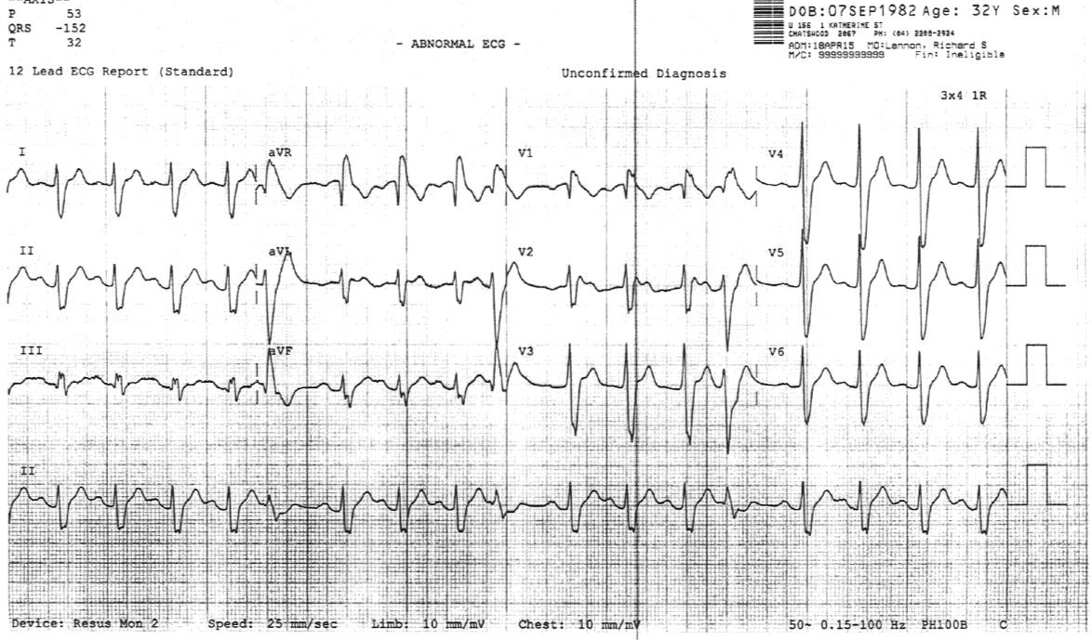

a) List 3 abnormalities in this ECG (3 marks)

_______________________________________________________________________________

_______________________________________________________________________________

_______________________________________________________________________________

The patients CXR is shown
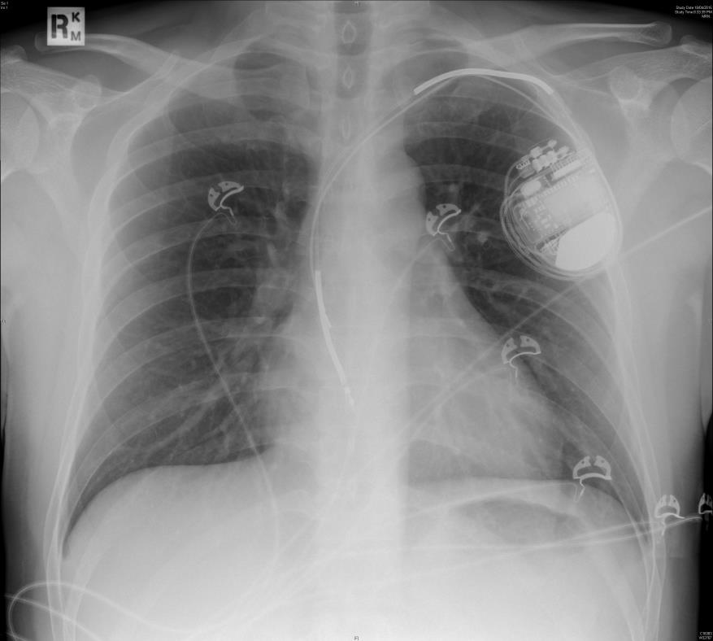

b) List the most relevant finding (1 mark)

_______________________________________________________________________________

c) Complete the following table identifying causes of pacemaker/defibrillator malfunction. Provide two examples/causes for each category (9 marks)

Catergory of PPM Malfunction | ECG Findings | Example/Cause
Failure to Sense
Failure to Pace
Over-sensing

Circular magnets can be used to alter the function of implanted devices.
d) What is the usual effect of placing a magnet over a pacemaker? (1 mark)

_______________________________________________________________________________

e) What is the usual effect of placing a magnet over a defib? (1 mark)

_______________________________________________________________________________

Question 7
A 56 year old presents with a SOB and chest pain. He has recently been diagnosed with hypertension and started on perindopril and amlodipine. He presents to ED because he has measured a BP of 210/110 at home. He is convinced that he is going to have a stroke. You are concerned that he is having an aortic dissection.

BP 230/120
P 130
Sats 99% RA
RR 26
T 36.9

a) Complete the table below outlining the other acute serious consequences of uncontrolled hypertension and the signs or bedside investigations you will employ to rule them in or out. State nil of no relevant diagnostic bedside test. (15 marks)

Acute Consequence | Possible Signs | Potentially Diagnostic Bedside Investigations

His chest pain worsens and you decide to send him for a CT Aortagram

c) List 2 drugs that you will choose to lower his BP assuming that this study is positive for aortic dissection. List them in the order you will chose to give them (4 marks)

_______________________________________________________________________________

_______________________________________________________________________________

_______________________________________________________________________________

_______________________________________________________________________________
Q8
A 37 year old refugee from South Sudan has been brought to ED from a detention centre with SOB and dizziness. He has been in Australia for 2 weeks and can only speak a few words of English. He only takes panadol PRN. He is in the resus bay with full non-invasive monitoring attached, 2 IVCs and has had an ECG, obs and BSL performed. Bloods have been sent for FBC/EUC/LFT/CRP/CMP/Troponin

P 150
BP 70/40
Sats 99% RA
Temp 36.3
RR 38
GCS 15
BSL 5.2

He has an ECG that shows the following.

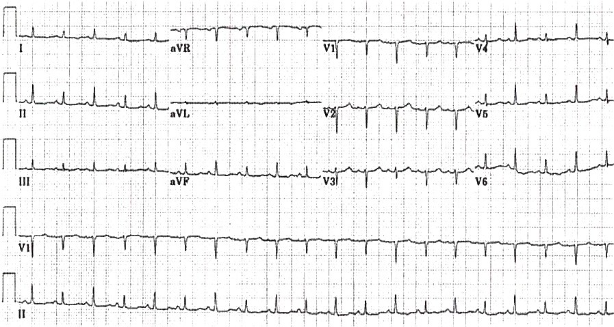

a) What is the most striking abnormality on this ECG and what diagnosis does it indicate (2)

_______________________________________________________________________________

_______________________________________________________________________________

b) List additional 5 clinical findings specific to this diagnosis that you might expect to find? (5 marks)

_______________________________________________________________________________

_______________________________________________________________________________

_______________________________________________________________________________

_______________________________________________________________________________

_______________________________________________________________________________

c) List the 3 most important immediate investigations that you will perform and state what you are looking for on each (6 marks)

_______________________________________________________________________________

_______________________________________________________________________________

_______________________________________________________________________________

_______________________________________________________________________________

_______________________________________________________________________________

_______________________________________________________________________________

d) List 5 possible underlying causes for him pathology

_______________________________________________________________________________

_______________________________________________________________________________

_______________________________________________________________________________

_______________________________________________________________________________

_______________________________________________________________________________
Q9

A 53 year old presents to the emergency department with lethargy. She underwent orthotopic cardiac transplant for idiopathic dilated cardiomyopathy 2 years ago. There have been no recent changes to her immunosuppressant medication.

a) List four diagnoses that should be excluded when assessing this unwell cardiac transplant patient. (4 marks)

_______________________________________________________________________________

_______________________________________________________________________________

_______________________________________________________________________________

_______________________________________________________________________________

b) List the 6 most important initial ED investigations and state a reason for each (12 marks)

Investigation | Reason

c) List 4 drugs that the patient is likely to be taking as regular medications (4 marks)

_______________________________________________________________________________

_______________________________________________________________________________

_______________________________________________________________________________

_______________________________________________________________________________

