[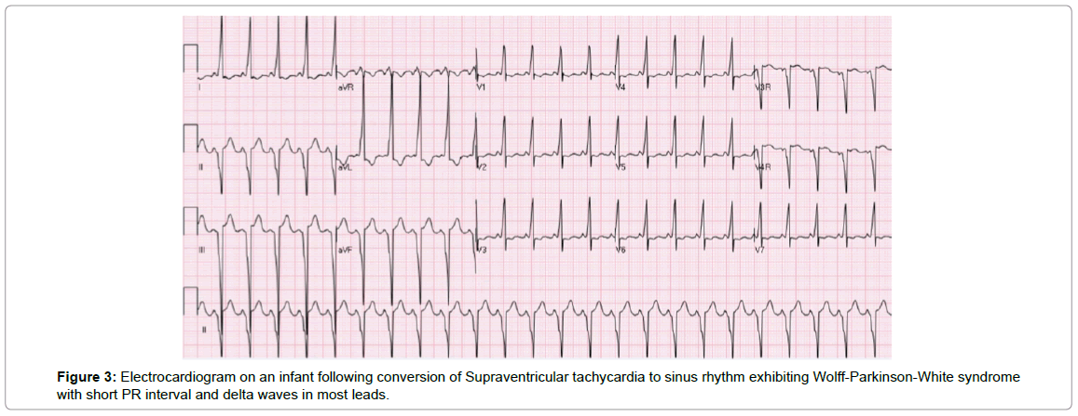](https://www.google.com.au/url?sa=i&rct=j&q=&esrc=s&source=images&cd=&cad=rja&uact=8&ved=0ahUKEwj5h8CC5M_TAhUFVxQKHU48B_sQjRwIBw&url=https://www.omicsgroup.org/journals/pediatric-cardiac-emergencies-2165-7548.1000164.php?aid%3D21064&psig=AFQjCNE4av6wjVK8xMPVj7WAqPTwOgKV1w&ust=1493765397659553)