[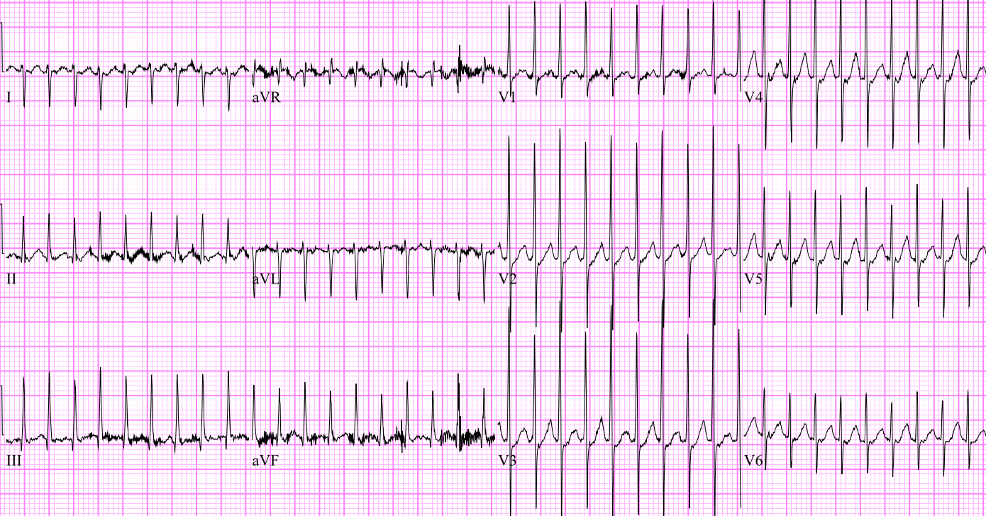](http://www.google.com.au/url?sa=i&rct=j&q=&esrc=s&source=images&cd=&cad=rja&uact=8&ved=0ahUKEwj0nea24s_TAhVI1RQKHdveACAQjRwIBw&url=http://pemcincinnati.com/blog/pediatric-svt/&psig=AFQjCNGwylEKR6QRaU2-gQ_vxpaP1bBnVw&ust=1493764911667311)