# Environmental Questions

**Question 1**

7 year old boy is brought to your major referral emergency department by his mother, who states that he has told her that he has been bitten on his ankle by a snake while playing in their back yard one hour previously. She has applied a pressure immobilization bandage top the leg. He is currently asymptomatic with the following vital signs:

PR 90 per min

BP 95/55 mmHg

RR 20 per min

O2 Sat 99% room air

What features on history would indicate envenomation? (4 marks)

________________________________________________________________________________________________________________________________________________________________________________________________________________________________________________________________________________________________________________________

List the blood tests that you would perform in the assessment of the patient and justify why you would do them

(4 marks)

|  |  |
| --- | --- |
| **Test** | **Justification** |
|  |  |
|  |  |
|  |  |
|  |  |
|  |  |
|  |  |
|  |  |

When would you consider removal of Pressure Immobilisation bandage? (2 marks) ____________________________________________________________________________________________________________________________________________________________

**Question 2**

A 35 year old man presents after collapsing during a marathon.

His vitals are:

HR 143

BP 88/60

RR 28 bpm

O2 sats 94% 15 L NRB

Temp 42.3°C

GCS 9 E2 V3 M4

What is the likely diagnosis? (1 mark)

__________________________________________________________________________________

List and justify your immediate emergency department management priorities for this patient. Include any drug doses (6 marks)

|  |  |  |
| --- | --- | --- |
| **Management** | **Justification** | **Dose** |
|  |  |  |
|  |  |  |
|  |  |  |
|  |  |  |
|  |  |  |
|  |  |  |
|  |  |  |

What are the potential complications? (3 marks)

______________________________________________________________________________________________________________________________________________________________________________________________________________________________________________________

**Question 3**

An 18 year old female tourist has been brought into your ED in Darwin by her friends after she experienced sudden extreme pain whilst swimming in the ocean.

Her vitals are

HR 140 beats/min (regular)

BP 138/95 mmHg

RR 26 /min

O2 Saturation 92 % on air

GCS 15

A photograph of her right leg is below:



What is the abnormality and demonstrated in the photograph, and what is the likely cause?

(2 marks)

____________________________________________________________________________________________________________________________________________________________________

What is the treatment for this leg injury (3 marks)

______________________________________________________________________________________________________________________________________________________________________________________________________________________________________________________

What are the indications for antivenom? (2 marks)

____________________________________________________________________________________________________________________________________________________________________

List 3 potential causes for hypoxia in this case? (3 marks)

______________________________________________________________________________________________________________________________________________________________________________________________________________________________________________________

**Question 4**

A 60 year old man is struck by lightning whilst playing golf

His vital signs are:

HR 120 /min

BP 100/60 mmHg supine

RR 18 /min

Temperature 35° Celsius

GCS 9

What may be the causes of the patient’s reduced GCS (4 marks)

________________________________________________________________________________________________________________________________________________________________________________________________________________________________________________________________________________________________________________________________________

Complete the following table regarding the effects of lightning strike on organ systems: (6 marks)

|  |  |
| --- | --- |
| **System** | **Effects** |
| Vascular |  |
| Ocular |  |
| Auditory |  |
| Dermatological |  |
|  |  |
| Cardiac |  |
|  |  |
|  |  |

**Question 5**

A 45 year old man has been brought into the ED having been found unconscious

HR 35

BP 90/60

RR 8

T 28o

This is his ECG

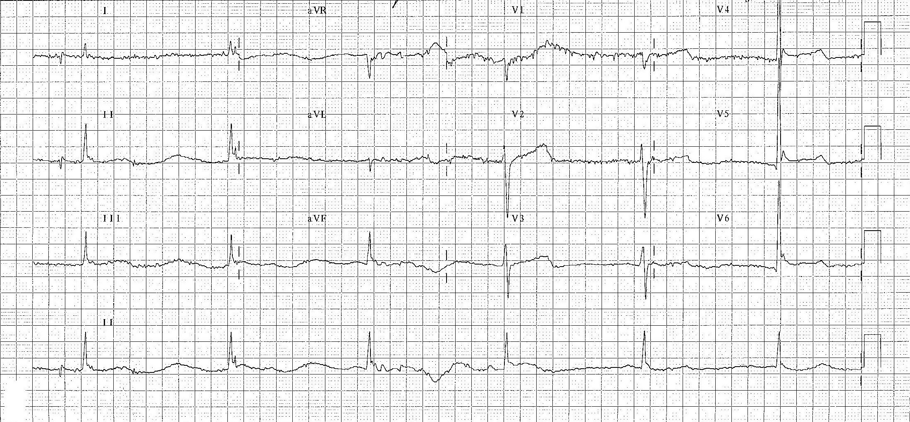

Describe the changes in this ECG associated with hypothermia (2 marks)

*______________________________________________________________________________________________________________________________________________________________________________________________________________________________________________________*

The patient becomes pulseless and cardiorespiratory resuscitation is commenced.

What are the principles of resuscitation in hypothermia that differ from the usual ACLS algorithm? (5 marks)

|  |
| --- |
|  |
|  |
|  |
|  |
|  |

Describe 3 methods of warming

*________________________________________________________________________________________________________________________________________________________________________________________________________________________________________________________________________________________________________________________________________*