Question 3.
A previously well 38yo man presents with a week of worsening vomiting, diarrhoea and abdominal pain. On the day of presentation to the ED he has become drowsy and confused
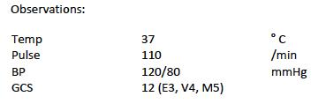
His liver function tests (LFTs) and coagulation profile are shown
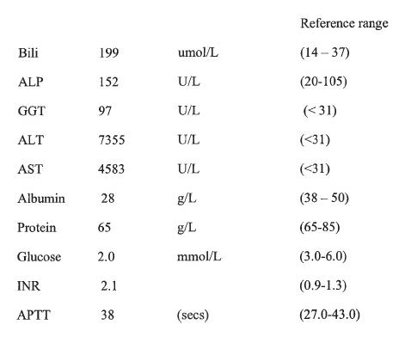

- What liver dysfunction pattern is this and why? (2 marks)

- Is there an abnormality in the synthetic function of the liver and if so list the parameters that confirm this?

- What is the most likely cause of this patient’s confusion? (1 mark)

D.) List 3 other possible causes for his confusion (3 marks)

E.) What are the most likely causes (with examples) of his condition? (4 marks)

- Name one other rare cause of acute hepatocellular damage (1 mark)

