METABOLIC
Short Answer Questions
Book 1

Examination Time: 45 Minutes
(no reading time)
Q1. A 70 year old man presents via ambulance unwell after 3 days of abdominal pain, vomiting and diarrhoea. He has a past medical history of polymyalgia rheumatic and hypertension.
HR 110
BP 80/-
GCS 11 (E2,V4,M5)
T 34.5 with cool peripheries
BSL 2.9

a. What is the most important diagnosis?

b. What are three differential diagnoses to be considered?

c. What are 4 treatment priorities?

Q2.
A 70 year old man is brought in by ambulance with new onset confusion. He lives alone, and last been seen by his daughter 5 days earlier. Neither the patient nor his daughter know his past medical history or current medications. He weighs 60kg.

Initial observations with the ambulance were:
HR 110 BP 120/80 RR 28 SpO2 98% RA Temp 38.2

a. List 5 categories of differential diagnoses that should be considered in this patient, including an example of each. (5 marks)

Your intern has inserted a cannula and taken a venous blood gas which is included below:

pH 7.3
pCO2 36
pO2 76
HCO3 17
Hb 152
Na 160
K+ 3.9
Cl 122
Creatinine 140
Glucose 72
Fingerprick ketones 0.4

b. Interpret the blood gas, including relevant calculations and give a diagnosis (10 marks)

c. Outline your management plan for this patient (5 marks)

Q3.
A 65 year old man is brought in by family with concerns that he has become progressively confused over the past 48hrs. He has a history of squamous cell lung cancer with metastatic disease to his right humeral head, left iliac crest and thoracic spine. He started to deteriorate a week ago with refusing to eat, occasional vomits, and being unable to open his bowels in this time.

T 36.0
P 52 SR
BP 130/80
RR22
Sats 96%
GCS 14 (E4M6V4), MMSE 12

a. List 5 common causes of delirium in this setting. (5 marks)

His ECG is shown on page 1 of the props booklet.

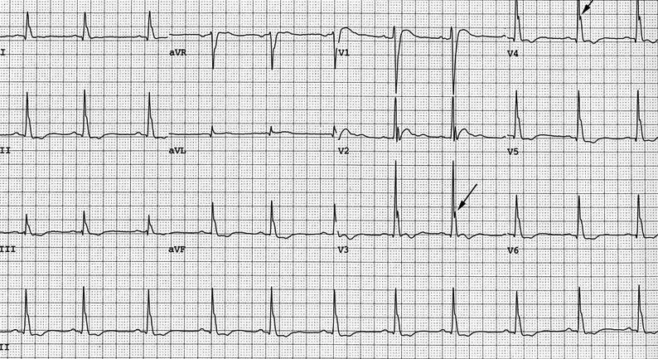

b. What is the major abnormality on the ECG and what is the most likely diagnosis for this patient? (2 marks)

His VBG shows an ionised Ca2+ of 2.9.
c. What are the two main factors that influence how ionised Ca2+ relates to corrected Ca2+? (2 marks)

d. How would you manage this patient? (6 marks)

Q4.
A 58yo woman on chemotherapy for breast cancer presents to your department feeling generally unwell.
Her vital signs are:
HR 105
BP 110/65
RR 28
Sats 92% 6L oxygen
T 38.6

Her ABG is shown below.
FiO2 0.4
pH 7.28
pO2 68
pCO2 40
HCO3 18
BE -6
Na 141
K 4.6
Cl 106

a. Describe and interpret the results. (10 marks)

b. List further investigations you would consider. (4 marks)

Q5.
A 26yo man presents with dyspnoea and weakness. His parents mention that he has a history of kidney problems and that he has not been compliant with his medication.

His arterial blood gas on arrival is shown below.

FiO2 0.21
pH 7.08
pO2 110
pCO2 19
HCO3 7
BE -16
O2Sats 100%
Na 136
K 1.8
Cl 124
Urea 4.7
Creat 42

a. Describe and interpret the results. (10 marks)

Q6
Regarding IV fluid composition and therapy:

a. Name composition of normal saline and Ringer’s lactate. (4 marks)

b. What are the targets to titrate fluid therapy? (4 marks)

c. What are the complications of fluid therapy? (4 marks)

