Metabolic Endocrine and Blood Gases

Fellowship SAQ 2017

CAH
Metabolic Acidosis inc Osm gap and AG
Respiratory Acidosis
Metabolic Alkalosis

Question 1
A 56 year old female is brought in by police with what is thought to be a psychiatric condition. She is appears to have an elevated mood and has been found in a shopping centre behaving erratically. She has grazes on her face and arms. The patient is unable to give you any useful information beyond this.

Observations
P 140
BP 150/100
Sats 99%
RR 30
T 39.9
GCS 14

a) List your differential diagnosis (6 marks)

Blood results shown

Hb 140
WCC 12
Plts 140
TSH 0.00
Na 156
K 5.4
Ur 10
Cr 140
LFT Normal
CMP Normal
CRP 12
UA negative
CXR Normal
ECG Sinus Rhythm 130bpm, no changes to suggest hyperkalaemic effect

b) List the initial emergency management steps (10 marks)

Question 2
A 20kg 6 year old boy presents with 2 weeks of lethargy. He is now complaining of abdominal pain and his mother has noticed that he is breathing fast. He has vomited 3 times in the department. He has sunken eyes, reduced skin turgor and hasn’t passed any urine for 16 hrs. He has no history of medical illnesses.

P 160
BP 80/50
Sats 99%
RR 60
Temp 36.7

pH 7.01
pCO2 18
HCO3 6
Lact 7.1
Gluc 34
K 5.0
Na 129
Cl 90

a) Interpret the blood gas including all calculations that you would perform (6 marks)

b) List the management steps in the first hour (8 marks)

4 hours into the childs management you are still waiting for a bed on the paediatric HDU. The registrar tells you that the child became irritable and is now obtunded with a GCS of 6. He is becoming bradycardic and resp rate has fallen to 15.

c) What is the likely cause (1 mark)

d) Outline your immediate management (6 marks)

Question 3
A 23 year old woman presents with postural dizziness, lethargy and anorexia. She has vomited several times and describes having been unwell for 3 weeks. She denies taking any medications. On examination she looks mildly dehydrated and has vitiligo. Examination is otherwise unremarkable.

Observations
P 120
BP 80/30 (despite 2L NaCl stat)
T 36.7
RR 22
Sats 98

pH 7.23
pCO2 28
Lact 2.3
HCO3 14

Na 126
K 7
Cr 120
Gluc 3.1
Cl 110
LFT normal
CMP normal

a) Interpret the blood results including any calculations

b) List 3 differential diagnoses (3 marks)

Other things such as burns/pancreatitis/bowel obstn/cirrhosis all unlikely given the clinical setting
Normovolaemic and hypervolaemic causes of low Na don’t fit the clinical picture

c) List the most important 3 immediate management steps (3 marks)

d) What test will be most valuable in determining the underlying cause (1 mark)

Question 4

A 65 year old alcoholic male presents after a syncope. He has had a recent chest infection and is on a course of antibiotics. His ECG is shown below.

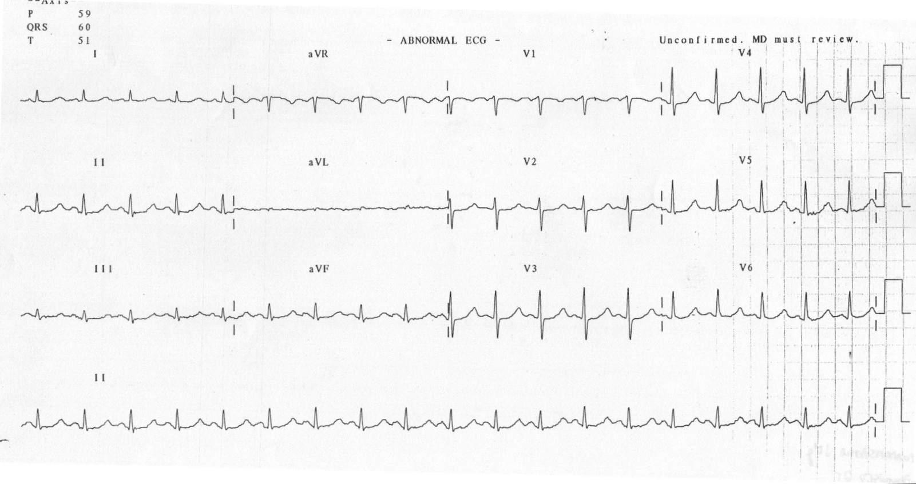
a) List the most abnormal finding on this ECG (1 mark)

b) What are 5 likely causes of this abnormality in this man, with justification for each (5 marks)

As you gathering the canulation trolley the cardiac arrest buzzer is pushed, when you arrive at the bedside the patient has no signs of life and the nurse shows you this.

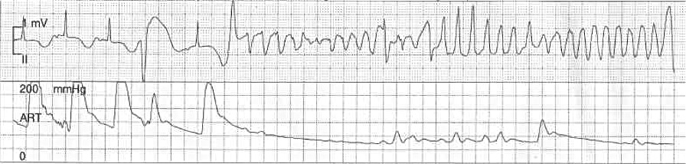

c) In the table below list the 4 most important actions you will direct your team to take in the first 2 minutes, with details of each (8 marks)

Action | Details

Question 5

A 54 year old man presents post ictal after a witnessed seizure. He has the following VBG

pH 7.2
pCO2 76
HCO3 18
Lactate 10
K 5.4
Na 110
Cl 109

a) List some possible causes for his hyponatraemia, classified by fluid status, in the table below (9 marks)

Euvolaemic | Hypovolaemic | Hypervolaemic

The patient has a further tonic clonic seizure.

b) How will you raise the Na and by how much will you aim to increase (2 marks)

c) List 10 investigations you will order with justification (20 marks)

