Metabolic Endocrine and Blood Gases

Fellowship SAQ 2017

Question 1
A 56 year old female is brought in by police with what is thought to be a psychiatric condition. She is appears to have an elevated mood and has been found in a shopping centre behaving erratically. She has grazes on her face and arms. The patient is unable to give you any useful information beyond this.

Observations
P 140
BP 150/100
Sats 99%
RR 30
T 39.9
GCS 14

a) List your differential diagnosis (6 marks)
Thyroid Storm – (hyperthyroidism not enough)
Drug Overdose inc TCA/anticholinergic agents
Psychiatric Condition e.g. Bipolar
Sepsis due to any cause (note new Sepsis 3 definition – life threatening organ dysfuction secondary to dysregulated host response to infection, mention qSOFA score Hypotension <100, Altered Mental State <15, Tachypnea >/= 22)
Intracerebral bleed/SDH
Intracerebral infection e.g encephalitis/meningitis
Heat stroke
NMS/MH

Blood results shown

Hb 140
WCC 12
Plts 140
TSH 0.00
Na 156
K 5.4
Ur 10
Cr 140
LFT Normal
CMP Normal
CRP 12
UA negative
CXR Normal
ECG Sinus Rhythm 130bpm, no changes to suggest hyperkalaemic effect

b) List the initial emergency management steps (10 marks)
Oxygen – total body consumption increased
Benzodiazepines titrated in 5mg aliquots of midazolam – gain control and sedate patient to reduce heat production
IV fluids - cooled, to likely sig dehydration causing renal dysfunction
Evaporative cooling – fan and water mist
IDC to monitor UO
PTU 900-1200mg orally or via NG
Lugols Iodine 5 drops (must be > 30mins after PTU)
Na Iodide 1g bd
Hydrocortisone 100mg 6 hrly IV (or dexamethasone)
Propranolol 0.5-1mg/min IV up to max 10mg
HDU/ICU disposition

Question 2
A 20kg 6 year old boy presents with 2 weeks of lethargy. He is now complaining of abdominal pain and his mother has noticed that he is breathing fast. He has vomited 3 times in the department. He has sunken eyes, reduced skin turgor and hasn’t passed any urine for 16 hrs. He has no history of medical illnesses.

P 160
BP 80/50
Sats 99%
RR 60
Temp 36.7

pH 7.01
pCO2 18
HCO3 6
Lact 7.1
Gluc 34
K 5.0
Na 129
Cl 90

a) Interpret the blood gas including all calculations that you would perform (6 marks)
HAGMA due to DKA
AG = (129 + 5) – (6 + 90) = 134 – 96 = 38
(or without K included = 33)

Corrected Na = 129 + (34-5.5)/3 = 138.5

Winters = (1.5 x 6) + 8 = 17
Appropriate respiratory response

Delta Ratio = 33-12/24 – 6 = 21/18 = 1.16
Isolated HAGMA

b) List the management steps in the first hour (8 marks)
Commence fluid resuscitation – 10mls/kg NaCl then reassess, unlikely to need > 20mls/kg
Ongoing NaCl guided by calculation of percentage dehydrated (likely severe) – can use charts to calculate or calculate total defecit plus maintainence and replace over 48hrs
Insulin – 0.1 units/kg/hr
Potassium replacement – commenced at a rate of 20-40mmol/L once K <4.5 and urine output established
2 x Iv lines – 1 for sampling
Consider arterial line if ongoing haemodynamic upset
Strict fluid balance – IDC
NGT and NBM
Ondansetron
Close monitoring of glucose/ketones/obs/neurological status

4 hours into the childs management you are still waiting for a bed on the paediatric HDU. The registrar tells you that the child became irritable and is now obtunded with a GCS of 6. He is becoming bradycardic and resp rate has fallen to 15.

c) What is the likely cause (1 mark)
Child has cerebral oedema and may be coning

d) Outline your immediate management (6 marks)
0.5g/kg of 20% Mannitol stat
Intubate – any appropriate drugs but avoid sux
ETT 5.5, depth 15cm
Hyperventilate
Reduce rate of fluids by 1/3
Nurse head up
Arrange CT brain once stabilised
Urgently contact paeds and ICU

Question 3
A 23 year old woman presents with postural dizziness, lethargy and anorexia. She has vomited several times and describes having been unwell for 3 weeks. She denies taking any medications. On examination she looks mildly dehydrated and has vitiligo. Examination is otherwise unremarkable.

Observations
P 120
BP 80/30 (despite 2L NaCl stat)
T 36.7
RR 22
Sats 98

pH 7.23
pCO2 28
Lact 2.3
HCO3 14

Na 126
K 7
Cr 120
Gluc 3.1
Cl 110
LFT normal
CMP normal

a) Interpret the blood results including any calculations
NAGMA
AG = (126 + 7) – (14 + 110) = 133- 124 = 9
Hyponatraemia and Hyperkalemia
Relative Hyperchloraemia
Winters = 1.5 x 14 +8 = 29 (appropriate)

No need for delta gap calc as not HAGMA

b) List 3 differential diagnoses (3 marks)
Addisonian crisis
Diarrhoea of any cause inc villous adenoma, SB fistula, IBD, laxative abuse
RTA/Diuretic abuse

Other things such as burns/pancreatitis/bowel obstn/cirrhosis all unlikely given the clinical setting
Normovolaemic and hypervolaemic causes of low Na don’t fit the clinical picture

c) List the most important 3 immediate management steps (3 marks)
Hydrocortisone 200mg IV stat
Appropriate Rx of hyperkalaemia with insulin/dex, salbutamol, calcium gluconate
Feed if able to eat otherwise 50mls 50% dextrose for hypoglycaemia

d) What test will be most valuable in determining the underlying cause (1 mark)
Cortisol (random)

Question 4

A 65 year old alcoholic male presents after a syncope. He has had a recent chest infection and is on a course of antibiotics. His ECG is shown below.

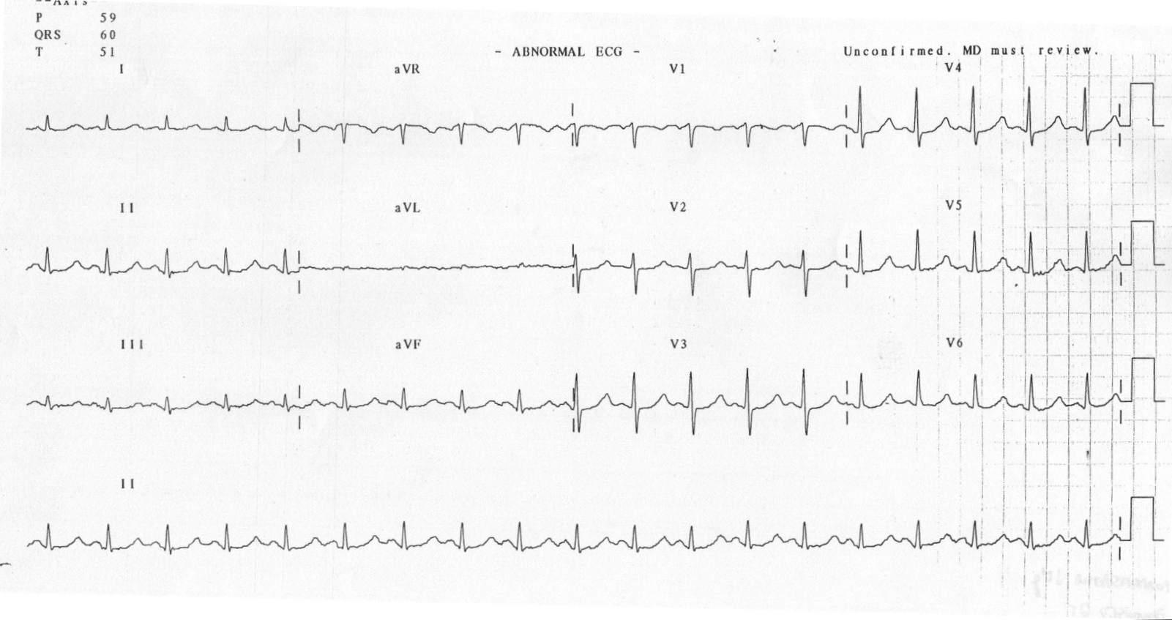
a) List the most abnormal finding on this ECG (1 mark)
Long QTc

b) What are 5 likely causes of this abnormality in this man, with justification for each (5 marks)
Hypomagnaesaemia
Hypocalcamia
Hypokalaemia –electrolytes often abnormal in hazardous drinking
Cardiac causes – e.g alcoholic cardiomyopathy
Drug induced e.g macrolide antibiotics for chest infection

As you gathering the canulation trolley the cardiac arrest buzzer is pushed, when you arrive at the bedside the patient has no signs of life and the nurse shows you this.

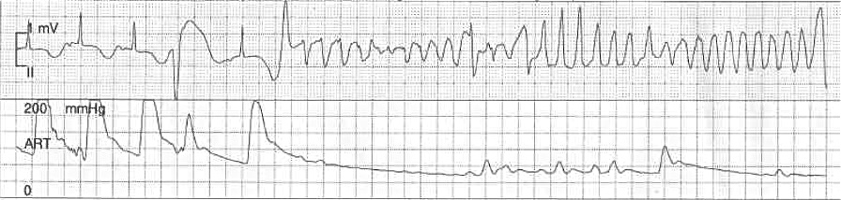

c) In the table below list the 4 most important actions you will direct your team to take in the first 2 minutes, with details of each (8 marks)

Action | Details

Action | Details
Commence CPR | 30:2 Compressions to ventilations via BVM, 2 min cycles between pulse checks
Defibrillate as soon as pads attached | AP paddle position, shock at 200J, stacked shocks as a witnessed arrest
IV access | Check VBG for K/Ca, send blood for CMP
Replace electrolytes as guided by VBG - | 10mmol MgSO4 prior to result as likely to be low, 10mls 10% CaGluc, 10mmol KCl

Adrenaline is incorrect as is only administered after the 2nd shock

Question 5

A 54 year old man presents post ictal after a witnessed seizure. He has the following VBG

pH 7.2
pCO2 76
HCO3 18
Lactate 10
K 5.4
Na 110
Cl 109

a) List some possible causes for his hyponatraemia, classified by fluid status, in the table below (9 marks)

Euvolaemic | Hypovolaemic | Hypervolaemic

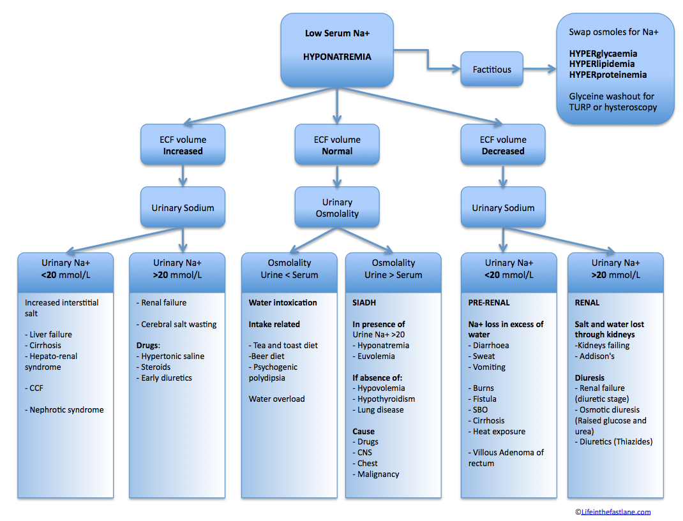

The patient has a further tonic clonic seizure

b) How will you raise the Na and by how much will you aim to increase (2 marks)
3% NaCl (hypertonic) 1-2mls/kg over 20 mins
Aim to increase by 5-7mmol
Total increase over 24 hrs of no more than 10mmol – risk of osmotic demyelination

DUNN
3% Saline
•100 mL = 50 mmol
•3 x normal osmolality
•must be given via a central line
Indications
•only for therapy of severe hyponatraemia with acute cerebral symptoms
•50 mmol/hour = (1-2 mL/kg/hour) until Na⁺ 125 -130 then maintained for 48 hours
•adult starting dose of 150mL (2mL/kg) 3% saline over 20 min
-repeat as required to raise [Na+] 5mmol/L by one hour
-remeasure [Na+] after the first 20min infusion has finished to monitor progress and adjust second infusion dose if required
-250 mmol over 10 min if seizures present (raises [Na⁺] 7 mmol/L)

c) List 10 investigations you will order with justification (20 marks)
Plasma and Urine Osm – helps to delineate cause e.g. SIADH
Formal EUC – formal Na level and other electrolytes
CMP – Potential for other elec abn, paraneoplastic phenomena
LFT - ?malignancy
FBC - ?infective causes
CTB – mass lesions as cause for
ECG – evidence of other electrolyte abnormalities/rhythm disturbances
TSH – hypothyroidism as a cause of hyponatraemia
Cortisol - ?addisions
CXR - ?pancoast tumour leading to SIADH
Glucose – possible cause for seizure

