Metabolic and Acid Base Questions

October 10th 2019

Total Mark 118
Question 1 (10 marks)
A 72 year old man presents with confusion. He is brought in by family who are concerned that he has worsening depression since his wife died 3 months ago. The patient is unable to give any clear history of the events. He has a history of atrial fibrillation and hypertension.
On full examination he has no abnormal physical examination findings aside from effortless tachypnoea and a GCS of 14 . ECG shows a sinus tachycardia. CXR no abnormalities.
Results of FBC, EUC, LFT, Coags, CRP and Blood Cultures are all pending

Observations

P 116
BP 110/60
Sats 91% RA
RR 36
Temp 37.4

VBG
pH 7.21
pCO2 22
HCO3 16
Cl 98
Lact 3.4
Gluc 3.0
Na 130
K 5.0
Cr 134
Hb 137

- List the two (2) key acid-base abnormalities on this VBG (2 marks)
____________________________________________________________________________________________________________________________________________________________________
- List the three (3) most relevant differential diagnoses (3 marks)
_____________________________________________________________________________________________________________________________________________________________________________________________________________________________________________

- List the five (5) MOST important additional investigations you will order (5 marks)
____________________________________________________________________________________________________________________________________________________________________________________________________________________________________________________________________________________________________________________________
Question 2 (10 marks)
A 19 year old male has been brought in by police after being found confused, agitated and vomiting. A plastic bottle full of an unknown substance was found in his back pack. He appears intoxicated and is unable to give any further history.
He has no identification on his person and there is no collateral history
Observations
P 110
BP 90/70
Sats 100% RA
RR 30
Temp 36.5

Venous Blood Gas
pH 7.22
pCO2 32
HCO3 16
Lact 4.5
Gluc 4.0
Bloods
Na 134
K 4.0
Cl 100
Ur 6.0
Cr 140

Serum Osm 302
- List the two (2) MOST important laboratory findings including the two (2) appropriate calculations used when determining those findings (4 marks)
____________________________________________________________________________________________________________________________________________________________________________________________________________________________________________________________________________________________________________________________

- List the three (3) MOST important investigations you will order to confirm the nature of the ingested liquid (3 marks)
_____________________________________________________________________________________________________________________________________________________________________________________________________________________________________________

The patient is attempting leave the department and is becoming physically aggressive to staff. The decision is made to intubate the patient for his own and the safety of staff.

- List three (3) measures you will take, specifically related to this patients presentation, to avoid peri-intubation complications (3 marks)
_____________________________________________________________________________________________________________________________________________________________________________________________________________________________________________

Question 3 (11 marks)
A 71 year old man with a history of severe COPD presents with drowsiness, wheeze and a cough. He has had a recent ICU admission for pneumonia, during which he was ventilated for 3 weeks and had a lengthy stay in a rehabilitation ward on discharge.
He has hypertension but no other significant comorbidities.
Has been using Ventolin 12 puffs 3 hourly via spacer for 2 days, Spiriva 18mcg MDI mane, prednisolone 30mg daily for 3 days and his usual perindopril 5mg daily.
He has severe tachypnoea with use of all accessory muscles, tripod position and agitation. Continuous salbutamol nebulisation commenced 5 minutes ago. CXR shows only hyperinflated lungs.

Observations
P 130
BP 160/98
RR 40
Sats 82% 15L NRB
Temp 35.2

VBG
pH 7.2
pCO2 85
HCO3 20
Cl 105
Lact 6.2
Na 145
K 3.0
Cr 180

- List the two (2) MOST important acid-base abnormalities (2 marks)
______________________________________________________________________________________________________________________________________________________________

The patient has documented advanced care plans that state he doesn’t wish to be intubated or have CPR. All other active treatment measures are to be taken in the event that he has a respiratory deterioration, including non-invasive ventilation and inotropes.

- List the five (5) MOST important instructions you will give to the bedside nurses regarding commencement and ongoing management of non-invasive ventilatory support for this patient (5 marks)
___________________________________________________________________________________________________________________________________________________________________________________________________________________________________________________________________________________________________________________________________________________________________________________________________________

The patient has a repeat VBG 4 hours later when he appears to have significantly less work of breathing and a saturation of 92% on FIO2 0.4 on NIV. He has had Ventolin 5mg nebulised 1 hourly for the last 2 hrs

pH 7.18
pCO2 60
HCO3 14
Lact 9.2
Na 146
Cl 106
K 3.0

- List the findings and your interpretation of the cause of the repeat VBG result (4 marks)

Findings | Interpretation

Question 4 (9 marks)
A 70kg, 23 years old female present with a very sudden onset of shortness of breath and right sided chest discomfort 1 hour ago while sitting at her desk at work. She has a history of anxiety but reports no current stressors.
She has been placed on 15L NRB Oxygen by the paramedics and her VBG and observations are shown below.

pH 7.54
pCO2 20
HCO3 28
Lactate 2.3

P 110
BP 100/70
Sats 99% 15L NRB
RR 36
Temp 36.9

- Describe the primary acid base abnormality and compensatory response (2 marks)
______________________________________________________________________________________________________________________________________________________________

- List the three (3) MOST likely differential diagnoses (3 marks)
_____________________________________________________________________________________________________________________________________________________________________________________________________________________________________________

10 minutes later the patient has a sudden cardiac arrest in the resus bay. Standard ALS management is ongoing when you arrive with adequate CPR and ventilation in a 15:2 ratio. She has narrow complex PEA and has received 1mg of adrenaline and a bolus of 1000mls Normal Saline has been commenced.

- In the table list the two (2) MOST important specific interventions (outside of the standard ALS algorithm) that you will that consider with details of each (4 marks)

Intervention | Details

Question 5 (15 marks)
An unknown man, who appears to be approximately 50 years old, is brought in by ambulance after a 10 minute tonic clonic seizure. The seizure was witnessed by paramedics and was terminated with intranasal midazolam. He has a GCS of 9 (M5V2E2) at 30 minutes post event. He appears malnourished and poorly kempt, there is no obvious sign of trauma. There is no available collateral history.
As you enter the resus bay he commences having a second tonic clonic seizure
Observations immediately prior to second seizure
BP 190/100
P 60
Sats 95% RA
RR 14
T 37.2

VBG
pH 7.21
pCO2 56
HCO3 16
Lact 9.0
Na 115
K 3.4
BSL 2.9
ECG shows no abnormality
FBC, EUC, LFT, Coags, CMP, urine and serum osmolalities have all been sent

- List the five (5) MOST important management priorities in the next hour in the table below (10 marks)
Treatment Priority | Brief Details/Doses/Agents

A CT scan of the brain is performed

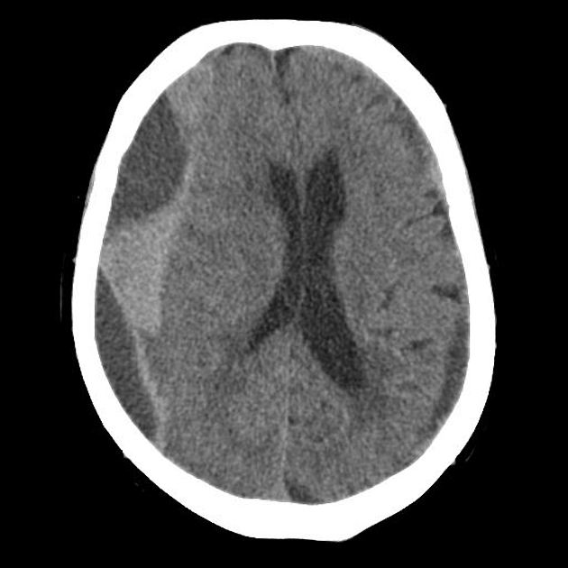

- Describe four (4) abnormal findings on this CT slice and state the diagnosis (5 marks)
____________________________________________________________________________________________________________________________________________________________________________________________________________________________________________________________________________________________________________________________

Diagnosis_______________________________________________________________________

Question 6 (19 marks)
A 14 year old female has been brought in by her parents due to concerns around weight loss and lethargy for 6 months duration. She has been seeing a psychologist for 6 months for anxiety that is related to school attendance.
Observations
BP 80/60
P 72
Sats 98% RA
RR 22
Temp 35.8

Her ECG is shown
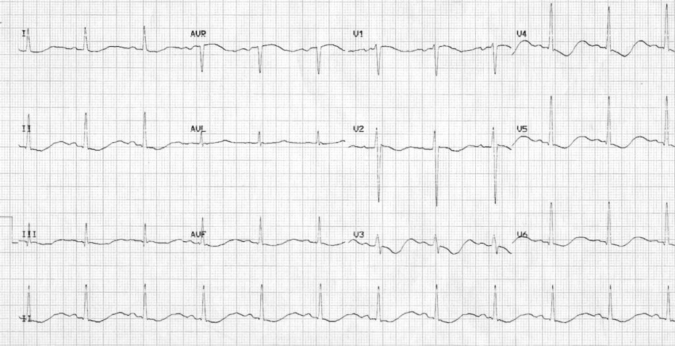

- List three (3) abnormalities on the ECG and the one (1) MOST likely cause of these abnormalities (4 marks)
_____________________________________________________________________________________________________________________________________________________________________________________________________________________________________________
Cause_______________________________________________________________________

- In the table below list the MOST important features you will seek specific to the assessment of this patient (10 marks)

Historical Features | Clinical Examination Features

The patient has the following blood results, she wants to go home and is threatening to run away
TSH/T4 normal
Hb 98
MCV 69
Phos 0.3
CCa 2.2
K 1.7
Mg 0.4
Cr 154
Ur 8.7
LFT normal

- List the five (5) MOST important management priorities in this patient (5 marks)
___________________________________________________________________________________________________________________________________________________________________________________________________________________________________________________________________________________________________________________________________________________________________________________________________________

Question 7 (18 marks)
A 67 years old cachectic man presents with recurrent collapses. He is of no fixed abode and has a history of hazardous alcohol use, with frequent presentations to the Emergency Department for withdrawal seizures. Past history of IHD and hypertension.
An ECG was taken during a transient unconscious episode in ED
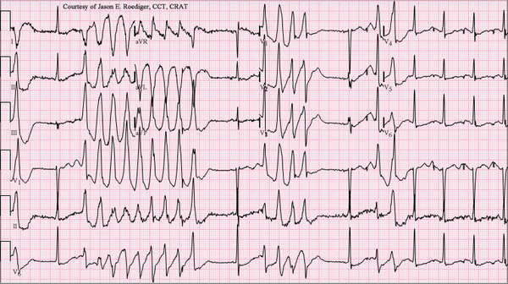

Observations post episode
P 56
BP 90/60
RR 22
Sats 96% RA
Temp 37.7

- Descrive the three (3) MOST important abnormalities on the ECG shown and state the ECG diagnosis (4 marks)
_____________________________________________________________________________________________________________________________________________________________________________________________________________________________________________Diagnosis_______________________________________________________________________

- List four (4) likely causes or contributing factors for this arrhythmia in this patient (4 marks)
____________________________________________________________________________________________________________________________________________________________________________________________________________________________________________________________________________________________________________________________

The patient has 6 further unresponsive episodes due to the same arrhythmia.
- List five (5) specific treatment options for this arrhythmia in the table below (10 marks)
Treatment Option | Details

Question 8 (14 marks)
A 90 year old man is sent in by his GP for investigation of has renal dysfunction. The triage information states that he has had several months of lethargy. He has no significant medical history aside from a hip replacement 10 years ago. He is independently living with his wife, takes no medications and not had any contact with his GP since his hip replacement.
A brief physical assessment reveals a well hydrated, but slender man who has no overt abnormalities on external physical examination.
Observations
P 90
BP 140/80
RR 24
Sats 96% RA
Temp 37.1

VBG
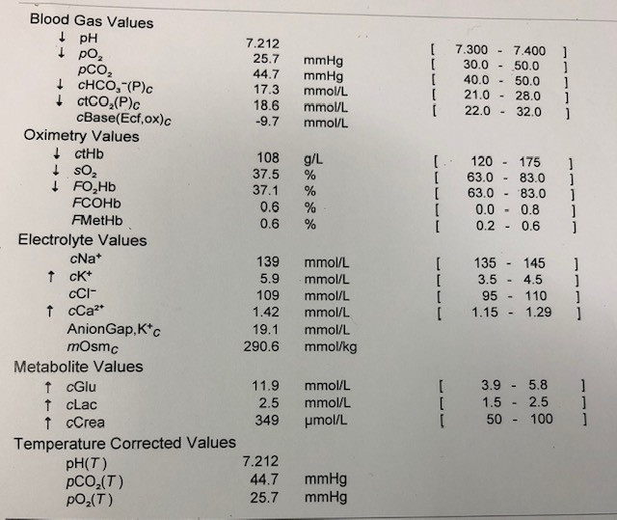
- In the table below list the abnormalities seen in the blood gas shown and provide the most likely reasons for these abnormalities (10 marks)
Abnormality | Likely Explanation(s)

The formal serum potassium level is 6.4mmol/L and the patient has the following ECG. The nurses have performed a post void residual bladder scan that shows 400mls
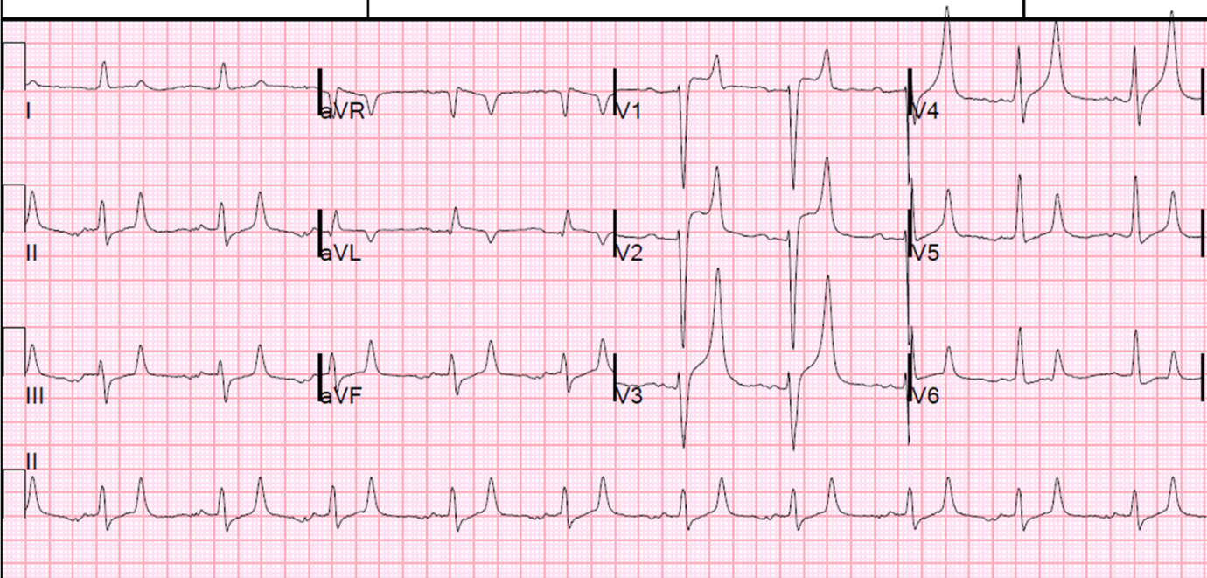

- List the four (4) most important next actions you will take in managing this patient (4 marks)
____________________________________________________________________________________________________________________________________________________________________________________________________________________________________________________________________________________________________________________________

Question 9 (12 marks)
You are called urgently to assist with a 9 week old baby who presents with 1 week of increasing lethargy, vomiting and poor feeding. The baby was born at term and had an uneventful neonatal period. The baby is exclusively breast fed.
The child appears dehydrated and hypotonic. Fontanelles are sunken, capillary return 4 seconds. No overt signs of focal infection, pulses feeble but equal in all limbs, no murmurs, chest clear with no increase in work of breathing. Abdomen non distended and soft.
The child is fully monitored with a patent IV line
Observations
P 190
BP 70/50
RR 40
T 36.5
Sats 91% RA

VBG
pH 7.21
pCO2 45
HCO3 12
Lact 4.5
K 6.5
Na 124
Gluc 3.0
Cl 100
Hb 140
Cr 110

- What is the acid base abnormality (2 marks)
______________________________________________________________________________________________________________________________________________________________

- List the four (5) potential differential diagnoses (5 marks)
___________________________________________________________________________________________________________________________________________________________________________________________________________________________________________________________________________________________________________________________________________________________________________________________________________

- List your five (5) immediate treatment steps for this child (5 marks)
___________________________________________________________________________________________________________________________________________________________________________________________________________________________________________________________________________________________________________________________________________________________________________________________________________

