Metabolic and Acid Base Fellowship Session

Question 1 (10 marks) - VBG – Aspirin Toxicity
A 72 year old man presents with confusion. He is brought in by family who are concerned that he has worsening depression since his wife died 3 months ago. The patient is unable to give any clear history of the events. He has a history of atrial fibrillation and hypertension.
On full examination he has no abnormal physical examination findings aside from effortless tachypnoea and a GCS of 14 . ECG shows a sinus tachycardia only. CXR no abnormalities.
Results of FBC, EUC, LFT, Coags, CRP, Blood Cultures are all pending

Observations

P 116
BP 110/60
Sats 91% RA
RR 36
Temp 37.4

VBG
pH 7.21
pCO2 22
HCO3 16
Cl 98
Lact 3.4
Gluc 3.0
Na 130
K 5.0
Cr 134
Hb 137

- List the two (2) key acid-base abnormalities on this VBG (2 marks)
____________________________________________________________________________________________________________________________________________________________________

Primary uncompensated HAGMA
Primary respiratory alkalosis

- List the three (3) most relevant differential diagnoses (3 marks)
_____________________________________________________________________________________________________________________________________________________________________________________________________________________________________________

Salicylate Overdose
Overdose of any other toxin known to cause metabolic acidosis (e.g. toxic alcohol/ TCA)
PE
Sepsis e.g. from urine (as no signs) – need to specify a site that would be non detectable clinically i.e. can’t say cellulitis/LRTI as no clinical signs
Multiple other causes may be appropriate

- List the five (5) MOST important additional investigations you will order (5 marks)
____________________________________________________________________________________________________________________________________________________________________________________________________________________________________________________________________________________________________________________________

Salicylate level
Panadol level
DDImer (or CTPA) – will depend upon risk assessment
Urine dip and MC&S
CT Brain
Osmolarity (to calc gap)
Question 2 – (10 marks) - Toxic Alcohol, Osmolar Gap
A 19 year old male has been brought in by police after being found confused, agitated and vomiting. A plastic bottle full of an unknown substance was found in his back pack. He appears intoxicated and is unable to give any further history.
He has no identification on his person and there is no collateral history
Observations
P 110
BP 90/70
Sats 100% RA
RR 30
Temp 36.5
Venous Blood Gas
pH 7.22
pCO2 32
HCO3 16
Lact 4.5
Gluc 4.0
Bloods
Na 134
K 4.0
Cl 100
Ur 6.0
Cr 140

Serum Osm 302
- List the two (2) MOST important laboratory findings including the two (2) appropriate calculations used when determining those findings (4 marks)
____________________________________________________________________________________________________________________________________________________________________________________________________________________________________________________________________________________________________________________________

High Anion Gap Metabolic acidosis with appropriate respiratory compensatory efforts
e.g. winters formula for expected CO2 1.5 x 16 +8 = 32 or AG calculation= (Na) – (Cl + HCO3), ref range 4-12 (if use K 4-16)
Osm Gap = 302 – ((2x134) + 4 + 6.) = 24

- List the three (3) MOST important investigations you will order to confirm the nature of the ingested liquid (3 marks)
_____________________________________________________________________________________________________________________________________________________________________________________________________________________________________________

Alcohol levels/BAL
Serum Calcium
Urine Microscopy for Calcium Oxalate Crystals (poor sens and spec however)
Levels for ethylene glycol/methanol/isopropyl alcohol

The patient is attempting leave the department and is becoming physically aggressive to staff. The decision to is made to intubate the patient for his own and the safety of staff.
- List three (3) measures you will take, specifically related to this patients presentation, to avoid peri-intubation complications (3 marks)
_____________________________________________________________________________________________________________________________________________________________________________________________________________________________________________

No apnoeic period – gentle bagging to prevent hypercarbia and worsening acidosis
Match the pre intubation resp rate when setting ventilator
Utilise push dose pressors/fluid loading to avoid hypotension
Reduced dose of induction agent/use ketamine
Double suction available to avoid aspiration if vomits on induction
DSI to prevent staff assault

Question 3 – (11 marks) - Resp Acidosis with hypoxia, needs BIPAP
A 71 year old man with a history of severe COPD presents with drowsiness, wheeze and a cough. He has had a recent ICU admission for pneumonia, during which he was ventilated for 3 weeks and had a lengthy stay in a rehabilitation ward on discharge.
He has hypertension but no other significant comorbidities.
Has been using Ventolin 12 puffs 3 hourly via spacer for 2 days, Spiriva 18mcg MDI mane, prednisolone 30mg daily for 3 days and his usual perindopril 5mg daily.
He has severe tachypnoea with use of all accessory muscles, tripod position and agitation. Continuous salbutamol nebulisation commenced 5 minutes ago. CXR shows only hyperinflated lungs.
Observations
P 130
BP 160/98
RR 40
Sats 82% 15L NRB
Temp 35.2

VBG
pH 7.2
pCO2 85
HCO3 20
Cl 105
Lact 6.2
Na 145
K 3.0
Cr 180

- List the two (2) MOST important acid-base abnormalities (2 marks)
______________________________________________________________________________________________________________________________________________________________

Primary Respiratory Acidosis
Primary High Anion Gap Metabolic Acidosis
- Expected HCO3 if acute acidosis = +4
- Expected HCO3 if chronic = +16
- HCO3 is actually reduced therefore has a concomitant metabolic acidosis
- AG 145-105-20 = 20 ?due to lactate/secondary to ventolin

The patient has documented advanced care plans that state he doesn’t wish to be intubated or have CPR. All other active treatment measures are to be taken in the event that he has a respiratory deterioration, including non-invasive ventilation and inotropes.

- List the five (5) MOST important instructions you will give to the bedside nurses regarding commencement and ongoing management of non-invasive ventilatory support for this patient (5 marks)
___________________________________________________________________________________________________________________________________________________________________________________________________________________________________________________________________________________________________________________________________________________________________________________________________________

Commence BIPAP mode
IPAP:EPAP 10-14/5-8 with appropriate instructions
Continue to deliver bronchodilators through the non invasive machine
Titrate FIO2 to saturations of 88-92%
Repeat VBG at 2-4 hour intervals
Pressure care area and breaks
The patient has a repeat VBG 4 hours later when he appears to have significantly less work of breathing and a saturation of 92% on FIO2 0.4 on NIV. He has had Ventolin 5mg nebulised 1 hourly for the last 2 hrs
pH 7.18
pCO2 60
HCO3 14
Lact 9.2
Na 146
Cl 106
K 3.0

- List the findings and your interpretation of the cause of the repeat VBG result (4 marks)

Findings | Interpretation

Findings | Interpretation
Improvement in respiratory component of acidosis with downtrending pCO2 | Effective treatment of COPD exacerbation with NIV and bronchodilators
BUT worsening of HAGMA and lactataemia | Another cause for HAGMA – need to exclude sepsis, overdose, intraabdominal catastrophe, renal failure, DKA, bleeding etc  Not enough Ventolin given to cause such a significant lactateaemia

Question 4 – (9 marks) - Respiratory Alkalosis
A 70kg, 23 years old female present with a very sudden onset of shortness of breath and right sided chest discomfort 1 hour ago while sitting at her desk at work. She has a history of anxiety but reports no current stressors.
She has been placed on 15L NRB Oxygen by the paramedics and her VBG and observations are shown below.

pH 7.54
pCO2 20
HCO3 28
Lactate 2.3

P 110
BP 100/70
Sats 99% 15L NRB
RR 36
Temp 36.9

- Describe the primary acid base abnormality and compensatory response (2 marks)
______________________________________________________________________________________________________________________________________________________________

Primary respiratory alkalosis
Appropriate compensation for an ACUTE onset

- List the three (3) MOST likely differential diagnoses (3 marks)
_____________________________________________________________________________________________________________________________________________________________________________________________________________________________________________

Hyperventilation secondary to anxiety/panic attack
Pulmonary Embolus
Pneumothorax
Cardiac Arrhythmia ?SVT
10 minutes later the patient has a sudden cardiac arrest in the resus bay. Standard ALS management is ongoing when you arrive with adequate CPR and ventilation in a 15:2 ratio. She has narrow complex PEA and has received 1mg of adrenaline and a bolus of 1000mls Normal Saline has been commenced.
- In the table list the two (2) MOST important specific interventions (out with the standard ALS algorithm) that you will that consider with details of each (4 marks)
Intervention | Details

Intervention | Details
Chest decompression (right then left) | 2nd ICS needle decompression bilaterally  5th ICS finger thoracostomy
Thrombolysis | Alteplase 10mg bolus, then 90mg over 2 hrs  Allow weight based IVI of remainder of dose

Question 5 (14 marks) - Hyponatramia with seizure/confusion
An unknown man, who appears to be approximately 50 years old, is brought in by ambulance after a 10 minute tonic clonic seizure. The seizure was witnessed by paramedics and was terminated with intranasal midazolam. He has a GCS of 9 (M5V2E2) at 30 minutes post event. He appears malnourished and poorly kempt, there is no obvious sign of trauma. There is no available collateral history.
As you enter the resus bay he commences having a second tonic clonic seizure
Observations immediately prior to second seizure
BP 190/100
P 60
Sats 95% RA
RR 14
T 37.2

VBG
pH 7.21
pCO2 56
HCO3 16
Lact 9.0
Na 115
K 3.4
BSL 2.9
ECG shows no abnormality
FBC, EUC, LFT, Coags, CMP, urine and serum osmolalities have all been sent
- List the five (5) MOST important management priorities in the next hour in the table below (10 marks)
Treatment Priority | Brief Details/Doses/Agents

Priority | Brief Details/Doses/Agents
Termination of Seizure | 3% saline  Or appropriate Benzodiazepine
Slow correction of Na avoiding osmotic demyelination | Aim for 5mmol rise/up to max 125mmol/l  No greater than 10-12mmol/L rise per 24h
Correction of BSL | 50mls 50% dextrose  Regular BSL checks – every
Airway Management | Intubate – any appropriate doses of induction and paralysis
Neuroprotective strategies | Head up, oxygenation and control of CO2  Tape not tie etc

Would not actively manage BP beyond hypertonic saline till know whether any intracranial lesion/bleed/watershed area

A CT scan of the brain is performed

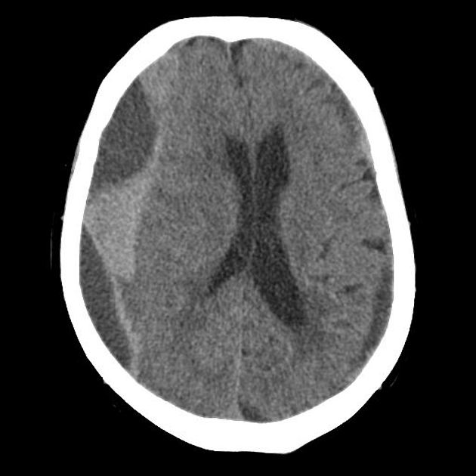

- Describe four (4) abnormal findings on this CT slice and state the diagnosis (4 marks)
_____________________________________________________________________________________________________________________________________________________________________________________________________________________________________________

Diagnosis_______________________________________________________________________

FINDINGS:
Large right parietal crescentric extraaxial fluid collection - crosses coronal suture
Mixed density collection with hypo and hyperechoic elements
Midline shift
Effacement of the right lateral ventricle
Small hypoechoic (chronic) left sided crescentric collection

DIAGNOSIS: Acute on Chronic Subdural with significant mass effect
Question 6 (marks) - Refeeding syndrome in anorexic
A 14 year old female has been brought in by her parents due to concerns around weight loss and lethargy for 6 months duration. She has been seeing a psychologist for 6 months for anxiety that is related to school attendance.
Observations
BP 80/60
P 72
Sats 98% RA
RR 22
Temp 35.8

Her ECG is shown
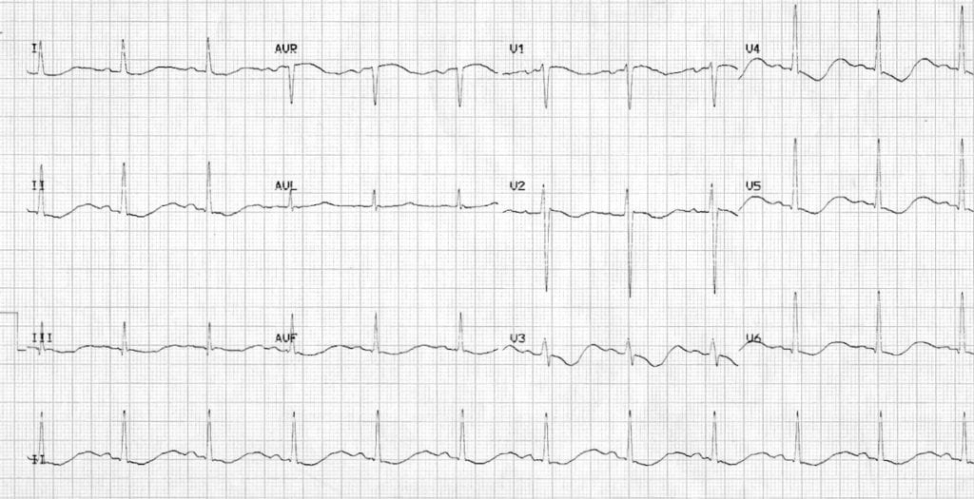

- List 3 abnormalities on the ECG and the likely cause of these abnormalities (4 marks)
_____________________________________________________________________________________________________________________________________________________________________________________________________________________________________________

Cause_______________________________________________________________________

ST depression.
T wave inversion.
Prominent U waves.
Long QU interval.
CAUSE: Electrolyte abnormalities – HypoK/HypoMg +/- Hypocalcaemia/Phos

- In the table below list the MOST important features you will seek specific to the assessment of this patient (10 marks)
Historical Features | Clinical Examination Features

Historical Features | Clinical Examination Features
Intentional vs Unintentional weight loss  Purging/Binging/Exercise/laxatives/diuretics | Weight and height - BMI
Physical Sx that might suggest an underlying medical illness  Thyrotoxicosis/Malignancy/ | Purging signs – teeth/knuckles
Depression and suicidality Hx  e.g. HEADS assessment/SADPERSONS | Lanugo hair and other nutritional signs- tongue B12, nails,
Social Factors – school bullying, family issues etc | Signs of cardiac failure
History of eating disorders in the past/treatments in the past | ?Goitre/features of thyrotoxicosis e.g. tremor/eye signs
Symptoms related to dehydration/hypoglycaemia/nutritional deficiency e.g. dizziness/collapse/palpitations

The patient has the following blood results, she wants to go home and is threatening to run away
TSH/T4 normal
Hb 98
MCV 69
Phos 0.3
CCa 2.2
K 1.7
Mg 0.4
Cr 154
Ur 8.7
LFT normal

- List the five (5) MOST important management priorities in this patient (5 marks)
___________________________________________________________________________________________________________________________________________________________________________________________________________________________________________________________________________________________________________________________________________________________________________________________________________

Treatment against patient wishes if cannot convince to be a voluntary patient – common law or section appropriate, patient is a minor so cannot refuse treatment
Urgent correction of electrolyte abnormalities with IV KCl, MgSO4, NaH2PO4 on a monitor till K>2.5, PO4 normalised
Consideration of Refeeding Syndrome – dietician assessment and withholding of carbohydrate till appropriate feeding regime decided
Appropriate IV hydration for renal failure
Psychiatric assessment/therapy ideally with eating disorder specialist involved
Admission to medical team/HDU – too unwell for

Question 7 (13 marks) – HypoMg Torsdes
A 67 years old cachectic man presents with recurrent collapses. He is of no fixed abode and has a history of hazardous alcohol use, with frequent presentations to the Emergency Department for withdrawal seizures. Past history of IHD and hypertension.
An ECG was taken during a transient unconscious episode in ED
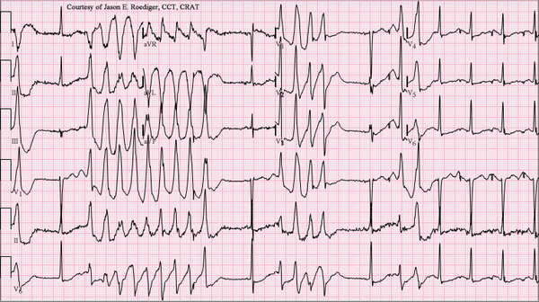

Observations post episode
P 56
BP 90/60
RR 22
Sats 96% RA
Temp 37.7

- Descrive the three (3) MOST important abnormalities on the ECG shown and state the ECG diagnosis (4 marks)
_____________________________________________________________________________________________________________________________________________________________________________________________________________________________________________

Diagnosis_______________________________________________________________________

Recurrent WCT approx. 300bpm
Twisting of the QRS around isoelectric baseline
Long QTc
R on T phenomenon
DIAGNOSIS: Torsades de Pointes

- List four (4) likely causes or contributing factors for this arrhythmia in this patient (4 marks)
____________________________________________________________________________________________________________________________________________________________________________________________________________________________________________________________________________________________________________________________

Causes likely in this man
Hypokalemia
Hypomagnesemia
Hypocalcemia
Medications – anything prolonging QTc
Heart failure
Left ventricular hypertrophy

Other causes unlikely in this case
Hypothermia
Subarachnoid hemorrhage
Hypothyroidism
Bradycardia

The patient has 6 further unresponsive episodes due to the same arrhythmia.
- List five (5) specific treatment options for this arrhythmia in the table below (5 marks)
Treatment Option | Details

Treatment Options | Details
Atropine IV | 500mcg IV repeated q3-5mins up to max 3g  Appropriate
Magnesium sulfate | 50% solution 4 mL (2 g) by intravenous infusion, over 10 to 15 minutes followed, if required, by 1 to 1.5 mL (0.5 to 0.75 g) per hour by intravenous infusion for 12 to 24 hours
Correct other electrolyte abnormalities  Specifically K | KCL minibags 10mmol/30-60mins on monitor till K 4.5mmol/L acheived
Isoprenaline | 20 micrograms intravenously, repeated according to clinical response, followed by 1 to 4 micrograms/minute by intravenous infusion
DC Cardioversion | Syncronised shock at 200J if prolonged episode , but if unsuccessful as sync may need
Temporary transvenous pacing | At 90-100 bpm (overdrive) to prevent bradycardia
lignocaine | 75 to 100 mg intravenously, over 1 to 2 minutes followed, if successful, by 4 mg/minute by intravenous infusion for 1 hour, then reduce to 1 to 3 mg/minute.

Question 8 (14 marks)
A 90 year old man is sent in by his GP for investigation of has renal dysfunction. The triage information states that he has had several months of lethargy. He has no significant medical history aside from a hip replacement 10 years ago. He is independently living with his wife, takes no medications and not had any contact with his GP since his hip replacement.
A brief physical assessment reveals a well hydrated, but slender man who has no overt abnormalities on external physical examination.
Observations
P 90
BP 140/80
RR 24
Sats 96% RA
Temp 37.1

VBG
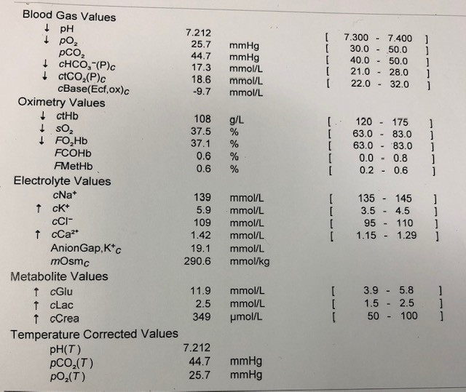
- In the table below list the abnormalities seen in the blood gas shown and provide the most likely reasons for these abnormalities (10 marks)
Abnormality | Likely Explanation(s)

Abnormality | Likely Explanation (s)
HAGMA | Renal failure – potential intrinsic and post renal causes -
Renal Failure – unclear if acute or chronic | Possible causes include age related decline, renal parenchymal disease and post obstructive causes e.g. BPH/Prostate Ca
Hyperkalaemia | Secondary to renal failure, also due to acidosis. O.05 rise in K for every 0.1 drop in pH
Anaemia | Likely related to chronic renal dysfunction, lack of epo.  Need to exclude bleeding
Hyperglycaemia | ?undiagnosed T2DM vs stress response  Meets non fasting criteria for diagnosis of DM
Hypercalcaemia | ?due to renal disease, need to exclude malignancy with bony mets e.g. prostate

The formal serum potassium level is 6.4mmol/L and the patient has the following ECG. The nurses have performed a post void residual bladder scan that shows 400mls
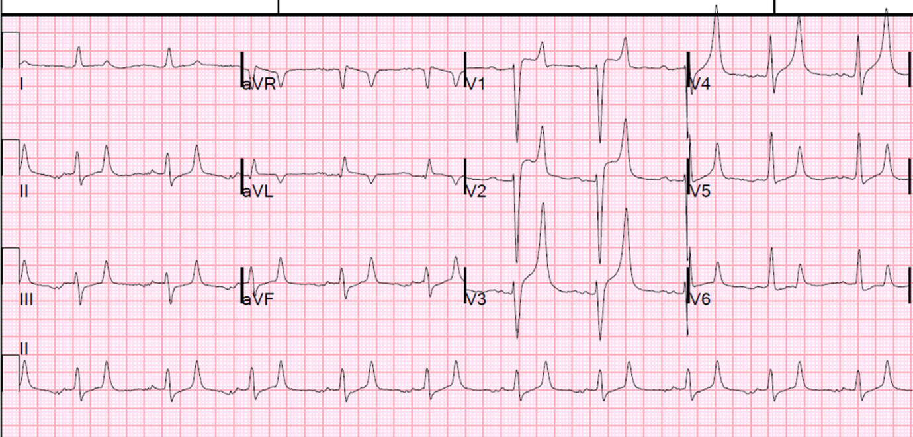

- List the four (4) most important next actions you will take in managing this patient (4 marks)
____________________________________________________________________________________________________________________________________________________________________________________________________________________________________________________________________________________________________________________________
Calcium gluconate 10-20 10% IV – end point normalisation of ECG changes
20mg nebulised salbutamol stat
10units of actrapid with 50mls of 50% dextrose
Insert IDC carefully to relieve bladder obstruction
(Bicarbonate could be considered as a K excreter given acidosis)
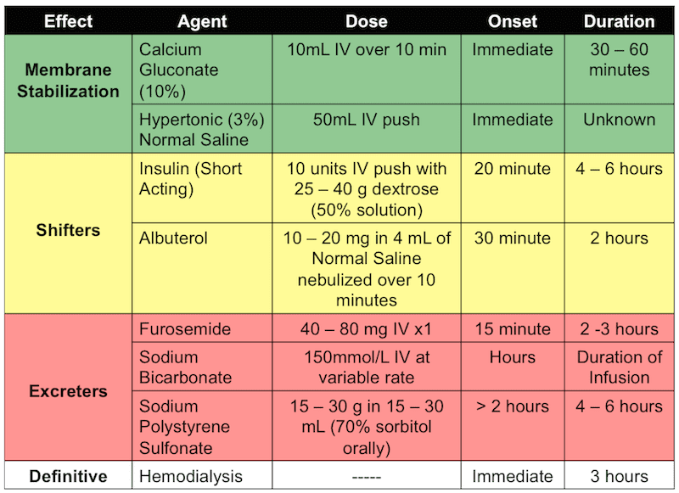

Question 9 (11 marks)
You are called urgently to assist with a 9 week old baby who presents with 1 week of increasing lethargy, vomiting and poor feeding. The baby was born at term and had an uneventful neonatal period. The baby is exclusively breast fed.
The child appears dehydrated and hypotonic. Fontanelles are sunken, capillary return 4 seconds. No overt signs of focal infection, pulses feeble but equal in all limbs, no murmurs, chest clear with no increase in work of breathing. Abdomen non distended and soft.
The child is fully monitored with a patent IV line
Observations
P 190
BP 70/50
RR 40
T 36.5
Sats 91% RA

VBG
pH 7.21
pCO2 45
HCO3 12
Lact 4.5
K 6.5
Na 124
Gluc 3.0
Cl 100
Hb 140
Cr 110

- What is the acid base abnormality (2 marks)
____________________________________________________________________________________________________________________________________________________________________

Mixed HAGMA and Respiratory Acidosis

- List the four (5) potential differential diagnoses (5 marks)
____________________________________________________________________________________________________________________________________________________________________________________________________________________________________________________________________________________________________________________________

Sepsis - ?UTI/Meningitis/pneumonia/skin etc
Adrenal Failure – classic VBG
Congenital Cardiac disease
Other metabolic disorder/Inborn errors of metabolism
Dehydration due to poor feeding
Consider NAI
RTA/renal disorders

Unlikely pyloric stenosis with this combination of Na/K/Cl/Acidosis – usually hypochloraemic metabolic alkalosis

- List your five (5) immediate treatment steps for this child (5 marks)
____________________________________________________________________________________________________________________________________________________________________________________________________________________________________________________________________________________________________________________________

Oxygen via face mark or nasal prongs
Fluids bolus of 10 mls/kg – can be titrated depending on signs of cardiac failure
Calculate fluid defecit/maintainence and replace with 0.9%NS and 5% dextrose over 24-48hrs
2mls/kg 10% dextrose – repeat till BGL >4.0
Hydrocortisone (after taking metabolic bloods)
Calcium gluconate/Insulin and Dextrose (doses not required – would look up)
Antibiotics – per eTG
cefotaxime 50 mg/kg intravenously, 6-hourly
OR
ceftriaxone 50 mg/kg intravenously, 12-hourly
PLUS EITHER
amoxicillin 50 mg/kg intravenously, 6-hourly
OR
ampicillin 50 mg/kg intravenously, 6-hourly.

