Trauma SAQ 1

A 15 year old male has been brought in to the resuscitation room of a trauma centre by ambulance. He has a large wound to his neck, and no other obvious injuries. He is awake and alert.

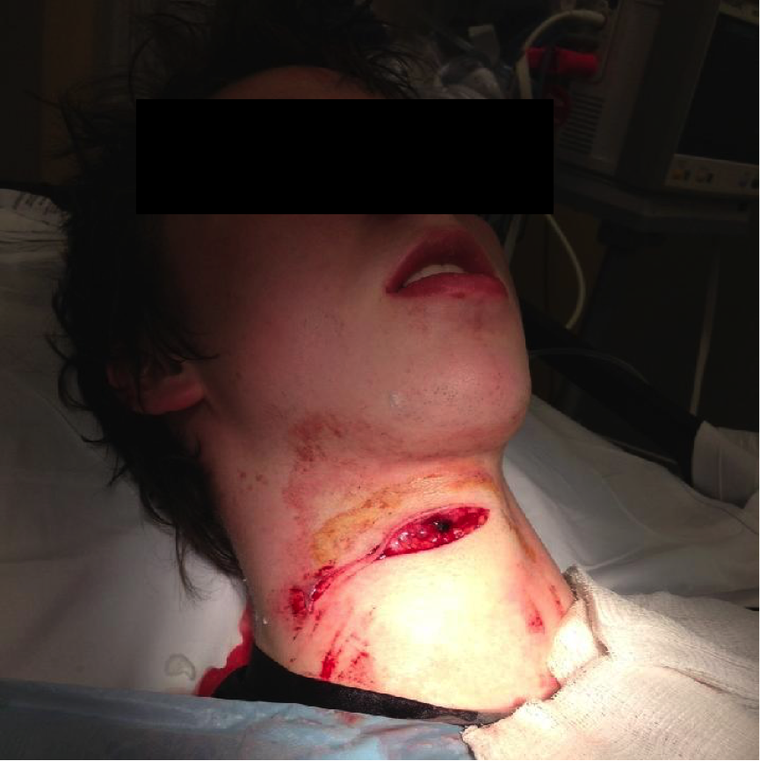

Observations
P100
BP 100/70
RR 22
Sats 99% RA

Question 1
Which zone of the neck does this injury involve? (1)

Question 2
Can you define the boundaries of this zone? (2)

Question 3
List 4 HARD clinical signs that would mandate immediate transfer to the operating theatre for urgent mandatory exploration? (4)

Question 4
Assuming that there are no hard signs present and he is stable, what would be the ideal next radiological investigation of choice in this case? (1)

