Trauma SAQ 1

A 15 year old male has been brought in to the resuscitation room of a trauma centre by ambulance. He has a large wound to his neck, and no other obvious injuries. He is awake and alert.

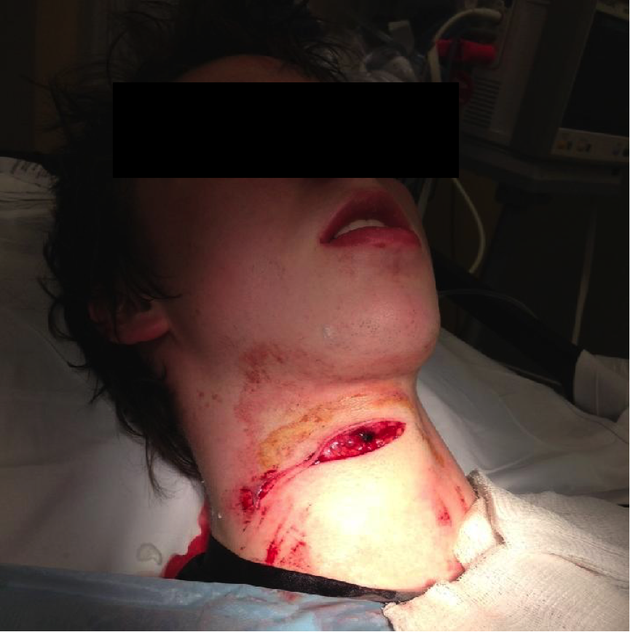

Observations
P100
BP 100/70
RR 22
Sats 99% RA

Question 1
Which zone of the neck does this injury involve? (1)
Zone 2

Question 2
Can you define the boundaries of this zone? (2)
Inferior border – cricoid cartilage
Superior border – horizontal line drawn between the angles of the mandible

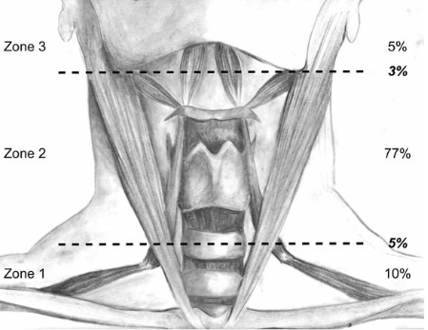

Question 3
List 4 HARD clinical signs that would mandate immediate transfer to the operating theatre for urgent mandatory exploration? (4)

ANY 4 OF:
- Airway Compromise
- Air Bubbling in wound
- Haemodynamically unstable patient
- Pulsatile or active arterial bleeding
- Expanding or pulsatile haematoma
- Haematemesis
- Significant neurological defecit

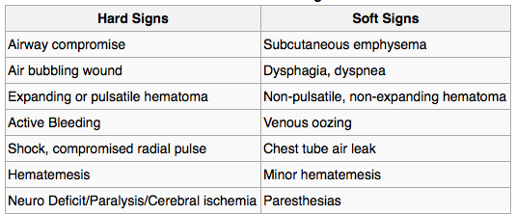

Question 4
Assuming that there are no hard signs present and he is stable, what would be the ideal next radiological investigation of choice in this case? (1)

Spiral CT Angiogram

