Anaesthetics SAQ 1

Rebecca Day

Pre-Accident (patients Employment ID Card)
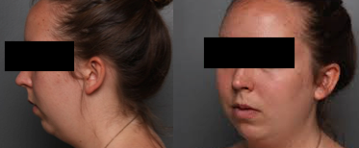

Post Intubation in ED
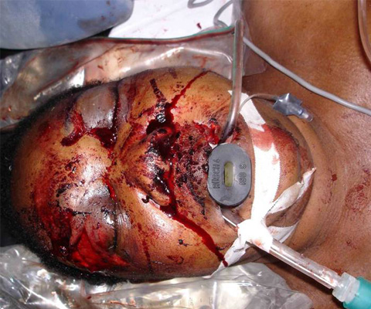

A 24 year old woman is BIBA after being involved in a head on MVA at high speed. She was the unrestrained driver travelling at high speed. She was agitated and confused (GCS 10), with Cspine precautions in situ on arrival.

Observations PRE-INTUBATION

P 130
BP 90/60
Sats 91% (FI02 1.0)
RR 28
Temp 35.6

Question 1
The decision is made to intubate. What are the factors that will make safe intubation with an RSI more difficult in this case ? (Max 6 – BOLD necessary)

- Preexisting Micrognathia
- Obesity
- Facial swelling and deformity - ?Le Fort fractures/swollen tongue
- Potential for foreign material in airway – teeth/blood/secretions
- CSpine immobilisation hindering optimal airway positioning
- Agitation hindering attempts to preoxygenate/physically control
- Hypotension, presumabley due to hypovolaemia, likely to be exacerbated
- Hypoxia will be exacerbated during RSI
- Potential for full stomach/gastroparesis and aspiration

Question 2
State the measures that you will employ to improve your chances of successful first pass intubation without complications? (Max 7)

-Adequate suction available/presuctioning of airway – x2 wide bore yankeur suckers (1)
- Use of video-laryngoscopy (1)
- Fluid/blood bolus to improve hypotension (1)
- Delayed sequence intubation with ketamine to gain control of situation without compromising airway reflexes (1)
- Sensible choice of anaesthetic agent e.g Ketamine (1)
(- Alternatively can use vastly reduced dose of other agent e.g. propofol or thiopentone – controversial) (1/2)
- Preoxygenation with a well fitting bag valve mask and FI02 1.0 (1/2)
- Apnoeic oxygenation with high flow nasal prongs at 15L/min flow (1)
- Orogastric insertion and suction of gastric contents (1)
- Have smaller sized ETT available in case of airway swelling (1/2)
- Ensure that an experienced anaesthetist is available in the resus room if possible (1/2)
-

Question 3
First pass intubation appears successful, how will you confirm the correct position of the ETT? (Max 3 – Bold necessary)

- End tidal CO2 measurement/colorimetric device
- Fogging of ETT
- Chest wall rise and fall in bagging
- Equal breath sounds bilaterally inc axillae
- Absence of breath sounds over gastric area on bagging
- CXR

